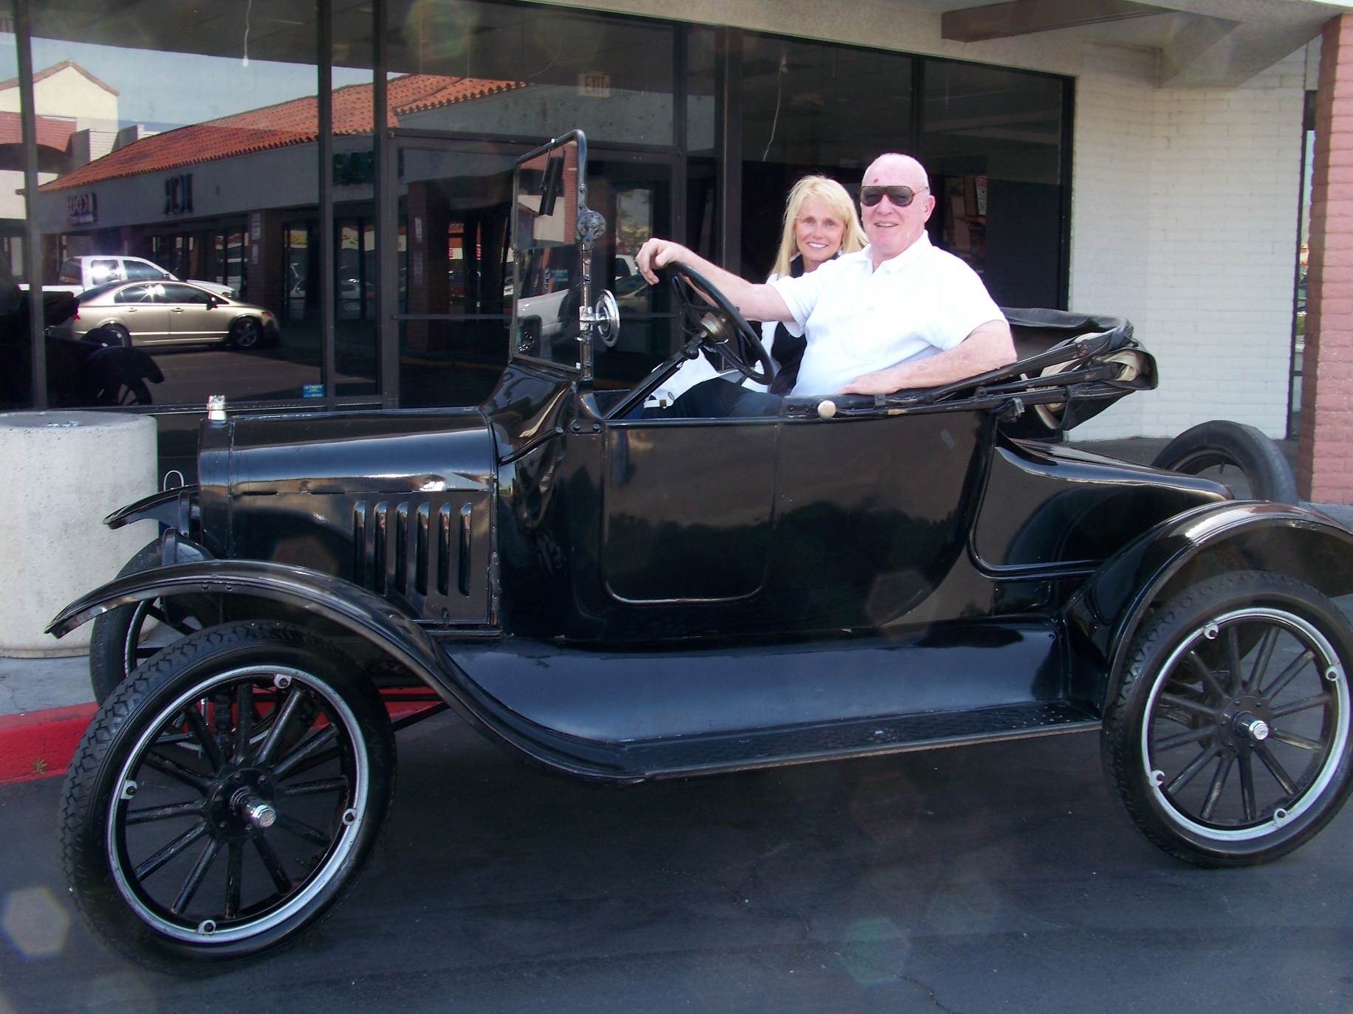
Jim Marsh and his daughter, Stacee, in his 1922 Ford Roadster Convertible, April 17, 2010. Photograph and profile by G.A. Villa. Copyright G.A. Villa and SNMTC 2010.
Jim Marsh and his daughter Stacee are Southern Nevada icons by nature of their television commercials in which both appear for Mr. Marsh's auto dealerships. In those commercials, they rib one another, and Jim's "foibles" receive the good kidding of Stacee's lovely dignity. As I sat with them at breakfast, it was apparent that the affection seen in those commercials is real and every bit as much fun.
Both are intrigued with the antiques and the artifacts of particular times and places and with the history of the Western United States and Nevada in particular. Stacee spoke forthrightly and with an ever-so-slightly wrinkled nose about the dainty cuspidors (spittoons) used by women in the early West and about the elegance of both their smaller size and their lovely designs, and Mr. Marsh talked about the riding gloves in his collection of Western memorabilia that were worn by a Pony Express rider in the mid 19th century.
Both Jim and Stacee, a respected teacher, have a down-to-earth delight in the parts of Nevada that Mr. Marsh has bought and brought back to a contemporary dignity and historical flavor as in the rebuilding of the Longstreet hotel and casino in the Amargosa Valley. His projects are myriad and are part of a remarkable, ongoing historical effort.
The car pictured was purchased by Jim when he was living in Denver, Colorado, with his parents in 1958. He paid $110 for it, and when he drove it home, his dad, a car dealer himself, was appalled about the leaky condition of the car. The car was repaired, and to this day it continues to run well and look good.
Jim Marsh and Stacee represent the Southern Nevada Model T Club well with their devotion to the history of Nevada and the West.

