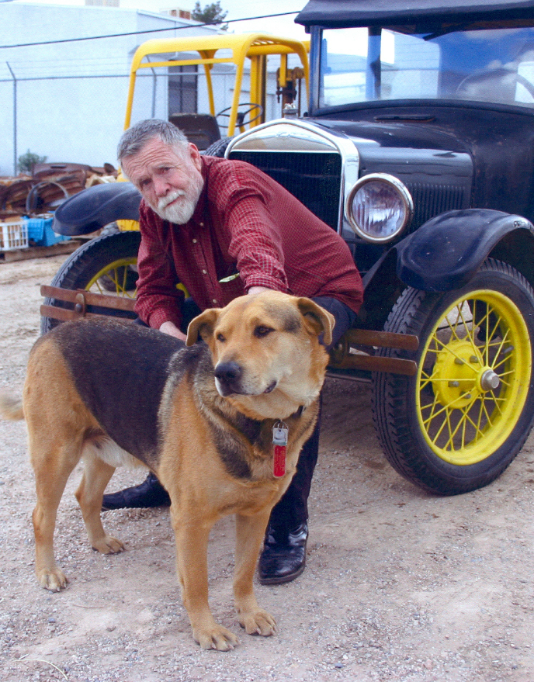
Photograph of Mr. Carter and Rufus by John T. Craft, February 6, 2009. Copyright John T. Craft and SNMTC 2018. Profile by G.A. Villa, SNMTC
SECRETARY 2018
With the exception of the years 2011 and 2012, Jimmy Carter has been Secretary of the Club since 2008. Jimmy brings a diverse and talented background to the Club. Born in Kansas City, Kansas, Jimmy was 13 years old when he got his first Model T Ford, a 1926 Tudor. That car was sold while he was in Augsburg, Germany, serving as an MP with the U.S. Army from 1958 to 1962, and when he returned stateside, he bought a 1923 Model T Touring car. His work as a millwright, a fabricator, a machinist, a welder, a pipe fitter, and a mechanic shows the range of his respected abilities. Jimmy was seriously injured when a golf club car he was working on fell on him, and a series of surgeries were required to return him to the fold of Model T aficionados. The club members are grateful for his good work and his always good spirits and the quality of his help. Pictured with Jimmy is Rufus, the dog who lent his considerable presence to the Club meeting place. Jimmy has come full circle as he once again owns a 1926 Model T Ford Tudor pictured here.

