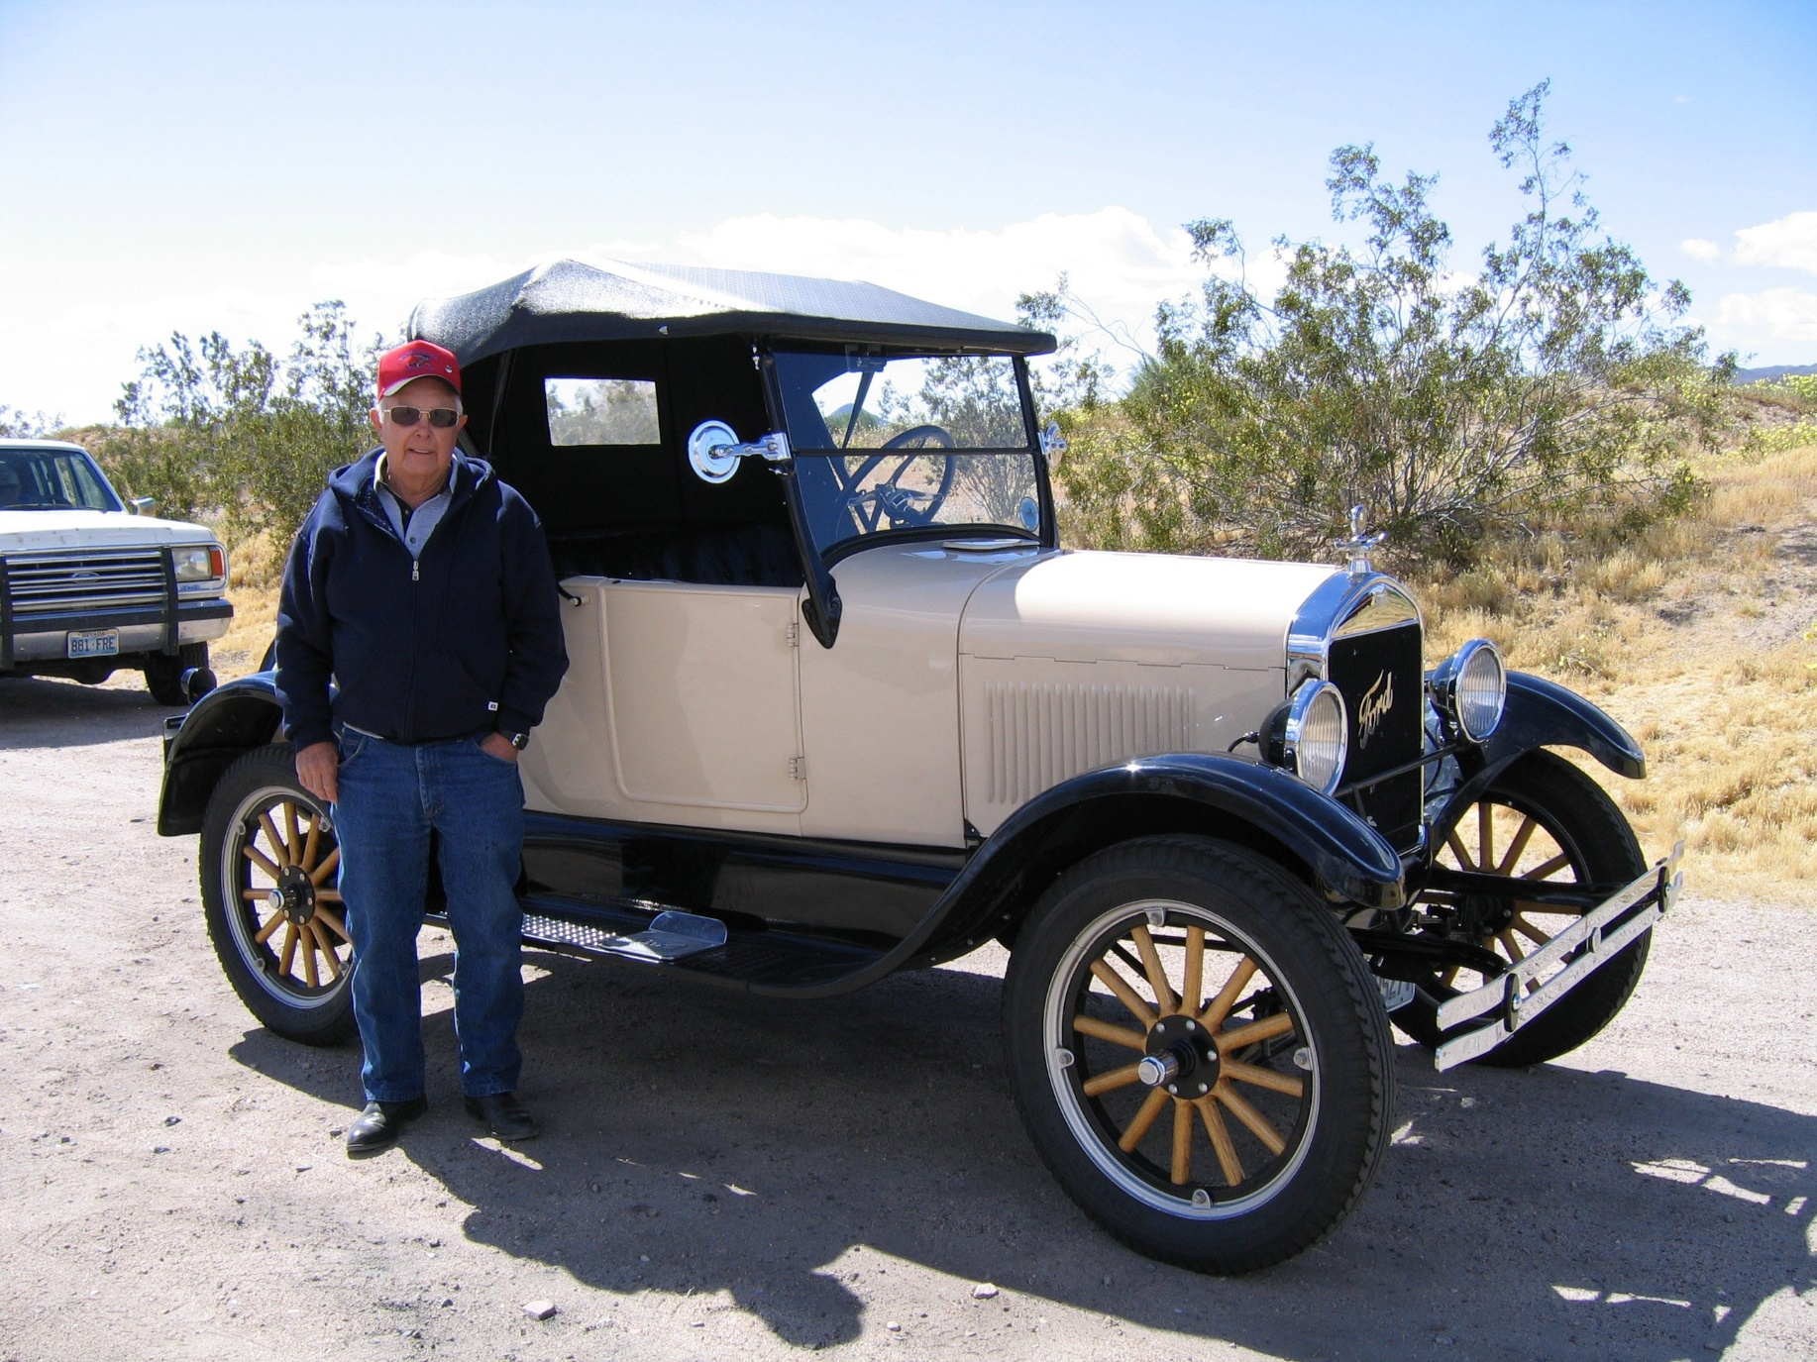
Photograph by Ken Schofield, Cheshire, England. Copyright Ken Scholfield and SNMTC 2018. Profile by G.A. Villa, copyright G.A. Villa and SNMTC.
HISTORIAN 2018
John Craft is a 21-year member of the Southern Nevada Model T Club, and he led the club as President in 2003. He has served the club as the Historian since 2004. John was born in Kansas, and he began his varied and distinguished work career with a two-year stint as a U.S. Army paratrooper from 1953 to 1955. He served as Jumpmaster from 1954 to 1955. Following his time in the U.S. Army, he met and married his wife of 62 years, Sharolyn, in Nebraska. A natural engineer and craftsman, John graduated from the Spartan School of Aeronautics in Tulsa, Oklahoma, in 1959, and he went on to work for the Boeing Company, during which time he earned his Private Pilot Certificate in 1962. Later John was President of the Jolyn Corporation in South Dakota where he oversaw the manufacture of self-loading, loader-mounted concrete mixers. Privately, John invented the Bedcap-Camper and was awarded U.S. Patent No.3,512,828 in 1970, and he was the co-inventor of the circumferential friction chain drive which holds U.S. Patent No. 3,599,502. John also served as project manager for paving and bridge projects and for water treatment plants. His work as a designer and pattern maker of sophisticated window shutters sets the tone for the known quality of his work on his Model T cars and overall: meticulously crafted, carefully finished, and beautifully maintained. John's generosity within the club finds expression with mechanical help and wood-working help where the need arises. His written and photographic histories of club events are appreciated and prized. John has a 1927 Ford Model T Roadster (pictured here) and a 1927 Ford Model T Depot Hack, and he presently owns and drives a 1929 Super Deluxe Model A Ford Roadster built by the Shay Motors Corporation of Detroit, Michigan.

