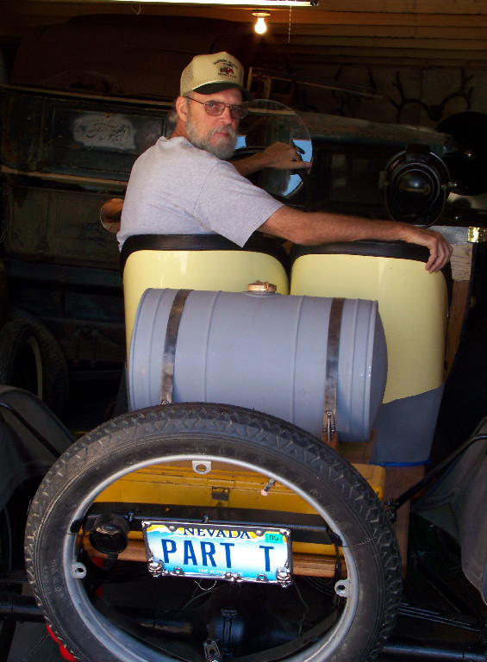
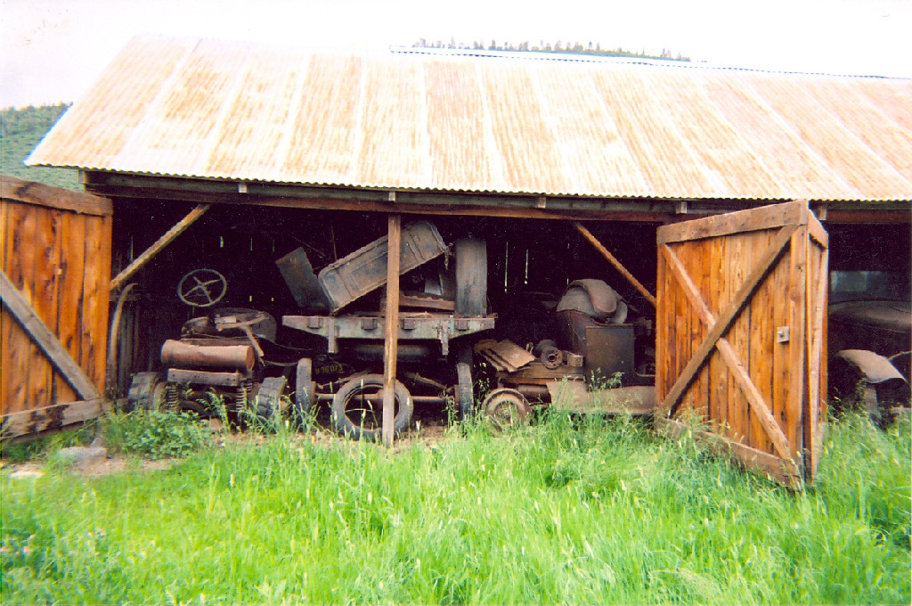
Jon and Pam Bibbens share an interest in the fine art of painting pictures. Pam enjoys the actual painting of pictures, and Jon regularly scours thrift stores looking for paintings of interest for his growing collection. The fact that Pam genuinely appreciates Jon's like for paintings and the fact that Jon genuinely appreciates Pam's efforts as a painter were perhaps foretold when they met as they both seem to enjoy the details of that enduring story.
Jon is a construction carpenter and supervisor who has been with the Bomel Company for 30 years, and earlier in that career, he was working on a construction site at Lake Elsinore, California. Pam saw him at the site and walked up and asked him to go to lunch. They went to lunch, and when it was time to leave, Pam got up and, it may be assumed, was so distracted by the dynamic Mr. Bibbens that she turned around and fell over a planter that was behind her. Jon says with an enviable grin, "She fell for me." Their extended family of four girls reflects their genuine respect for each other.
Jon has nurtured an interest in all things Model T since he was 13 years old when his granddad, George Bibbens, gave him a Model T headlight and running board. As Jon never did anything with them, his granddad replaced them in his predominantly Model T collection of car parts and chassis. Jon's life-long interest in cars and antiques began with his granddad's gentle and serious introduction to collecting and preserving older things of value. Jon notes that his granddad often found parts that had been abandoned in the countryside and that he sometimes had the indigenous Hat Creek Indians bring him parts that they found. After his granddad and grandmother passed away, Jon was able to buy the entire collection of parts (see the photo above) and begin the long, loving process of organizing them in storage and beginning to restore cars part by part. The speedster pictured above is one of the first of those efforts which will eventually include restoration of some lumber cutting equipment powered by modified Model T power plants.
Jon took this writer through his two-floor garage and storage shed where he has perhaps thousands of Model T parts and, most notably, a fascinating collection of early automotive mechanical turn signals. Jon explains that early in the history of the automobile, there were no rules or restrictions about turn signals or stop signals, and the result is a collection of devices similar to the railroad semaphores. Such is one interesting nook in Jon's collecting talent.
It is very good to have Jon and Pam and their lovely and intelligent daughters as members of the Southern Nevada Model T Club.
Photograph and profile by G.A. Villa. Copyright G.A. Villa and SNMTC 2018.

