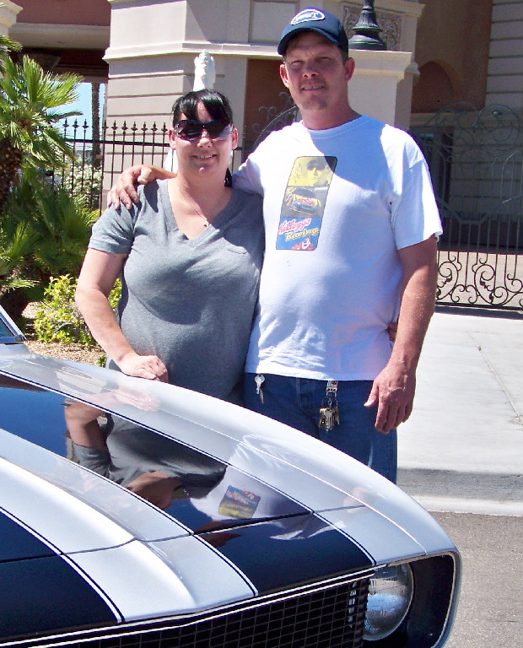
Photograph and profile by G.A. Villa. Copyright G.A. Villa and SNMTC 2010.
It would perhaps be difficult to find a story of two people that goes back as far as that of Mike and Melissa Karr. They met in kindergarten at Walter Bracken Elementary School in Las Vegas, Nevada, when they were five years old and are two people who obviously have had a very strong direction in life from very early on. Additionally, Melissa had her first motorcycle at the age of four (before she met Mike), and perhaps it was her influence that found its way into Mike's life when he got his first quad at age seven. However one wishes to put it all together, Mike raced quads in motorcross and Melissa raced Yamaha YZ80 to 125 class motorcycles in motorcross for a good number of years. They have been married for 17 years and have a son, Gregory, and a daughter, Christina.
As parents the Karrs have turned their energies and talents to the rigors of car restorations, and among their work to date are the 1967 Chevy Camaro in the picture, a 1966 Mustang, a 1961 Corvette, and a 1957 Chevy Stepside. In perhaps their first family restoration effort, they recently purchased a rolling 1926 Ford Model T chassis, and they and their son Gregory are doing some preliminary body work on fenders on the car.
Both Mike and Melissa are sure in their praise for their parents, noting their long years of work and good and strong guidance. Mike notes that dad and Southern Nevada Model T Club member Jerry is unquestionably the patriarch of the family and that he is more than worthy in that role. Aside from Mike's three-year stint in the U.S. Army as a crew chief for Blackhawk helicopters at Ft. Campbell, Kentucky, most of the family efforts have been under the canopy of Jerry Karr's Western Electric Motors, Inc., where Mike works with his dad. Basically, Mike says, the company repairs and services anything electrical in-house or with field service, and he is proud of the trade that his dad has handed on to him.
In turn it is good to have the good fellowship and abilities and talents of all of the Karr family under the Southern Nevada Model T Club canopy.

