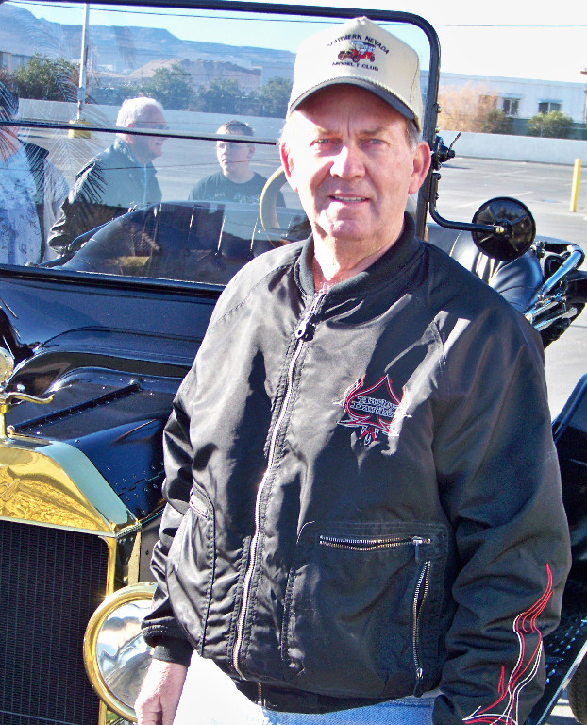
Photograph and profile of Mr. Collett by G.A. Villa. Copyright G.A. Villa and SNMTC 2018.
VICE PRESIDENT 2018
Steve Collett is the Vice President for 2018 and has also served as President in 2007 and 2008. He is devoted to the Southern Nevada Model T Club and has served as Vice President for many years. As the founder and owner of Collett Electric, a commercial and underground utilities contractor, he brings his considerable business acumen to this responsibility. A 46-year resident of Las Vegas, Mr. Collett’s commercial building houses some of his Model T restoration and other classic auto rebuilding work. Born in Harlan County, Kentucky, Steve worked for two years in a coal mine as a teenager before moving to North Carolina where he began a successful path to his trade as a master electrician. Steve brings his astute and practical abilities to the preservation of Model T Fords and many other automobiles, and he has rebuilt two Model T Fords: a 1926 Model T Pickup and a 1926 Model T Tudor Sedan. Mr. Collett's Model T collection includes two restored 1911 Model T Touring cars and a 1915 Model T touring car, 1914 and 1920 Model T Speedsters, a 1925 Model T Touring car, a 1926 Model T Tudor, and a 1927 Roadster. His restorations are known for his meticulous attention to detail and historical accuracy. He is also a motorcycle and hot rod enthusiast who rounds out his talents as one who enjoys both indoor and outdoor cooking. Steve and member Judy Fine are devoted to both the Southern Nevada Model T Club and to each other, and it is a privilege to have them as members.

