|  |  |
| --- | --- |
| **Numbers** | **Details** |
| Natural Numbers | N ={ 1, 2,3,4,5 … } |
| Whole Numbers | W={ 0, 1, 2, 3, 4, 5… } |
| Rational Numbers | Those numbers which can be presented in the form of a/b are called Rational Numbers. |
| Re Numbers | Real Numbers can be found on a number line |
|  |  |

**Chapter 1: Real Numbers**

* (a+b)2= a2+ b2+ 2ab
* (a-b)2= a2+ b2– 2ab
* (a+b) (a-b) = a2– b2
* (x + a)(x + b) = x2 + (a + b)x + ab
* (x + a)(x – b) = x2 + (a – b)x – ab
* (x – a)(x + b) = x2 + (b – a)x – ab
* (x – a)(x – b) = x2 – (a + b)x + ab
* (a + b)3 = a3 + b3 + 3ab(a + b)
* (a – b)3 = a3 – b3 – 3ab(a – b)
* (x + y + z)2 = x2 + y2 + z2 + 2xy + 2yz + 2xz
* (x + y – z)2 = x2 + y2 + z2 + 2xy – 2yz – 2xz
* (x – y + z)2 = x2 + y2 + z2 – 2xy – 2yz + 2xz
* (x – y – z)2 = x2 + y2 + z2 – 2xy + 2yz – 2xz
* x3 + y3 + z3 – 3xyz = (x + y + z)(x2 + y2 + z2 – xy – yz -xz)
* x2+ y2 =½ [(x + y)2 + (x – y)2]
* (x + a) (x + b) (x + c) = x3 + (a + b +c)x2 + (ab + bc + ca)x + abc
* x3 + y3= (x + y) (x2 – xy + y2)
* x3 – y3 = (x – y) (x2 + xy + y2)
* x2 + y2 + z2 -xy – yz – zx = ½ [(x-y)2 + (y-z)2 + (z-x)2]

### **Basic formulas for powers**

* pmx pn= pm+n
* {pm}⁄{pn} = pm-n
* (pm)n= pmn
* p-m = 1/pm
* p1 = p
* P0= 1

## Chapter 2 Polynomials

## Chapter 2 - Polynomials Formula part-1

## Chapter 3: Pair of Linear Equations in Two Variables

* Linear equation in one variable: ax +b =0
* Linear equation in two variables: ax+ by+ c =0
* Linear equation in three variables: ax+ by+ cz= 0

## Chapter 4: Quadratic Equations

For a quadratic equation, ax2+ bx + c = 0

**ax2+bx+c=0 where a ≠ 0 And x = [-b ± √(b2 – 4ac)]/2a**

* Sum of roots = –b/a
* Product of roots = c/a
* If roots of a quadratic equation are given, then the quadratic equation can be represented as:

**x2 – (sum of the roots)x + product of the roots = 0**

## Chapter 5: Arithmetic Progression

If a1, a2, a3, a4, a5, a6,… are the terms of AP and d is the common difference between each term, then we can write the sequence as; a,a+d, a+2d, a+3d, a+4d, a+5d,….,nth term… where a is the first term. Now, nth term for [arithmetic progression](https://byjus.com/maths/arithmetic-progression/) is given as;

|  |
| --- |
| **nth term = a + (n-1) d** |

Sum of the first n terms in Arithmetic Progression;

|  |
| --- |
| **Sn=n2[2a+(n−1)d]** |

## Chapter 6: Triangles

## Chapter 6 - Triangles Formula part-1

## Chapter 6 - Triangles Formula part-2

## Chapter 6 - Triangles Formula part-3

## Chapter 6 - Triangles Formula part-5

## Chapter 6 - Triangles Formula part-8

## Chapter 7: Coordinate Geometry

* *For a line having two-point A(x1, y1) and B(x2, y2), then the distance of these points is given as:*

*AB= √[(x2− x1)2+ (y2− y1)2]*

* [***Section Formula***](https://www.geeksforgeeks.org/section-formula-internal-and-external-division-coordinate-geometry/)***:****For any point p divides a line AB with coordinates A(x1, y1) and B(x2, y2), in ratio m:n, then the coordinates of the point p are given as:*

*P={[(mx2+ nx1) / (m + n)] , [(my2+ ny1) / (m + n)]}*

* [***Midpoint Formula***](https://www.geeksforgeeks.org/mid-point-formula-in-coordinate-geometry/)***:****The coordinates of the mid-point of a line AB with coordinates A(x1, y1) and B(x2, y2), are given as:*

*P = {(x1+ x2)/ 2, (y1+y2) / 2}*

* [***Area of a Triangle:***](https://www.geeksforgeeks.org/area-of-a-triangle-coordinate-geometry-class-10-maths/)*Consider the triangle formed by the points A(x1, y1) and B(x2, y2) and C(x3, y3) then the area of a triangle is given as-*

*∆ABC = ½ |x1(y2− y3) + x2(y3– y1) + x3(y1– y2)|*

## Chapter 8: Trigonometry

|  |  |  |  |  |  |  |
| --- | --- | --- | --- | --- | --- | --- |
| **θ** | **0°** | **30°** | **45°** | **60°** | **90°** | **180°** |
| **Sin** | 0 | 1/2 | 1/2 | 3/2 | 1 | 0 |
| **Cos** | 1 | 3/2 | 1/2 | 1/2 | 0 | -1 |
| **Tan** | 0 | 1/3 | 1 | 3 | ∞ | 0 |
| **Cot** | ∞ | 3 | 1 | 1/3 | 0 | ∞ |
| **Sec** | 1 | 2/3 | 2 | 2 | ∞ | -1 |
| **Cosec** | ∞ | 2 | 2 | 2/3 | 1 | ∞ |

* Sinθ= 1/ Cosecθ or Sin θ.Cosecθ= 1
* Cosθ= 1/Secθ or Cos θ.Secθ= 1
* Tanθ= 1/Cotθ or Tanθ.Cotθ= 1
* Sin (A+B)= SinA.CosB + CosA.SinB
* Sin (A-B)= SinA.CosB – CosA.SinB
* Cos (A+B)= CosA.CosB- SinA.SinB
* Cos (A-B)= CosA.CosB+SinA.SinB
* Tan (A+B)= (TanA + TanB)/ (1-TanA TanB)
* Tan (A-B)= (TanA- TanB)/ (1+TanA TanB)

**Additional Maths Formulas for Trigonometry**

* sin θ = Side opposite to angle θ/ Hypotenuse = Perpendicular/Hypotenuse= P/H
* cos θ = Adjacent side to angle θ/ Hypotenuse= Adjacentside/ Hypotenuse= B/H
* tan θ = Side opposite to angle θ/ Adjacent side to angle θ
* sec θ = 1/ cosθ
* cot θ = 1/ tanθ
* cosec θ = 1/ sinθ
* tan θ = Sinθ/ Cosθ
* sin (90° – θ) = cos θ
* cos (90° – θ) = sin θ
* tan (90° – θ) = cot θ
* cot (90° – θ) = tan θ
* sec (90° – θ) = cosecθ
* cosec (90° – θ) = secθ
* sin2θ + cos2 θ = 1
* sec2 θ = 1 + tan2θ for 0° ≤ θ < 90°
* Cosec2 θ = 1 + cot2 θ for 0° ≤ θ ≤ 90°

## Chapter 10: Area of Circle

* Circumference of the circle = 2 π r
* Area of the circle = π r2
* Area of the sector of angle θ = (θ/360) × π r2
* Length of an arc of a sector of angle θ = (θ/360) × 2 π r

(r = radius of the circle)

## Chapter 12: Areas Related to Circle

|  |  |
| --- | --- |
| **arameters of Circles** | **Formulas** |
| Area of the sector of angle θ | (θ/360°) × πr2 |
| Length of an arc of a sector of angle θ | (θ/360°) × 2πr |
| Area of major sector | πr2 – (θ/360°) × πr2 |
| Area of a segment of a circle | Area of the corresponding sector – Area of the corresponding triangle |
| Area of the major segment | πr2 – Area of segment (minor segment) |

## Chapter 13: Surface Area and Volume

* **Sphere Formulas**

|  |  |
| --- | --- |
| Diameter of sphere | 2r |
| Surface area of sphere | 4 π r2 |
| Volume of Sphere | 4/3 π r3 |

* **Cylinder Formulas**

|  |  |
| --- | --- |
| Curved surface area of Cylinder | 2 πrh |
| Area of two circular bases | 2 πr2 |
| Total surface area of Cylinder | Curved surface area of Cylinder + Area of Circular bases = 2 πrh + 2 πr2 |
| Volume of Cylinder | π r2h |

* **Cone Formulas**

|  |  |
| --- | --- |
| Slant height of cone | l = √(r2 + h2) |
| Curved surface area of cone | πrl |
| Total surface area of cone | πr (l + r) |
| Volume of cone | ⅓ π r2h |

* **Cuboid Formulas**

|  |  |
| --- | --- |
| Perimeter of cuboid | 4(l + b +h) |
| Length of the longest diagonal of a cuboid | √(l2 + b2 + h2) |
| Total surface area of cuboid | 2(l×b + b×h + l×h) |
| Volume of Cuboid | l × b × h |

Here, l = length, b = breadth and h = height. In case of Cube, put l = b = h = a, as cube all its sides of equal length, to find the surface area and volumes.

## Chapter 14: Statistics

**(I) The mean of the grouped data** can be found by 3 methods.

**Direct Method:**

$\begin{aligned}\overline{x}=\frac{\sum_{i=1}^{n}{}f_{i}x_{i }}{\sum_{i=1}^{n}{}f_{i}}\end{aligned}$ where ∑fixiis the sum of observations from value i = 1 to n

And ∑fiis the number of observations from value i = 1 to n

**Assumed mean method** :

$\begin{aligned}\overline{x}=a+\frac{\sum_{i=1}^{n}{}f_{i}u_{i}}{\sum_{i=1}^{n}{}f_{i}}\end{aligned}$ where a is assumed mean and di is deviation of a from each of the xi.

Also, di = xi – a

**Step deviation method :**

$\begin{aligned}\overline{x}=a+\frac{\sum_{i=1}^{n}{}f_{i}d_{i}}{\sum_{i=1}^{n}{}f_{i}}\end{aligned}$ x h

Where, ui= x-a / h

and h is class size

**(II) The mode of grouped data:**

Statistics Class 10 Notes Maths Chapter 14 6

l=lower limit of modal class.

h= size of the class interval

f1= frequency of modal class.

f0= frequency of the class preceding the modal class.

f2= frequency of the class succeeding the modal class.

**(III) The median for a grouped data:**

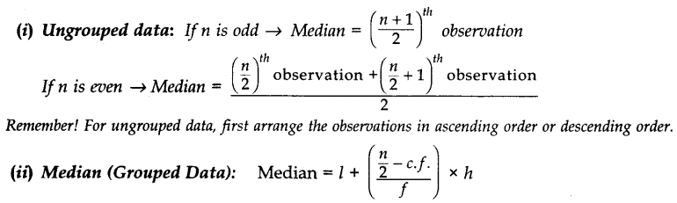 l=lower limit of median class.

n= number of observations.

cf= cumulative frequency of class preceding the median class.

f= frequency of median class

h= class size

## Chapter 15: Probability

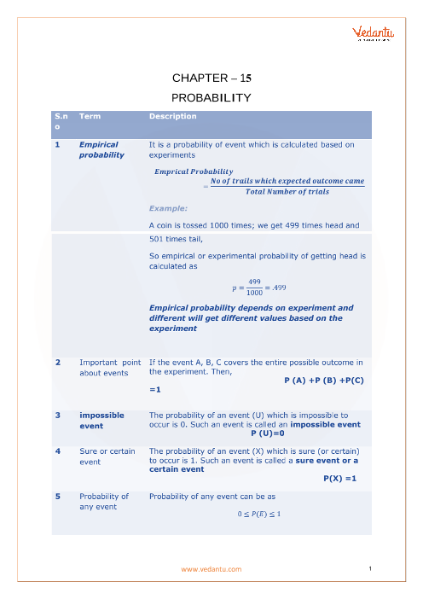

## Chapter 1 - Real Numbers Formula part-1

## Chapter 1 - Real Numbers Formula part-2