Welcome to your new Surveillance System!

Thank you for purchasing your system through Colorado Complete Security. Here are some basic instructions on how to view, playback and change settings.
If you have questions, please feel free to call us anytime! 719-505-2347

Guard Station (Personal Computer Viewing)

Our technician will get you started with application on your computer. He will set default setting on the NVR and add the cameras to your application.

Logging In
- After logging in you will see your control panel
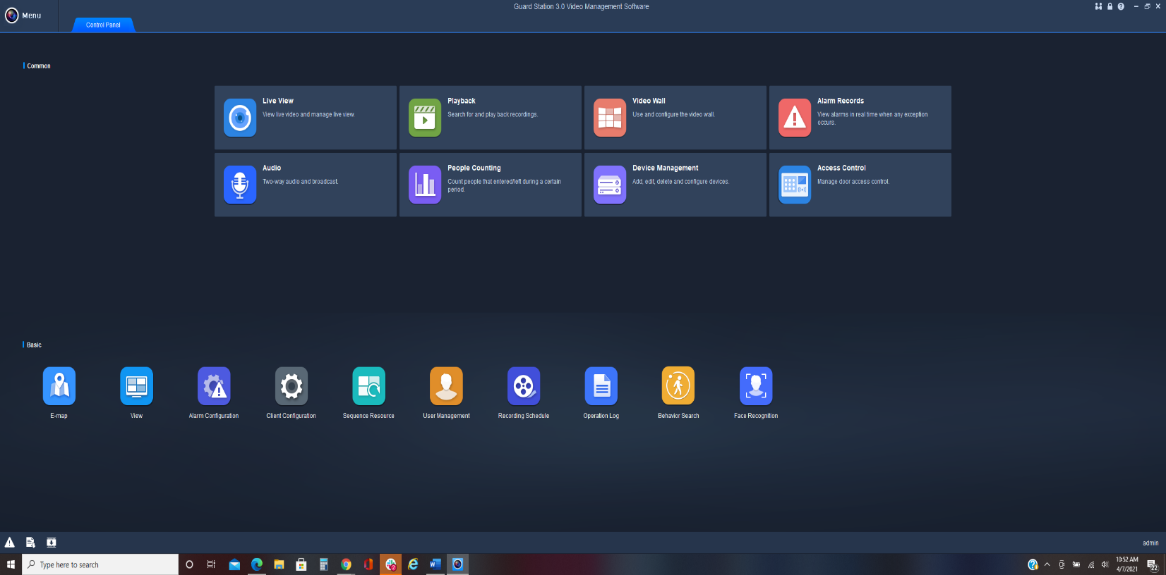
- This is where you will be able to change passwords, live view, or playback.
- Select (double click) Device management

- This is where you will be able to select your system (check the box), and you will be able to edit.

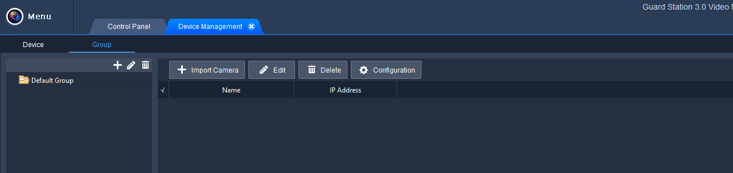
- Then you will close out of the Device Management tab and return to Control Panel.

Live View
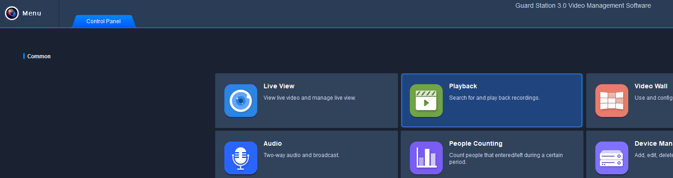
- Select Live View on Control Panel

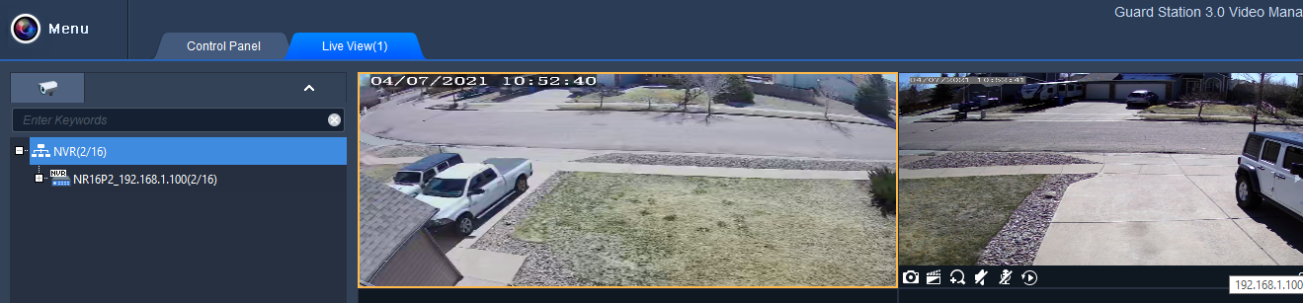
- Then will need to select your NVR. And then you can select how many cameras you would like to view.

Playback
- From your control panel, select Playback

- Select NVR, Click +

- Check the box next to the camera or cameras you wish to view. Then select a date from the calendar below. You will then click search. This will give you a 24-hour block of video of the selected date.
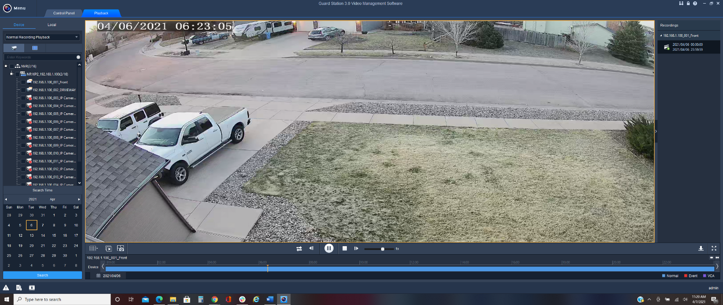

- You then be able to scroll through the day and isolate what time you need.
- Notice the playback choices at the bottom of the video; you can change the speed of play back to easily find the incident you are looking for.

