Safeguarding Concern Form

Forest Gate Baptist Church, Forest Gate, Blackpool FY3 9AW
Tel: 01253 397400. Email: forestgatebaptistchurch@gmail.com

1. Person Raising the Concern
Person Raising the concern, or to whom the disclosure was made.
Contact Details

2. Individual you are concerned about
Name |  | Date of Birth or approx. age if not known
Contact Details

3. Nature of the concern (to be completed by the person named in table 1)
What happened? (Nature of Concern / Disclosure made – use the young person’s own words when possible)

Who was allegedly involved and how? (Name / Contact Details when known - include witnesses)

When did it happen? (date and time)
Where did it happen? (specific location)

Have handwritten notes been made? Yes / No
If so, have they been attached to this form? Yes / No
4. Body Map
Name of Person you are mapping:
Name of Person Completing this Map:

These diagrams for the recording any visible injuries that may appear on the person. Where bruises, burns, cuts or other injuries, occur, shade and label them clearly on the diagram. The child should not be examined in order to complete this map, just record what you can see. It may be useful to note the person’s clothing, i.e. were they wearing long or short sleeves, were they wearing shoes.
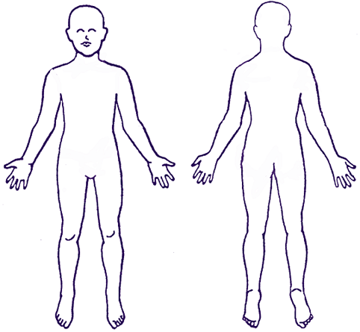
Remember it is not your job to investigate or to decide if an injury or mark is non-accidental. Listen, Record and pass it on.

Signature of Person Completing Map |  | Date & Time

Sections 5 to 11 should be completed by the Designated Person

5. Designated Person Completing this Form.
Name of Designated Person for Safeguarding
Contact Details

6. Have the Parents / Guardians / Next of Kin been told? Yes / No
If so, when and by whom?

7. Have Statutory Authorities / Partner Agencies been told? Yes / No
E.g. Social Services, Youth Services, Education, Health Service, Police etc.
If so, please complete the table below.
Agency
Contact Name
Position
Phone Number
Email Address
Contacted by
Date / Time contacted

8. Have the following people been told? They do not all need to be told, but if they are spoken to please include the details below. If two people serve as Designate Persons (one of each genser), then both DPS should normally be informed.

 | Name | Date & Time | By whom
Other Designated Person for Safeguarding
Minister

Children's / Youth Worker
Safeguarding Trustee

NWBA Safeguarding Contact

9. What actions have been taken so far, and by whom?

Action
By Whom?

Date

10. What further actions need to be taken and who will be responsible?

Action
By Whom?

11. Other Notes / Observations / Continuations

12. Signatures
Designated Person for Safeguarding |  | Minister, or Safeguarding Team Member
Date & Time |  | Date & Time
13. Any other Notes / Observations / Continuation of previous sections

