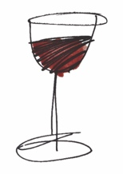 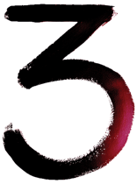 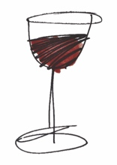
HOUSE WINES
Entre Ciel et Mer Vermentino, Languedoc ................................................................................................. 28
Cinco Fincas Malbec, Mendoza .................................................................................................................... 30
Le Pic Rosé, Roussillon .................................................................................................................................. 28
WINES BY THE GLASS
WHITE
Vermentino, Languedoc
125ml 5.90 | 175ml 6.70
Mayfly Sauvignon Blanc, Marlborough
125ml 7.00 | 175ml 8.00
RED
Cinco Fincas Malbec, Mendoza
125ml 6.50 | 175ml 7.50
Aloe Tree Shiraz, Western Cape
125ml 7.00 | 175ml 8.00
ROSÉ
Le Pic Rosé, Roussillon
125ml 5.90 | 175ml 6.70
WHITE
Palazzo del Mare Catarratto, Sicily ................................................................................................................ 30
Vale do Homen Branco Vinho Verde, Braga .............................................................................................. 32
Domaine Jean-Paul Picard Sancerre, Loire....................................................................................................64
Entre Ciel et Mer Vermentino, Languedoc ................................................................................................. 34
Aloe Tree Chenin Blanc, Western Cape ...................................................................................................... 34
Mayfly Sauvignon Blanc, Marlborough ....................................................................................................... 36
Alice Verdeca, Puglia ....................................................................................................................................... 40
El Camarón Albariño, Galicia ....................................................................................................................... 42
Domaine Fichet Mâcon-Villages, Burgundy ............................................................................................... 48
ROSÉ
Le Pic Rosé, Roussillon .................................................................................................................................. 32
RED
Palazzo del Mare Rosso, Sicily ……………………………………………….................................... 30
One Chain “The Wrong ’Un” Shiraz Cabernet .......................................................................................... 32
Cinco Fincas Malbec, Mendoza .................................................................................................................... 32
Aloe Tree Shiraz, Western Cape ................................................................................................................... 34
Montsable Pinot Noir, Haute Vallée de l’Aude ...........................................................................................36
Entre Les Vents Côtes du Rhône Villages .................................................................................................. 38
Lirica Primitivo di Manduria ......................................................................................................................... 44

