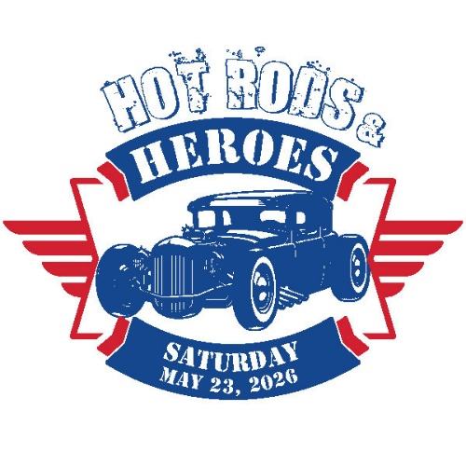
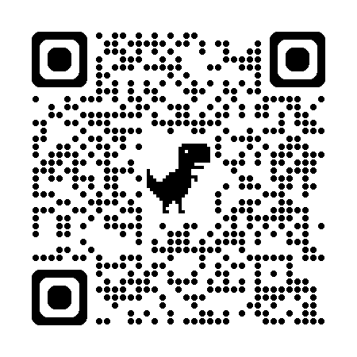
$50 DONATION REQUIRED
MUST PROVIDE OWN TENT & TABLE
Make checks/M.O. payable to
HVAF of Indiana
Memo: HRH 4 PTSD
Mail to:
HRH 4 PTSD
c/o Melissa Bischof
1469 E 52nd St
Indianapolis, IN 46205
Vendor Registration
Form
Saturday, May 23, 2026
Set up starts at 10 am
and ends at 12 pm
Melissa Clawson, Event Director
HRH4PTSD@outlook.com
317-941-6605
Vendor Name: ____________________________________ Contact: ____________________________
Address: ________________________________________ State: ______________ Zip: ____________
Email: ___________________________________________ Business phone: _____________________

Type of Booth & Description of Product sold: (NO ELECTRICITY PROVIDED)

____________________________________________________________________________________
____________________________________________________________________________________
_____________ Proof of Insurance Attached
____________________________________________________________________________________
WAIVER: Hot Rods & Heroes Car Show Fundraiser (HRH) and The American Legion (TAL) Post 34 reserves the right to refuse any vendor application, should this occur, the fee will be refunded. The Vendor shall defend, save and hold harmless HRH, ALA Unit 34 and TAL Post 34, their respective officers, agents, board members, staff, volunteers, sponsors and assigns from any claims, damages, losses, liability or expense which may arise, and shall not be held responsible for any loss or damage due to fire, accident, theft, weather, acts of God, vandalism or any other loss or injury whatsoever or not specifically described herein, whether past, present or future. Booths are not insured by HRH, ALA Unit 34 and TAL Post 34 or any sponsoring agents. Exhibitors must make provisions for safeguarding their goods. Exhibitor must have replacement cost insurance for all personal property. Exhibitor assumes full liability for the protection, care & maintenance of exhibitor’s property.
ANY VENDOR NOT HOLDING A VALID LIABILITY INSURANCE POLICY WILL EXIBIT AT THEIR OWN RISK AND ASSUMES ALL LIABILITY.
Please sign to acknowledge that you have read all the information, rules and regulations and agree to be bound by this contract.
_________________________________________________________ Date: ____________
Printed Name
_________________________________________________________
Signature
_________________________________________________________ Date: ____________
Accepted by Print
_________________________________________________________
Accepted by Signature
* OFFICE USE ONLY *
Date received:
___________________
Booth #: ____________

