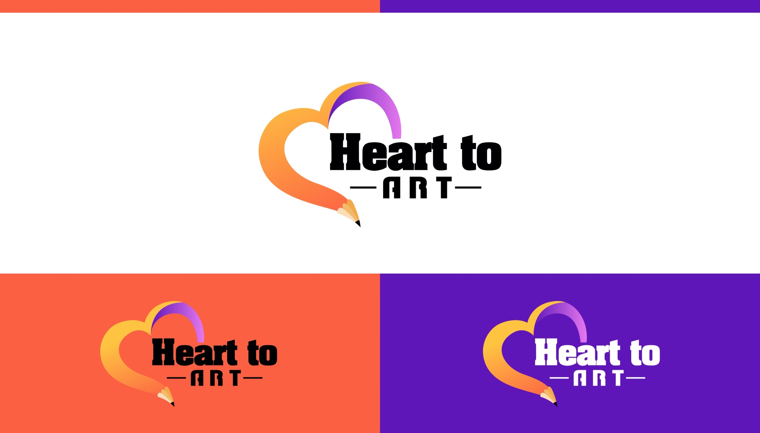

**SUBMISSION DETAILS & STUDENT RELEASE FORM**

**By your participation in this HearttoArt.org art contest, you agree to release, indemnify, and hold Sponsor, their affiliates, parents, officers, and directors and agents harmless from any and all claims.**

**Name _________________________________ Date _____________**

**High School ______________________ Grade _______ Age _______**

**Submission #1**

**Title _________________________________**

**Dimensions ___________ Medium _____________________**

**Submission #2**

**Title _________________________________**

**Dimensions ___________ Medium _____________________**

**Submission #3**

**Title _________________________________**

**Dimensions ___________ Medium _____________________**