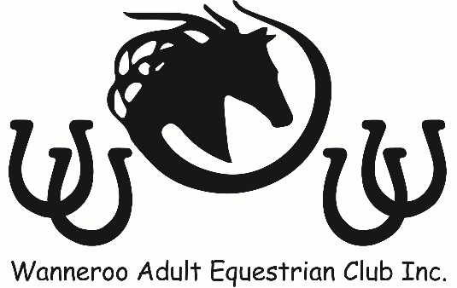

UNIFORM ORDER FORM
NAME: ______________________________________________________
PHONE: ______________________________________________________

ITEM | PRICE | SIZE | QTY
SHORT SLEEVE SHIRT | $45.00 each
LONG SLEEVE SHIRT | $50.00 each
JACKET | $55.00 each
VEST | $45.00 each
BROWBAND | Please enquire
STUBBY HOLDER | $5.00 each
HELMET COVER | $20.00
NAME EMBROIDERED (Optional Extra – Shirts Only) | $5.00 each item
 |  | TOTAL

Pay by Cheque/Cash/ Money Order/Direct Deposit
Cheques and Money Orders made payable to: Wanneroo Adult Equestrian Club Inc.
Direct Deposit:
BSB: 633 108
Account: 1323 93935
Account name: Wanneroo Adult Equestrian Club Inc.

Please scan and forward form to rallycoordinator@hotmail.com
Uniform Co-ordinator Use Only
Paid Amount: |  | Payment received:
Member Received Date: |  | Member Signature:

