**Hugo Rodeo Association Royalty Competition Rule Book**

**Pageant Overview:**

The Hugo Rodeo Association Royalty Contest provides the opportunity for young people to participate in a positive competition which promotes our western heritage, furthers the sport of rodeo, and spreads good will for their communities. These experiences enrich their lives and lay a solid foundation for their future. The young people who are a part of the Hugo PRCA Rodeo Royalty are the official representatives of the Hugo Pro Rodeo and the Professional Rodeo Cowboys Association. Contestants should constantly be aware of the importance of the public relations between the public and everyone who comes in contact.

**1.** Who is Hugo Rodeo Association Royalty? The title holder symbolizes the youth of the State of Oklahoma whose desire is to promote and represent the sport of rodeo, and in so doing, the western way of life.

**2.** What does it mean to be Hugo PRCA Royalty? This young person desires to act as the official representative of Hugo Rodeo Association professional rodeo, must portray good sportsmanship, high moral, and ethical character, and reflect careful and humane treatment of animals. Contestant should understand the sport of rodeo in its entirety and be able to “sell” rodeo to anyone whom he/she comes in contact. She/he should be able to communicate intelligently and with dignity and sincere interest for our sport and should realize that the Hugo Rodeo Association Royalty Pageant is not a “beauty” pageant. However, she/he should act, speak and dress according to the prestige the title deserves, and always use the proper etiquette. She/he shall always wear appropriate attire when she/he may be seen by the public, and not be seen wearing “fad” type clothing, exposing skin, etc. She shall conduct herself/himself with the dignity benefiting the title she/he holds and shall never put herself/himself in a position to be considered inappropriate.

**3.** How do you become Hugo Rodeo Association Royalty? One must meet the requirements set forth in the application process and these official rules. **The contestant must compile the highest combined scores that are awarded in the categories of Horsemanship, Interview, Essay, Parade, Rodeo Performance and Photogenic.**

**All contestants must attend mandatory meeting with Director and Board member.**

**Tuesday, May 14, 2024 at 6pm meeting with Director and Board member**

**If you need to practice pattern, arena will be open Tuesday, May 14 at 5-6:30 or after pivot practice.**

**All Title holders and Contestants are required to attend and help with the Kids Stick horse Rodeo Thursday, May 30, 2024**

**Eligibility:**

To be eligible for crowning, all contestants must abide by ticket sale rules as well as compete in all judged event categories. Additional information regarding judged events and appearance guidelines can be found in the subsequent sections of this document. All contestants must abide by all rules of Hugo Rodeo Association Royalty Pageant or forfeit all awards given as a part of the winner of the pageant. Additional eligibility guidelines are as follows:

**• Queen Division: 13-17 years of age**

**• Princess Division: 8-12 years of age**

**• Sweetheart: 5-7 years of age**

* **Lil Miss HRA 3-4 years of age**
* **Lil Mr. HRA 3-7 years of age**
* **Top Salesperson Winner – 0-17 open to any youth. Competes in Ticket Sales only. Must abide by Clothing rules. Contestants in Royalty Divisions will compete for this title.** 
  + A birth certificate is not required to enter the competition, but contestants must be able to produce a copy at the request of the PRCA committee or pageant officials. Age is as of January 1st of the current year
  + No contestant may have been married, pregnant, have a child, nor become engaged, married, or pregnant during the year of her reign.
  + During competition, contestant must use the same horse for all activities. If horse becomes lame during this time, the Hugo Rodeo Association Royalty Director will need to be notified for horse change approval.

**Competition Rules & Guidelines**:

Contestants must abide by the following rules and guidelines to be eligible for Hugo Rodeo Association Royalty. If at any time, a contestant fails to complete one or more of the following rules she will be subject to immediate disqualification.

1. **Ticket Sales:** Ticket sales are required for each category.

o Queen - $1,500 of Advanced Rodeo Tickets and/or Raffle Ticket (Adult and/or Child) to qualify for crowning.

o Princess - $1,500 of Advanced Rodeo Tickets and/or Raffle Tickets (Adult and/or Child) to qualify for crowning.

o Sweetheart - $1200 of Advanced Rodeo Tickets and/or Raffle tickets (Adult and/or Child) to qualify for crowning.

o Lil Miss HRA - $1200 of Advanced Rodeo Tickets and/or Raffle tickets (Adult and/or Child) to qualify for crowning.

o Lil Mr. HRA - $1200 of Advanced Rodeo Tickets and/or Raffle tickets (Adult and/or Child) to qualify for crowning.

o Contestants will receive 10% payback on all ticket sales over the qualifying amount. (Ex: Qualifying amount is $1500, contestant turns in $2000, this is $500 over the qualifying amount and contestant will receive $50 back.)

No tickets can be sold on **North 5th Street**, from Jackson to arena, starting Thursday of Hugo PRCA Rodeo. If tickets are sold on North 5th Street, from Jackson to arena, contest will be subject to immediate disqualification.

Contestants may sell tickets at **Arena** during Rodeo events on Wednesday and Thursday.

Contestants are **NOT** permitted to sell tickets at the arena before or during the Friday and Saturday Rodeo.

1. **\*\*All monies are due Saturday of Hugo Rodeo Association Rodeo by 12:00 PM. Failure to do so will result in immediate disqualification of contestant.** If no arrangements have been made prior to that time, money and tickets will be presumed stolen and legal action will be taken.
2. If a contestant chooses not to compete after submitting his/her application, all money and tickets must be returned to the Hugo Rodeo Association Royalty Director ASAP, if money and tickets are not returned, they will be presumed stolen and legal action will be taken.
3. **Judged Categories:**

All contestants (excluding high ticket sales) must compete in all judged category events to be eligible for crowning. Additional information regarding appearance guidelines, timeline, etc. can be found under Judged Events Breakdown.

**o Horsemanship o Interview o Essay o Parade**

**o Queen Run/Rodeo Appearance o Photogenic**

1. In the event of any ties, the contestant with the highest overall horsemanship score becomes the winner. If there is still a tie, the person with the highest ticket sales will be the winner.
2. The Hugo Rodeo Association committee will serve as the grievance committee in the case one is needed. All

grievances must be submitted in writing to the committee within 10 days of crowning. All decisions and/or actions made by the grievance committee are final.

1. Score sheets will **not** be returned, but comment sheets will be given to contestants following the pageant. Comment sheets will be completed at the judges’ discretion and available to contestants to be picked up from Director within 14 days following the end of the Hugo Rodeo Association Rodeo.
2. Contestants will have numbers before the first competition event. The order (lowest to highest number) will be used throughout the rest of the competition. All events will start at the discretion of director or judges.
3. Contestants must wear western attire, including boots, hat, and belt to all functions.
4. If there is only one contestant in an age division, he/she must compete in all categories to win the title.
5. An adult must be available to always accompany Sweethearts, Lil Miss HRA, and Lil Mr. HRA.
6. Should circumstances occur that a contestant is conducting herself/himself in an improper manner, especially regarding treatment of animals or unethical/unmoral behavior, a meeting will be held between Pageant committee and judges to determine course of action. This can be up to and including dismissal or disqualification of the contestant.

**Hugo Rodeo Association Royalty Dress Code:**

**Attitude and Appearance (ENTIRE Competition):**

• All contestants will be judged throughout the competition on their appearance and overall **attitude**.

• No use of foul or derogatory language.

• All clothing must be appropriate to age, event, and western style.

• **Felt hats required.**

• No revealing tops.

• Shirts must be long sleeved during all events.

**Hugo PRCA Rodeo Royalty Application & Supporting Documents Checklist**

**Application packets are due no later than Friday, May 3, 2024 at 6pm**

** Application  Essay  Biography  Black & White 5x7  Color 5x7  Coggins(CAN BE DIGITAL)**

**Judged Events Breakdown:**

Judged Events will begin promptly on the day of horsemanship. Judges will consist of 3 suitable and qualified judges during each portion of competition. Below is a brief explanation of judged events. Please see the Dress Code section for additional details regarding clothing and tack guidelines as well as other pertinent information. Hugo Rodeo Association Royalty contestants are judged in six (6) divisions: Horsemanship, Interview, Essay, Parade, Queen Run/Rodeo Appearance and Photogenic.

**a. Horsemanship (150 points):** Contestants will be judged on execution of maneuvers, grooming of horse and tack, cleanliness and appearance of contestant and responses to general questions from the judge’s following execution of the pattern.

**Horsemanship –**

**Contestants must wear black felt hat, white shirt, black wranglers (or other appropriate black riding jeans), black belt and black boots.** Horses may NOT have any colored form of tack. Horsemanship competition allows the contestants to showcase their riding ability; control of mount; precise execution of patterns; balance of rider; position of hands, feet, and seat; mounting and dismounting. Each age division must follow the pattern provided in the rule book for respective age division.

• Cowboy Hat (BLACK FELT) • Boots • Belt • Jeans (BLACK)

• Western Shirt (MUST be long sleeved & WHITE) • Hair should be pulled back and neat.

• It is the responsibility of the contestants to make sure their hats stay securely on their heads. Failure to do so will result in severe point penalties.

• All contestants are required to provide their own horse for the competition.

• Horses may NOT have any colored form of tack. Should a contestant choose to ride with splint or bell boots, they must be black.

• No horses under the age of three (3) years of age are allowed. No stallions are allowed.

• Current Negative Coggins must be shown to Pageant Director before Horsemanship Competition. Any horse without current negative will not be allowed to compete.

• No unbroken or unsafe horses allowed. The judges of the competition and royalty committee will determine whether a horse is broke and safe.

• The use of spurs and tie-downs are at the contestants’ option.

• All tack must be leather. Leather tack with bling will be allowed but no colored tack. Colored saddle pad is NOT acceptable for this event. Saddle pad MUST be black.

• No chaps are allowed.

• Lil Miss HRA, Lil Mr. HRA and Sweethearts will be required to always have an adult in the arena. Lil Miss HRA parent must lead contestant. The sweetheart parents may lead the contestant or let contestant complete pattern on their own. Optional. We are not responsible for your children.

• Should an unfair situation occur, at no fault of the contestant, a re-ride will be granted. All re-rides are at the sole discretion of the pageant judges.

• Every element of the horsemanship portion of the competition will be scored regardless of execution of set pattern.

• Patterns for Queen, Princess, Sweetheart, Lil Miss, and Lil Mr can be found at the back of this rule book.

• Failure to execute the set pattern will not constitute disqualification of contestant.

• The judges will ask the contestant questions during the horsemanship competition. After question, Contestant proceed to gate and wait to perform Royalty Run. Queen and Princess Contestants will perform a flag run after their Royalty Run. See pattern for additional clarifications.

**b. Interviews (150 points):** Contestants will be judged on their knowledge of past and present rodeo titleholders and events as well as other categories listed on the Interview Topics Sheet at the end of this packet.

**Interview – Immediately following horsemanship. Wear Horsemanship Clothing**

The purpose of the interview is to allow judges to observe the personality, intelligence, common sense, conversational ability, and maturity of each contestant. The questions posed by the judges are not limited to any subject but may include topics from the Interview Topics Sheet. Topics include rodeo knowledge, current events, general horse health care, contestant’s goals and aspirations, contestants’ life experiences, etc.

• The interview portion will be closed to the public, parents, and contestants. The only persons allowed in the interview are the judges and individual contestant.

• The interview may not be recorded on cassette, video tape, or technological device such as a cell phone or i-Pod.

**c. Essay (50 points):** Contestants will be required to complete a **hand-written** essay. All essays are due upon completion of application packet.

i. Queen Essay: 500-750 words

Topic includes all of the following:

Your knowledge on the history of rodeo and Choctaw County Rodeo

Why do you want to represent Hugo Rodeo Association Royalty?

Who in the rodeo industry inspired you to compete for Hugo Rodeo Royalty and Why?

What do you plan to do if you win? What is plan B if you don’t?

ii. Princess Essay: 250-500 words

Topic includes all of the following:

Your knowledge on the history of rodeo and Choctaw County Rodeo

What is your favorite rodeo memory?

Why do you want to represent Hugo Rodeo Association Royalty?

What do you plan to do if you win? What is plan B if you don’t?

iii. Sweetheart Essay: Draw a picture of Rodeo – must be contestants drawing

iv. Lil Miss HRA: Draw a picture of Rodeo – must be contestants drawing

v. Lil Mr Essay: Draw a picture of Rodeo – must be contestants drawing

**d. Parade (75 points) usually wear red/white/blue but optional:**

Queen and Princess Contestants will be judged on attitude, congeniality, cleanliness and appearance of contestant, horse and tack as well as overall crowd appearance and control of horse.

Sweetheart, Lil Miss and Lil Mr will be judged on appearance of contestant, overall crowd appearance, attitude, Congeniality. Transportation will be provided for contestants for Parade. Parent need to be available. Lil Mr, Lil Miss, and Sweetheart contestants will not ride horses in parade.

**e. Royalty Run/Rodeo Appearance Friday night performance (75 points)**: Contestants will be judged on cleanliness and appearance of contestant, horse and tack as well as overall control of horse. Appearance/Attitude during the rodeo.

**Parade/Rodeo Performance - Clothing should be flashy (all the bling you want)!**

• Hat • Boots • Belt • Jeans • Western Shirt (must be long sleeved)

• Vests are permitted.

• **Friday Night Performance is “Tough Enough to Wear Pink”**

Queen and Princess Divisions will be required to provide their own horse to ride in the parade and for introductions at rodeo. For safety reasons, One parent from each Sweetheart, Lil Miss and Lil Mr contestant will be required to be available at all times with their child. Sweetheart, Lil Miss and Lil Mr contestants will be introduced in the Rodeo. (more details to be announced at a later time) They will not need a horse for Parade or Rodeo. Participation in Grand Entry for Queen and Princess Divisions is recommended but not required. QUEEN AND PRINCESS CONTESTANTS MAY BE ASKED TO CARRY SPONSOR FLAGS IF NEEDED. Grand Entry for Sweethearts, Lil Miss and Lil Mr. is at the sole discretion of the parent. NOT REQUIRED.

**g. Photogenic (50 points):** Contestants will be judged on photograph which will be submitted by contestant along with this application by no later than Friday May 3, 2024. Each contestant must submit a 5x7 color and a 5x7 black and white photo of herself. The color photo will be used for judging and the black and white for media or other events throughout the competition.

**Photogenic** –

Each contestant must submit a 5x7 color and a 5x7 black and white photo of self. The color photo will be used for judging and the black and white for media or other events throughout the competition.

• The photograph should be a vertical head and shoulders (bust) shot.

• The contestant must be dressed in tasteful western attire, including a cowboy hat.

• Copyrighted pictures must have a release.

• The photo must not be framed or mounted.

• Failure to submit the photo by Friday, May 3, 2024 will result in immediate disqualification.

**Explanation of Reign (This is what you must do if you win):**

Hugo Rodeo Association Royalty wins the title at the annual Hugo Rodeo Association Royalty Pageant and performs the duties of said title for one year, giving up the title at the following Hugo Rodeo. As Hugo PRCA Royalty, she/he is expected to abide by the following:

1. Title winners must be **willing and able to participate in rodeo appearances and other special events as requested by the Hugo Rodeo Association Committee. Title winner will be asked to take pictures with their prizes.**

2. Title winners will be required to represent the Hugo Rodeo Association at a **minimum of four (4) events** throughout the year of reign. Pictures must be supplied to the Royalty Director.

3. Title winners will be **required to attend all Hugo Rodeo Association Royalty events the following year.**

4. Title winners must understand that if they win a title the funding for all expenses including travel and wardrobe will be their responsibility.

5. All title holders will **reign from Saturday Crowing Ceremony of Hugo Rodeo Association Rodeo until the following years crowning ceremony and new title holder is awarded**.

6. Winners of competition will be eligible to compete in the next years Miss Rodeo Oklahoma Pageant, due to the deadline of the application being same weekend as Hugo PRCA Rodeo. Excluding Lil Mr. HRA

**Royalty Expectation Statement & Code of Conduct**

I understand that as contestant or if I am awarded the title of Hugo Rodeo Association Rodeo Royalty, I will be a representative of Hugo Rodeo Association which is produced by the Hugo Rodeo Association. I am responsible to represent the sport of rodeo in a professional manner. I will strive to represent unparalleled sportsmanship with high moral and ethical character. This title recognizes several attributes: sportsmanship, personality, public speaking and appearance. Therefore, it is my responsibility, as Hugo Rodeo Association Royalty representative to act, speak, and dress according to the presence my title requires any time I am in the public eye. Riding and horsemanship skills are essential to the promotion of the sport of rodeo. Therefore, I will strive to improve my riding and horsemanship skills to better promote the sport. I understand that I am responsible to provide my own horse that can perform queen activities during

rodeo activities and events. During competition, contestant must use the same horse for all activities. If horse becomes lame during this time, the Hugo Rodeo Association Royalty Director will need to be notified for horse change approval.

• If I win, I will Wear my crown and sash any time I am acting in the capacity as Hugo Rodeo Association Royalty.

• Make myself available for all opportunities to appear as Hugo Rodeo Association Royalty to the public.

• Attend specific events as requested by the rodeo committee.

• Understand it is my financial responsibility to attend all required appearances.

• **Be on time. No one should have to wait on you. Prepare for the next event so you are ready.**

• Do my homework on directions, layout, schedules, and requirements for each event. Know what to bring, wear and pack.

• Follow through on my responsibilities through the end of competition or reign.

• Not drink, smoke, or use profanity in public while acting in the capacity as the Hugo Rodeo Association Royalty.

• Not hang out in bars and/or parties at a rodeo or event while acting in the capacity as the Hugo Rodeo Association Royalty.

• Never publicly complain - while visiting I will remain positive and professional.

• Work with the rodeo committees on whatever promotions they may desire.

• Not use cell phones in public, check messages, or keep phones in pockets or public view while wearing the crown and banner.

• Remember the last thing you do is what they will remember. First impressions are important and last impressions are forever.

• At no time during the term of my contract shall I post suggestive photos or use profanity on

social media (no photos or discussions about parties or alcohol). I will never appear inappropriate on social media (Facebook, Twitter, Snapchat, Instagram or Other) whether it be a personal page or account or the intellectual property of Hugo Rodeo Association Rodeo.

• At all times keep posts professional in verbiage, with no language or images that is unbecoming to, or in any way compromise the professional image of Miss Hugo Rodeo Association Royalty or the professional brand of the Hugo Rodeo Association.

**Dress Code Requirements:**

• Hugo Rodeo Association Royalty must adhere to PRCA arena dress codes in the rodeo arena.

• Dress or skirt no shorter than 2” above knees.

• No visible tattoos or facial piercings.

• No sleeveless or tank tops.

• No cleavage, no braless attire, no open back or bare midriff.

• At no time should bra straps be visible.

• Clothing should reflect a professional western image. No evening gowns or cocktail type dresses.

• No burn out, transparent material, or see-through lace on body portion of top.

• Hair is to be styled fashionably. Ponytails and or braids may be periodic acceptable alternatives, however, hair must still be styled.

• Hats: keep a brush for each color. Keep them clean and well-shaped.

• Boots: keep clean and free of mud.

• Jeans: clean and preferably ironed.

• Shirt: Flashy for the arena. You need to be set apart from the rest. Always wear the shirt color for the rodeo theme of the performance when applicable (e.g., pink for Pink Night).

• Pay attention to your fingernails and makeup, especially lipstick.

• After changing into non-rodeo attire continue to follow professional, conservative clothing and attire.

**Coronation: Will be held Saturday of the Rodeo**

**Prizes: All Contestants will win prizes.**

***Queen:***

• **Titleholder**

o Flowers o Saddle o Belt Buckle o Crown o Sash o Chaps

**• 1st Runner-Up**

o Flowers o Misc. Items

• **Remaining Contestants**

o Flowers o Misc. Items

***Princess:***

• **Titleholder**

o Flowers o Saddle o Belt Buckle o Crown o Sash o Chaps

• **1st Runner-Up**

o Flowers o Misc. Items

• **Remaining Contestants**

o Flowers o Misc. Items

***Sweetheart:***

• **Titleholder**

o Flowers o Saddle o Belt Buckle o Crown o Sash o Chaps

• **1st Runner-Up**

o Flowers o Misc. Items

• **Remaining Contestants**

o Flowers o Misc. Items

***Lil Miss HRA:***

• **Titleholder**

o Flowers o Saddle o Belt Buckle o Crown o Sash o Chaps

• **1st Runner-Up**

o Flowers o Misc. Items

• **Remaining Contestants**

o Flowers o Misc. Items

***Lil Mr. HRA***

o Saddle o Belt Buckle o Chaps o Hat Band & Breast Collar

• **1st Runner-Up**

o Misc. Items

• **Remaining Contestants**

o Misc. Items

**High Ticket Salesperson: Top seller will win a SADDLE for Overall High-Ticket Sales. Open to contestants 0-17. Winner will be awarded to high ticket sales only. $2500 to qualify.**

**1st place Saddle**

**2nd place To be announced**

**3rd place To Be announced**

**4th place To be announced**

**Loss of Title and Benefits:**

Subsequent to the Hugo Rodeo Association Royalty Pageant, any person being awarded the title shall follow all rules set forth here. Also, during the year of reign, each title holder must abide by the rules and guidelines set forth in this document provided upon receipt of application and Agreement and Release accompanying the Official Entry Form. Any open acts of defiance, disrespect for Hugo Rodeo Association Committee members, and/or the Royalty Director, or unwillingness to cooperate will not be tolerated and will result in drastic action(s) by the Hugo Rodeo Association. The titleholder should understand that it is a privilege and an opportunity to represent the community, state, and sport of professional rodeo in such a prestigious manner. Upon the occurrence of any of the events listed above, the title, together with any and all benefits (prizes) derived by such person shall be forfeited and awarded to the next qualified runner-up.

1. The rule of “Once a Queen, always a Queen” applies and each titleholder should act and dress appropriately.

2. Should the titleholder be seen dressed in an inappropriate manner; he/she shall be counseled. If this occurs again, a disciplinary action shall be necessary. Anytime Hugo Rodeo Association Royalty is at an event of any kind, he/she shall be attired properly, unless otherwise specified. In the arena, this is to include hat, crown, long-sleeved shirt, jeans/wranglers, boots, belt, and buckle. Her/his shirt shall be tucked in and long sleeves with the sleeves buttoned and snapped. Whenever, representing the rodeo, i.e., an autograph appearance, the titleholder shall be dressed in appropriate rodeo attire. Other apparel may be appropriate for pageants and other activities.

**Hugo PRCA Rodeo Royalty Interview Topic Sheet**

The topics listed below are merely to be used as a study sheet. Judges reserve the right to ask additional questions not pertaining to those listed below. It is the contestant’s responsibility to obtain the answers to the following questions. If a contestant has any questions or would like any clarification on the following questions, please consult the Pageant Director.

**Queen:**

• Where are the National Head Quarters for PRCA?

• How much do tickets to the event cost and where can they be purchased?

• Who is providing the stock for your rodeo?

• Who is the announcer? • Who is the specialty act for the rodeo?

• What association is sanctioning your rodeo?

• Who is the president of your rodeo committee?

• How many years has the Hugo PRCA Rodeo been held? • Who is the reigning Miss Rodeo USA?

• In what year did the PRCA adopt the word “Professional” to their name?

• Name the three rough stock events. • Define the mark-out rule.

• How many total points are possible for a rough stock rider to earn in their event?

• What event is a barrier used in?

• What does the phrase “Breaking the barrier” mean? Is there a penalty for breaking the barrier?

• What is the number one reason for death in horses? • Name three sponsors of your rodeo.

• What are your goals for life after high school graduation?

• Name four external parts of the horse. • What is the job of rodeo royalty?

**Princess Division:**

• Define PRCA. • Are there any pre-rodeo or after rodeo activities to take part in?

• What time does each nightly performance begin? • Name five events in the rodeo.

• How often do you feed your horse? • What is your favorite event in the rodeo and why?

• What is another name for steer wrestling? • How long is the penalty for knocking over a barrel?

• Are you involved in any extra-curricular activities? If so, tell us about them.

• Tell us about your plans for the future. (i.e., career goals etc.)

**Lil Mr, Lil Miss and Sweetheart Division:**

• How old is your horse? • How often do you ride your horse?

• What is your horse’s name? • What is your favorite event at the rodeo?

• What is your favorite outfit you have worn throughout the pageant? Why?

**Tentative Schedule and checklist – Schedule is subject to change**

All Contestants will be required to sign in at each event with Director or Director assistant. Can be subjected to point deduction up to 5 points.

**Application packets are due no later than Friday, May 3, 2024 at 6pm**

** Application  Essay  Biography  Black & White 5x7  Color 5x7  Coggins**

Mandatory meeting May 14 6PM ARENA

NOT MANDATORY Practice MAY 14 AT 5-6:30 pm or after pivot team practice

All title holders and contestants are required to attend and help with the Kids Stick Horse Rodeo at the Gazebo by the Depot. May 30. Starts are 4 pm. Contestants must be there by 330

Auto zone trailer schedule will be sent out at later date- contestants will have set times but are not mandatory to be there. If no one is there at their allocated time, it is first come. Be on your best behavior at all times, look the part and Clean up your mess.

Horsemanship/Interview will be Saturday MAY 25. START AT 10AM. Pictures at 9:15am. Arena open 8:30

Friday PARADE MAY 31 and rodeo performance that night

Saturday, June 1 Tickets and Money due by 12

Coronation Saturday, June 1 at 4pm. Place to be announced

We will have a Royalty table for Friday night Rodeo and every contestant will be required to help at appointed times.

Hugo PRCA Royalty Rodeo Tips

* Make sure clothing for all appearances are fitted and looks good on you.
* Do not be afraid to ask for help. Find someone you trust and reach out.
* Important: First impression – you need to look the part!
* There are so many styles of hair, makeup, hat shapes, clothing – this is personal preference so go with what looks good on you. But Look the part!
* Be Confident and know yourself. Study about the history of Hugo Rodeo, legends, what’s going on in the industry, equine information, etc..

Horsemanship pattern and interview:

* White long sleeve Shirt – no fringe or colors. Can have some bling but don’t over do it.
* Black felt hat – make sure clean and shaped DO NOT let your hat come off! Do not touch it during pattern.
* Black pants, boots, belt. Limit jewelry.
* An interview is just a way for the judges to get to know you. It is a simple conversation. Answers don’t have to be perfect, just speak and answer the questions. You need to be able to put together sentences, just talk.
* Sitting in chair – be relaxed but not slouching, sit on front of the chair with hand in lap, if need to use hand gestures return hand to lap, do not swivel chair or fidget.
* Practice and ride!
* Flag and queen run – SMILE! Be safe!
* No colored tack, make sure to use leather

Parade: Be flashy as you want! Look the part! RED, WHITE, BLUE CLOTHING

Rodeo Friday night: Pink Night – be as flashy as you want!

IF YOU HAVE QUESTIONS PLEASE GET WITH ME OR TEXT ME. I want this to be fun and fair for everyone.

**We appreciate every one of you. We couldn’t do this without you.**

**Congratulations to each one of you for being a part of the Hugo PRCA Royalty.**

The following words are from By Brandon Baumgarten

1. Your Identity is Bigger Than a Crown/Title: You are not defined by defeat, you are refined by the process of preparing, learning, and improving yourself along the way.

2. Saddle Up Again and Again: Even if a competition doesn’t go your way. Remember that the saddle is there to get back on and keep trying.

3. Don’t beat yourself up: Instead reflect on the process and write down what you learned from it. How did you grow as a leader?

4. Like Tim McGraw, Always Stay Humble and Kind: Whether you win or lose never be too proud to pick up trash, clean up after the horses, and be a servant who serves all. You don’t have to have a title to be a true Queen at heart.

5. Be Bootstrap Ready: Ready to work, ready to serve, ready to ride, ready to recover, and ready to impact. Sometimes you’ll have to pull life up by the bootstraps and that’s okay! Just keep stepping into your calling as a leader!

**LIL MISS PATTERN**

**The parent will lead the contestant to complete the pattern.**

1. **Begin work to the right**
2. **Walk figure eight**
3. **Stop at A**
4. **Back up**
5. **Walk to judge, stay mounted. Answer Questions.**
6. **When excused, walk horse to entry gate to Perform Royalty Run. Use half of arena. Parent will lead contestant.**
7. **Hugo Rodeo Association reserves right to make Alterations and/or additions to this pattern.**

V b

**North End of Arena**

Start

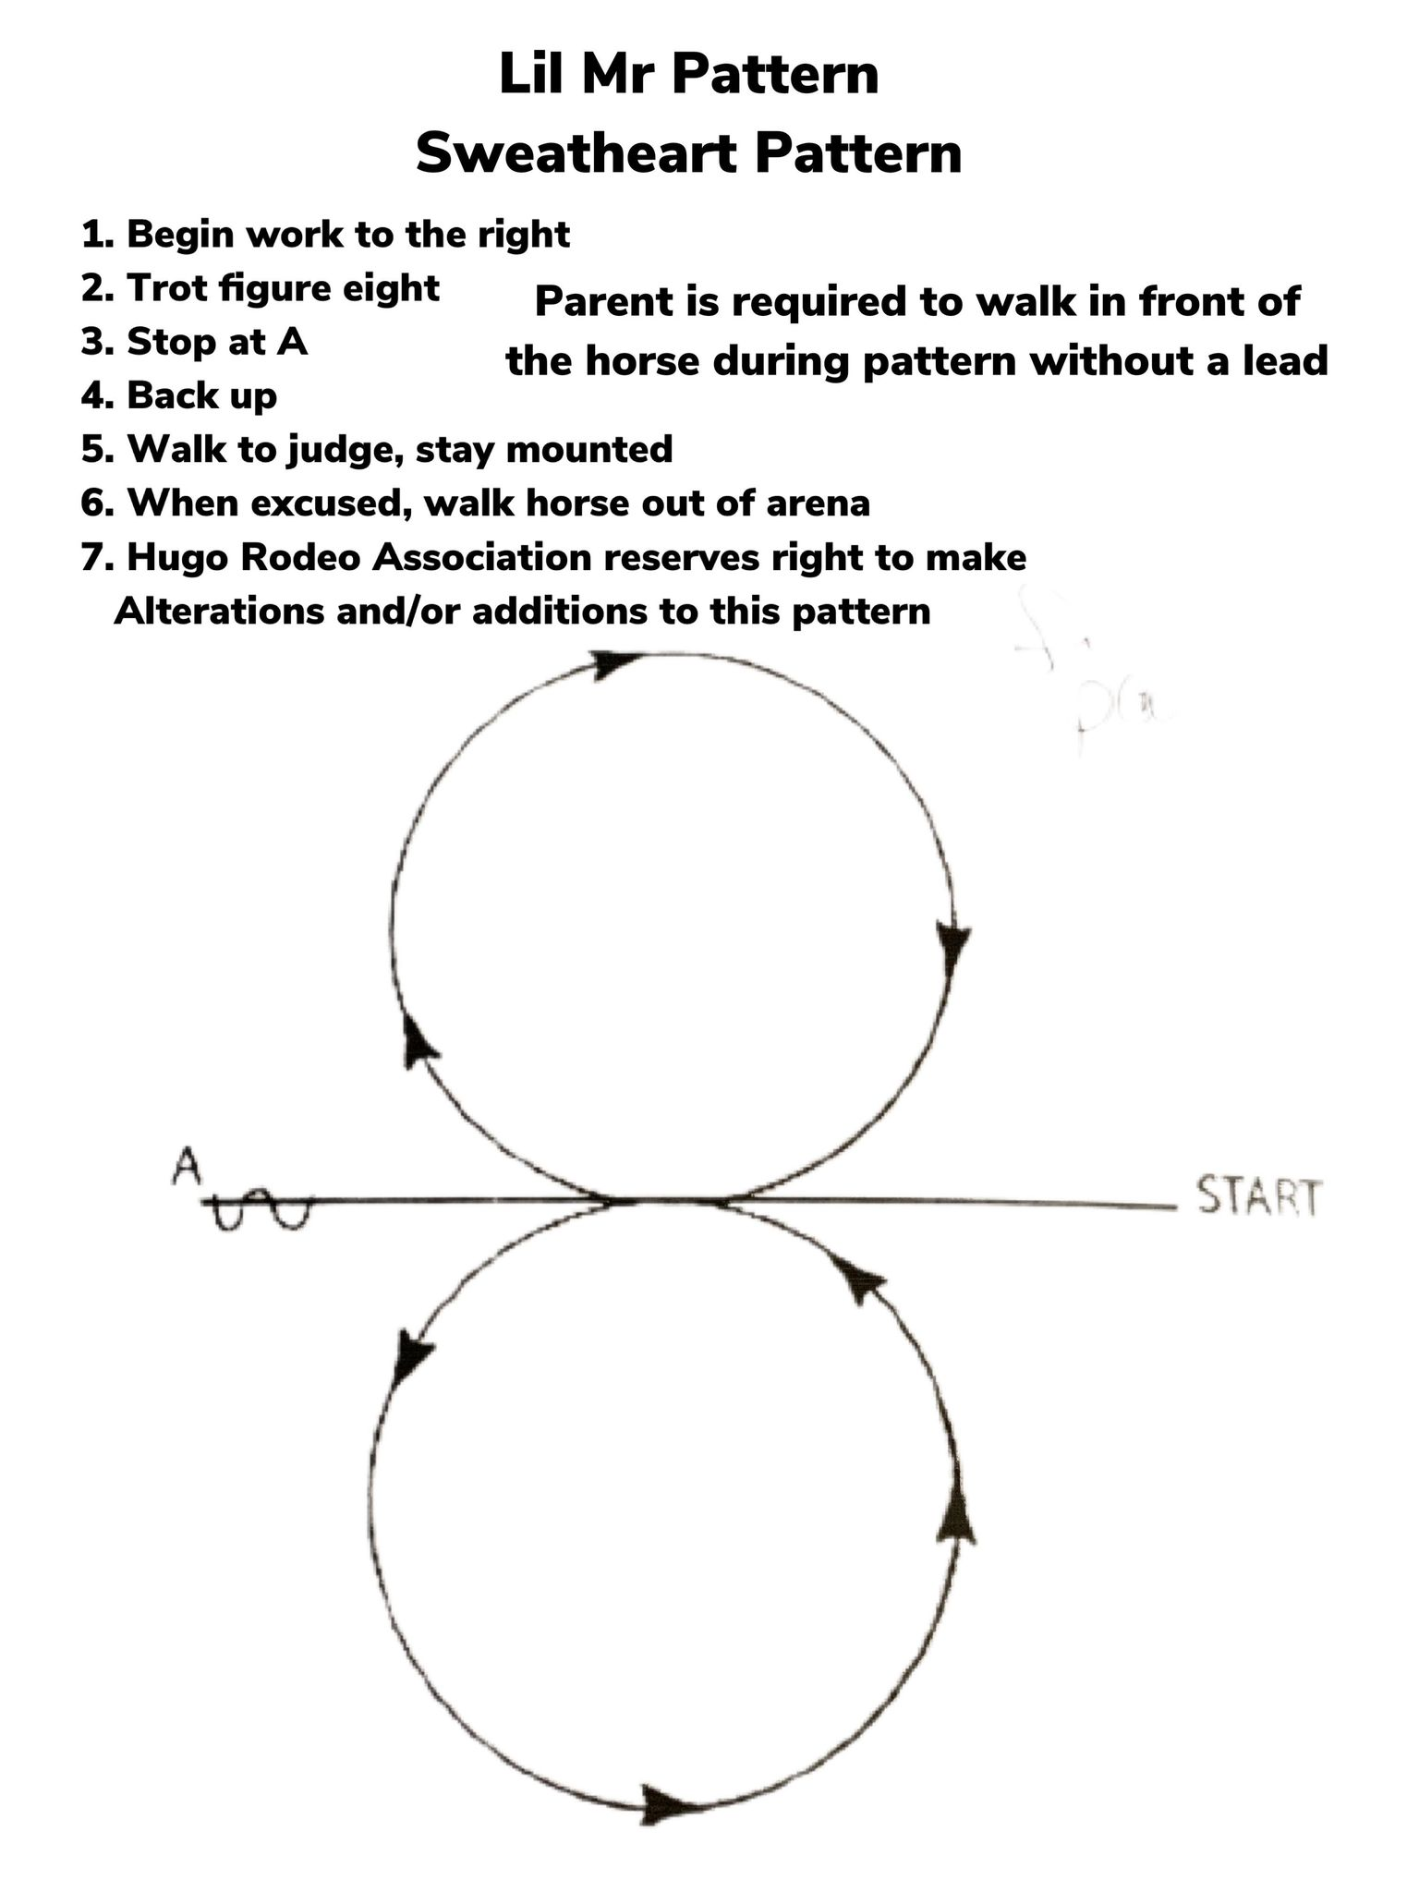

**JUDGES**

**Lil Mr and SWEETHEART PATTERN**

**The parent may lead the contestant or let contestant complete pattern on their own. Optional.**

1. **Begin work to the right**
2. **Walk/Trot figure eight**
3. **Stop at A**
4. **Back up**
5. **Walk to judge, stay mounted. Answer Questions.**
6. **When excused, walk horse to entry gate to Perform Royalty Run. Use half of arena. Parent may lead contestant or contestant can perform on their own.**
7. **Hugo Rodeo Association reserves right to make Alterations and/or additions to this pattern.**

Start

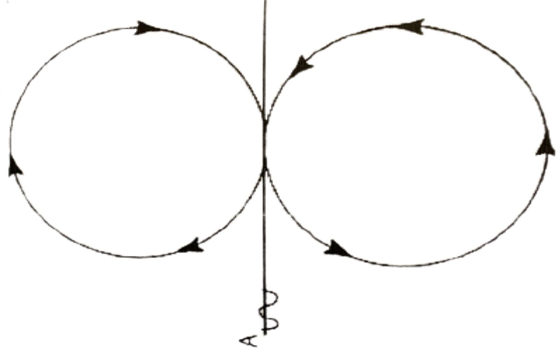

**JUDGES**

**PRINCESS PATTERN** Simple or flying lead changes are acceptable. ** Princess pattern is four circles – not figure eights.

1. **Begin work at a lope at point A**
2. **First circle slow and small to the left**
3. **Second circle larger and faster to the left**
4. **Third circle slow and small to the right**
5. **Fourth circle larger and faster to the right**
6. **Stop at Point B**
7. **Back**
8. **Walk forward a few steps**
9. **Pivot no more than 90 degrees either direction**
10. **Pivot opposite direction no more than 180 degrees**
11. **Turn walk to judge, stay mounted. Answer Questions.**
12. **When excused, walk horse to entry gate to Perform Royalty Run. Use full arena.**
13. **Following Royalty Run, Princess contestant will return to alley to pick up flag to perform a flag run. Must bring your own flag boot.**
14. **Hugo Rodeo Association reserves right to make Alterations and/or additions to this pattern.**

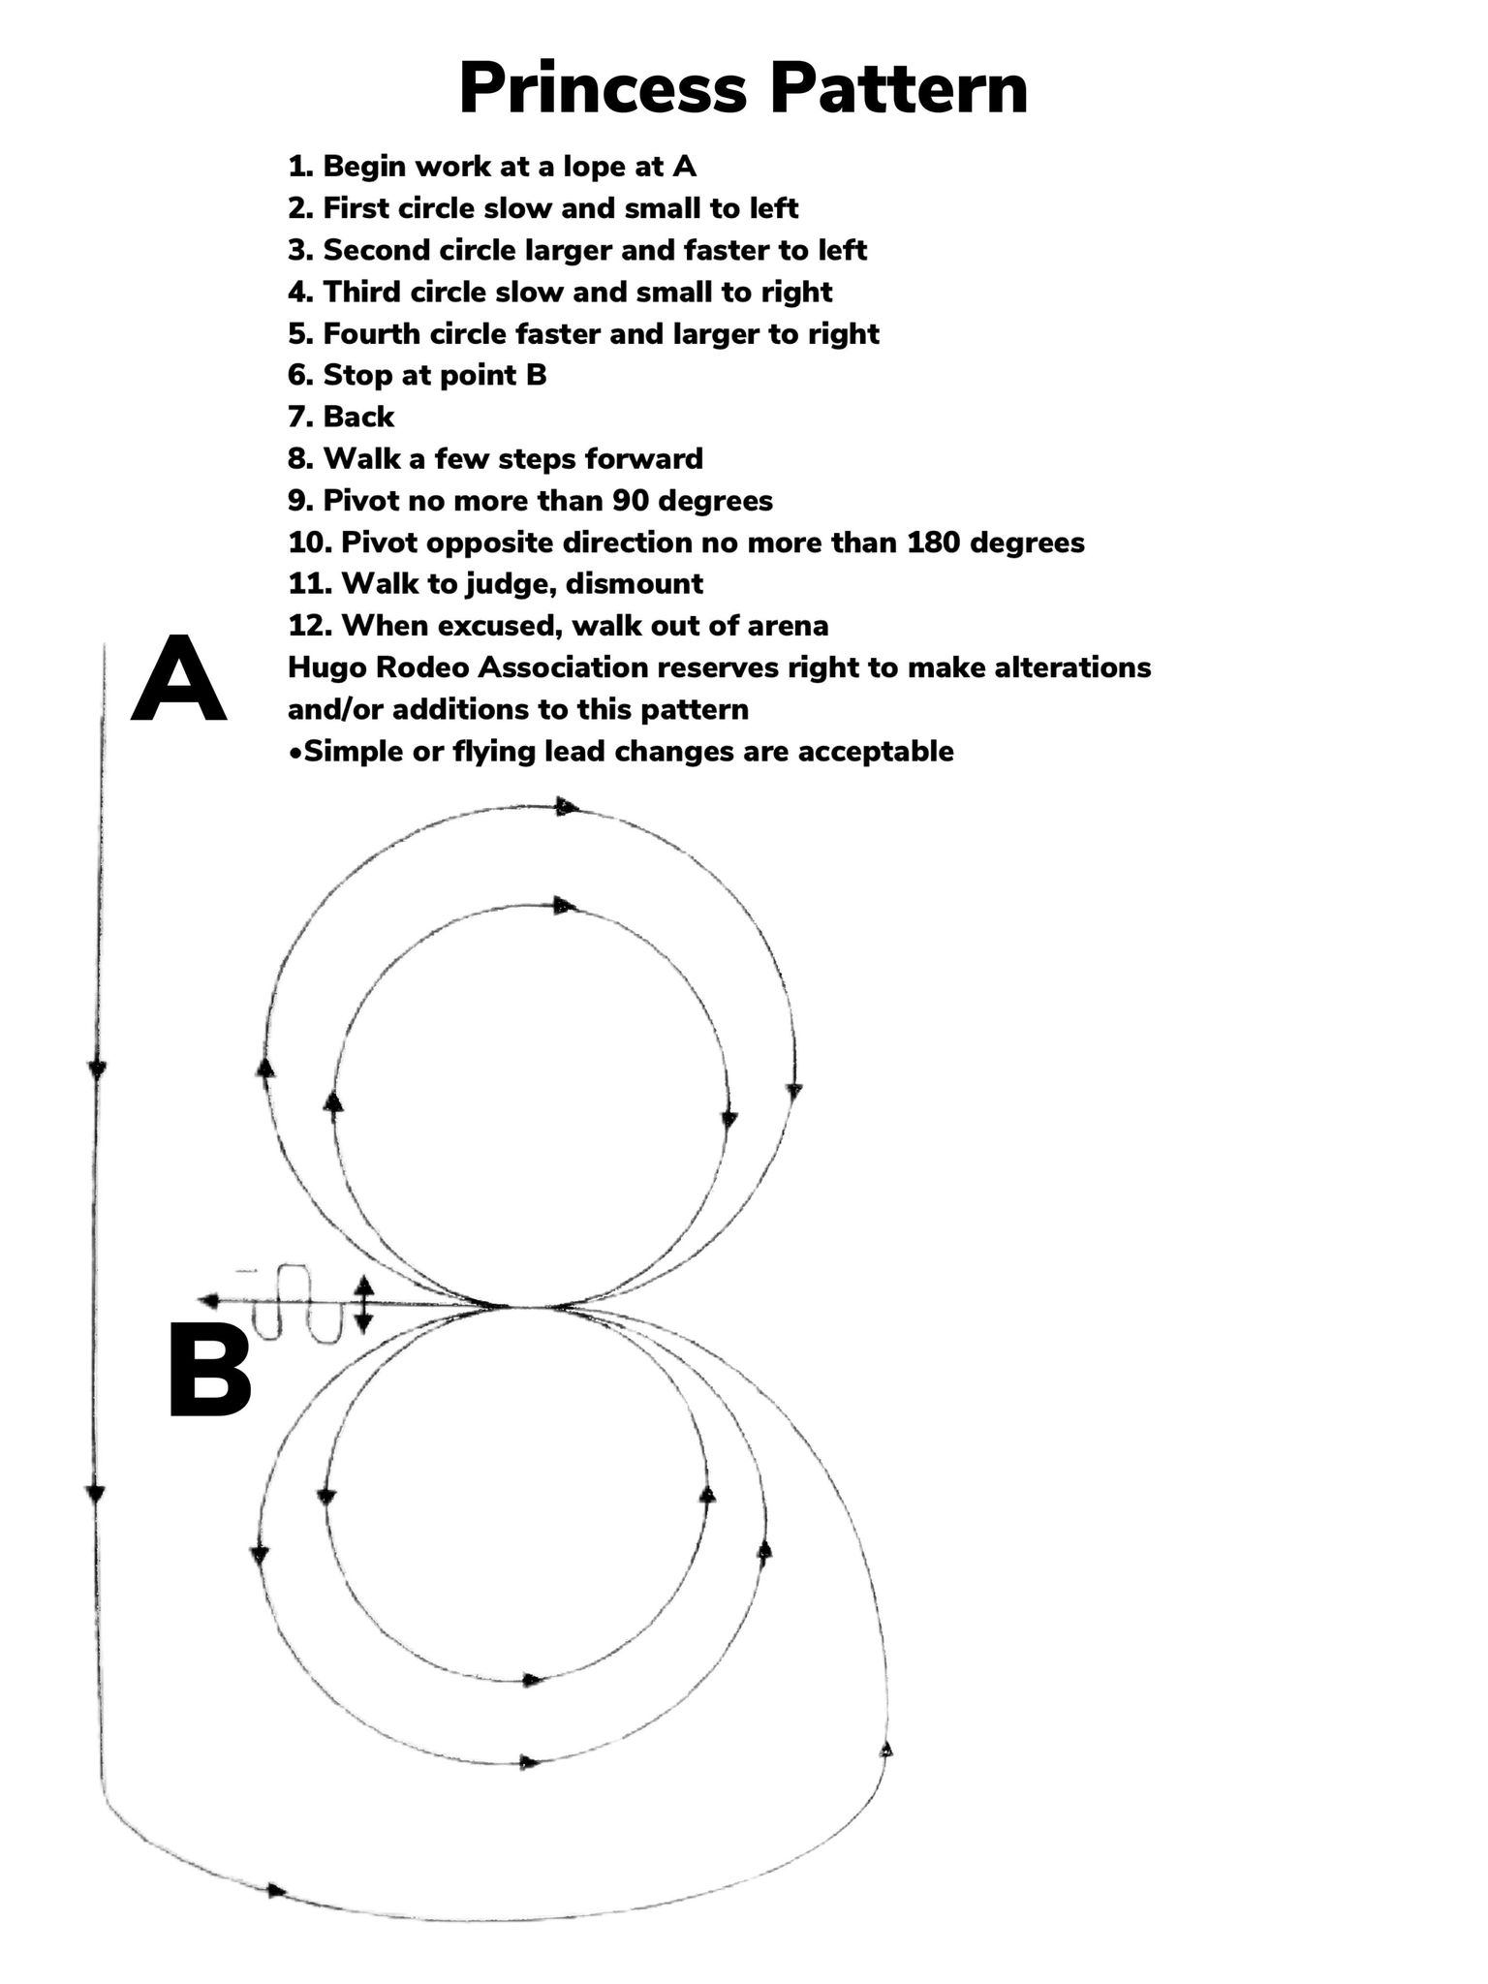

**JUDGES**

**North End of Arena**

A

**QUEEN PATTERN**

1. **Begin work at a lope at point A**
2. **First figure eight slow to the left**
3. **Second figure eight larger and faster**
4. **Stop at Point B**
5. **Back**
6. **Walk forward a few steps**
7. **Pivot no more than 90 degrees either direction**
8. **Pivot opposite direction no more than 180 degrees**
9. **Turn walk to judge, stay mounted. Answer Questions.**
10. **When excused, walk horse to entry gate to Perform Royalty Run. Use full arena.**
11. **Following Royalty Run, Queen contestant will return to alley to pick up flag to perform a flag run. Must bring your own flag boot.**
12. **Hugo Rodeo Association reserves right to make Alterations and/or additions to this pattern.**

A

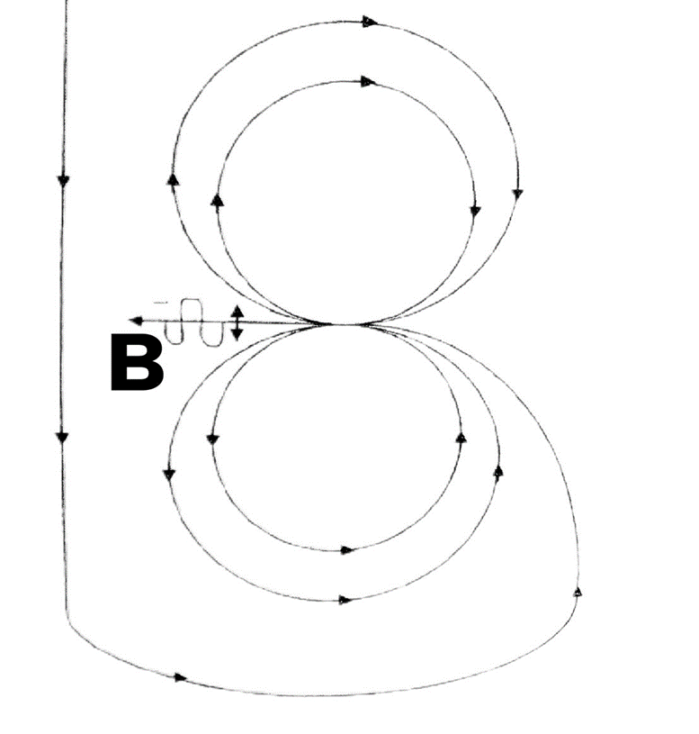

**North End of Arena**

**JUDGES**