Blue Ridge
Fire & Rescue

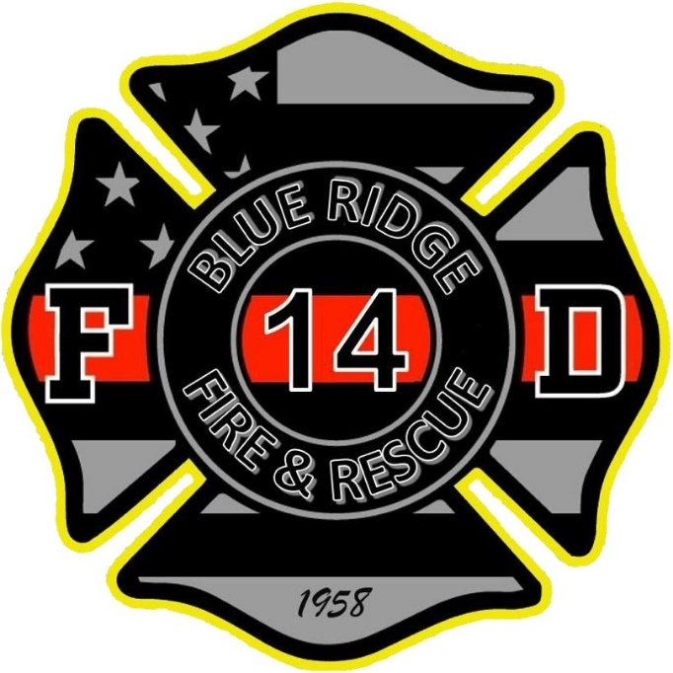

Application Packet

Application for Employment/Membership

The Blue Ridge Fire & Rescue considers all applicants for all positions without regard to race, color, religion, creed, gender, national origin, age, disability, marital, veteran status, sexual orientation, or any other legally protected status.

Last Name First Name Middle Name

/ /
Street & Mailing Address |  | City / State / Zip
( ) - | ( ) - | ( ) -
Home Phone | Business Phone | Cell Phone
- - |  | / /
Social Security Number DL Number DOB

Email Address: __________________________________________________________________

Circle: Married Single Divorced Widowed

Emergency Contacts

Name | Address | Phone #

Dependents (Spouse/Children)

Name | Gender | D.O.B

Employment History

Are you currently a member of another Fire Department? □ Yes □ No

If Yes, which department? _______________________________________

Are you employed in a profession other than the fire service? □ Yes □ No

May we contact your supervisor at your current employer? □ Yes □ No

What date are you available to begin employment? _______________

Have you ever been convicted of a crime, including a misdemeanor?
(Conviction may not disqualify an applicant) □ Yes □ No

If Yes, please attach a supplemental sheet with explanation.

Begin with your present employer.
Include any job related, military, and volunteer activities.

Employer __________________________ Phone _____________

Address _________________________________________________

Job Title ________________ Supervisors Name ________________

Dates Employed ________-________ Salary: Start _____ End _____

Duties performed __________________________________________
________________________________________________________
________________________________________________________

Employer __________________________ Phone _____________

Address _________________________________________________

Job Title ________________ Supervisors Name ________________

Dates Employed ________-________ Salary: Start _____ End _____

Duties performed __________________________________________
________________________________________________________
________________________________________________________

Employment History (con’t)

Employer __________________________ Phone _____________

Address _________________________________________________

Job Title ________________ Supervisors Name ________________

Dates Employed ________-________ Salary: Start _____ End _____

Duties performed __________________________________________
________________________________________________________
________________________________________________________

Employer __________________________ Phone _____________

Address _________________________________________________

Job Title ________________ Supervisors Name ________________

Dates Employed ________-________ Salary : Start _____ End _____

Duties performed __________________________________________
________________________________________________________
________________________________________________________

Education

 | School Name | Major/Study | Years Completed
High School

Undergraduate

Graduate

Other

Other

Describe any specialized training, apprenticeship, skills, and extracurricular activities from other fire departments/military/organizations etc:

Professional/Personal References
(2 ea. Professional/2 ea. Personal)
Name | Address | Phone Number

By signing here, you are stating that all the information that you have provided above is
correct. If found not to be truthful, it may affect your status of membership.

Print Name: ______________________________

Signature: _____________________________Date ____/____/____

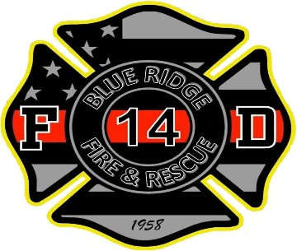
Blue Ridge Fire & Rescue, Inc.
2503 Old Spartanburg Road
East Flat Rock, North Carolina 28726
(828) 692-4416

International Seat Belt Pledge

Firefighter Christopher Brian Hunton, age 27, was a member of the Amarillo Texas fire department for one year. On April 23, 2005 he fell out of his fire truck responding to an alarm. He died two days later from his injuries. Brian was not wearing his seat belt.

"I pledge to wear my seat belt whenever I am riding in a Fire Department vehicle. I further pledge to ensure that all my brother and sister firefighters riding with me wear their seat belts. I am making this pledge willingly; to honor Brian Hunton, my brother firefighter, because wearing seat belts is the right thing to do."

Seat Belts Save Lives

Motor vehicle crashes are one of the leading causes of death in the US.

Don’t become a statistic, sign the Seat Belt Safety Pledge and promise to always wear your seat belt.

Enjoy life. Make it there safely. BUCKLE UP!

By Signing below, I pledge to always wear my seatbelt when traveling in a motor vehicle. I also pledge to encourage those riding with me to do the same.

Name: _______________________________

Signature: _______________________________ Date: ___/___/___

Witness: _________________________________ Date: ___/___/___

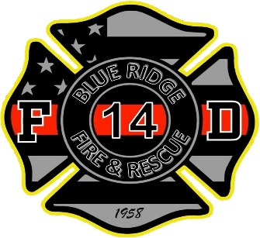
Blue Ridge Fire & Rescue, Inc.
2503 Old Spartanburg Road
East Flat Rock, North Carolina 28726
(828) 692-4416

Hepatitis B Declination Statement
I understand that due to my occupational exposure to blood or other potentially infectious materials I may be at risk of acquiring hepatitis B virus (HBV) infection. I have been given the opportunity to be vaccinated with hepatitis B vaccine, at no charge to me; however, I decline hepatitis B vaccination at this time. I understand that by declining this vaccine I continue to be at risk of acquiring hepatitis B, a serious disease. If, in the future I continue to have occupational exposure to blood or other potentially infectious materials and I want to be vaccinated with hepatitis B vaccine, I can receive the vaccination series at no charge to me.
Employee/Member Signature: _____________________________

Date: ____________________

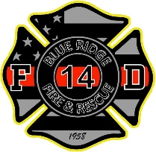
Blue Ridge Fire & Rescue, Inc.
2503 Old Spartanburg Rd.
East Flat Rock, NC 28726

Release Authorization Form

DISCLOSURE - NOTICE REGARDING BACKGROUND INVESTIGATION
Blue Ridge Fire & Rescue, Inc. (“The Department”) may obtain information about you from a consumer reporting agency for employment or volunteering purposes. Thus, you may be the subject of a “consumer report” and/or an “investigative consumer report” which may include information about your character, general reputation, personal characteristics, and/or mode of living and which can involve personal interviews with sources such as your neighbors, friends, or associates. These reports may be obtained at any time after receipt of your authorization and, if you are hired, throughout your employment or volunteering. You have the right, upon written request made within a reasonable time after receipt of this notice, to request disclosure of the nature and scope of any investigative consumer report. The most common form of investigative consumer report obtained with regard to applicants for employment or volunteering is an investigation into your education and/or employment or volunteering history conducted by Background Information Bureau, (“BIB”) who may be reached at by phone at (877) 439-3900. Other types of information that may be obtained include but are not limited to social security number verification, sex offender registry checks, criminal records checks, inmate records searches, motor vehicle records, and court records checks. The information contained in these consumer reports may be obtained by BIB from public record sources and will not be used to discriminate against you in violation of any law. The scope of this Disclosure and Authorization is all-encompassing, allowing the Department to obtain from any outside organization all manner of consumer reports and investigative consumer reports now and, if you are hired, throughout the course of your employment or volunteering to the extent permitted by law.

AUTHORIZATION AND ACKNOWLEDGMENT
I acknowledge receipt of the “A SUMMARY OF YOUR RIGHTS UNDER THE FAIR CREDIT REPORTING ACT” and certify that I have read and understand this document. I hereby authorize the obtaining of “consumer reports” and/or “investigative consumer reports” at any time after receipt of this authorization and, if I am hired, throughout my employment or volunteering. To this end, I hereby authorize, without reservation, any law enforcement agency, administrator, state or federal agency, military branch, institution, school or university (public or private), information service bureau, past or present employer, supervisor or officer, private business, insurance company or personal reference, and/or other persons to furnish any and all background information requested by BIB, additional third-party organizations acting on behalf of Employer, and/or Employer itself.

I agree that a facsimile (“fax”) or photographic copy of this Authorization shall be as valid as the original.

Name (First) ________________________ (Middle) ____________ (Last) ____________________________

List any other name used in the last 7 years (Maiden Name) ______________________________________

Address: _________________________________ City ___________________ State ________ Zip____________

County ______________________________ Driver’s License #______________________ State ____________

Email:_____________________________________________________________________________________

Gender: Male or Female Race: _______________ Phone: (__________) ____________-___________

Social Security Number_____________-___________-___________ Date of Birth _______-________-________
Month / Day / Year

Applicants Signature________________________________________________ Date ____________________

(Applicant to keep this Summary of Rights) Page 1
A Summary of Your Rights Under the Fair Credit Reporting Act: The federal Fair Credit Reporting Act (FCRA) promotes the accuracy, fairness, and privacy of information in the files of consumer reporting agencies. There are many types of consumer reporting agencies, including credit bureaus and specialty agencies (such as agencies that sell information about check writing histories, medical records, and rental history records). Here is a summary of your major rights under the FCRA. For more information, including information about additional rights, go to www.ftc.gov/credit or write to: Consumer Response Center, Room 130A, Federal Trade Commission, 600 Pennsylvania Ave. N.W., Washington, D.C. 20580.
• You must be told if information in your file has been used against you. Anyone who uses a credit report or another type of consumer report to deny your application for credit, insurance, or employment – or to take another adverse action against you – must tell you, and must give you the name, address, and phone number of the agency that provided the information.
• You have the right to know what is in your file. You may request and obtain all the information about you in the files of a consumer reporting agency (your “file disclosure”). You will be required to provide proper identification, which may include your Social Security number. In many cases, the disclosure will be free. You are entitled to a free file disclosure if:
• a person has taken adverse action against you because of information in your credit report; • you are the victim of identity theft and place a fraud alert in your file;
• your file contains inaccurate information because of fraud;
• you are on public assistance;
• you are unemployed but expect to apply for employment within 60 days. In addition, by September 2005 all consumers will be entitled to one free disclosure every 12 months upon request from each nationwide credit bureau and from nationwide specialty consumer reporting agencies. See www.ftc.gov/credit for additional information.
• You have the right to ask for a credit score. Credit scores are numerical summaries of your credit-worthiness based on information from credit bureaus. You may request a credit score from consumer reporting agencies that create scores or distribute scores used in residential real property loans, but you will have to pay for it. In some mortgage transactions, you will receive credit score information for free from the mortgage lender.
• You have the right to dispute incomplete or inaccurate information. If you identify information in your file that is incomplete or inaccurate, and report it to the consumer reporting agency, the agency must investigate unless your dispute is frivolous. See www.ftc.gov/credit for an explanation of dispute procedures.
• Consumer reporting agencies must correct or delete inaccurate, incomplete, or unverifiable information. Inaccurate, incomplete or unverifiable information must be removed or corrected, usually within 30 days. However, a consumer reporting agency may continue to report information it has verified as accurate.
• Consumer reporting agencies may not report outdated negative information. In most cases, a consumer reporting agency may not report negative information that is more than seven years old, or bankruptcies that are more than 10 years old.
• Access to your file is limited. A consumer reporting agency may provide information about you only to people with a valid need -- usually to consider an application with a creditor, insurer, employer, landlord, or other business. The FCRA specifies those with a valid need for access.
• You must give your consent for reports to be provided to employers. A consumer reporting agency may not give out information about you to your employer, or a potential employer, without your written consent given to the employer. Written consent generally is not required in the trucking industry. For more information, go to www.ftc.gov/credit.
• You may limit “prescreened” offers of credit and insurance you get based on information in your credit report. Unsolicited “prescreened” offers for credit and insurance must include a toll-free phone number you can call if you choose to remove your name and address from the lists these offers are based on. You may opt-out with the nationwide credit bureaus at 1-888-5-OPTOUT (1-888-567-8688).

(Applicant to keep this Summary of Rights) Page 2
• You may seek damages from violators. If a consumer reporting agency, or, in some cases, a user of consumer reports or a furnisher of information to a consumer reporting agency violates the FCRA, you may be able to sue in state or federal court.
• Identity theft victims and active duty military personnel have additional rights. For more information, visit www.ftc.gov/credit.
States may enforce the FCRA, and many states have their own consumer reporting laws. In some cases, you may have more rights under state law. For more information, contact your state or local consumer protection agency or your state Attorney General. Federal enforcers are:
TYPE OF BUSINESS: CONTACT: Consumer reporting agencies, creditors and others not listed below Federal Trade Commission: Consumer Response Center - FCRA Washington, DC 20580 1-877-382-4357
National banks, federal branches/agencies of foreign banks (word "National" or initials "N.A." appear in or after bank's name)
Office of the Comptroller of the Currency Compliance Management, Mail Stop 6-6 Washington, DC 20219 800-613-6743
Federal Reserve System member banks (except national banks, and federal branches/agencies of foreign banks)
Federal Reserve Consumer Help (FRCH) P O Box 1200 Minneapolis, MN 55480 Telephone: 888-851-1920 Website Address: www.federalreserveconsumerhelp.gov Email Address: ConsumerHelp@FederalReserve.gov
Savings associations and federally chartered savings banks (word "Federal" or initials "F.S.B." appear in federal institution's name)
Office of Thrift Supervision Consumer Complaints Washington, DC 20552 800-842-6929
Federal credit unions (words "Federal Credit Union" appear in institution's name)
National Credit Union Administration 1775 Duke Street Alexandria, VA 22314 703-519-4600
State-chartered banks that are not members of the Federal Reserve System
Federal Deposit Insurance Corporation Consumer Response Center, 2345 Grand Avenue, Suite 100 Kansas City, Missouri 64108-2638 1-877-275-3342
Air, surface, or rail common carriers regulated by former Civil Aeronautics Board or Interstate Commerce Commission
Department of Transportation, Office of Financial Management Washington, DC 20590 202-366-1306
Activities subject to the Packers and Stockyards Act, 1921 Department of Agriculture Office of Deputy Administrator - GIPSA Washington, DC 20250 202-720-7051

Blue Ridge Fire & Rescue

Please return these items listed below when you submit your
application.

- Copy of your Driver’s License.

- Copy of your Social Security Card.

- Copy of your High School diploma or equivalent.

- Copies of all Firefighter and EMT Certifications and a print out of the OSFM Transcript and any other applicable transcripts/certifications.

- A current certified driving record from all states resided in the last seven years. You can obtain these from that states Department of Motor Vehicles (DMV).

- Blue Ridge Fire & Rescue Background “Release Authorization Form”.

- Hepatitis B Vaccination Declination Letter

- Background Check Release Form

