

THE EFFECTS OF CORE ENERGY™ ON LEADERSHIP COMPETENCIES

## ENERGY LEADERSHIP INDEX™ 360 STUDY

Lynn Waldorf, Ph.D., CPC

**ABSTRACT**

## The Energy Leadership Index™ 360 is a scaled assessment that measures a person’s Average Resonating Level of Core Energy (ARL), leadership skill and traits, and life/work satisfaction.

Baseline assessment data from one hundred eighty-four business leaders were analyzed to determine whether their level of Core Energy was signiﬁcantly correlated with leadership competencies and satisfaction at work. Colleagues completed a parallel assessment to provide additional perspectives on the leaders’ capabilities. The results indicated that leaders with a higher ARL and more constructive, anabolic energy were more conﬁdent in their leadership skills, more engaged at work, and experienced a higher level of overall satisfaction than leaders with a lower ARL and more constrictive, catabolic energy.

**INTRODUCTION**

Leadership is a topic of great interest in the business world because it is considered a central factor in an enterprise’s success or failure.1 According to American General Colin Powell, great leaders are made, not born. In an address to Stanford University business students, he remarked that one becomes an effective leader through trial and error and from experience.2 Research on the topic also suggests that although someone may be born with certain neurological, intellectual, and social attributes that lend themselves to the role, leadership must be learned.3,4 While there is no consensus on what constitutes effective leadership,5 there are a number of skills and capabilities that are commonly recognized as inﬂuential factors. Among these are emotional intelligence, personal inﬂuence, clear communication, conﬂict management, ability to problem solve, strategizing, time management, engagement, and productivity.

Just because leaders possess these skills, however, doesn’t mean that they put them into action. To do so, they need energy. Energy is the power and capacity to do work, which is constantly being affected by a host of internal and external factors. As energy is essential for accomplishing almost anything, it is considered to be at the heart of what drives performance. According to Bruce D Schneider, founder of the Institute for Professional Excellence in Coaching (iPEC), there are two different forms of energy: anabolic and catabolic.

1 Nixon, P., Harrington, M., & Parker, D. (2012). Leadership performance is signiﬁcant to project success or failure: a criticalanalysis, *International Journal of Productivity and Performance Management* , 61(2),204-216.

2 Stanford GSB Staff (2005). Colin Powell: “Never show fear or anger.” Downloaded from Stanford Graduate School of Business website on 9/21/18. https:/[/www.gsb.stanford.edu/insights/colin-powell-ne](http://www.gsb.stanford.edu/insights/colin-powell-never-show-fear-or-anger)v[er-show-fear-or-anger.](http://www.gsb.stanford.edu/insights/colin-powell-never-show-fear-or-anger)

3 Arvey, R., Zhang, Z., Avolio, B., & Krueger, R. (2007). Developmental and genetic determinants of leadership role occupancy among women. *Journal of Applied Psychology*, 92(3), 693-706.

4 Keating, K., Rosch, D., & Burgoon, L. (2014). Development Readiness for Leadership: The differential effects of leadership courses on creating “ready, willing, and able” leaders. *Journal of Leadership Education*. 13(3). 1-16 .

5 Kumar, S., Adhish, V., & Deoki, N. (2014). Making sense of theories of leadership for capacity building. *Indian Journal of Community Medicine* , 39(2), 82-86.

## Anabolic energy is constructive, expanding, fueling, healing, and growth-oriented.



It is the energy behind creativity, intuition, cooperation, compassion, and caring. Anabolic energy fuels people’s minds and bodies, positively affects their interactions with others, and helps them move forward and achieve goals; it is described as the cornerstone of high performance and is accompanied by a heightened sense of self-awareness.

## Catabolic energy, on the other hand, is described as draining, resisting, and contracting, and often arises out of self-protection.

It is unconsciously and appropriately evoked in short-term, stressful situations to enable a ﬁght-or-ﬂight survival response. Remaining in a catabolic state for long periods of time, however, can be mentally, emotionally, and physically destructive. When people are in a stressful, catabolic energy state, their self-awareness and ability to see potential options is diminished, resulting in missed opportunities.

## Schneider’s model proposes two levels of catabolic energy and ﬁve levels of anabolic energy.

As leaders become consciously aware of the level of their energy and what affects it, they can develop better control over their thoughts, emotions, and behavior, raise their overall energy, and increase their ability to achieve the results they ultimately desire from a given situation. The inﬂuence of energy on leadership is a growing area of research. Previous studies have revealed the signiﬁcant and positive relationship between a leader’s Average Resonating Level of energy and their level of life satisfaction, as measured by iPEC’s Energy Leadership IndexTM assessment (ELI).6,7 This study extends the work to examine the relationship between a person’s energetic makeup, their perceived effectiveness as a business leader, and their level of satisfaction at work using a 360 version of the ELI assessment. The ELI 360 allows leaders to rate themselves on a set of key leadership competencies and provides a way for their colleagues to rate them as well.

The research was sponsored by iPEC to determine whether a leader’s energetic make-up was an indicator of their leadership competencies, as viewed by themselves and others. The study also looked at whether a leader’s perception of their key leadership competencies affected their sense of satisfaction with factors commonly associated with work environments, such as levels of engagement, relationships, communication skills, and productivity. To conduct the study, data were analyzed from ELI 360 assessments that had been completed by one hundred eighty-four C-suite executives and managers between March 2015 and January 2018. The data included the ratings of a total of 4,008 of their colleagues as well.

6 (2014). Zajonc Corp. Replication Study: Factor Revealed for Determining Success in Work and Life. (K. Barrington & J. Park)

7,8 (2018). iPEC. Your Core Energy Determines Your Life Potential. (L. Waldorf).



# THE ENERGY LEADERSHIP INDEX 360

## The ELI 360 is a four-part assessment system that provides a multi-dimensional perspective on leadership.

The ﬁrst part is the standard ELI, which contains seventy self-rating questions used to determine a leader’s energetic make-up. The questions measure aspects of the seven levels that make up a person’s Core Energy. The prevailing state of mind that correspond with each level are:

1. **apathy (5) peace**
2. **anger (6) joy**
3. **forgiveness (7) absolutely passion**
4. **compassion**

Levels 1 and 2 represent the catabolic or destructive and draining energy states. Levels

3 through 7 represent increasingly anabolic or constructive energy states. The ELI measures a leader’s Average Resonating Level (ARL), providing a picture of his or her current level of consciousness and ability to create what she or he wants from life. The questions have a ﬁve-point rating scale ranging from (1) Completely Untrue to (5) Completely True.

The second part of the ELI 360 consists of fourteen questions that measure peoples’ current level of satisfaction with factors related to their personal and professional lives. The items have a six-point rating scale ranging from (1) Completely Dissatisﬁed to (6) Completely Satisﬁed . The third part consists of thirty-six items that measures a leader’s perceptions of their own leadership capabilities. Two ﬁve-point rating scales are used ranging from (1) Very Poor to (5) Excellent, and from (1) Never to (5) Always.

The ﬁnal part of the system is a thirty-six-item parallel assessment that measures the leader’s colleagues’ perceptions of their leadership. Given that people may be in leadership roles at work, at home, or in community life, their colleagues might include supervisors, peers, direct reports, customers, constituents, or close friends and family members.

A 2018 factor analysis of the ELI 360 assessment system indicated that the assessment is a valid and reliable tool for measuring Core Energy, work satisfaction, and leadership competencies. The items on all four parts of the system were found to meet or exceed the minimum acceptable coeﬃcient for response reliability, using Cronbach’s alpha of 0.70. The global

Average Resonating Level of Core Energy based on 29,717 ELI respondents was 3.23 (standard deviation ( SD ) = 0.33). Factor loadings for the seventy-item ELI section were all above the acceptable level of 0.30, conﬁrming construct validity.

**Figure 1** shows that the leaders’ self-ratings of the thirty-six leadership items had a normal distribution, (skew value of -0.06), indicating they provided a reasonable and sincere assessment of their leadership competencies. **Figure 2** shows that when the colleagues rated their respective leaders on the same items, the data had a more notable skew value of -0.42. The skew indicated the raters were more generous with their assessment of the leaders’ skills than the leaders were of themselves. Descriptive statistics for each group veriﬁed that the leaders’ overall mean self-rating was 3.84 on a ﬁve-point scale and their colleagues’ mean rating was 4.12.

A visual comparison of the data revealed that the colleagues, as a group, had rated the leaders higher on every competency. Figure 2 reveals that average rating for each of the thirty-six leadership competencies was either a 4 or a 5 (on a ﬁve-point scale). The highly positive ratings were responsible for the skew in the distribution of item responses.

Fig. 1: Self-Ratings on 36 Leadership Competencies

Fig. 2: Colleagues’ Ratings of Leaders’ Competencies

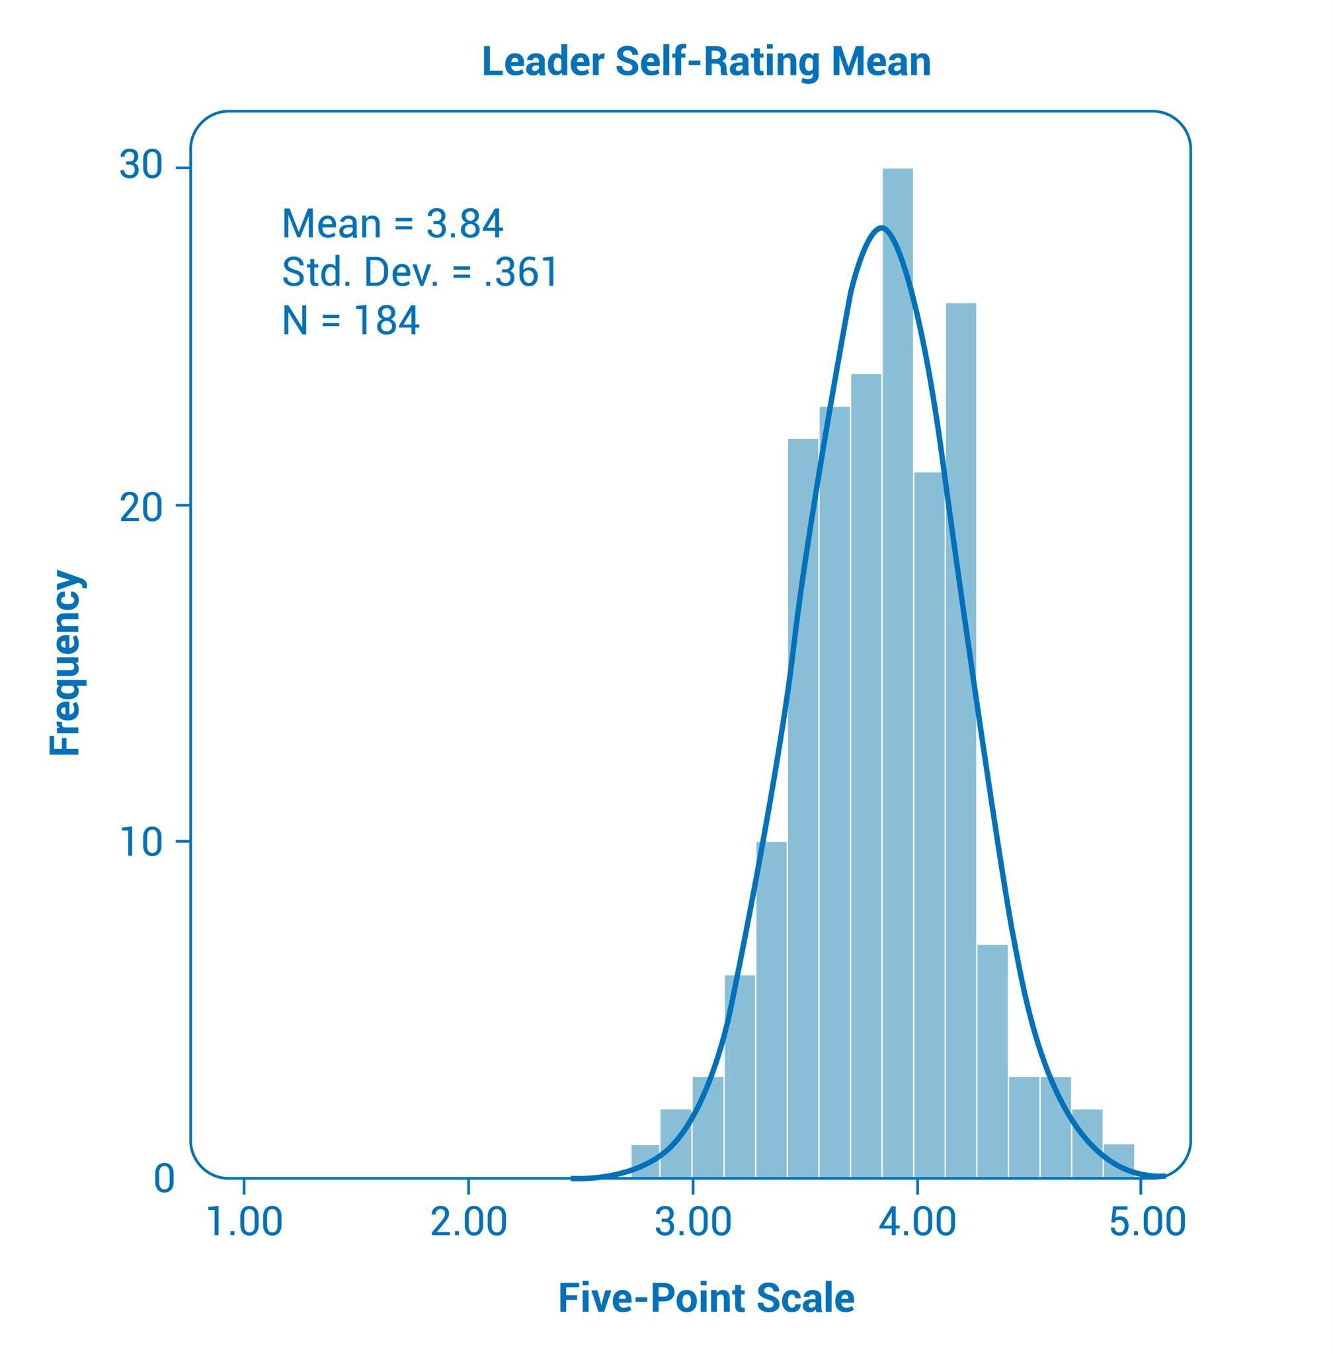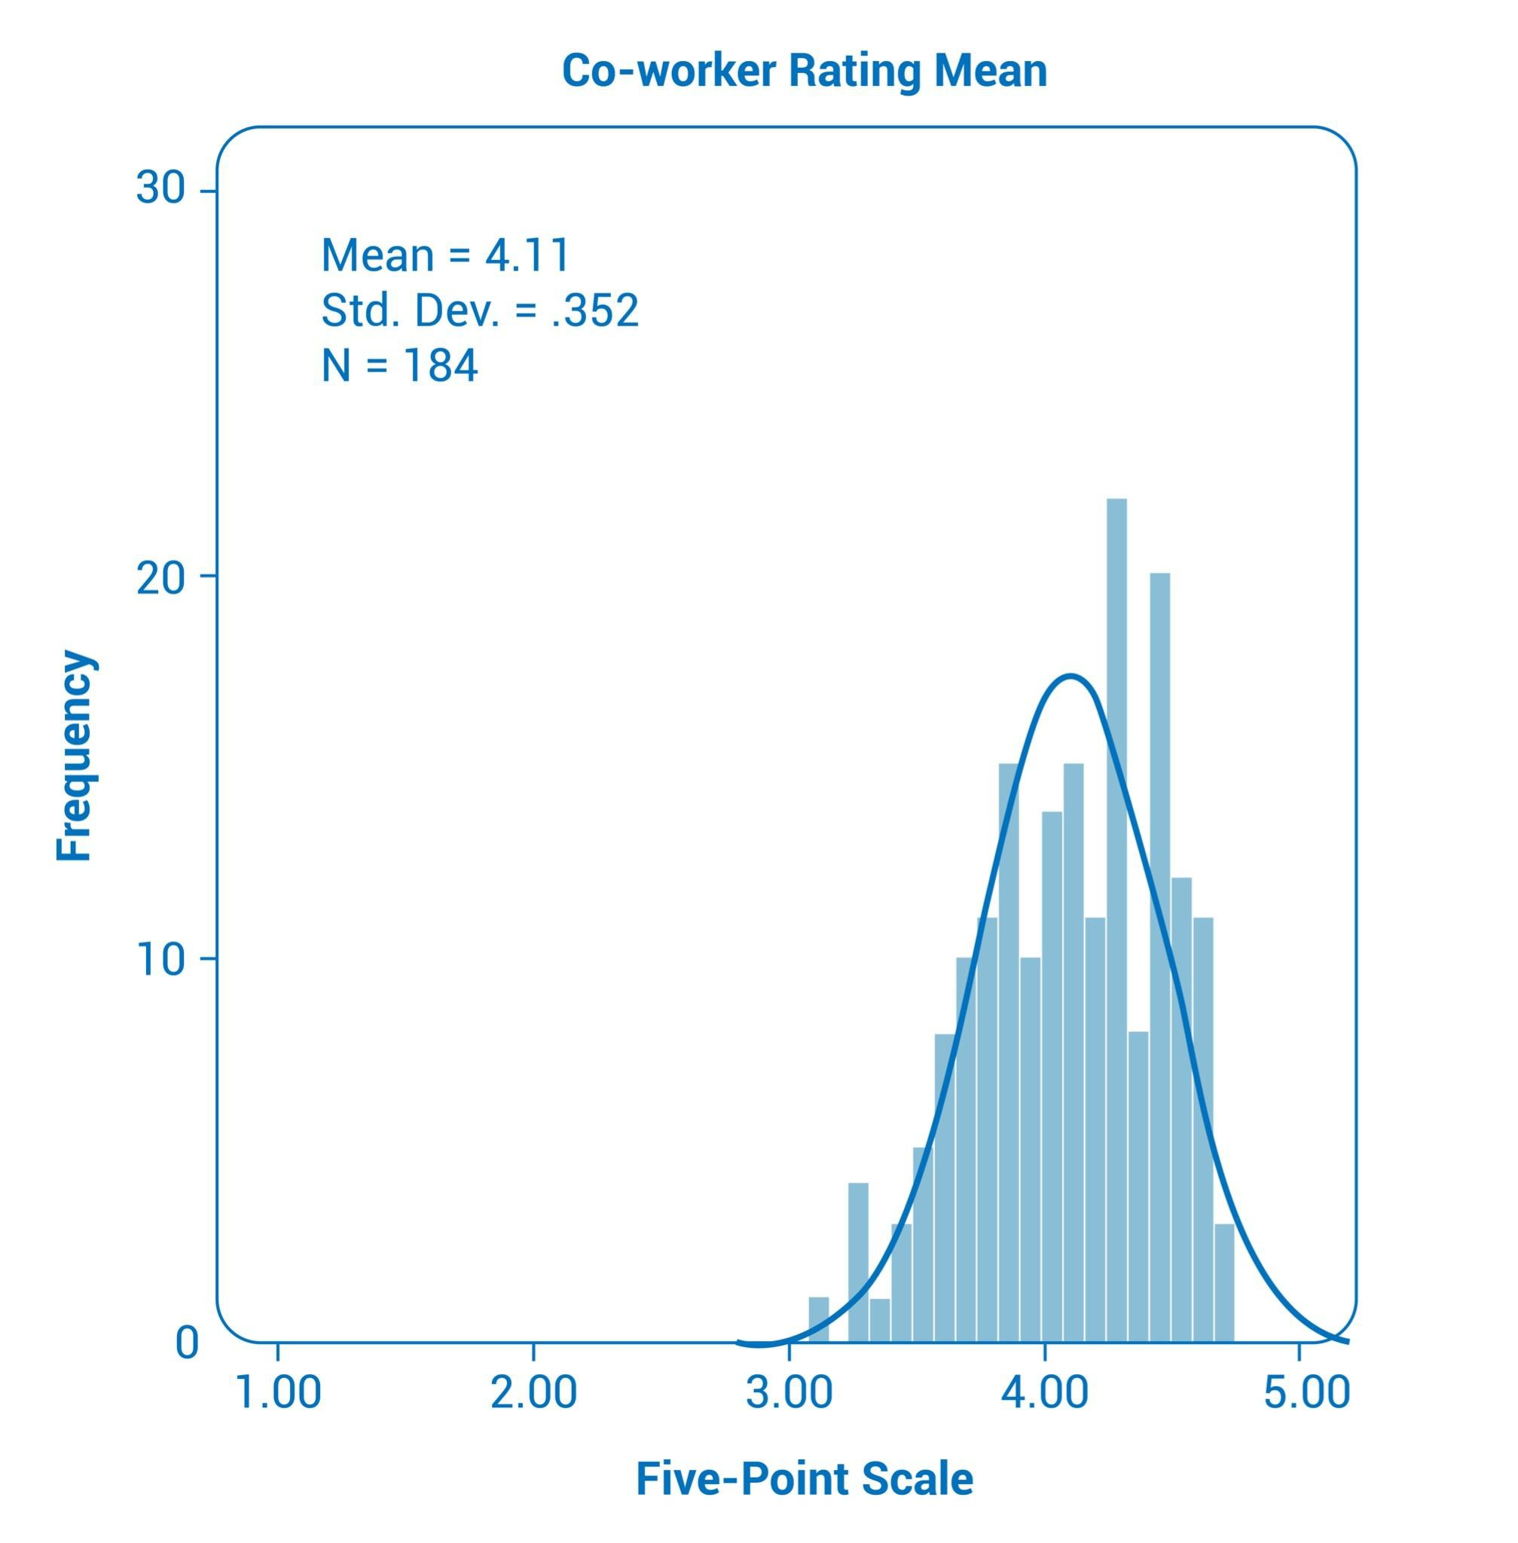

## Based on these results, extremely positive or extremely negative ratings were removed from the dataset before further analyses were conducted. This had the effect of lessening the impact of the skew, which allowed any trends in the ratings to emerge.

**LEADER DEMOGRAPHICS**

Table 1 contains the demographic characteristics of the one hundred eighty-four leaders included in the study. Forty-ﬁve percent of the leaders were female, and 55 percent were male. The leaders were all between the ages of twenty-ﬁve and sixty-ﬁve and employed full-time. Income levels ranged between $25,000 and $300,000, with half (53.5%) earning between $75,000 and $150,000. All respondents were either C-Suite executives (29.9%) or managers (70.1%). Eighty-nine percent resided in the US, and eleven percent resided in other countries, including Jamaica, Canada, United Kingdom, Israel, and Serbia. Before analyzing the assessment data, personal identiﬁers were removed to protect the privacy of each respondents.

TABLE 1. LEADER DEMOGRAPHIC CHARACTERISTICS

|  |  |  |
| --- | --- | --- |
| Characteristic | Number | % |
| Gender |  |  |
| Female | 82 | 44.6 |
| Male | 102 | 55.4 |
| Age |  |  |
| 26-35 y | 29 | 15.8 |
| 36-45 y | 71 | 38.5 |
| 46-55 y | 55 | 29.9 |
| 56-66 y | 29 | 15.8 |
| Income Range |  |  |
| $25,000 - $49,999 | 11 | 8.5 |
| $50,000 - $74,999 | 17 | 13.2 |
| $75,000 - $99,999 | 20 | 15.5 |
| $100,000 - $149,999 | 49 | 38.0 |
| $150,000 - $199,999 | 15 | 11.6 |
| $200,000 - $299,999 | 17 | 13.2 |
| Did not disclose | 55 | --- |
| Role Level |  |  |
| C-Suite Executive | 55 | 29.9 |
| Manager | 129 | 70.1 |
| Country of Residence |  |  |
| United States | 163 | 88.6 |
| Other | 21 | 11.4 |

**DATA ANALYSIS**

## The ELI 360 Study investigated two research questions:

1. What is the relationship between the leaders’ Average Resonating Level of energy (ARL), their perception of their leadership competencies, and how others perceive them?
2. What is the relationship between the leaders’ ARL, their perception of their leadership competencies, and their level of satisfaction with other aspects of work?

To investigate the relationships between energy and leadership competency ratings, nonparametric tests were conducted to determine the statistical relationship between the leaders’ ARLs, their leadership self-ratings, and their colleagues’ ratings. Between four and 34 colleagues completed the parallel assessment for each leader (mean (M) = 11). To address the second research question, nonparametric tests were used to compare the leaders’ ARL values, leadership self-ratings, and their ratings on six life satisfaction factors commonly associated with work: leadership ability, working relationships, level of engagement, communication skills, productivity, and work/life balance.

**Tests of normality.** Once the dataset was cleaned of cases with missing data, tests of normality were conducted on the four parts of the ELI 360 assessment system. As indicated by the ﬁgures in Table 2, the ARLs of the leaders showed a normal distribution of responses, with a skew value close to zero (-0.01). The fourteen life satisfaction items had a signiﬁcant negative skew of -0.39 because the leaders, as a group, reported having a higher than average level of life satisfaction (M = 4.49 on a six-point rating scale).

TABLE 2. ELI 360 TESTS OF ITEM RESPONSE NORMALITY

|  |  |  |  |  |  |  |  |  |
| --- | --- | --- | --- | --- | --- | --- | --- | --- |
| ELI 360 Assesment  (4 parts) | *i* | Mean Rating | Highest Possible Rating | Standard Deviation | Skewness | Std. Error of Skewness | Kurtosis | Std. Error of Kurtosis |
| 1. ELI: Leader ARLs | 70 | 3.28 | 7.0 | 0.25 | -0.01 | 0.18 | -0.29 | 0.36 |
| 2. Life Satisfaction: Leader Self-Ratings | 14 | 4.49 | 6.0 | 0.49 | -0.39 | 0.18 | 1.14 | 0.36 |
| 3. Leadership Competencies: Leader Self-Ratings | 36 | 3.84 | 5.0 | 0.36 | -0.06 | 0.18 | 0.12 | 0.36 |
| 4. Leadership Competencies: Colleague’s Ratings of Leaders | 36 | 4.11 | 5.0 | 0.35 | -0.42 | 0.18 | 0.50 | 0.36 |



Leader ARL and Leadership Self-Ratings Leader ARL and Collegue’s Ratings

Leadership Self-Ratings and Colleague’s Ratings

0.47**

0.21**

0.40**

** Signiﬁcant at the *p* < 0.01 level

**FINDINGS**

The results from the analysis of the relationship between each leader’s Average Resonating Level of Core Energy (ARL) and their leadership competencies are described ﬁrst. The results of how colleagues rated their leaders are presented next. Finally, the correlations between each leader’s energy level, their leadership self-ratings, and their work satisfaction ratings are explained.

COR.E Energy and Leadership

The mean value of the leaders’ ARL on the ELI 360 was 3.28 ( SD = 0.25) with a normal distribution of rating responses. Bivariate correlation analysis was conducted to determine whether there was a relationship between each leader’s ARL and their leadership competencies, as recognized by the leaders and their colleagues. The statistically signiﬁcant correlations indicated that the higher the leaders’ ARL, the higher they rated their own leadership skills and traits ( r s = 0.47, p < 0.01) and the higher those competencies were rated by their colleagues ( r s = 0.21, p < 0.01). In addition, the higher a leader’s ARL—the more anabolic the leader’s energy—the more aligned their self-ratings were with those of their colleagues ( r s = 0.40, p < 0.01). The scatter plot in Figure 3 shows the linear relationship between each leader’s ARL and their leadership ratings.

TABLE 3. SPEARMAN’S CORRELATIONS FOR ARL AND LEADERSHIP RATINGS (*N* = 184)

Fig. 3: ARL and Leadership Self-Ratings

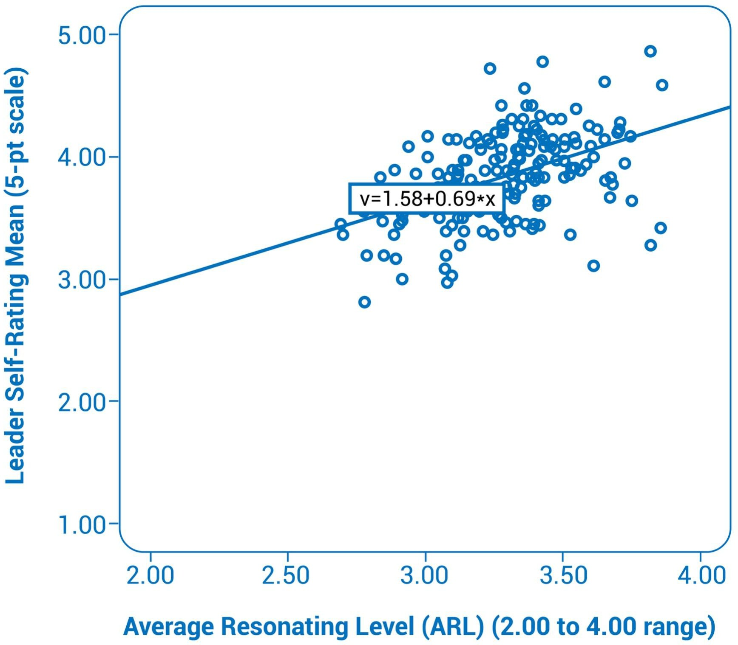

A follow-up analysis was conducted to compare the rating patterns on the 36 leadership items among leaders with signiﬁcantly different Average Resonating Levels of Core Energy. One group included twenty-nine leaders with ARL values that were at least one standard deviation above the mean, (3.53 or higher). The comparison group was twenty-nine leaders with ARLs at least one standard deviation below the mean (3.03 or lower).

## The results showed that the leaders with higher ARLs and more anabolic energy rated themselves higher than the other group on every leadership competency.

In over eighty percent of the cases (83.3%), there was a notable difference of more than one standard deviation between the two group’s ratings. On more than one-third of the competencies (36.1%), the difference was more than two standard deviations and statistically signiﬁcant.

The scoring pattern was visible in the colleagues’ ratings of the leaders’ competencies as well. On average, colleagues also rated the more anabolic leaders higher on every leadership competency, though the differences between their ratings of the two groups of leaders were not as pronounced. While their ratings were in close agreement with how the more anabolic leaders perceived themselves, the colleagues tended to be more generous in their ratings than were the more catabolic leaders in rating themselves.

## The most signiﬁcant differences between the colleagues’ ratings of the more anabolic leaders and the more catabolic leaders were in the areas of engagement, communication, relationships, and problem-solving abilities.

The anabolic leaders were perceived as:

* More enthusiastic about their role and responsibilities and more likely to be recognized by others as contributing to a positive work culture.
* Better at listening to others and demonstrating an understanding of the signiﬁcance of what was said. They more readily encouraged others to share their ideas and concerns and were more likely to offer meaningful feedback.
* More supportive of other people’s development and responded more effectively to the emotions and stress levels of others. They were better able to motivate, inspire, and boost the energy of others around them.
* Better at addressing challenges openly, seeing opportunities in challenging situations, and were more easily adaptive to change. They were also viewed as calmer and better at keeping their composure when confronting challenges.

Core Energy and satisfaction with other aspects of work. There were six work satisfaction factors that correlated with the leader’s Average Resonating Level of Core Energy (ARL) at the p < 0.01 level (see Table 4). These included perceived leadership ability, level of engagement at work, communication skills, work relationships, productivity, and work/life balance. The exception was time management ( r s = 0.05), which appeared to have almost no relationship with the leaders’ mean ARL. However, time management was signiﬁcantly correlated with the other work satisfaction factors. The results suggest that the higher the leaders’ ARL, the more satisﬁed they were with their ability to lead, have productive relationships, and be engaged and productive. An analysis of the relationship between the leaders’ mean ARL and their mean life satisfaction ratings revealed a statistically signiﬁcant correlation of 0.46, p <

0.01. The results suggest that leaders with more anabolic energy experience more overall life satisfaction as well.

TABLE 4. Spearman’s Correlations for ARL and Work Satisfaction Factors (*N*=184)

Leadership Ability

Level of Engagement

Communication Skills

Work Relationships

Productivity Time Management

Work/Life Balance



|  |  |  |  |  |  |  |
| --- | --- | --- | --- | --- | --- | --- |
| 0.41** | 0.40** | 0.21** | 0.25** | 0.25** | 0.05 | 0.20** |

**signiﬁcant at the *p* <0.01 level

# DISCUSSION

The ELI 360 study revealed several ﬁndings about the relationship between Core Energy and leadership.

## The data analysis showed that the higher the leaders’ ARL and the more anabolic their energetic makeup and outlook, the higher they rated their own leadership competencies and the more their colleagues agreed with them.

Conversely, leaders operating at lower, more catabolic levels of Core Energy were less conﬁdent in their leadership skills and were, in turn, viewed as less competent by their colleagues.



As a result, it was not possible to identify any differences in how a direct report might have rated a boss, or a spouse might have rated their partner, or how a supervisor might have rated a subordinate. Collecting this information would provide a clearer picture of how the ELI 360 assessment functions as a measure of leadership, whether at work or at home.

Most importantly, the skew in the colleagues’ response data might indicate that as a group, they were not completely honest in their ratings of their respective leaders, possibly because they were asked to identify themselves when they completed the assessment. While they were informed in advance of the intended conﬁdential handling of the data, some may have been wary of expressing a candid opinion of a colleague or supervisor, especially those with lower ARLs who may exhibit more catabolic behavior (e.g., anger, blame, victimization, or defeatism). It is equally possible that the colleagues were sincere and accurate in their ratings, while the leaders with the lowest ARLs rated themselves more harshly and were less aware of how they were actually perceived by those around them.

## The results of the Core Energy study conducted earlier this year suggest that if leaders were to participate in a model of coaching that increased their conscious awareness of how their thoughts affect their emotions and behavior, their Core Energy could then shift and expand in an anabolic direction.

According to the data examined in this study, even a seemingly small increase in Core Energy could have a notable impact on a leader’s ability to function more effectively, enjoy work more, and have those improvements noticed by others.

11