MAGIC CITY’S DANCE WORLD
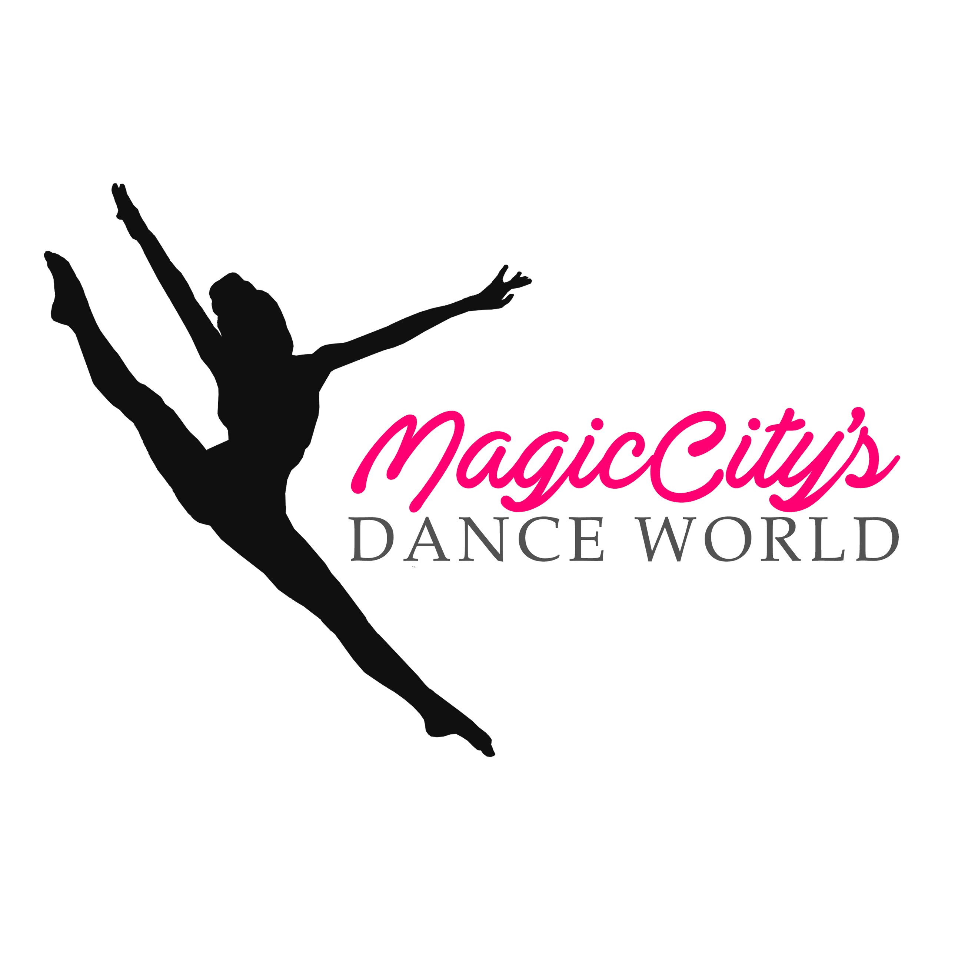
REVISED RULES AND REGULATIONS
IMPORTANT INFORMATION—PLEASE READ

Studio Directors:
You must complete one entry form for every routine. Please review your registrations. The parent, or guardian must sign a waiver release for each dancer participating. Studio Directors may NOT sign on behalf of a parent or legal guardian.
MCDW has no restriction for the number of entries one dancer submits. However, the dancers entering multiple solos may only place through their own highest scoring routine and may register on ONE level.
On the day of the event, studio directors must register their school at least one hour prior to their first performance. Dancers must arrive on the day of the event at least one hour prior to their performance.
This is a competition. Long hours are expected. Please do not bring infants. Crying in the audience may be distracting to performers. Rising or walking in the theater is restricted. While a performer is dancing, movement in the audience is prohibited. It is the responsibility of the studio owner to relate this rule to parents or other attendees supporting their school.
Concessions are open all day; also available for purchase are souvenirs, dance supplies, and photos and videos. OUTSIDE FOOD OR DRINKS ARE NOT ALLOWED. ALCOHOL IS PROHIBITED.
You may purchase all your photos and videos through your studio at a reduced rate OR parents may purchase individual photos. Studios who entered one to six routines may purchase the entire roll at $300. Studios who entered seven or more routines, may purchase the entire roll for $600. This package is offered only through pre-sales. It will NOT be available at the competition. The purchase must be made through the school or studio, though the cost may be split by participating dancers.
Personal photography or video-taping is not permitted during performances. We are urging all studio owners, teachers and parents who witness a violation of this rule to report it immediately. Disqualification may occur. We are protecting the integrity of the choreographers who own their dances.
Routines that are entered in the wrong category are subject to point deductions, or disqualification. The age group entered for any routine is the age of the oldest dancer in the routine. Averaging ages is NOT accepted. The level entered for any routine is the highest level of one third (1/3) of the dancers in that routine. For example, a routine with 9 participants, three advanced, three intermediate, and three novice dancers, is entered as advance. It is the teacher’s responsibility to enter this information correctly.
Production numbers may be up to 7 minutes in length. A minimum of 12 participants may be in a production number. This is an Open Category. Dancers of all ages and abilities may participate. Teachers are not allowed to participate.
Props are allowed in all categories. A prop is anything not worn on the body. Props may not require extensive set up. Electricity, fire, smoke and fog devices, knives, confetti, balloons, glitter, live animals, or any item deemed unsafe at the moment by Magic City’s Dance World Staff are not allowed. The dance floor must be in the same condition at entry and at exit.
Tumbling/Acro/and lifts such as cartwheels, somersaults, handstands, walkovers are allowed. However, no more than three moves per routine are allowed, unless the routine is entered in the OPEN category. We will determine Real Acro categories as registrations are entered. Magic City’s Dance World is a Dance Challenge Competition, not a Talent Competition. Routines violating rules may be disqualified.
IMPORTANT--Music-All music must be on a good quality CD. Only ONE song per CD. The performance number must be written on the CD sleeve and on the CD. The music must be cued to Track I to start immediately. It is recommended that you carry a back-up set of CDs. Maximum timing for all music is three (3) minutes, with the exception of production, which may be up to seven (7) minutes. Entrances and exists from the floor may NOT exceed 10 seconds.
Awards-Entries compete against a determined amount of points. A “Titanium” is the highest award that can be received and only granted to Advanced Dancers. It is followed by Platinum, High Gold, Gold, and Silver. All dancers will receive medals indicating their rating. First Place trophies will be given to the top scoring routine in the category. Routines will be ranked in order of highest score in each category. Routines earning Silver, or lower are not eligible for a medal. If only one entry exists in the category, it will receive a first place trophy, but only if it earned a Platinum, or Higher. All high score participants in each age group division will receive 1st through 10th place plaques.
ADVANCED |  | INTERMEDIATE |  | NOVICE
95-100 | Titanium
90-94.99 | Platinum | 83-100 | Platinum | 79-100 | Platinum
85-89.99 | High Gold | 80-82.99 | High Gold | 74-78.99 | High Gold
80-84.99 | Gold | 75-79.99 | Gold | 70-73.99 | Gold
75-79.99 | Silver | 70-74.99 | Silver | 67-69.99 | Silver

Time schedule, final directions and updates will be released by E-mail to all studio directors by January 11, 2019. It is imperative that studio directors review the schedule and report discrepancies immediately. No refunds to dancers who cannot attend will be issued.
Scholarships and MCDW dollars may be awarded to performers, but must be redeemed at the National Competition. If you are awarded a free entry solo or group pass, the named recipient must use it. Further, you must still attend the studio where you earned it.
Our judges are available to offer personal feedback during private sessions. Private sessions are available for $50.00 per routine and must be scheduled through Magic City’s Dance World.
By entering, studio directors agree that all judge’s decisions are final. Routines cannot dance out of order under any circumstances.
Be Ready! Inappropriate music including sexual content and racial slurs will result in disqualification.
Spirit Day is January 26! The studio or school showing the most Spirit will win a $700 Magic Ticket to Naitonals!
Magic City’s Dance World must be in receipt of all signed waivers by January 15, 2019.

Waiver and Release of Liability
I hereby waive all claims of injury, damage, or loss to my person and property during my participation. Further, I release the promoters, directors, officers, and all employees or sub-contractors of Magic City’s Dance World from any liability.
I understand that the purpose of Magic City’s Dance World is to provide performing experiences, including possible rehearsals and/or workshops by all participants. I understand I will be competing with other dancers and groups. I understand that photographs, recording, taping and other types of filming may be used by any staff member of Magic City’s Dance World for future publicity or to be posted in social media.
By signing below, the parent and participant agree to be bound by the above waiver and release agreement. It is required that both the parent (or legal guardian) and the dancer sign the agreement. Teachers or Directors may not sign for the parents or the dancer. If the form is not completed, the dancer may not participate.

PLEASE PRINT PLEASE PRINT PLEASE SIGN
Dancer’s Name | AGE  On Event Date | Parent/ Legal Guardian’s Name | Parent/ Legal Guardian’s Name | Date
Dancer’s Name | AGE  On Event Date | Parent/ Legal Guardian’s Name | Parent/ Legal Guardian’s Name | Date

