Attach Photograph

**HEALTH CARE ASSISTANT**

**APPLICATION FORM**

**Please complete this form in black ink and complete all sections**

**Position Applied for:**

Domiciliary Carer

**Your Surname and Initials:**

**Data Protection Statement**

The personal information (data) collected on this form, and on the attachments, (which includes the collection of sensitive personal data) are collected for the purposes of recruitment, personnel administration (for new employees)

and monitoring. Unless you direct otherwise (for example in a situation where you would like this Application kept on

file for future vacancies) the Application Forms (and attachments) of unsuccessful applicants will be destroyed after 6 months. It is the policy of the Agency to protect, and keep secure, all personal data collected. All personal data is processed for the purposes of recruitment, and, in the case of successful Applicants, for the satisfactory administration of their employment, and for no other purpose.

**Equality of Opportunity Statement**

The Agency’s Equal Opportunities Policy covers all employees, or potential employees, and embraces the principle that all people shall be treated equally, regardless of their age, gender, ethnic origin, nationality, colour, religion, marital status, sexual orientation, religion or belief, disability, or offending background.

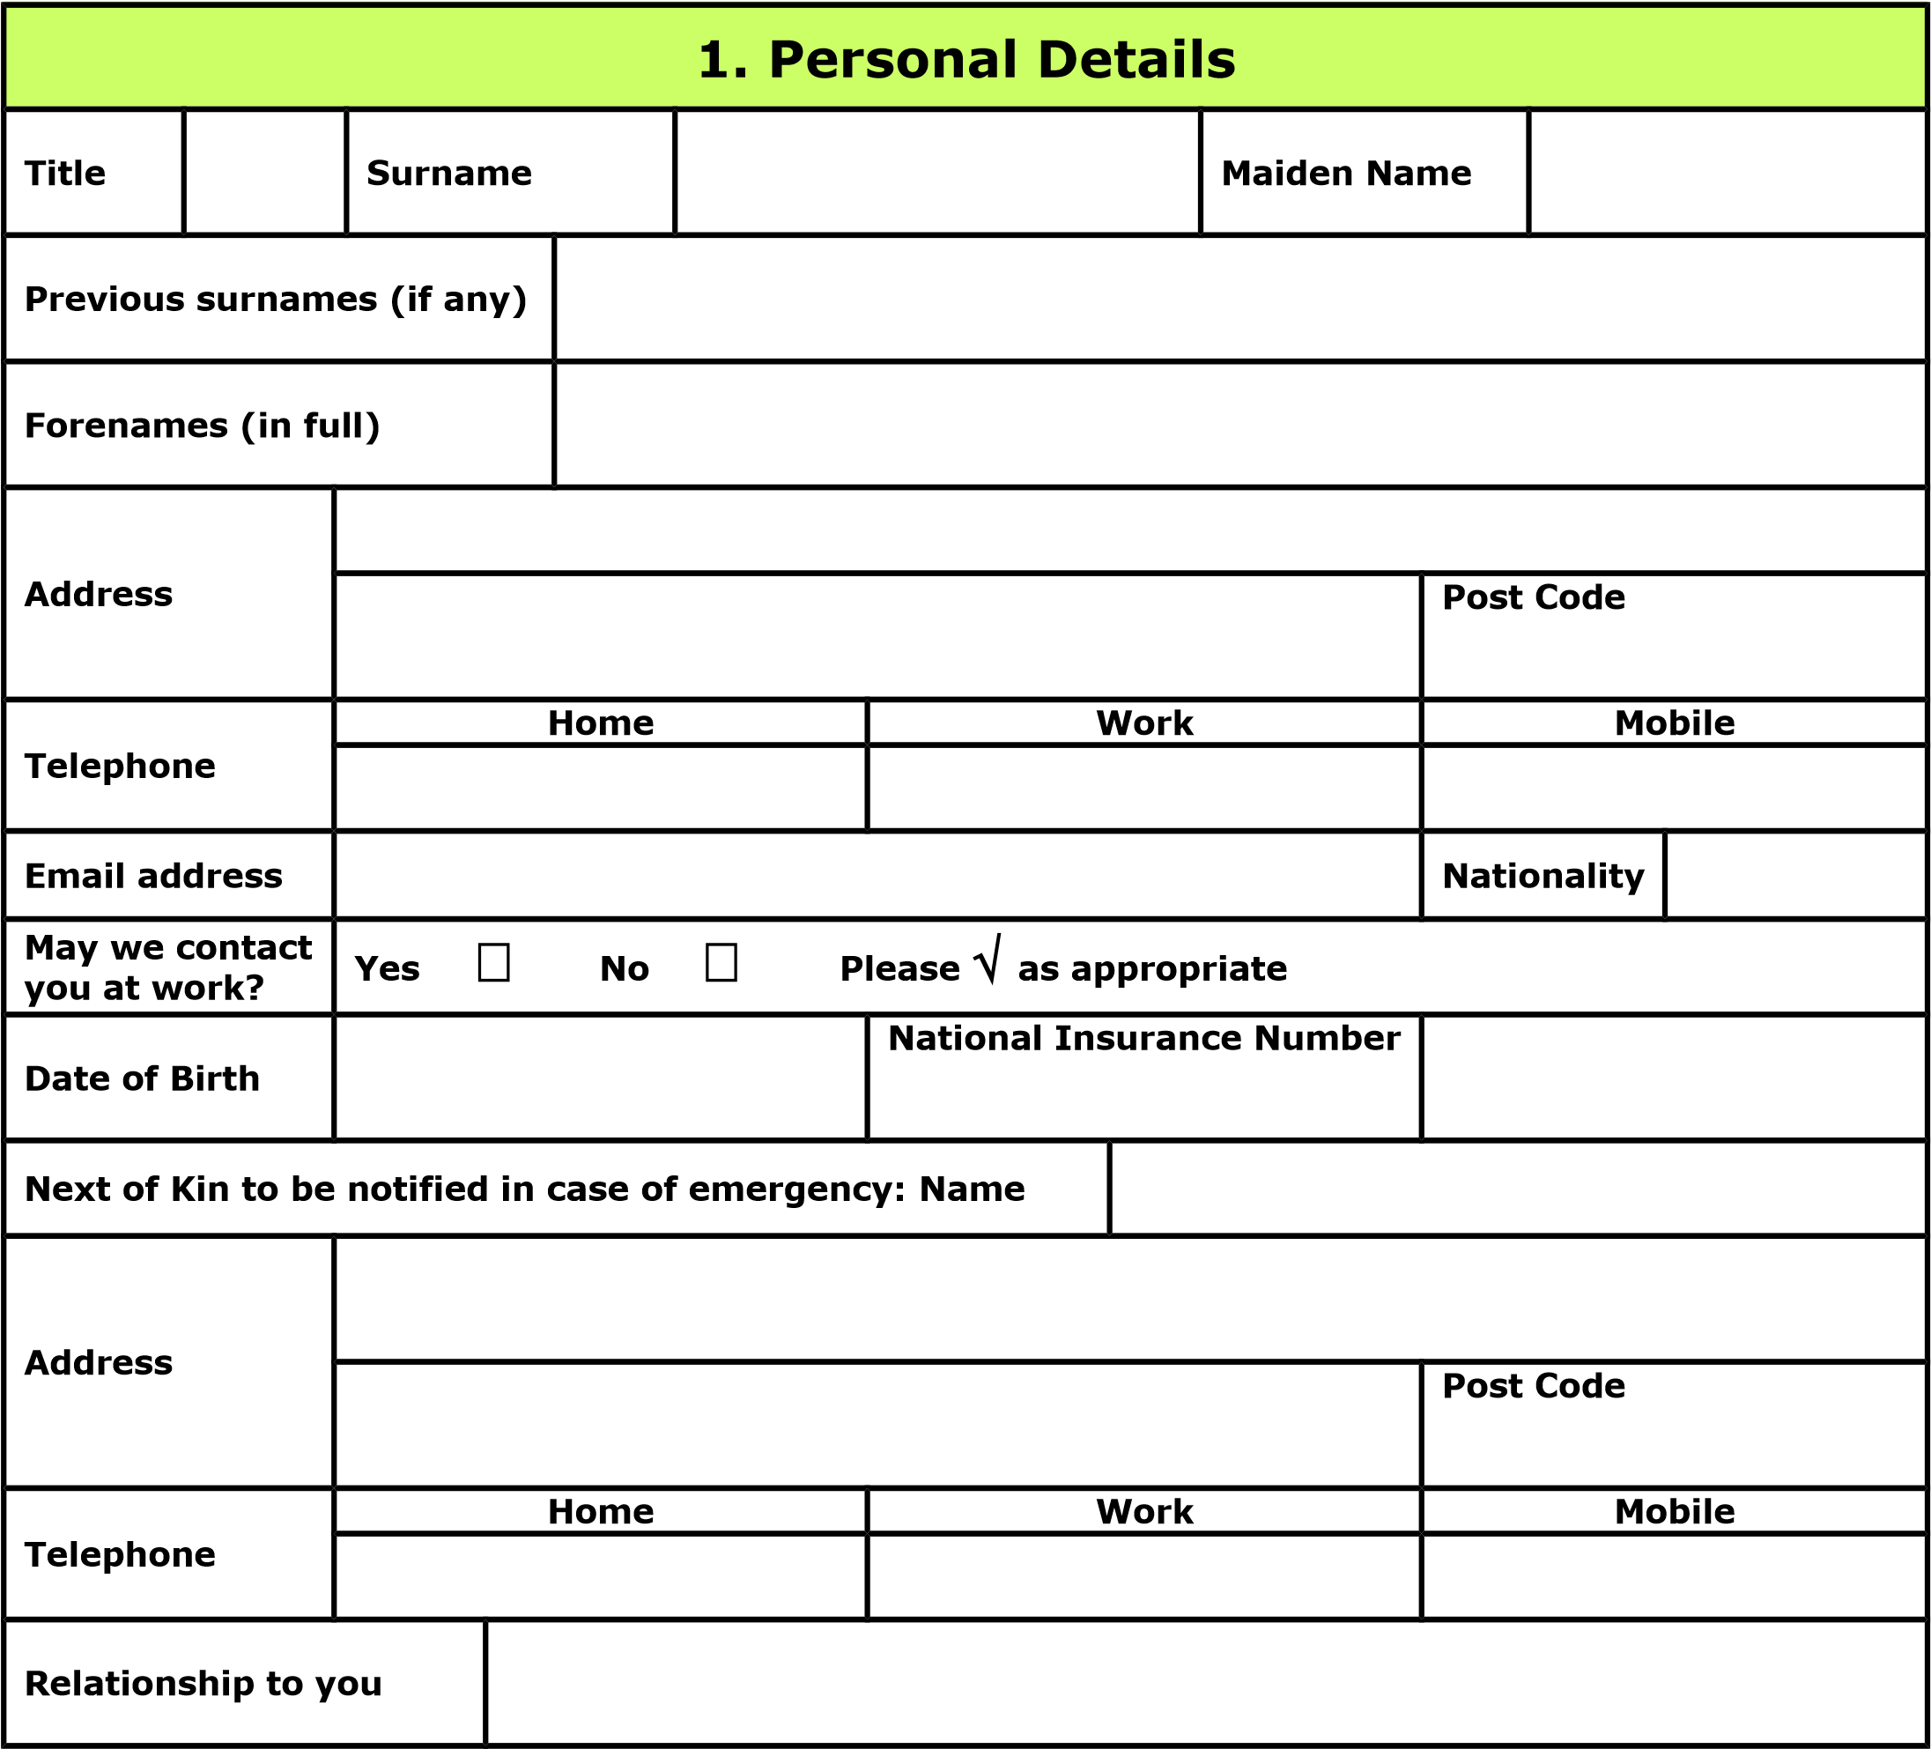

**2**

**. Formal Education and Qualifications**

**Name of**

**School/College/University**

**and Location**

**Dates of attendance**

**Course of**

**Study/Qualification(s)**

**gained e.g. GCSE’s, “A”**

**levels, NVQ, Degree etc**

**Grade**

**From**

**To**

**Month/Year**

**Month/Year**

**3**

**. Employment History**

**Please print details of all your employment for a period of at least the last 10 years, to include**

**all nursing agency memberships, in reverse date order; starting with your present or last**

**position. Please include reasons for gaps.**

**Name & address of**

**Employer**

**Dates of Employment**

**Position held and brief**

**summary of duties and**

**responsibilities**

**Reason for**

**leaving/Last**

**salary or wage**

**From**

**To**

**Month/Year**

**Month/Year**

**. General information**

**4**

**Do you hold a valid and current Driver’s Licence? Yes**



**No**



**Please**



**as appropriate**

**If Yes, what type?**



**Provisional**



**Full**



**LGV**



**PCV**



**EU**



**non-EU**

**Do you have any endorsements? Yes**



**No**



**Please**



**as appropriate**

**If Yes, please give details**

**Please state which languages you speak, including**

**an indication of fluency**

**5**

**. Preference regarding work**

**Please specify which types of work you would prefer. You should tick all appropriate boxes. The**

**service we give depends on accurate, up to date information. Please keep us informed of all**

**developments, in your career and work preferences.**

**Positions**



**part time**



**full time**



**employed**



**self-employed**

**Do you have any other work commitments? Yes**



**No**



**If yes, please give details:**

**Are there any areas of work you wish to exclude?**

**When will you be available to start work?**

**6**

**. Additional Information**

**Give details of any additional information which you would like to include in support of your application.**

**Such information, for example, may include skills and/or achievements which you think may be of**

**interest, and/or a summary of why you believe that you have the qualities we are looking for.**

**7**

**. References**

**References are normally taken up for candidates selected for interview. Give details of the names/addresses of two**

**work-related Referees. One of the Referees should be your current employer, or if presently unemployed or self-**

**employed, your last employer**

**Name, Address and Post Code**

**Name, Address and Post Code**

**Telephone Number**

**Telephone Number**

**Position**

**Position**

**Relationship to you**

**Relationship to you**

**May we contact the above person now?**

**Yes**



**No**



**Please**



**as appropriate**

**May we contact the above person now?**

**Yes**



**No**



**Please**



**as appropriate**

# Confidentiality Declaration

Registration implies acceptance of our code of confidentiality.

In the course of your duties, you may have access to confidential information about our clients. On no account must information relating to identifiable client be divulged to anyone other than the manger. You should not disclose ANY information to your family, friends or neighbours.

If you are worried by any information, you have obtained and consider that you should talk about it to someone else MAKE AN APPOINTMENT TO SPEAK IN PRIVATE TO YOUR MANAGER.

Failure to observe these rules will be regarded as serious misconduct which could result in disciplinary dismissal.

I have read and I understand the above and I agree to abide by the contents therein.

**Signed**  **Date**

# Rehabilitation of Offenders Act

As a general rule, no-one needs answer questions about spent convictions. However, this general rule does not apply to specified professions, employments and occupations. By virtue of the Rehabilitation of Offenders Act 1974 (Exceptions) (Amendment) Orders, the exemption rule does not apply to:

1. any employment or other work which is concerned with the provision of health services, and which is of such a kind as to enable the holder of that employment or the person engaged in that work to have access to persons in receipt of such services in the course of his normal duties, or
2. any employment or other work which is concerned with the provision of care services to vulnerable adults, and which is of such a kind as to enable the holder of that employment, or the person engaged in that work to have access to vulnerable adults in receipt of such services in the course of his normal duties

You are therefore requested to provide details of all convictions, including those which would otherwise be considered as “spent”. *All employment applications will be considered carefully, and the disclosure of a conviction does not imply that this employment application will be rejected.*

**Records will be checked via the Criminal Records Bureau procedures**

**I have no convictions**  **I have convictions (see Note below)  Please**  **as appropriate**

**Note**

(To protect the confidentiality of this information, please detail convictions on a separate sheet of paper. Place it in a sealed envelope with your name clearly visible, and headed “Private and Confidential – Criminal Convictions” and attach this to your completed Application Form)

# Criminal Records – Disclosure Certificate

The Disclosure and Barring Service (DBS) have issued a Code of Practice regarding Disclosure Information, a copy of which is available upon request. A Disclosure Certificate (standard or enhanced) will be requested from the which will detail all convictions, including those which would otherwise be “spent”, as well as details of cautions, reprimands or final warnings. You will be advised of the type of certificate being requested and asked to give your approval to this application. The Disclosure Certificate will only be requested if you are successful in your application for employment.

# Asylum and Immigration Act 1996

Under Section 8 of the Asylum and Immigration Act 1996 it is a criminal offence to employ a person aged 16 or over who is subject to immigration control unless:

That person has current and valid permission to be in the United Kingdom and that permission does not prevent him or her from taking the job in question; or

The person comes into a category specified by the Home Secretary where such employment is allowed

Any employment offered will be subject to the successful applicant producing appropriate evidence that the Asylum and Immigration Act is not being contravened. **Are you eligible to work in the UK? Yes**  **No**  **Please**  **as appropriate**

# Personal Declaration

**I declare that to the best of my knowledge the above information, and that submitted in any accompanying documents, is correct, and**

* I give permission for any enquiries that need to be made to confirm such matters as qualifications. experience and dates of employment, and for the release by other people or organisations of such information as may be necessary for that purpose.
* I give permission for the processing of the personal data contained in this form for employment purposes • I understand that any false or misleading information could result in my dismissal.

**Signed**  **Date**

**13**

**. Equal Opportunities Monitoring Form**

**Hearts Care Services UK Ltd operates a policy of Equal Opportunities: therefore, we need to ensure that**

**decisions are not influenced by unfair or unlawful discrimination. To help us do this we would be**

**grateful if you could complete this short questionnaire.**

**Your answers will be treated with the utmost confidence and will be used only for statistical purposes.**

**What is your ethnic group?**

**Choose ONE section from A to E, and then circle the appropriate box to indicate your cultural**

**background.**

**A White**



British



Irish



European



Any other White background

**B Mixed**



White and Black Caribbean



White and Black African



White and Asian



Any other Mixed background

**C Asian or Asian British**



Indian



Pakistan



Bangladesh



Any other Asian background

**D Black or Black British**



Caribbean



African



Any other Black background

**E Chinese or other ethnic group**



Chinese



Any other, please write here

**SEX**

**Female**



**Male**



**DISABILIBY**

**Applicants with disabilities will be invited for interview if shortlisted and the essential job criteria are**

**met. Do you consider yourself to be a person with a disability as described by the disability**

**discrimination act 1995? i.e do you consider yourself to be someone who has a physical or mental**

**impairment which has a substantial and long-term adverse effect on your ability to carry out normal day**

**to day activities**

**Yes**



**No**



**For Office Use Only**

**Initials**

**Date Application received**

**Date Application acknowledged**

**Initial Decision**

**Date Applicant informed**

**Date(s) of Interview**

**Decision**

**Notes**