NEVER LIMIT EQUESTRIAN
SUMMER HORSE SHOW SERIES 2026
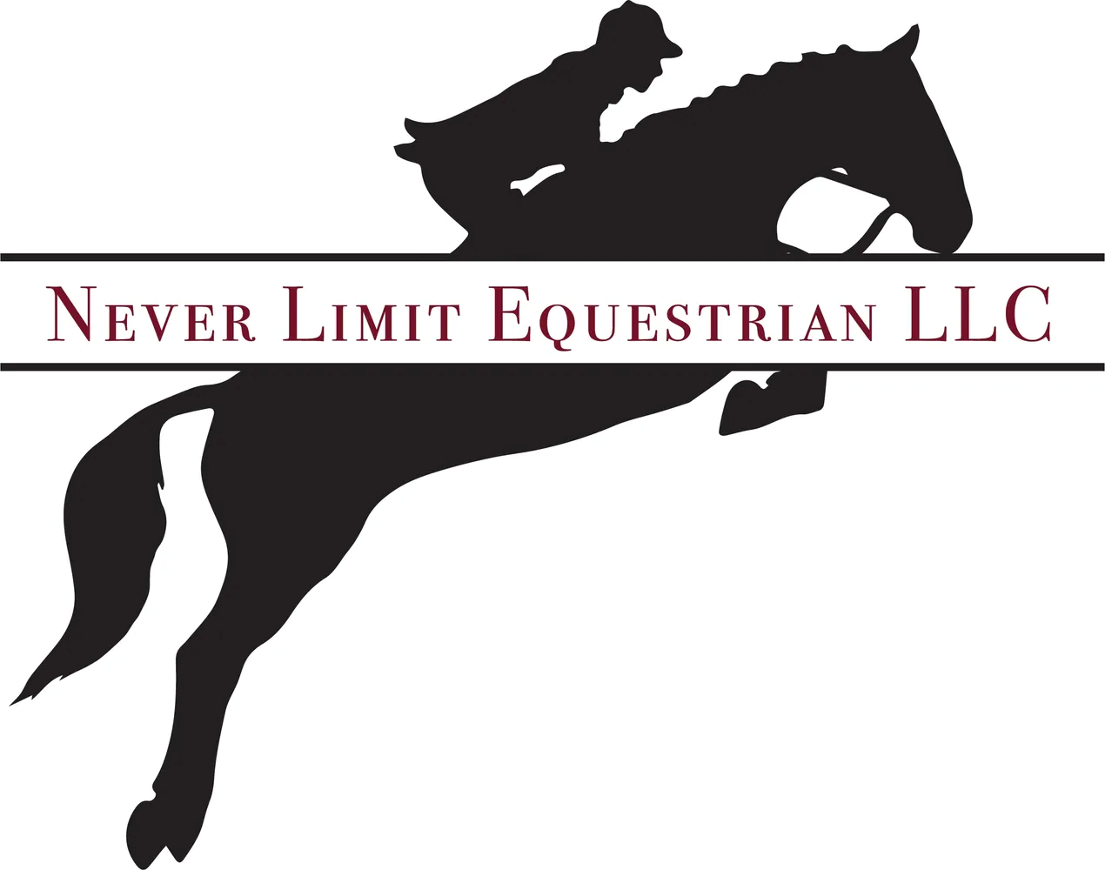

Rider:______________________________________ DOB:___________________________________
Horse:_____________________________________ Trainer:_________________________________
Phone:_____________________________________ Address:________________________________
Email:______________________________________ City/State/Zip:___________________________

Class # | Class Description | Class # | Class Description

Total Jumping/Flat Classes (____x$25)
Total Dressage Classes (____x$25)
NLE Medal Class $30
School Horse Usage Fee $20
Stabling $45 No Bedding Provided OR Haul in Fee $25
Office Fee $20 (non refundable)
Late Fee is after closing date $20
TOTAL (make checks payable to Never Limit)

RIDER/PARNET SIGNATURE_____________________________________ DATE_____________________
1 | Open Hunter U/S | 17 | Beginner Hunter U/S
2 | Open Equitation OTF | 18 | Beginner Equitation OTF
3 | Warm Up High O/F | 19 | Beginner Hunter O/F
4 | Open Hunter O/F | 20 | Beginner Equitation O/F
5 | Open Equitation O/F | 21 | Hunter Hack
6 | Twila Slavic Memorial Medal | 22 | Walk Trot Hunter U/S
7 | Advanced Hunter U/S | 23 | Walk Trot Equitation OTF
8 | Advanced Equitation OTF | 24 | Pole Pile Hunter O/F
9 | Advanced Hunter O/F | 25 | Pole Pile Equitation O/F
10 | Advanced Equitation O/F | 26 | Intro Level A
11 | Intermediate Hunter U/S | 27 | Intro Level B
12 | Intermediate Equitation OTF | 28 | Intro Level C
13 | Warm Up Low | 29 | Training Level 1
14 | Intermediate Hunter O/F | 30 | Training Level 2
15 | Intermediate Equitation O/F | 31 | Training Level 3
16 | NLE Mini Medal | 32 | Test of Choice
Class Descriptions
Equitation On the Flat: Open, Advanced, Intermediate, Beginner, Walk/Trot. Walk/Trot/Canter in both directions.
Hunter On the Flat: Open, Advanced, Intermediate, Beginner, Walk/Trot. Walk/Trot/Canter in both directions.
Pole Piles Riders in this class may not enter any other jumping classes.
Walk/Trot: For those not yet able to canter in a group class. Riders in this class may not enter any other classes except Pole Piles & Introductory Dressage
Equitation Over Fences: Open, Advanced, Intermediate, Beginner, Pole Piles. Course of 6-8 fences ranging in height from Pole Piles to 2’6”
Hunter Over Fences: Open, Advanced, Intermediate, Beginner, Pole Pile. Course of 6-8 fences ranging in height from Pole Piles to 2’6”
Hunter Hack: W/T/C both directions as a group and 2 fences taken individually. Height of fences DTB
Twila Slavic Memorial Medal: Equitation over fences. Fence Height 2’6”. Top 4 riders will return to test
NLE Mini Medal: Equitation over fences. Fence Height 2’. Test will be combined into course.
Stabling: Stalls are $45 NO BEDDING AVAILABLE. Negative Coggins test required
Schooling Times: Schooling available in dressage & jump arenas day before the show ONLY. Arenas closed for final dragging at dusk. No schooling permitted in any arena on show day. Sand warm up arena is available. Lunging permitted ONLY on the grass area north of show arena.
Fees: All fees MUST accompany entry form, or it will not be accepted. ALL ENTRIES RECEIVED AFTER CLOSING ARE SUBJECT TO A $20 FEE, NO EXCEPTIONS!
Refunds: Refunds on class fees only will be granted after closing date with a veterinary certificate and proper notification to the show secretary. ABSOLUTELY NO REFUNDS ON STALL OR OFFICE FEES.

For entry forms and/or information, visit our website at www.neverlimitequestrian.com or join us on facebook!
QUESTIONS? Email show secretary: neverlimiteq@gmail.com or call 248-343-0504

Negative Coggins Test, All Signatures & Full Payment required for entry acceptance

WARNING: Under the Michigan Equine Activity Liability Act, an Equine Professional is not liable for an injury to or death of a participant in an equine activity resulting from an inherent risk of the equine activity.
I agree to assume the risk of showing at the above-named show and waive any claims against the stable, owners, Show Management for any injuries to attendants, horses or myself. I further agree to waive any claims for property damage arising from showing at the above named show. I agree to abide by the rules under which these shows are conducted

