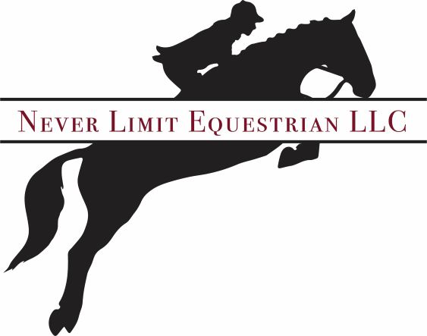

Owner/Trainer-Maggie Yash

Lesson Policy

Group Lessons

Payment Due 1st of Every Month

$55 School Horse

$45 Privately Owned Horse

Private Lessons

Payment Due 1st of Every Month

$65 School Horse

$55 Privately Owned Horse

If a Pre-Paid Lesson is Cancelled with 24 Hour Notice, A Make-Up Lesson is Offered, No Refunds.

\*Accepted Forms of Payment Cash, Check, Venmo, Zelle (Return Check Fee $25)