"Eons, the Tabernacle
and the revelation of God"
by Wim Janse
Many people take a look at a picture of the Tabernacle and think: "Ah, the Tabernacle, beautiful!" Most do not see more than a piece of land, with a fence and on it a tent. But there is much more attached to this. Not only is it a picture of heaven, where God resides and is all of God's plan of salvation pictured in it, there are also parallels in the Tabernacle and its surroundings that relate to the eons and God's revelation of Himself to His creatures.
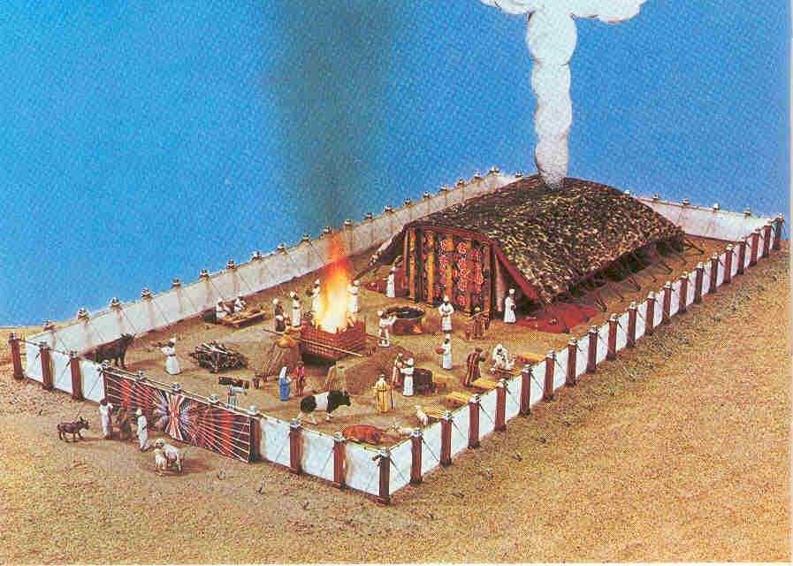
Here we see a model of the Tabernacle, with above it the "Shekinah," the smoke and fire column that indicated God's presence. Under the column we see the Tabernacle itself, with "the holy" (the first part) and the "holy of holies," the part where the smoke and fire column rest upon. These two tent parts represent eon 4 and 5, the eons that are still future. Around the tent is the "court," inside the fence, and this court represents eon 3, the present eon. Outside the fence is "the camp," where the Israelites lived. This area represents eon 2. And finally there is the area outside the camp, where the nations lived. This represents eon 1.
Eon 1.
We know very little about eon 1, just that it began in the original creation and ended in a flood that covered all of the earth. This was before the creation of Adam.
So we know very little, but we may put it on a level with the world outside the camp. During this first eon, God did, as far as we know, not reveal Himself to His then present creation, other than through nature. "For His invisible attributes are descried from the creation of the world, being apprehended by His achievements, besides His imperceptible power and divinity, for them to be defenseless"(Rom. 1:20;CLNT)
Eon 2.
Now we are in "the camp." This eon runs from the creation of Adam until the Flood in the days of Noah. In this eon God showed Himself sporadically. He walked in the Garden of Eden with Adam, was a friend of Enoch, and spoke with Noah. In this way He started to reveal Himself to mankind in a very careful and limited way.
Eon 3.
We are now in "the court" of the Tabernacle complex. This eon runs from the Flood in the days of Noah, until the return of Christ for Israel. In "the court" God made big steps in revealing Himself. First He comes, via Abraham, Isaac and Jacob, to the people of Israel, who learn to know Him through the salvation from Egypt, the Law of Moses, His protection against hostile nations, and via the Tabernacle- and Temple services. Later in this eon God showed Himself in His Image, in His Son, Jesus Christ, Who sacrificed Himself on our behalf -@ that is why the altar is in "the court." And finally He widened the knowledge about Himself through His revelations to Paul and by the calling out of the members of the Body of Christ.
Eon 4.
We have entered the Tabernacle and find ourselves in "the holy." This eon runs from the return of Christ until the fire judgment at the end of the eon. This eon is called "The Millennium". In "the holy" God came close via the service of the priests. In the 4th eon God will be further revealed through the Kingship and Priesthood of His Son in the Millennial reign, and the knowledge about Him will not be limited to Israel and the Body of Christ, but all the then living, all over the world, will know about Him.
Eon 5.
We walked on and have arrived in "the holy of holies." This eon runs from the fire judgment at the end of the Millennium, until the Consummation, when the last creature will be subjected to Christ. In this last eon God will show Himself in the new Jerusalem, on the new created world. Those who died in the past have now been resurrected and learn to know Him. Again the scale on which mankind knows God has been enlarged. Can it be that then will be what the Lord already announced in the sermon on the mount? "Happy are the clean in heart, for they shall see God" (Matt. 5:8;CLNT). Total knowledge and acquaintance!

© Wim Janse

