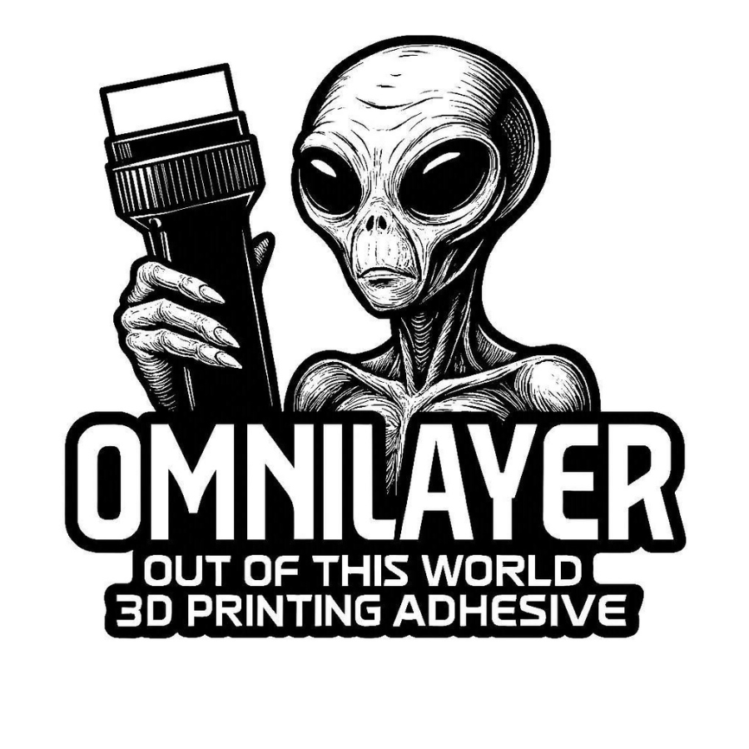
How to Apply OMNILAYER

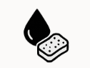
1. Clean the build surface
Wipe your bed with warm water and soap to remove dust and oils. Dry completely.
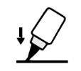
2. Saturate applicator
Use the builtin 30mm or 50mm applicator by pressing down the applicator on the build surface until OMNILAYER adhesive begins to flow out making sure the applicator tip is saturated.
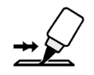
03. Apply OMNILAYER
Begin to spread a light thin layer across the print area. A little goes a long way.
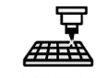
4. Start your print normally
The adhesive layer activates as the bed heats, creating strong adhesion for most filaments.
5. Easy part removal

Once the bed cools, parts release with minimal effort — no chiseling or scraping.

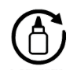
6. Reapply as needed
Most coatings last for 20-30 prints. Reapply when adhesion begins to fade.

