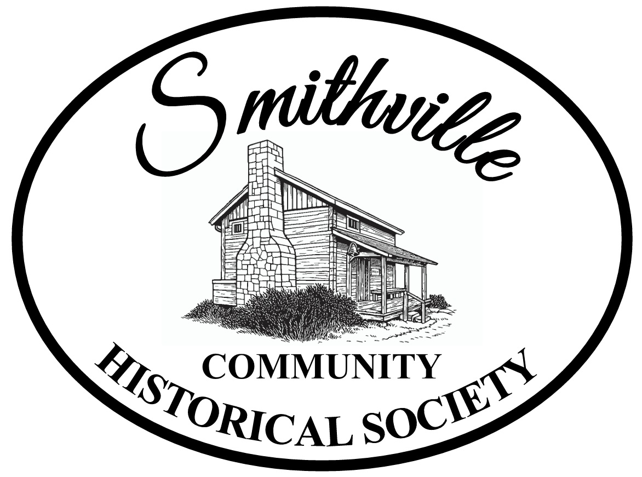

Heritage Center Rental Agreement
391 E. Main St., Smithville, OH 44677

Renter Name ________________________________________________________________

Address ____________________________________________________________________

Phone _______________________________ Email _________________________________

Organization (if applicable)_____________________________________________________

Purpose _____________________________________________________________________

Date requested:______________________________________________________________

Start time______________________ End Time;_____________

The renter Agrees to rent the Heritage Center meeting room on the dates above and to adhere to these terms;
1.Rental fee is $15.00 for SCHS members and $25.00 for non-members per day (up to 8 hours).
Fee is due the day of the rental. A refundable deposit of $25.00 for damage and/or cleaning is required. The deposit will be returned promptly upon inspection of the premises by a representative of SCHS.
2. If the rental is through an SCHS member, the SCHS member must be attending the event.
3. No Smoking is allowed on the premises.
4. No alcoholic beverages may be brought to the premises or consumed on the premises.
5. Your organization may use the stove, refrigerator, sink and microwave to prepare food during the course of your meeting.
6. Your organization should bring their own utensils, pots and pans, silverware, dishes, etc. used in the preparation and/or consumption of food during your stay here.
7. Your organization is responsible for cleaning the kitchen, stove, tables, disposing of trash in the dumpster behind the mill and sweeping and locking the door before you leave.

RELEASE AND INDEMNIFICATION: Renter hereby releases any and all claims against the Society, Society's heirs, legal representatives, including board trustees, successors and assigns arising from injury, damage or destruction to Renter, Renters assistants, personal items or equipment on Society's property. Renter hereby agrees to indemnify Society, Society's heirs, legal representatives, including board trustees, successors and assigns against claims of third parties for injuries or damages arising from Renter exercise of rights under this Agreement

Printed Name___________________________________________________Date:________________

Signature __________________________________________________________________________

Return to: Smithville Historical Society, P.O. Box 12, Smithville, OH 44677
For any questions please call 330-669-9308

