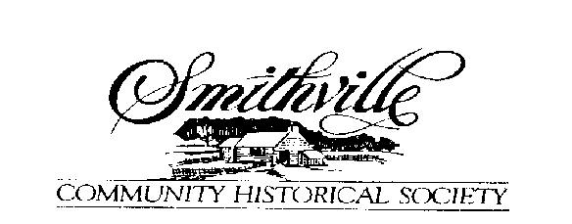
March 2019 The Heritage Times Established 1990

Notes from our President, Ralph Smucker
Index
2. Vice President Message
2. Treasurer Report
3. Acquisitions Report
3. Antique Market
3. Membership
4. Maintenance
4. Artisans & Tours
5. Stars Base Ball

The past year, 2018, was a good year with lots of good programs, Open House/tours for school students, Vintage base ball games and our tours for members.
After several revisions, the constitution of the Smithville Community Historical Society was adopted. Thanks to the diligent and hard work of the committee: Mark Irvin, Eric Mast and Lyn Miller.
A new sign was mounted for the Rail Road Depot and also one for the Pottery was mounted on the entrance arch building. The entrance arch and buildings received new windows, doors and was painted.
We would like to thank Nita Downey and her team for the beautiful flowers and mulching at all of the buildings. Also, Kenneth Reusser and Dale Shamp for the care of our lawn at both campuses. We had to re-cement the patio at the back of the Mishler rental house.
Limestone was added in all parking areas and drives at both campuses. Non-slip mats were put on the handicap ramps at the Mishler Mill and will be installed on our other ramps this year. New energy efficient lights and bulbs are being phased in to our buildings.
I personally want to thank everyone who helped volunteer in so many ways to make this past year enjoyable and a real success.
*************************************************
Cars, Cars everywhere, Model-T to Classic Cars
On July 25, 2018 over 50 cars from the Great Lakes Vintage Motor Car Club of
America paid us a visit. On September 1, the 30th Annual Model-T Jamboree made the Greater Akron Area Model-T Club Museum their base with more than 85 Model-T from 1908 to 1927 visiting our village. We would like to thank all of our members and our local businesses for making this :The Year of the Cars.”
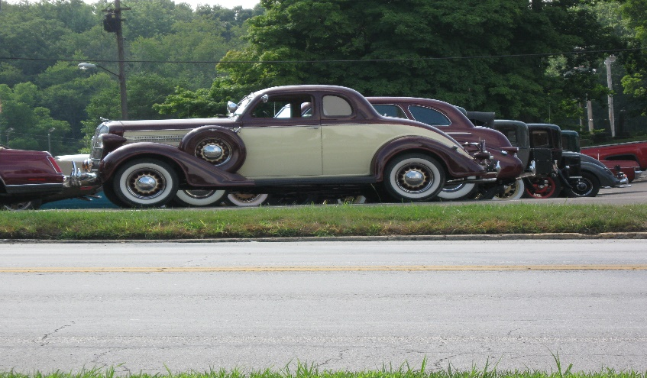

The Heritage Times 2019 (2)

Greetings from our Vice President, Mark Irvin

2018 was an interesting year of changes for the Smithville Community Historical Society. We added a couple of new attractions for our open houses in the spring that seem to have been big hits and look to be continued draws for the public in the future. We are looking for new ideas to increase our presence in the community and promote the purpose of the society.

One of the biggest changes in 2018 was the needed revision of our constitution. When I was asked to chair the constitution revision committee, I didn’t realize the scope of the projector the this challenge we would encounter trying to get our society up to standards and giving us the tools to be able to operate efficiently in the future. One of the big things that the committee looked at was not only updating the language in the constitution, but making our constitution flexible enough for the changing times we live in as well as being able to adapt to unforeseen changes in the future. I also didn’t realize the opposition the constitution revision that would be produced within the membership. I am glad we are past this and can move forward to taking care the real issues within the society.

Keith Chambers (Finance and Margo Stafford (Publicity) both decided to retire from the board at the end of the year, and we are happy to receive Jeff Carr and Tim Homan to fill their respective positions. Early this year, Phil Maasz announced his retirement from the board, and after a concentrated search for a replacement, Tim Homan agreed to step into the position. With Tim opening up the Publicity seat on the board, Margo agreed to temporarily step back into her old role until a replacement can be found.

Work is still moving forward to get our collection of artifacts cataloged and organized in our computer system. We are also working on archiving the many photographs we have in our collection and hopefully having them at least search able in our system if not search able online.
We have also been asked by the Smithville schools superintendent to see if we can digitally archive our collection of Smithville yearbooks and make them accessible for the school. This project alone could keep us busy for a long time, and we may try partnering with one of the computer classes at the High School to help with enormous task.

While we have many people, who are willing to volunteer their time and effort when we have a major building project or something like that going on, now is the time when we really need some people to step up and lend a hand. These are many small projects that almost anyone can help with, and we can always use help for our many open houses and events. I think we have many good things going so far, and I look forward to the exciting things that are happening at our Smithville Community Historical Society.
~~~~~~~~~~~~~~~~~~~~~~~~~~~~~~~~~~~~~~~~~~~~~~~~~~~~~~~~~~~~~~~~~~~~~~~~~~~~~~~~~~
2018 Treasurer’s Report
Phil Maasz, Treasurer
Five largest income items: Five largest expense items:

1. Rent income $17,315.00 1. Electricity $7,898.96
2. Cash donations $ 8,037.64 2. Repairs $6,569.66
3. Product sales $ 5,400.17 3. Property insurance $4,920.00
4. Tours $ 3,549.00 4. Natural gas $4,488.57
5. Lytle Fund Endowment $ 3,337.00 5. Real Estate taxes $3,357.26
The Heritage Times 2019 (3)
Acquisitions Report
Bob & Linda Platt, Chairmen
The major project for 2018 was setting up displays in the new Downey Pioneer Visitors Center. The upstairs features a large Abraham Lincoln collection, donated by Gerald and Marilyn Payn. Also, on the second floor, are local Native American arrowheads, local veteran’s military uniforms and a Point Breeze Chautauqua display. We recognized the 200th year celebration of the Smithville Inn and the Oak Grove Mennonite Church. Showcases featuring the local Smithville Granges and the Smithville Stars baseball team were also on the main floor.
Once again, many artifacts with historical significance to Green Township and Smithville were donated. These include:
1853 Old Normal School bell
B. Lechty, Bristol, O. 1852 coverlet
Myrtle Dairy Farm aerial photo
Smithville Post Office sorting table
O, J. Thompson, Elementary Principal’s desk
Misc. photos, post cards, documents, scrapbooks
During Christmas in the Village, Visitors to the Caboose Toy Museum saw a display celebrating the 30th anniversary of the movie classic “A Christmas Story.” Featured was the Red Rider BB gun belonging to
Harold Downey.
We want to thank all the generous people who see the importance of preserving our community’s history.
Donor Appreciation Day will be a part of the first Open House May 19. For information about donating, call 330-669-9455.

Antique Market
Bob & Linda Platt, Chairmen
As always, it was a hot summer day for the 7th annual SCHS Antiques Market. Visitors enjoyed strolling among the dealer booths on the tree-lined yard of the Mishler Weaving Mill. All Historical Society buildings were open for touring and volunteers were weaving in the Mill.
Furniture, glassware, jewelry, and pottery were among the many items for sale.
Plans are being made for the 2019 Antiques Market scheduled for Saturday, August 17. For information call 330-669-9455.

Membership Report – 2018 Pat Keristead
Our Society welcomed the following as Life Members:
Ruth Haidle Bob Hendershot
Dean Frank Randy & Jill Hutsell
The following members passed away this year:
Jan. 10, 2018 Dwight Harrison, Family Member
May 12, 2018 Nathan Worthen, Individual Member
July 30, 2018 Marilyn Deibel, Charter Life Member
October 5, 2018 Melf Lorenzen, Life Member
October 25, 2018 Dan Rehm, Charter Life Member

We welcome everyone to be part of the Historical Society. Dues are: Student - $5.00 ages 6 to18 Individuals - $10.00 Family - $15.00, includes child under 6 years of age Life - $100.00 .
The Heritage Times 2019 (4)
Building Maintenance Report
Dan Kaufman, Supervisor

The only thing that seems to be constant, is change, and last year has had its share. Constitution, policies, procedures, and buildings. Lit it or not good or bad time waits for no one or nothing. Our buildings are ment to be time capsules frozen in time. The only thing frozen this winter, was us.
Spring will bring a host of repairs, improvements and of course, spring clean-up. My goal every year is tofocus on safety, security and improvements that will reduce future workloads.
A few of the items completed in 2018; New floor in the hallway and common area of the Church of God annex for the preschool rental. Hope this one lasts 50 years as did the old one. Secondly, gutter and signage on the Heritage Center (Reception Center0. Thirdly, the camera display room is now the much, needed larger Administration Office in the Heritage Center. New cost savings through new flood and spot lighting at the bell tower in the village. The Caboose received new track ties and gravel in 2018 to get it back on level ground. The Depot had its “Smithville” sign repainted but otherwise is in good shape. New sign and paint for the Chautauqua arch and village entrance.
Some major repairs and upgrades are scheduled for 2019. Several quotes have been submitted and one selected for a new metal roof for the Heritage Center. The south entrance will get new door and platform with steps for safety. The Mishler Weaving Mill needs odds and ends but nothing major at this point. We are accepting quotes for new master key and locks for the entire campus.
The village with it’s many buildings always need attention. Log repair, windows in the Sheller House, paint and doors for the Tin Shop, and wall boards for the Blacksmith building. The Church of god being the oldest original build on campus is showing its age and needs much attention. A separate grant proposal is being applied for the renovation.
For that project I will be proposing the use of the coating technology from Germany that has been applied to the Mishler Weaving Mill annex several years ago that is a long-lasting coating. This material has a energy star rating and has been used extensively throughout Europe to reduce energy cost and preserve century old buildings.
A roof over the working drag saw display will need a zoning variance by the village, but is on my list.
Other improvements in addition to these maintenance issues will focus a better overall visitor experience. Video displays in certain buildings for historic and informative experience. Hardened walk ways for wheel chair access and that will reduce weed spray maintenance.
Well if that isn’t enough, I’m sure I’ve left out this that or the other thing.
Grants and a little fund raising hopefully will keep the Smithville Community Historical society campus looking its best for a safe and memorable experience for the whole family as 2019 goes down the road of history.
~~~~~~~~~~~~~~~~~~~~~~~~~~~~~~~~~~~~~~~~~~~~~~~~~~~~~~~~~~~~~~~~~~~~~~~~~~~~~~~~~~~
Mishler Mill – Kathy Meitzler, Artisans & Tours

The Mill and Pioneer Village hosted nearly 700 school students and a number of smaller tours, starting in the spring and going thru the fall.
Our donations have included clothing materials, wool scraps, jeans and balls of fabric. Most have been woven into rugs. We’ve filled orders for table cloths rugs and dish towels, which are the top seller.
We are still looking for an interested party to learn and run our power dish cloth loon or the press cloth loom. This person needs to have an interest/background in mechanical skills. Come and see, if interested, or just for
fun! There are about 11 to 13 volunteers at the mill. Busy place! If you haven’t been for a while, please stop in and see the Gift Shop which has all the village wares!
The Heritage Times 2019 (5)
Smithville Stars Base Ball
Jeff Carr, Manager
2019 Schedule
Sunday, May 5 @ Malabar Farms, 2 games, TBD
Sunday, May 19, Home vs. Wyandotte Ghostriders, 2 pm
Sunday, June 2 @ Canal Fulton, 2 pm
Saturday, June 15, Home vs. Bay Village Villagers,TBD
Sunday, June 23 @ Newcomerstown, Cy Young Festival 2 games, TBD
Sunday, July 21 Home vs Mansfield Independence, 2 pm
Sunday, July 28 @ Marshallville vs. Canal Fulton Mules, 2 pm
Saturday, August 10 @ Kidron, Sonnenberg Festival vs Kidron 9, 1 pm
Saturday, August 17 Home vs. Whiskey Island Shamrocks, 2 pm
August 31 or September 1 @ Columbus, Ohio, Ohio Cup, 3 games, TBD
Sunday September 15 Home vs. Canal Dover Red Legs, 2 pm
Dates and games could be added when information becomes available.

2018 Season Highlights
We celebrated 150 years of base ball in Smithville. 1868 Wooster Republican articles in Aprin, the Juniors team (males 14-20), August, the Pocahontas team (women?) and an October article about the Stars (male 21 and over).
This year bought an increase of interest in players and fans. The teams increase of the rules, strategies’ and the historical knowledge of the game.
Our players this year were: Jim Baer, Tyler Baer, Daryl Beeler, Bruce Blough, Dan Blough, Evan Blough, Rick Blough, Rod Blough, Bob Brooker, Phil Bumgardner, Jeff Carr, Matt Carr, Erik Davenstott, Mark Irvin, Kris Kendle, Kenny Larabee, Ryan Leifheit, John Miller, Mark Oser, Randy Oser, Ben Shaffer, Bob Shircliff, Doug Smith, Ryan Smith, Sr., Ryan Smith, Jr., and Terry Hershberger.
We are always looking for more players, both male and female.

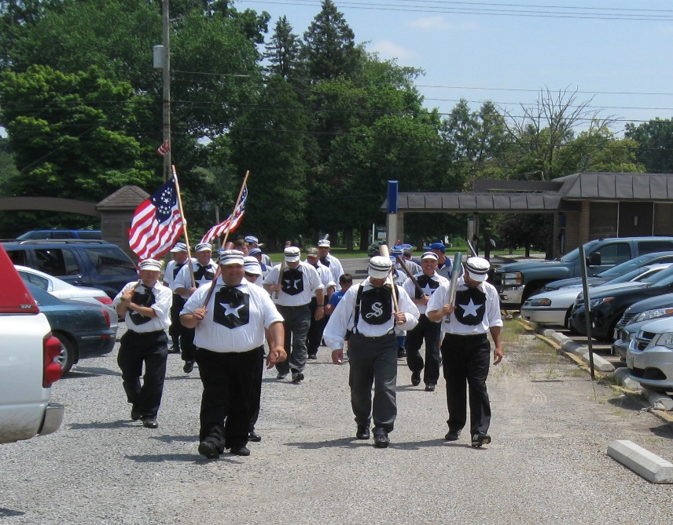
The Smithville Stars march to the playing field.
2018 Record 10-10-2

The Heritage Times 2019 (6)

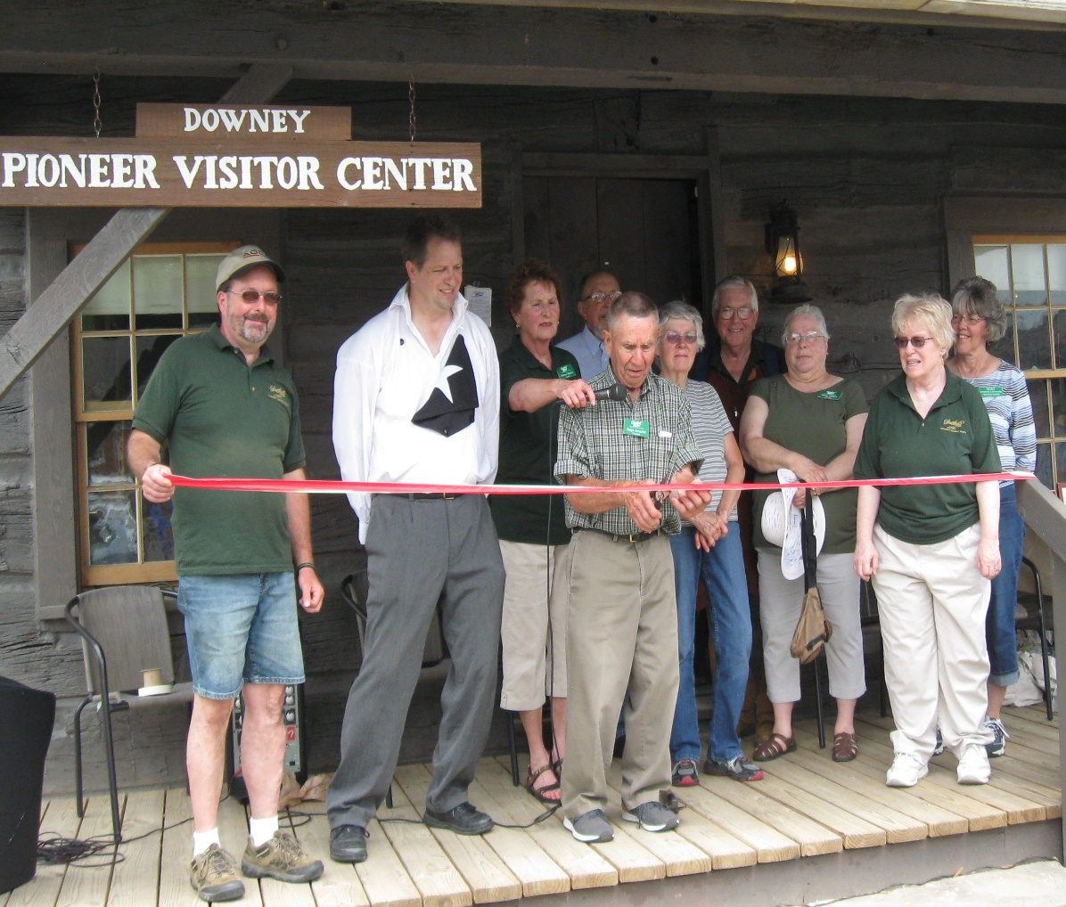

Our 2018 officers & Board (L – R) Dan Kaufman, Mark Irvin (VP),
Ralph Smucker (President), Kathy Meitzler, (rear) Harlene Steiner (Sec.),
Phil Maasz (Tres), Pat Keirstead, Keith Chambers, Margo Stafford,
Linda Platt.

Some interesting facts about our those who serve on our Board and the operations of the Society. The average of our board members is approximately 68 years. We have close to 150 years of museum experience among our Board, some having served at local, county and state levels. Our four main officers not only serve in their offices but usually serve as chairmen of other committees. One officer serves as our Statutory Agent reporting to the State of Ohio, Secretary of State Office and questions that may arise regarding our operations. We are a 501c3 Not for Profit Organization. Our campus consists of thirteen major structures and three smaller structures. This does include two homes which are rental properties and we also rent the rear of the Church of God to the Tri-county Pre-school. The income from these properties cover our monthly operational expenses.
We are one of the few museums whom have productive artisans making products to sell which cover a small portion of any unforeseen expenses that may arise.
With the endowments that have been established at the Wayne Count Community Foundation, especially one to assist for the cost of publicity, you will see changes and new advertising venues added. We hope this addition will increase the number of visitors to our Society.
With two new officers coming on the Board in 2019, they will give the expertise to generate more funds for the much needed, upkeep or our buildings. If you have questions please contact one of the Board members.
The Heritage Times 2019 (7)

2019 Events, Programs & Board Meeting
All meetings are held at the Church of God at 7 P.M unless otherwise stated.
If schools are closed our events and Wednesday work sessions are canceled.
Last minute announcements may be heard on WQKT for meeting cancelations.
Programs-General Meetings

January 7, Monday - General Meeting (6 P.M.) Program Doug Spence “Dining on the Railroads.”
Hostesses – Kathy Meitzler & Lila Smucker.
February 4, Monday – Road Trip, Lunch at Muddy’s in Wooster. Tour Buckeye Agricultural Museum.
Please make reservation by calling Nita at 330-669-3969 by 1-31-2019.
March 4, Monday - General Meeting, Program Deborah Kitoko, Genealogy Resources from the WCPL.
Hostesses – Pat Keirstead & Cheryl Long.
April 1, Monday – General Meeting, Program Michael Amstutz, Recipe Box Collection.
Hostesses – Marilyn Payn & Patty McFadden.
May 5, Monday – Road Trip, tour Mansfield, Kingwood Center, Dinner at The Reindeer Grill.
Please make reservations by calling Nita at 330-669-3969 by 4-22-2019 Fee $7 for Tour.
June 3, Monday – Road Trip, lunch at Trails End Restaurant at noon in Loudonville. Tour Cleo Redd Fisher
Museum & Log Cabin at 1:30 P.M.
July 1, Monday – General Meeting, Program Group presentation, 200 year history of Oak Grove Mennonite
Church. Hostesses – Nita Downey & Diane Miller
August 5, Monday – Picnic at 5 P.M. at East Chippewa Church pavilion. Program Cedar Valley Cloggers.
Bring a dish to share and table service, beverage will be furnished.
September no General Meeting
October 7, Monday – Road Trip, Medina, lunch at noon at JoJo’s Sports Bar. Group divides in half to tour
one of two museums starting at 1:30 P.M. then will switch to visit second museum.
November 4, Monday – General Meeting, Program Reed Hostetler, “An Appalachian Adventure.”
Hostesses - Nancy King & Dorine Widder.
December 2, Monday – General Meeting, Program “Merry Tuba Christmas Concert.” Bring cookies to share.
Hostesses – Board of Officers will furnish beverages.
Open Houses

April 14, Sunday – 3 P.M. Old Fashion Hymn Sing at the Church of God
presented by Norma Trotter and Heather Carr.
May 19, Sunday – 1:30 to 4 P.M. Open House – Antique Power Show
Stars Vintage Base Ball 2 P.M. playing Wyandotte Ghostriders
June 15, Saturday – 10 A.M. to 4 P.M. Open House – Civil War History Day.
Stars Vintage Base Ball 2 P.M. playing Bay Village Villagers
July 21, Sunday – 1:30 to 4 P.M. Open House, Band Concert 3:30 P.M. Ice Cream Social 4:30 P.M.
Stars Vintage Base Ball 2 P.M. playing Mansfield Independence
August 17, Saturday – 10 A.M. to 4 P.M. Antique Market at Mishler Mill, 1:30 to 4 P.M. Open House.
Stars Vintage Base Ball 2 P. M. playing Whiskey Island Shamrocks
September 15, Sunday – 1:30 to 4 P.M Model-T Day, Car Drive-in, Open House.
Stars Vintage Base Ball 2 P.M. playing Canal Dover Red Legs
October 19, Saturday – 1:30 to 4 P. M. Apple Butter Day (come early to help stir)
December 7, Saturday – 6 to 8:30 P.M. Christmas in the Village, St. Nicholas and ride the Kid Wagon.
December 8, Sunday – 1:30 to 4 P.M. Christmas Concert 3 P.M. in Church of God, Orrville Community Band.
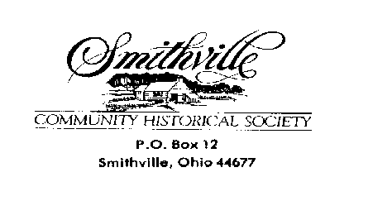

2019 Board & Officers Building Managers 2019
President -Ralph Smucker Blacksmith Shop -Eric Mast & Keith Chambers
Vice President -Mark Irvin Caboose -Bob & Linda Platt
Secretary -Harlene Steiner Children’s Museum -Bob & Linda Platt
Treasurer -Tim Homan Church of God -Dana Keirstead
Maintenance Supervisor- Dan Kaufman Depot -Doug Spence
Acquisitions -Bob& Linda Platt Woodworking -Shane Hartzler/Bob Sample
Finance & Fundraising -Jeff Carr Downey Pioneer
Membership - Pat Keirstead Visitor Center -Nita Downey
Artisans & Tours -Kathy Meitzler Irvin Pioneer Log - Mark & Olena Irvin
Publicity& Technology -Margo Stafford Cabin -Rosemarie Vrabel
Lydo Barn -Rex Miller
Committees Mishler Weaving Mill -Kathy Meitzler
Registrar/Newsletter -Margo Stafford Sheller Log House -Lila Smucker
Tour Coordinator -Kathy Meitzler Spring House -Carole Martin
-Nita Downey Summer Kitchen -Dorine Widder
Facebook & Web site -Margo Stafford Tin Shop -Fred Wetshstein/Patty McFadden
Christmas in the Village -Nita Downey Village Pottery -David Sollenberger/Sam Sheller Stars Vintage Base Ball -Jeff Carr Wheelwright -Walter Mullett
Heritage Center -Harlene Steiner
Model-T Museum -Frank Krajcovic
Board of Officer Meetings
All meetings are held at the Heritage Center at 7 P.M. on the third Monday of each month.
January 18 February 18 March 18 April 15 May 20
June 17 July 15 August 19 September 16 October 21
November 18 December 16
Members are invited to come but must notify President prior to the meeting if you wish to speak.

