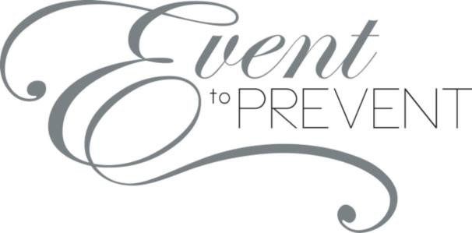

Dear Catawba County Business,

The Council on Adolescents is a 501(c)(3) organization that has been in existence since 1986 and offers a menu of services to youth in Catawba County. Our goal is to encourage healthy behaviors among all youth in our county and provide at-risk youth with positive, adult mentors on a regular basis. Our agency relies on the support of grants, fundraisers, local businesses and community leaders to fund our mentoring initiative, the **Lunch Buddy Program** and **Healthy Youth Education Programs**. We are seeking financial assistance from small businesses, large corporations and community members to help support operating and program expenses for 2023.

The Council on Adolescents invites you to participate in our ***10th Annual* “Event to Prevent”** evening fundraiser that will be held November 4th, 2022 at Catawba Country Club. We are requesting your support of the Council by taking part in our sponsorship opportunities for this event. **Since our inception, teen pregnancy rates have dropped more than 70% in Catawba County!** Catawba County youth need our programs and we need your assistance so that we can continue providing them with our services. We are the only agency dedicated to providing state approved puberty and reproductive health education programs in Catawba County and offer one of the few mentoring programs in our county.

Please see the attached packet for further details regarding our programs and donation options. All sponsors and supporters will be highlighted throughout the evening as well as in marketing for the event. Your contribution is tax-deductible and we will send you a letter acknowledging receipt of your gift as soon as we receive your donation. We hope you will help us make 2023 a great success at the Council on Adolescents. We appreciate you supporting our efforts to promote healthy lifestyle choices to youth across Catawba County!

**Thank you for supporting the youth of Catawba County!**

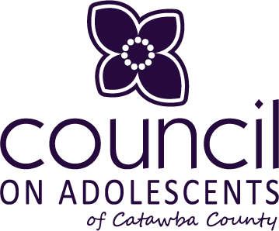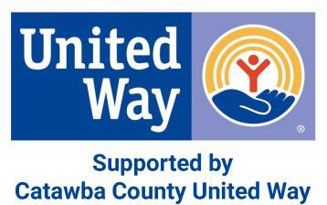

1120 Fairgrove Church Road SE, Suite 22 Hickory, NC 28602 ■ 828.322.4591 ■

[www.coacatawba.org](http://www.coacatawba.org/)





To inspire today’s Youth to Be Physically and Emotionally Healthy

OUR MISSION

through Education, Awareness and Advocacy.

OUR GOALS

Provide puberty and reproductive health and safety education to youth and their parents.

Provide mentoring program to at-risk youth in our community.

Promote community awareness of issues affecting adolescents’ well

being.

# HEALTHY YOUTH

## EDUCATION PROGRAMS

Educated 5,435 youth across Catawba County during 2021-2022 school year.

46% increase in knowledge among students

7.3% decrease in teen pregnancies since 2019!

Our Healthy Youth Education Program focuses on providing integrated, sequential, age-appropriate, medically accurate, and interactive puberty and reproductive health and safety education to adolescents ages 10-18. We contract with local school systems in Catawba County to provide unfunded, state-mandated programs at significantly reduced costs. Our agency

follows North Carolina’s Healthful Living Guidelines and Healthy Youth Act requirements, and allows students to have an impartial party provide them with accurate information. The ultimate goal of these programs is to decrease teen pregnancy rates across our community.

# LUNCH BUDDY

## MENTORING PROGRAM

Served all nine middle schools across Catawba County, including one alternative school & five elementary schools

62 mentors served 62 students virtual/in-person during the 2020-2021 school year

This mentoring program is designed to help reach students who are identified by school personnel as being at-risk and meet the criteria of potentially dropping out of school. The goal of this program is to create healthy attitudes and behavior in youth, as well as provide skills, resources, and positive experiences that will help them become successful, productive citizens. Mentors spend one lunch period each week during an entire school year with their mentee to accomplish this goal. Students in all nine middle schools across Catawba County as well as five elementary schools are served thru this program.



Silent Auction Commitment Form

Company |Organization: Contact Name: _

Email Address: Phone:

Billing Address: _

City:

State:

Zip:

Website:

Donation Information

Item(s) Donated: _ Value of Item(s): _$

Item Description:

_ Please list any conditions associated with your donation (expiration or blackout dates, restrictions, etc.) *We respectfully ask for the expiration date to be **one year** from the date of the event, November 4, 2022*

_

_

**Please include a copy of this form when submitting your silent auction item!** Mail or Email this form to: Council on Adolescents of Catawba County ■ Attn: Jordan Ledford 1120 Fairgrove Church Road SE, Suite 22 ■ Hickory, NC 28602 ■ [JLedford@coacatawba.org](mailto:JLedford@coacatawba.org)

Council on Adolescents is a non-profit 501(c)(3) organization. Contributions are tax-deductible to the extent allowed by law.

1120 Fairgrove Church Road SE, Suite 22 Hickory, NC 28602 ■ 828.322.4591 ■

[www.coacatawba.org](http://www.coacatawba.org/)