1120 Fairgrove Church Road SE, Suite 22 ■ Hickory, NC 28602 ■ 828.322.4591 www.coacatawba.org

Support Adolescent Programs
in Catawba County!

Dear Catawba County Business,
Do you want to continue making a difference in the lives of youth in Catawba County? We are grateful for your past support of the Council on Adolescents and we are seeking a Corporate Sponsorship for general operating and program expenses for 2023.
The Council on Adolescents is a 501(c)(3) organization that has been in existence since 1986 and offers a menu of services to youth in Catawba County. Our goal is to encourage healthy behaviors among all youth in our county and provide at-risk youth with positive, adult mentors on a regular basis. Our agency relies on the support of grants, fundraisers, local businesses and community leaders to fund our mentoring initiative, the Lunch Buddy Program, Healthy Youth Education Programs, and the Preventing Distracted Driving Initiative.
The Council on Adolescents offers various sponsorship options for your business to be involved at the level most appropriate for you. In addition to fundraising, we will help you market your business to students and their parents, as well as teachers and community members through our programs. Youth in Catawba County need our programs and we need your assistance to continue providing them with our services. We are the only agency dedicated to providing state approved puberty and reproductive health education programs in Catawba County and offer one of the few mentoring programs in our county.
Please see the attached packet for further details regarding our programs and sponsorship levels. Your contribution is tax-deductible and we will send you a letter acknowledging receipt of your gift as soon as we receive your donation. We appreciate you supporting our efforts to promote healthy lifestyle choices to youth across Catawba County!
Sincerely,
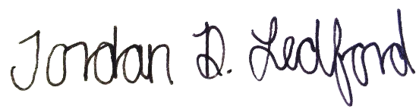
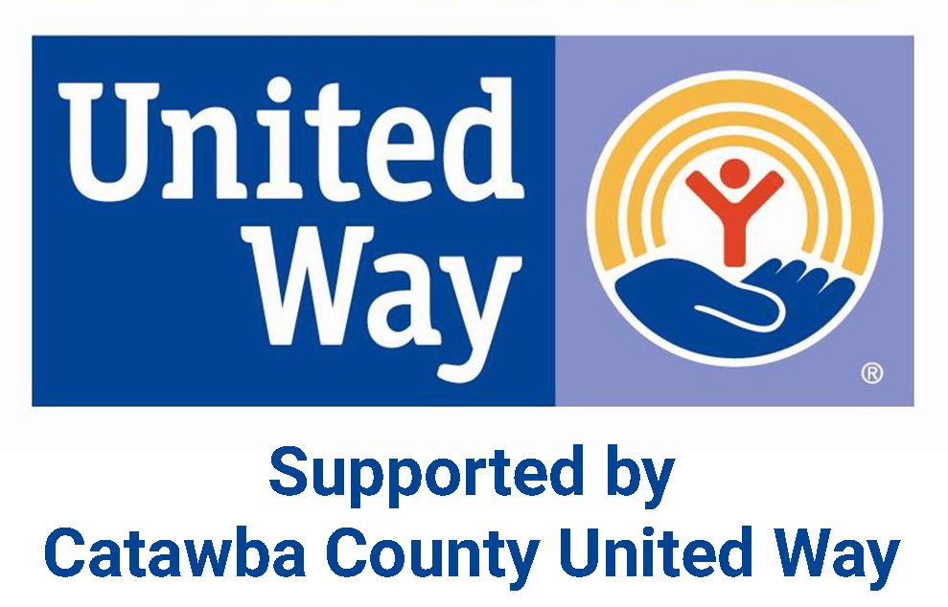
Jordan Ledford

Executive Director

OUR MISSION

To inspire today’s Youth to Be Physically and Emotionally Healthy through Education, Awareness and Advocacy.

OUR GOALS

Provide puberty and reproductive health and safety education to youth and their parents.
Provide mentoring program to at-risk youth in our community.
Promote community awareness of issues affecting adolescents’ well being.
Facilitate the coordination of services related to the needs of adolescents.

LUNCH BUDDY
MENTORING PROGRAM
Served all nine middle schools across Catawba County, including one alternative school & three elementary schools
54 mentors served 54 students during the 2020-2021 school year
While many students met in-person others met virtually
This mentoring program is designed to help reach students who are identified by school personnel as being at-risk and meet the criteria of potentially dropping out of school. The goal of this program is to create healthy attitudes and behavior in youth, as well as provide skills, resources, and positive experiences that will help them become successful, productive citizens. Mentors spend one lunch period each week during an entire school year with their mentee to accomplish this goal.

HEALTHY YOUTH
EDUCATION PROGRAMS

Educated 5,027 youth across Catawba County during the 2020-2021 school year
43.4% increase in knowledge among students
70% decrease in teen pregnancies since 2009! In 2020 there were ONLY 93 teen pregnancies in Catawba County!
Our Healthy Youth Education Program focuses on providing integrated, sequential,
age-appropriate, medically accurate, and interactive puberty and reproductive health and safety education to adolescents ages 10-18. We contract with local school systems in Catawba County to provide unfunded, state-mandated programs at significantly reduced costs. Our agency follows North Carolina’s Healthful Living Guidelines and Healthy Youth Act requirements, and allows students to have an impartial party provide them with accurate information. The ultimate goal of these programs is to decrease teen pregnancy rates across our community.

Sponsorship Levels

ELITE SPONSOR - $5,000+
- Acknowledgement in all publications/marketing throughout the year
- Distinct placement of company logo on COA’s website and social media pages
- Detailed description of company and logo, with a link to company’s website under dedicated “Corporate Sponsors” page on COA website and social media pages
- Logo prominently displayed and recognized in all monthly e-newsletters
- Recognition as Elite sponsor of the annual benefit breakfast, “Wake-Up Call” and “Event to Prevent” Dinner fundraiser
- Six tickets to the “Wake-Up Call” Breakfast and Event to Prevent Dinner fundraiser

PLATINUM SPONSOR - $3,000+
- Company logo and link to webpage will be included under “Corporate Sponsors” page on COA website
- Logo prominently displayed in all monthly e-newsletters and social media pages
- Recognition as Platinum sponsor of the annual benefit breakfast, “Wake-Up Call” and “Event to Prevent” dinner fundraiser
- Four Tickets to the “Wake-Up Call” Breakfast and “Event to Prevent” Dinner fundraiser

GOLD SPONSOR - $1,500+
- Company logo and link to webpage will be included under “Corporate Sponsors” page on COA website.
- Recognition as Gold sponsor of the annual benefit breakfast, “Wake-Up Call” and “Event to Prevent” dinner fundraiser
- Two Tickets to the “Wake-Up Call” Breakfast and “Event to Prevent” Dinner fundraiser

Sponsorship Commitment Form

Company |Organization: _____________________________________________________________________
Contact Name: ________________________________________________________________________________
Email Address: ________________________________________________________________________________

Billing Address: _______________________________________________________________________________

City: ________________________________ State: _______ Zip: __________________________

Business Phone: ______________________________ Fax: ________________________________________

Website: _______________________________________________________________________________________

Sponsorship
Please indicate level of sponsorship:
_____ Elite ($5,000+)
_____ Platinum ($3,000+)
_____ Gold ($1,500+)
_____ Other: Amt.___________________

Please submit company logo [and 2 to 3 sentences describing company] electronically to JLedford@coacatawba.org or call 828.322.4591 for instructions.

Payment Information
Please check one
_____ Check (please make payable to Council on Adolescents of Catawba County, Inc.)
_____ Cash
_____ Please send invoice to receive payment
$ Amount enclosed

Please include a copy of this form with payment and send to:
Council on Adolescents of Catawba County, Inc.
1120 Fairgrove Church Road SE, Suite 22, Hickory, NC 28602

Council on Adolescents is a non-profit 501(c)(3) organization.
Contributions are tax-deductible to the extent allowed by law.

