Spring
Newsletter
Volume 2019 | Spring | Pine Creek Preservation Association
Announcement  Message from the President.  What is happening in the Pine Creek Valley! Updates from Trout Unlimited, and other meetings concerning the Pine Creek Valley management.  If you have any pictures of the Pine Creek Valley that you would like to share with us, please email them to Lou Anne Gasperine, Secretary at lgasperine@verizon.net. |  | Inside This Issue  PG. 2 Update on the membership!  PG. 3 Fact sheet on the PCPA  Meeting dates and speakers  PG. 4 President’s Messsage  PG. 5 Membership application

Membership Updates  SPECIAL MEMBERSHIP CATAGORIES  If you would like to remember PCPA through one of our special membership categories please refer to the Membership Application on the next page of the newsletter.  2018 New Life Members  We are pleased to introduce the new Life Members:  Charles and Jane Darrow Ray and Linda Fox  John and Lou Anne Gasperine Stratton Family Cabin  Dallas L. Krapf  Their names will be proudly added to our Life Membership Plaque.  2018 Memorial Memberships  This special category is for individuals who would like to honor the name and memory of a loved one.  We received memorial memberships in loving memory of:  John M. Gaidos Alan Rothenberger  Mary Gummo Bernell Kreider  Dennis “Denny” McFall Terry Myers  Raymond Thompson James R. Schoonover  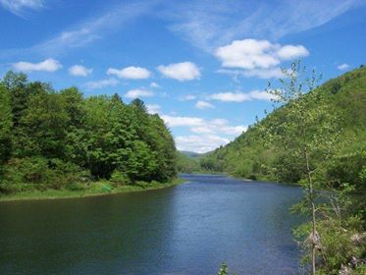  Photo by Lisa Linn |  | 2018 Friends of Pine Creek  It is especially important to recognize that the revenue from our Friends of Pine Creek Memberships is vital to our mission, as it goes directly to our “Legal Defense Fund”, which is used to support actions such as the PEDF lawsuit, and not our day-to-day operations. We want to recognize the generosity of the following individuals who went beyond their regular membership level in 2018.  Artz, Eric & Katie McConnell, William & Judy F.  Asper, Kathy & Ray/Susan Sipe Miller, Robin C.  Bierly, Barbara & Ronald Nolen, Chris & Cathy  Bower, Cindy & Jim Ombalski, Katie  Brennan, Daniel and Chris Pearson, Donna  Burns, J. Robert & Janet M Platusich, Bruce & Catherine  Burns, Norma Jean Porter, Beverly, Abbey & Chris  Deeuer, John & Bonita Potter, James & Marjorie  Eck, Steve and Deb Rankin, Jim & Kathy  Ely, Sarah & James Converse Rothenberger, D. Alan & Lois  Fennelly, Jane and Dave Ruth, Rick & Suzanne  Gable, Jeffrey & Diane Small, Bob & Gay  Garverick, Carl & Nancy Torbert Development Assoc.  Hagan, Mark & Denise Udowenko, Alex & Michelle  Handwerk, Keith & Marilee Urner, David & Barbara  Harakel, Debra & Al Waterville Tavern  Hawkins, Phil & Mary Jane Whittenmore, Michael & Kim  Hershberger Jr., Raloh & Denise Wolgemuth, Wayd W.  Kiessling, John & Jill Yothers, Jerry and Ronnie  Kohler, Maynard R. McClure, Kathryn & Jonathan  Yoxheimer, Dave & Carrie Kauffman  Young, Donald & Marybeth
PCPA Fact Sheet
2019 Meetings / Speakers
April 15 – Outdoor Club – James Smith, Eric Hess, William Ferguson (7 pm)
May 18 – Invasive Plants Event – Ben Gamble - DCNR (Saturday 1 pm)
June 17 - Mange in Bears – Harold Cole - PGC (7 pm)
July 15 – Friends of Lycoming County Cemetaries – Chrissy Preston (7 pm)
August 3 – Picnic
September 16 – Bear Habitat - Mark Ternant PGC (7 pm)
October 21 – Pictorial Presentation of the Relocation of Bob Webber Cabin (7 pm)
All meetings are held at the DCNR facility in Waterville.

Service Area: The Pine Creek Watershed including the counties of Potter, Tioga, and Lycoming in northcentral Pennsylvania.
Membership Information: An annual membership application is available on the next page. Memberships run from April to April.
Typical PCPA Projects promote and support:
- Anti-Littering Campaigns
- Recycling Activities
- Litter and Dump-Site Cleanup projects
Acid Mine Drainage Remediation projects
- Oversight-Regulation of Natural Gas Industry Activities
- Implementation of the “Pine Creek Valley Management
Plan”
- Implementation of the “Pine Creek Watershed Rivers Conservation Plan”
- Implementation of Pine Creek COG’s “PA Wilds Initiative”
Typical PCPA Officer/Board Activities include attending:
- State Agency meetings pertaining to subjects of interest or concern to Pine Creek Valley
- County Government Department meetings pertaining to subjects of interest or concern to Pine Creek Valley
- Regional or local DCNR meetings regarding issues of interest or concern to PCPA’s mission
- meetings of the “Pine Creek Council of Governments”
- meetings of the “Pine Creek Watershed Council”
- meetings of the “Pine Creek Rail Trail Advisory Committee”
Memberships/Affiliations:
- Founding Member of the “Pine Creek Council of Governments”
- Founding Member of the “Pine Creek Watershed Council”
- Member-at-Large of the “Pine Creek Rail Trail Advisory Committee”
- Member of the “Pennsylvania Environmental Defense Foundation”
- Member of the “North Central Pennsylvania Conservancy”
- Member of “Clinton County CleanScapes”
Photo by Lisa Linn
Annual & Periodic Financial Support Provided to:
Contact Information:
PO Box 11, Waterville, PA 17776
Website: www.pinecreekvalley.com/PCCOG/PCPAInfo.as
Email: pinecreekpcpa@gmail.com
- Black Forest Volunteer Fire Co.
- Brown Twp. Volunteer Fire Co.
- Haneyville Volunteer Fire Co.
- Waterville Volunteer Fire Co.
- Pennsylvania Environmental Defense Foundation
- Clinton County CleanScapes
Presidents Message
President’s message Spring 2019
This time of year we start looking forward to spring and new beginnings, and PCPA is no exception to this tradition. As most of you know, PCPA began 2018 with an almost new set of officers. Many thanks to Paul Hoffmaster, vice president, for his continued guidance.

We accomplished some important tasks last year, including replacing our beloved ‘Burma Shave’ signs at the southern terminus of the Pine Creek Valley. We assisted with the relocation of the Bob Webber cabin from his homestead on the mountain to the Pennsylvania Lumber Museum on Route 6 near Ulysses PA by providing monetary donations for supplies, and funding for ongoing education at the newly located cabin. Special thanks to Jack Deurer for his tireless effort to dismantle the cabin and replace it log by log at its new home.

We made our first appearance at the Apple Butter Festival in October; that showing garnered almost 50 new memberships! We continue to work on setting up a dedicated room at the DCNR Resource facility to display our lifetime membership plaques, memorials and a listening booth for discs on the history of PCV.

Presentations at our regular monthly meetings will include:
April 15 - The Outdoor Club of JSHS
May 18 – Invasive Plant Species (see below)
June 17 - Bear Mange in the Pine Creek Valley
July 15 - Lycoming Historical Cemeteries in Pine Creek Valley
August 3 – Picnic (Little Pine State Park)
September 16 – Bear Habitat
October 21 - pictorial presentation on the relocation of the Bob Webber cabin project

We are particularly excited to host a special event on Saturday, May 18, 2019 (a Saturday meeting!) at the Waterville DCNR Resource facility. Our Invasive Plant Event will start at 1:00. Ben Gamble (DCNR) will show how to identify and when to treat invasive plants in the Pine Creek Valley. Come early, this informal, educational event will include free hot dogs at 12:30 and is open to all. Working together we can manage invasive plants.

I look forward to another productive year with PCPA to continue our mission of stewardship of our incredible Pine Creek Valley.
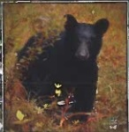
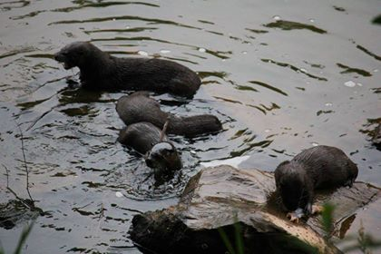

MEMBERSHIP APPLICATION FORM
MEMBER INFO: MEMBERSHIP TYPE (check one):
Name _________________________________________ [ ] Individual Membership - $5
Street _________________________________________ [ ] Family Membership - $10
State ____________________________ZIP____________ [ ] Camp/Organ. Membership - $20
Email __________________________________________ [ ] Friends of Pine Creek - $100
[ ] Memorial Membership - $250
Camp/Cottage: In Memory or Honor of (below):
Camp Name _______________________________________ ____________________________________________
Address or________________________________________ Donated by (below)
Location__________________________________________ ____________________________________________
Camp/Organization – please indicate number of members Acknowledgement To (below):
over 18 years of age (voters) --- ( ) _____________________________________________

Make checks payable to PCPA [ ] Life Membership - $500
Mail to: PCPA Secretary
P.O. Box 11, Waterville, PA 17776 [ ] Other Donation - $____________

PCPA is going green!
If you would like to receive your newsletters via email, please provide your email above.

Note: Unless the Friends of PC box is checked, we assume that any additional donation of $100 or more is meant to be anonymous.
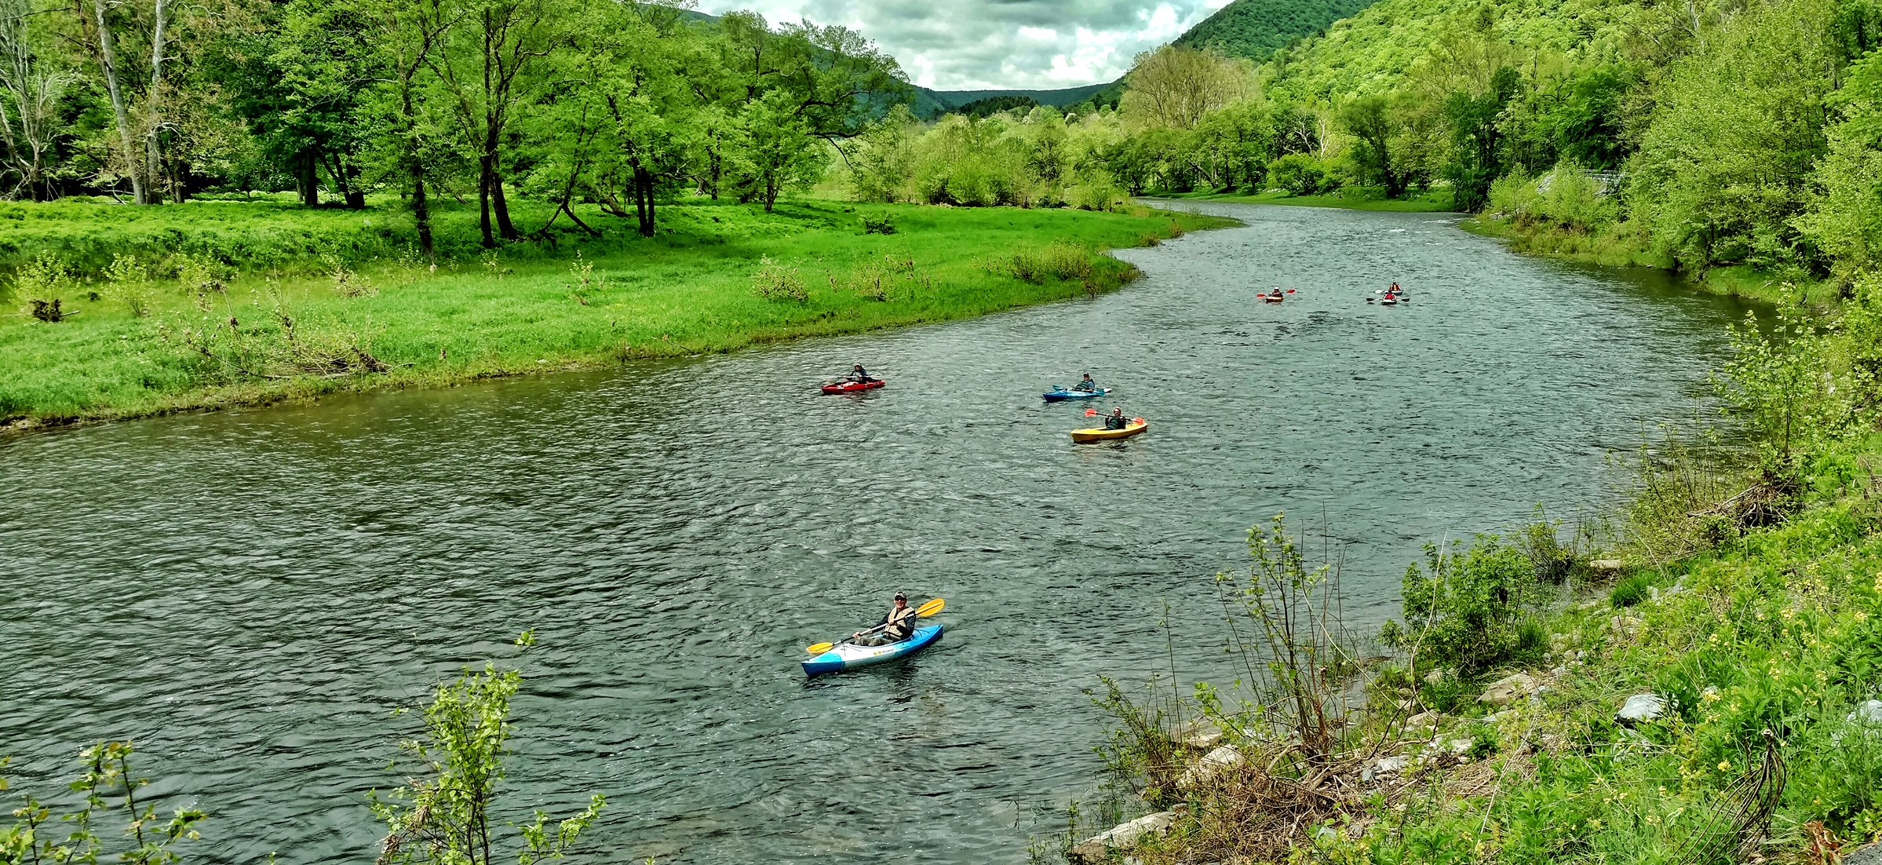

News and Views
Waterville Apple Butter Festival
Last year was the first year the PCPA had a informational booth at the Waterville Fire Company’s Apple Butter Festival. Many individuals stopped by and we shared a fact sheet about activities of the PCPA. It was nice to meet many longtime PCPA members that live out of the area.
We appreciated hearing your concerns and ideas. We have taken your ideas to heart and are planning a Saturday meeting in May to discuss Invasive Plants Species, How to Identify and When to Target for Removal.
We hope to return to the Apple Butter Festival to hear more of your ideas and concerns.

“Email & Website News”
Email and Website News
If you would like to be included on our Email News for Members, simply include your email address (or change of email address) on your Membership Application or send us an Email at pinecreekpcpa@gmail.com. If you want to learn more about our organization and activities, visit our website at pinecreekpcpa.org. If you would like to receive your newsletter by email please send an email to lgasperine@verizon.net to request your correspondence by email.

2019 Large Trash Collection
Members who own property in McHenry and Brown Townships have the opportunity to dispose of large non-refrigerant appliances and other large trash items at the respective townships “Large Trash Collection Day”. Both townships collection date is Saturday, May 11^{th .} Both are open from 8:00am to 1:00pm -- watch for local notices.

