l
Pine Creek Preservation Association

Property owners and concerned citizens dedicated to preserving the natural and rural character of Pine Creek Valley.

P.O. Box 11 Waterville, PA 17776

Pine Creek Valley 2019 Summer Newsletter
Property Owners and concerned citizens dedicated to preserving the natural and rural character of Pine Creek Valley
Officers
President: Mary Vuccola

Vice-President: Paul Hoffmaster

Secretary: Lou Anne Gasperine

Assistant Secretary: Charlene Sawyer

Treasurer: Donna Pearson

2019 Meeting Dates

June 17… Regular Meeting @ 7 pm

July 15… Regular Meeting @ 7 pm Barn on Pine Creek, 4729 Rte 44N near ball fields

August 3… Picnic @ 12 noon – Little Pine State Park

Sept. 16 … Regular Meeting @ 7 pm

Oct. 21 … Election of Officers @ 7 pm

Dec. 17 … Optional Meeting @ 7 pm

Meeting Location
Scheduled meetings are usually held at the DCNR Facility just north of Waterville. Specific meetings are noted above.

All members, residents, property owners and interested parties are welcome.

The Pine Creek Preservation Association is a non-profit 501 (c)(3) organization. Contributions are deductible to the fullest extent allowed by law. The official registration and financial information for the PCPA may be obtained from the PA Dept. of State by calling 1-800-732-0999.
Registration does not imply endorsement.
President’s Message

Summer has finally come to the Pine Creek Valley and with it the ability to enjoy outdoor activities that the mountains and streams offer. This summer also brings a fresh slate of activities for the PCPA. Officers have met over the winter months to create a slate of guest speakers for all the meetings and scheduled a Saturday meeting with refreshments.

The May meeting was held at the DCNR building in Waterville on a Saturday afternoon. The program included Ben Gamble from Forestry (an invasive species specialist) to educate members on identification and control measures. Potted samples were available for identification purposes as well as free paper handouts from DCNR for future reference.

The July 15 meeting will be held at the Barn on Pine Creek, 4729 North Rte 44 venue near the ballfields. Our scheduled speaker is Officer Cole of the Pennsylvania Game Commission on the topic of Mange in Bears in the area. We hope to see you at the meeting to see this new venue.

Finally, it must be mentioned that our President Mary Vuccola was unavailable to write the message for the summer newsletter. However, Mary’s take on our valley needs to be communicated one more time.

“The surge of seasonal tourists visiting our valley for biking, hiking, and kayaking has brought revenue to our local business, but also brings increased littering along the roadside, and pollution to our creek and mountains. As residents of Pine Creek, we welcome these visitors to our neighborhood. After all, they are seeking the same tranquility that we already have, if even for only a short time. It is my hope that we can bring about an awareness of the need to be stewards of our trails and streams, to ensure that the same peaceful beauty is preserved for future generations.”

The annual picnic in August 3rd. It’s hard to beat the gathering of friends old and new, reminiscing, catching up, and sharing ideas at Little Pine State Park. We are hoping for a great turnout and of course, good weather!
Lou Anne Gasperine
Invasive Species in the Pine Creek Valley.

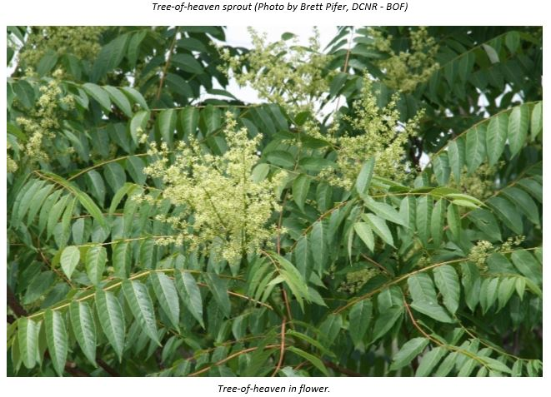
On Saturday, May 18, the PCPA held their May meeting at the DCNR building in Waterville. Before the meeting attendees were treated to grilled hot dogs and the fixins’ and refreshing cold water bottles. There were potted plants and cuttings of various invasives as well as others that are often misidentified. Ben Gamble was the presenter on the topic of Invasive Plants in the Pine Creek Valley. He had several handouts for reference for attendees to take with them. As part of the presentation, Ben offered identification points and how to control the pesky plants. Admittedly, persistence in removing the plants and in some cases the application of pesticides seems to be the remedy.

Cuttings from the Tree of Heaven, Staghorn Sumac, and Black Walnut were available to demonstrate how to distinguish the invasive from the natives. This tree has both a female and a male plant. Getting ride of the tree involves finding the female plant as well as getting the whole tree out, roots and all!

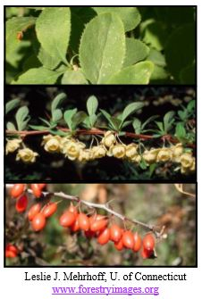
Japanese Barberry is now considered an invasive plant but was once promoted by the forestry and game commission as a food source for birds and other animals. This shrub can have bright red berries in the fall that animals will use. If left unattended and pruned back, can quickly take over an area under trees preventing regrowth of favorable plants. The shrub also has long, sharp thorns all over the plant making it difficult to manage and handle even with gloves.

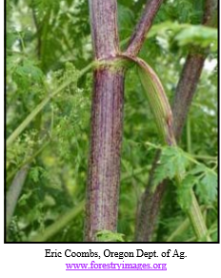
Japanese Knotweed is a pervasive invasive. It can reproduce with just a small piece of root and grows rapidly. It can be found about anywhere, along the roads, stream banks or open areas in the forest floor. Japanese Knotweed is extremely difficult to eradicate but through persistence (weeding it out by the roots), mowing it down and applying pesticides in the fall, the plant may be controlled. Unfortunately, if any neighbors have this nuisance plant nearby, it will not take long for the knotweed to come back to your back yard!

Poison Hemlock is a newcomer to the area but deserves to be treated carefully. It is a biennial herb that is mistaken with the giant hogweed or the native water hemlock. It is a plant that will colonize a newly disturbed area (a pioneer species) and can be found along roadsides, field margins and irrigation ditches. However, all parts of the plant are extremely poisonous, especially the seeds, to humans and livestock and should be handled carefully and disposed of appropriately.
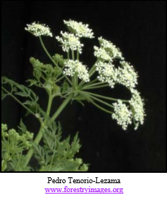
If you missed this presentation, you missed a very informative and interesting guest speaker.

Additional information on these plants and many others may be found on the DCNR website by doing a search for PA DCNR Invasive Plants or

https://www.dcnr.pa.gov/Conservation/WildPlants/InvasivePlants/Pages/default.aspx .

Summer Picnic
Saturday, August 3, 2019 @ 12:00 noon
Little Pine State Park – Pavilion No. 3

Be sure to mark your calendars for our summer picnic, which is planned for Little Pine State Park (weather alternative the Waterville Fire Hall) on Saturday, August 3, 2019 beginning promptly at noon. This is an “active members only” event, so if you have not yet re-joined PCPA this year, you need to complete the attached Membership Application Form along with your Picnic Reservation.

The food for our picnic is prepared by a professional caterer, so we need to have an accurate count of reservations in advance. Please note that “walk-ins” without prepaid reservations will be charged $10.00 per individual. The menu will again include fried chicken, macaroni salad, baked beans, ham, turkey, cheese, Caesar salad, pulled pork bbq sandwiches, and cake, lemonade and iced tea.

Lunch will be followed by a brief update by your officers and special guest speakers on what we believe are the challenges facing the Pine Creek Valley area and our recent organizational activities to deal with those challenges. As always, the brief meeting will be followed by the drawing for the many door prizes donated by our local businesses and your fellow members for your fun and entertainment.
Please complete and return your paid reservation by July 20, 2019.

Please clip and return
PICNIC RESERVATION FORM
MEMBER:

NAME ___________________________________________________________________________________

ADDRESS________________________________________________________________________________

_________________________________________________________________________________________

No. of Adults ___________ @ $7.50 No. of Children (7 – 12) _________@$5.00

No. of Children (under 7) ____________@ free

Checks payable to P.C.P.A. Mail to: P.C.P.A., P.O. Box 11, Waterville, PA 17776

MEMBERSHIP APPLICATION (SHORT) FORM

$5 Individual $10 Family $20 Camp/Organization $100 Friends of Pine Creek $250 Memorial $500 Life

NAME ____________________________________________________________________________
ADDRESS_________________________________________________________________________
_____________________________________________________EMAIL______________________

Send my newsletters through email _______ Yes ________ No

Pine Creek Preservation Association
P.O.Box 11
Waterville, PA 17776



Email News List

If you would like to be included on our Email News for Members, or receive your newsletter by email, simply include your email address (or change of email address) on your Membership Application or send us an email at pinecreekpcpa@gmail.com.

PCPA Website
More information concerning PCPA and our activities may be found on our website at Pinecreekpcpa.org (https://pinecreekpcpa.org/). You may also want to view pinecreekvalley.com the host for our website, as well as other links in the valley.

Apple Butter Festival
We are planning on being at the Apple Butter Festival again this year. Stop by the booth and say hello!

