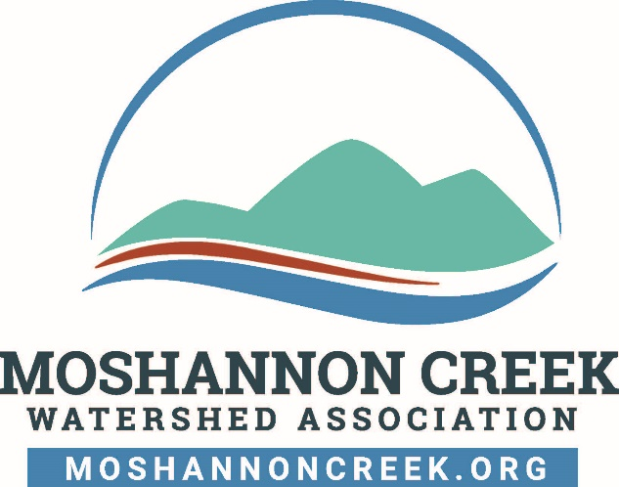

Moshannon Creek Watershed Association Gift Acceptance Policy Adopted 8/13/2024
- The Moshannon Creek Watershed Association (MCWA) solicits and accepts gifts that are consistent with its mission and that support its core programs, as well as special projects.
- Donations, grants, and other forms of support will generally be accepted from individuals, partnerships, corporations, foundations, government agencies, or other entities, subject to the following limitations:
- Donations that could lead to MCWA suffering reputational harm will not be accepted without board approval.
- Donations with restrictions that would make the donation difficult to use in furthering MCWA’s core mission will not be accepted without board approval.
- Donations that would require MCWA to assume a financial obligation (such as, but not limited to, a mortgage, taxes, rent, maintenance, or utility costs) will not be accepted without board approval.
Gifts of Real Property, Personal Property or Securities may only be accepted upon approval of the Board of Directors of the Moshannon Creek Watershed Association.

