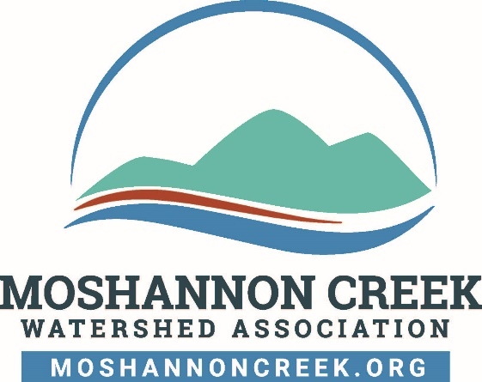
The Moshannon Creek Watershed Association (MCWA) requires directors, officers, volunteers and employees to observe high standards of business and personal ethics in the conduct of their duties and responsibilities. As representatives of the Moshannon Creek Watershed Association, we must practice honesty and integrity in fulfilling our responsibilities and comply with all applicable laws and regulations.

Reporting Responsibility
This Whistleblower Policy is intended to encourage and enable employees, volunteers and others to raise serious concerns internally so that MCWA can address and correct inappropriate conduct and actions. It is the responsibility of all board members, officers, employees and volunteers to report concerns about violations of MCWA’s policies, constitution and bylaws, and/or suspected violations of law or regulations that govern MCWA’s operations.

No Retaliation
It is contrary to the values of the Moshannon Creek Watershed Association for anyone to retaliate against any board member, officer, employee or volunteer who in good faith reports an ethics violation, or a suspected violation of law, such as a complaint of discrimination, or suspected fraud, or suspected violation of any regulation governing the operations of the Moshannon Creek Watershed Association. An officer, director, employee or volunteer who retaliates against someone who has reported a violation in good faith is subject to discipline up to and including termination of employment, removal from leadership, and/or removal from membership with the Moshannon Creek Watershed Association.

Reporting Procedure
MCWA has an open-door policy and suggests that volunteers, members and employees share their questions, concerns, suggestions or complaints with MCWA’s President. If you are not comfortable speaking with MCWA’s President, or you are not satisfied with their response, you are encouraged to speak with MCWA’s Vice President. The MCWA officer who receives the complaint is required to report notice of receipt of the complaints or concerns about suspected ethical and legal violations in writing to MCWA’s board members via email within 72 hours of receipt of the complaint. MCWA’s President is the Compliance Officer responsible for ensuring that all complaints about unethical or illegal conduct are investigated and resolved. If the allegation involves the President, the Vice President will be the Compliance Officer responsible for ensuring that the complaint about unethical or illegal conduct is investigated and resolved.

Acting in Good Faith
Anyone filing a written complaint concerning a violation or suspected violation must be acting in good faith and have reasonable grounds for believing the information disclosed indicates a violation. Any allegations that prove not to be substantiated and which prove to have been made maliciously or knowingly to be false will be viewed as a serious disciplinary offense.

Confidentiality
Violations or suspected violations may be submitted on a confidential basis by the complainant. Reports of violations or suspected violations will be kept confidential to the extent possible, consistent with the need to conduct an adequate investigation.

Handling of Reported Violations
The Moshannon Creek Watershed Association’s President, or Vice President when the President is unavailable or mentioned in the complaint, will notify the person who submitted a complaint and acknowledge receipt of the reported violation or suspected violation. All reports will be promptly investigated, and appropriate corrective action will be taken if warranted by the investigation. Corrective actions will be taken by the Board by following the procedures outlined in the Constitution and Bylaws of the Moshannon Creek Watershed Association. For the purposes of complaint resolution, any officer or director subject to the corrective action for the complaint will not have voting privileges for the complaint resolution or count as a vote necessary for a quorum for that complaint resolution.

President – Moshannon Creek Watershed Association
president@moshannoncreek.onmicrosoft.com

Vice President – Moshannon Creek Watershed Association
vicepresident@moshannoncreek.onmicrosoft.com

Policy first approved by the Board of Directors on September 10, 2024.
Policy revised on April 8,2025 to add constant email addresses for president and vice president.

