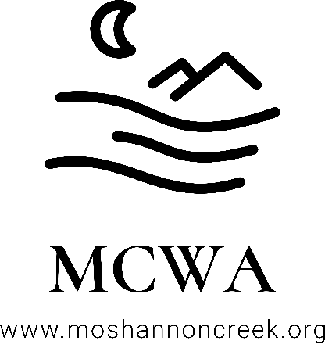
Moshannon Creek Watershed Association
P.O. Box 701
Philipsburg, PA 16866
Membership in the Moshannon Creek Watershed Association
The Moshannon Creek Watershed Association is a non-profit corporation chartered in Pennsylvania. Moshannon Creek is a beautiful stream with often terrible water quality. Much of the main stream and some of the tributaries of Moshannon Creek are contaminated by mine drainage from abandoned coal and clay mines. Moshannon Creek's headwaters, and many of the tributary streams in the Moshannon Creek watershed, have clean water and wild trout populations. Our mission can be described very simply as protecting the clean water streams and improving the streams with tainted water.
Dues for membership in the Moshannon Creek Watershed Association are renewed annually. Dues amounts were established for 2020 by the board of directors and continue at the same amounts in 2021. To join MCWA, please complete the form below, select the desired form of membership, and return this completed form with the dues amount to our mailing address above.

Name _____________________________________________________________________
Business/Organization ________________________________________________________
Address ____________________________________________________________________
City ________________________________ State __________ Zip _____________________
Phone _______________________________ Fax ___________________________________
Email ______________________________________________________________________
Please circle the desired membership type
Individual - $18
Family - $25
Organization/Business - $50

