**Passover Commentary for Video Part 1**

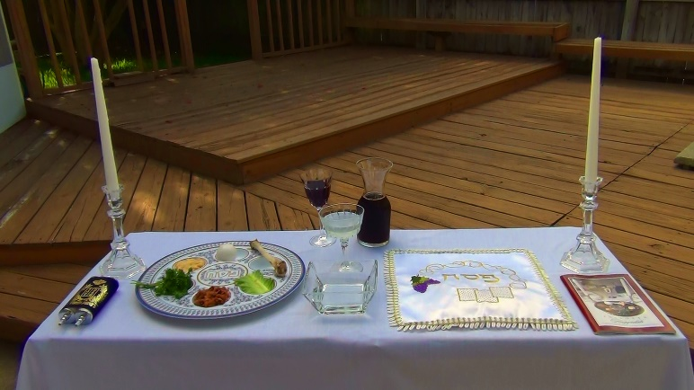

**Passover Table :34**

This table has the main foods and objects used in the Passover Seder Service or Dinner which are used to tell the historical account of the Passover in Egypt. The Passover is celebrated in Jewish family’s homes. The Passover Seder can be 4 to 5 hours long. I will not go through a whole service; but will show you many of the ways in which it pictures Jesus Christ.

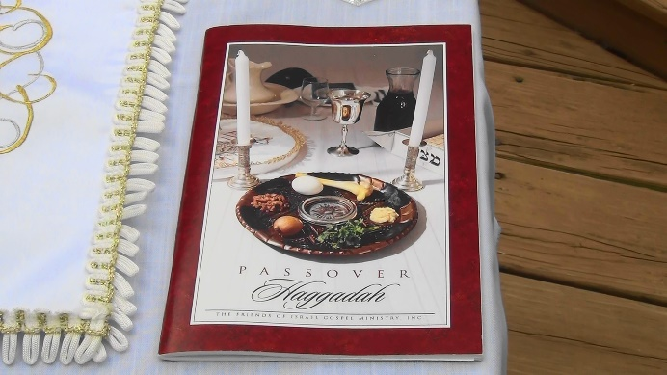

**Haggadah :27**

This book is called the Haggadah, It tells the historical account of the Passover, along with the meal. It is very interactive and uses a lot of different foods to explain the Passover. There are questions for children, reading of the Torah, And also singing of Psalms. Mainly Psalms 113-118

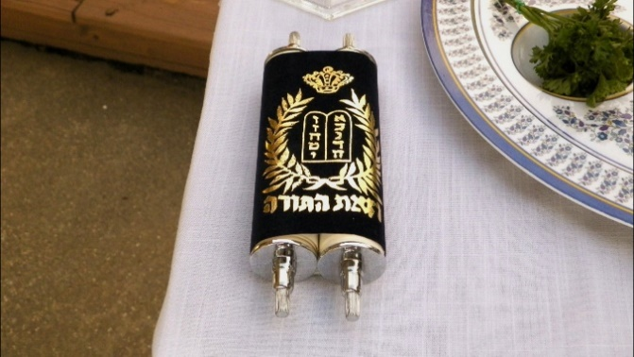

**Torah Scroll 22 Sec.**

This is a Hebrew Torah scroll; it is often read along with the Haggadah in the Passover Seder service. The Torah is comprised of the first five books of Moses which are: Genesis, Exodus, Leviticus, Numbers and Deuteronomy.

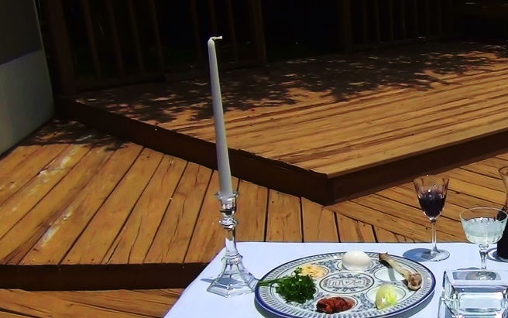

**Candles 1:53**

The candles have great significance in the Passover celebration. The Jewish mother starts the ceremony by the lighting of the candles in a dark room. Only a woman can do this job; it represents the **seed** of the woman bringing forth the light of the world; Jesus Christ

**Genesis 3:15**  
**15** And I will put enmity between thee and the woman, and between thy seed and **her seed**; it shall bruise thy head, and thou shalt bruise his heel.

**A woman does not have seed. The seed was from God, and was God. The Lord Jesus Christ**

**Galatians 3:16** Now to Abraham and his seed were the promises made.

He saith not, And to seeds, as of many; but as of one, And to **thy seed, which is Christ.**

**Matthew 1:18** Now the birth of Jesus Christ was on this wise: When as his mother Mary was espoused

to Joseph, before they came together, **she was found with child of the Holy Ghost.**

**See also: Prophecy: Isaiah 7:14** Fulfillment: **Matthew 1:22-23**

**John 8:12** Then spake Jesus again unto them, saying, **I am the light of the world**: he that followeth me shall not walk in darkness, but shall have the light of life.

The woman being alone lighting the candle portrays the virgin bringing forth the light of the world.

The virgin birth of Jesus Christ.

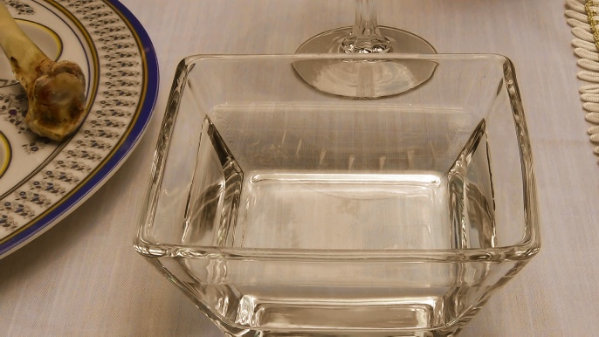

**The Washing Bowl or Laver     42 sec.**

This bowl is used for washing hands. While the Temple stood in Jerusalem, the priests used the laver for ceremonial cleansing to signify their separation to God for service. Before the story of redemption can be told, all must wash their hands to symbolize that they too should be sanctified before a holy God This also reminds us of **Revelation 1:5**.....Jesus Christ....loved us, and washed us from our sins in his own blood,

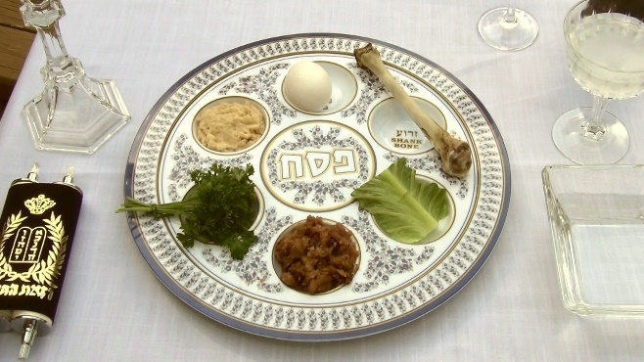

**The Passover Seder Plate 7:15**

**This is the Passover Seder Plate** . A Seder is a Jewish ceremonial dinner telling the story of the Passover. Starting at the top and going clockwise. is an egg.

**The egg** is the first food a mourner may eat after the burial of a near relative. Christ was a Jew, of the seed of Abraham.... A near relative. On this great feast the Saviour of the world was put to death; wasn't this a cause for mourning? It is also an emblem of life hidden unseen buried and yet alive that's also symbolic of Christs temporary stay in the grave and the new birth of believers.

**Next is The shank bone of the lamb** is symbolic of the sacrificed lamb in Exodus chapter 12 which also portrays Christ

**Exodus 12:5-7 and 13**

**5** **Your lamb shall be without blemish, a male….**

**6**…**and the whole assembly of the congregation of Israel shall kill it in the evening.**

**7**  **And they shall take of the blood, and strike *it* on the two side posts and on the upper**

**door post of the houses…**

**13…and when I see the blood, I will pass over you, and the plague shall not be upon you**

**to destroy *you,* when I smite the land of Egypt.**

The blood of the sacrificed lamb in Egypt saved the Jews from physical death. The blood of

Jesus Christ the Messiah, the Lamb of God saves those who trust in him from spiritual death

in hell for eternity

The Temple was torn down in 70 AD so the Jews would not have a place to make sacrifices to God anymore. God himself made sure they could not make another sacrifice because Jesus is the Last Sacrifice of all. Jesus paid the full penalty for all of our sins past present and future. There are no longer priests for the Jews only rabbis.  **Jesus is the last high priest.**

**1 Corinthians 5 :7 says: .....For even Christ our Passover is sacrificed for us**

When John the Baptist saw Jesus in **John 1:29 he said:**…**behold the Lamb of God**

**which taketh away the sin of the World**

**1 Peter 1:18-19** ( See also Revelation 5:9 )

**18** Forasmuch as ye know that ye were not **redeemed** with corruptible things, *as* silver and gold,

from your vain conversation *received* by tradition from your fathers;

**19**  But **with the precious blood of Christ**, **as of a lamb without blemish and without spot:** 2:43

**Hebrews 10:11-12, 14 and 17-18**  
**11**…every priest standeth daily ministering and offering oftentimes the same sacrifices, which can never take away sins:  
**12** But this man, ( Jesus Christ ) after he had offered one sacrifice for sins for ever, sat down on the right hand of God;  
**14** For by one offering he hath perfected for ever them that are sanctified.  
**17** And their sins and iniquities will I remember no more.  
**18** Now where remission of these is, there is no more offering for sin.

**John 19:30**  When Jesus therefore had received the vinegar, he said, It is finished: and he bowed his head, and gave up the ghost.

**Matthew 27:50-51 50** Jesus, when he had cried again with a loud voice, yielded up the ghost.  
**51** And, behold, **the** **veil of the temple** was rent in twain from the top to the bottom; and the earth

did quake, and the rocks rent;

God himself tore the **veil of the temple** from the top to the bottom, Signifying that we could now come directly to God through the blood of Jesus. We no longer have to go to a priest or a prophet as a mediator and we no longer have to make any sacrifices to atone for our sins.

**Hebrews 10:19-22** **19 Having therefore, brethren, boldness to enter into the holiest by the blood of Jesus, 20** By a new and living way, which he hath consecrated for us, **through the veil**, that is to say,his flesh; **21** And having an high priest over the house of God; **22** Let us draw near with a true heart in full assurance of faith....

**1 Timothy 2:5-6 5** For *there is* one God, and one mediator between God and men, the man Christ

Jesus; **6** Who gave himself a ransom for all, to be testified in due time.

**Next is The Bitter Herb:** The stem of  Romaine lettuce is hard and bitter and is symbolic of life being hard and bitter while in slavery in Egypt. It is used to dip in the Charoset

**Next is the Charoset:** It is a mixture of apples walnuts honey cranberries and grape juice. It is the color of the mortar in Egypt that was pressed together to make the bricks to build the cities of Ramses for the Pharaoh.

The Romaine lettuce is dipped in it and eaten. Jesus spoke of dipping in the dish in.....

**Mark 14:18-20**  
**18** And as they sat and did eat, Jesus said, Verily I say unto you, One of you which eateth with me shall betray me. **19** And they began to be sorrowful, and to say unto him one by one, Is it I? and another said, Is it I? **20** And he answered and said unto them, It is one of the twelve, that dippeth with me in the dish.

**Next is the Parsley:** The parsley on this plate is symbolic of spring and Israel as a new nation.

I will tell you More about the parsley in the next picture

**The Last one is the Horseradish:** It is to bring tears to our eyes in memory of the tears shed in Egypt while in slavery

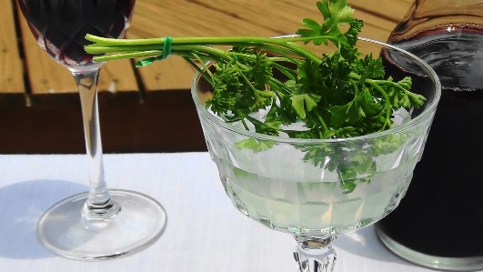

**Parsley in Saltwater 1:25**

**The Parsley when dipped in Saltwater:** Reminds us of the hyssop that God's people used to apply the blood on to the door posts in the book of Exodus; not only did the blood have to be shed but it had to be applied to each individual door to be effective. Just as the blood of Jesus has to be applied by faith to each individual person to be effective in cleansing us from all sin.

**Romans 3:23-26**

**23**  For all have sinned, and come short of the glory of God;

**24** Being justified freely by his grace through the redemption that is in Christ Jesus:

**25** Whom God hath set forth to be a propitiation **through faith in his blood**, to declare his righteousness for the remission of sins that are past, through the forbearance of God;   
**26** To declare, I say, at this time his righteousness: that he might be just, and the justifier of him which **believeth in Jesus.**

**Saltwater**

**The Saltwater:** Reminds us of the tears shed while in bondage in Egypt and the sweat of the hard work while in bondage in Egypt. It is also symbolic of the Red Sea Crossing.

**Passover Commentary for Video Part 2**

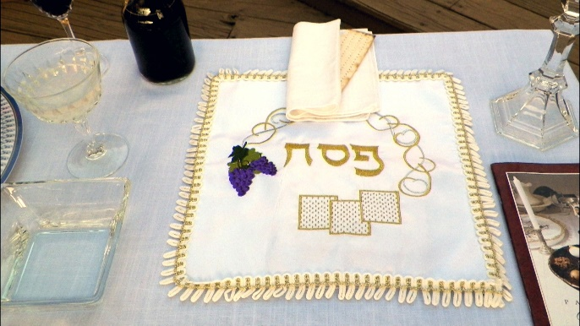

**Motzah cover with Afikomen on Top 41 sec**

**This white cloth bag with the gold trim is a Motzah cover.**

**It has three compartments inside and each one holds unleavened bread**

There is also a small piece of unleavened bread wrapped in a linen cloth on top of the Motzah Cover at the back of the photo. This smaller piece of unleavened bread is called the Afikomen

and it is a piece of unleavened bread that was broken off from a larger piece of unleavened bread in the middle compartment of the Motzah cover.

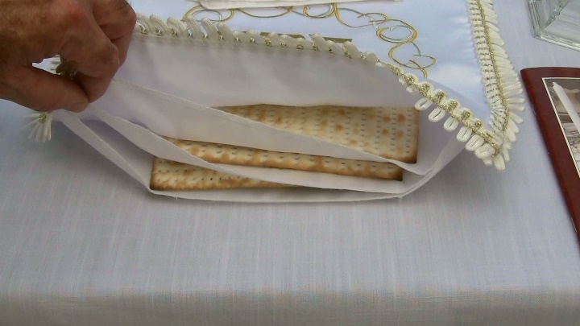

**The Motzah cover has three Compartments 7:39**

**This picture shows the three compartments inside the Motzah cover**

The Jews believe the three compartments stand for:

God, the High Priest, and the people

Or Abraham, Isaac, and Jacob

**The whole cover pictures the Trinity God the Father, God the Son, and God the Holy Spirit. Three Persons in one God. The middle piece of Matzah Bread** in the Motzah Cover is called the **Afikomen** which is Greek for " The Coming One." Strange as it may sound the Jews have this one Greek word in their vocabulary for this middle piece of unleavened bread.

**Isaac, represented in the middle piece, portrays the middle person**

**of the Trinity which is Christ…Here are a few of the ways in which**

**Isaac is a picture of Jesus Christ.**

**The announcement of the miraculous births to Sarah and Mary both seemed incredible and impossible.** Genesis 17:17, Genesis 18:12, Luke 1:34

**Isaac and Jesus were both named before their births. Abraham and Sarah were told that they were going to have a son and that they were to name him Isaac.** Genesis 17:19

**And with the Lord Jesus, we find that He was named beforehand. The angel said to Joseph, thou shalt call his name Jesus: for he shall save his people from their sins".** Matthew 1:21

**Both Isaac and Jesus' births occurred at *God's* appointed time and not before.**

Genesis 21:2 , Galatians 4:4

**Both Isaac and Jesus were to be killed as a sacrifice**

Genesis 22:2, 1 Corinthians 15:3

**Both Isaac and Jesus were offered up as a sacrifice by their Fathers**

Genesis 22:9-17, Romans 8:32

**Both Isaac and Jesus were obedient to their Father even unto death**

Genesis 22:9 , Matthew 26:39

**Both Jesus and Isaac carried wood on their back up a hill to be a sacrifice.**Genesis 22:6 , John 19:17   
 **Both Jesus and Isaac were fastened onto the wood to be sacrificed.**

Genesis 22:9 , Luke 23:33

**It was God who would provide the lamb to be sacrificed in the Place of Isaac.**

**It was God who would provide himself to be a Lamb ( Jesus ) in the place of us.**Genesis 22:8, John 1:29, Romans 8:32, John 10:17-18

**A Substitute Sacrifice ( A Ram ) was offered to save Isaacs life.** Genesis 22:9-13

**Jesus was A Substitute Sacrifice to die for our sins to save our souls from hell**

John 3:16, 1 Corinthians 15:3-4

**Isaac went on a 3 day journey to be made a sacrifice, and was released from death on the third day.** Genesis 22:4 and 8-13 **Jesus was released from death on the third day as well. ( when he he arose from the dead )** 1 Corinthians 15:3-4

**Abraham sent his servant to get a wife for Isaac** Genesis 24.

**God sends his servants to go forth and get the bride for Christ.** Mark 16:15, Matthew 28:19-20 Revelation 19:7-9

**Abrahams servant offers Gifts to Isaacs prospective bride.**Genesis 24:10

**Jesus servants offer the Gift of salvation through the Gospel to Christs prospective bride the church** Mark 16:15, Romans 6:23, Ephesians 2:8-9

**The** **middle** **piece of the** **Matzah** in the Motzah Cover is broken by the Father of the family and it Pictures Christ. One part of **this broken Matzah middle piece of bread** is left in the Motzah Cover, ( Christ is still fully God ) the other piece is wrapped in linen ( called the Afikomen ) and hidden by the father of the family. ( Christ the man is crucified, dies and is buried ) This protrays Christ as the second person in the Trinity and being fully God and fully man and it also portrays Christs death and burial.

**Later on in the ceremony it portrays Christs resurrection** as the hidden Matzah ( The Afikomen ) is searched for ( It must be searched for and found by a child ) It is brought forth and whosoever finds The " Afikomen " receives a **gift** from the father of the family. ( John 3:16 ) Everyone at the table is invited to take part. Whosoever finds and receives Jesus as their Lord and Saviour receives the **gift** of eternal life.

**Matthew 18:3**….Except ye be converted,and become as little children,

ye shall not enter into the kingdom of heaven

**1 John 4:14** And we have seen and do testify that the Father sent the Son *to be* the Saviour of the world.

**Romans 6:23** ( See also Ephesians 2:8-9 )

For the wages of sin *is* death; but the gift of God *is* eternal life through Jesus Christ our Lord.

**1 Corinthians 15:1-4**

**1** **Moreover, brethren, I declare unto you the gospel**…**2** By which also ye are saved…

**3**...**Christ died for our sins** **according to the scriptures; 4** **And that he was buried,**

**and that he rose again the third day according to the scriptures:**

**Matthew 26:26**

And as they were eating, Jesus took bread, and blessed *it,* and brake *it,* and gave *it* to the disciples, and

said, Take, eat; this is my body.

**1 Corinthians 11:24** And when he had given thanks, he brake *it,* and said, Take, eat: this is my

body, which is **broken** **for you**: this do in remembrance of me.

This was just before Jesus was going to be made a sacrifice and be crucified

And it was symbolic of what was about to happen.

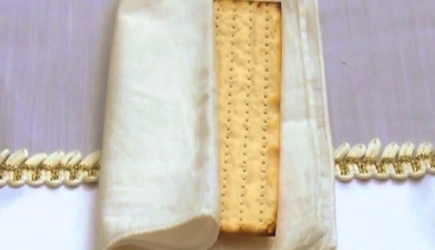

**Take a Closer Look at this Piece of Unleavened Bread called**

**The Afikomen. Notice that it is both striped and pierced 1:34**

**By His stripes we are healed**

**Isaiah 53:5**

But he was wounded for our transgressions, he was bruised for our iniquities: the chastisement of our peace was upon him; and with his stripes we are healed.

**1 Peter 2:24** Who his own self bare our sins in his own body on the tree, that we,

being dead to sins, should live unto righteousness: **by whose stripes ye were healed.**

**Jesus was pierced**

**Psalm 22:16 ( See also** Zechariah 12:10 )

For dogs have compassed me: the assembly of the wicked have inclosed me: they pierced my hands and my feet.

**Luke 24:7** ( See also Acts 2:22-24 )

**7**…The Son of man must be delivered into the hands of sinful men, **and be crucified**,

**and the third day rise again.** ( Being pierced was part of crucification )

Today only a bone remains of the lamb on the Passover Seder Plate because without the Temple the

Jews cannot make a sacrifice. According to the Rabbis the Afikomen takes the place of The Passover

Lamb which all, would have eaten

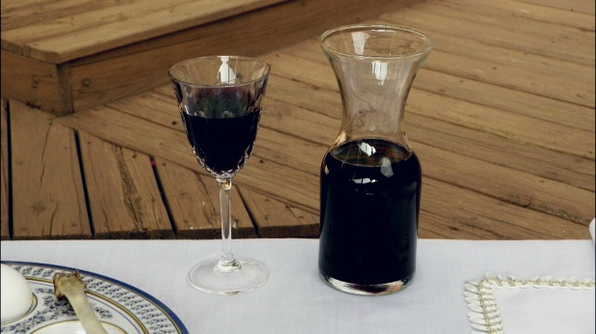

**The Fruit of The Vine 5:58**

**In The Passover Service There are 4 cups of the Fruit Of The Vine served,**

**based on the four I Wills in Exodus 6:6-7 and each one is drunk**

**at a specified time during the service.**

**There are many different names used for the 4 cups based on Exodus 6:6-7**

**and although they are different they still portray the truths in Exodus 6:6-7**

**The First Cup is the cup of Sanctification or Blessing**

**From Exodus 6:6…I will** bring you out from under the burdens of the Egyptians…

God was separating Israel to be a special treasure for himself

Hands are washed after this First Cup which is symbolic of them being set apart for God

**The Second Cup is the cup of Thanksgiving or Deliverance or Judgement**

**From Exodus 6:6…I will** rid you out of their bondage…

Here they dip their finger in the cup to put a drop of grape juice on the plate, one for each of the

10 plagues in Exodus chapters 7 – 12, which were judgements on the false gods of Egypt

**The 10 plagues are:**

Blood, frogs, lice, flies, pestilence, boils, hail, locusts, darkness, death of the first born

**The Third Cup is the cup of Redemption**

**From Exodus 6:6…I will** **redeem** you with **a stretched out arm**, and **with great judgments:**

**This cup is drunk immediately after eating the Afikomen**

**At The Last Supper Jesus took this Cup in… Matthew 26:27-28**

**27** And he took the cup, and gave thanks, and gave *it* to them, saying, Drink ye all of it;

**28** For this is my blood of the new testament, which is shed for many for the remission of sins.

The Cup of Redemption in The Passover Previews the The Last Supper in The New Testament which

is symbolic of the blood that was to be shed on the cross to pay the full penalty for our sins. Jesus did for

us what we could not do for ourselves, he redeemed us from the slavery to, and the penalty for, our sins

which is **The Second Death, an Eternity in Hell** ( See Revelation 21:8 and Revelation 20:14 )

**Romans 6:23**

**For the wages of sin *is* death**; but the **gift** of God *is* eternal life through Jesus Christ our Lord.

**Christ Redeemed us**

**Galatians 3:13** Christ hath **redeemed** us from the curse of the law,

being made a curse for us: for it is written, Cursed *is* every one that hangeth on a tree:

**Ephesians 1:7**

In whom we have **redemption through his blood**, the forgiveness of sins….

**Acts 13:39** And by him all that believe are justified from all things, from which ye could not be justified by

the law of Moses.

**He Redeemed Us With Great Judgments**

Death was inescapable on that first Passover either the first born of man and beast died; or the lamb died; in their place

God brought **judgmen**t on Pharoah, Egypt, and the false gods of Egypt in The Book of Exodus

God The Father brought **judgment** on all the worlds sin ( See also 1 John 2:1-2 ) in the New Testament by putting all our sins on Jesus and allowing him to be put to death for our sins and raising him up from the dead. Christs death, burial and resurrection for our sins was also foretold in Isaiah 53:5-10

**2 Corinthians 5:21** For he ( God The Father ) hath made him ( Jesus God The Son ) *to be* sin for us,

who knew no sin; that we might be made the righteousness of God in him.

**1 Peter 3:18** For Christ also hath once suffered for sins, the just for the unjust,

that he might bring us to God, being put to death in the flesh, but quickened by the Spirit:

**The Fourth Cup is The cup of The Coming Kingdom or Hope or Acceptance**

**From Exodus 6:7…I will** take you to me for a people, and I will be to you a God…

**Jesus did not partake of this Fourth Cup**

**He will not partake of it until his second coming.**

**Matthew 26:29**  
**29** But I say unto you, I will not drink henceforth of this fruit of the vine, until that day when I drink it new with you in my Father's kingdom.

**Jesus said in John 14:1-3** ( See also Revelation 21:3-4 )

**1** Let not your heart be troubled: ye believe in God, believe also in me.

**2**  In my Father's house are many mansions: if *it were* not *so,* I would have told you. I go to

prepare a place for you. **3**  And if I go and prepare a place for you, **I will come again,**

**and receive you unto myself; that where I am, *there* ye may be also.**

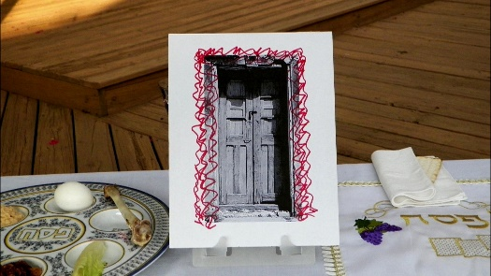

**This Door is a Representation of the door that had blood Put on**

**the side posts and on the upper door post in Exodus Chapter 12. 2:27**

**Exodus 12:21-23**

**21** Then Moses called for all the elders of Israel, and said unto them, Draw out and **take you a**

**lamb** according to your families, **and** **kill the passover.**

**22** And ye shall take a bunch of hyssop, and dip *it* in the blood that *is* in the bason, and strike

the lintel and the two side posts with the blood that *is* in the bason; and none of you shall go out

at the **door** of his house until the morning.

**23** For the LORD will pass through to smite the Egyptians; **and when he seeth the blood**

**upon the lintel, and on the two side posts,** **the LORD will pass over the door,** and will not

suffer the destroyer to come in unto your houses to smite *you.*

**Jesus said in……John 10:9 and 11**

**9** **I am the door: by me if any man enter in, he shall be saved**…

**11**  **I am the good shepherd: the good shepherd giveth his life for the sheep.**

**John 8:31-32 and 36**

**31** Then said Jesus to those Jews which believed on him, If ye continue in my word, *then* are ye my

disciples indeed;

**32** And ye shall know the truth, and the truth shall make you free.

**36** If the Son therefore shall make you free, ye shall be free indeed

**Ephesians 2:8-9 8** For by grace are ye saved through faith; and that not of yourselves: *it is* the gift of

God: **9** Not of works, lest any man should boast.

**God won’t accept your works you must accept his work; dying on the cross**

**to pay for your sins. As with any gift it does not become yours until you receive it**

**John 1:12**

**12** But as many as received him, to them gave he power to become the sons of God,

*even* to them that believe on his name:

**Acts 16:31**…Believe on the Lord Jesus Christ, and thou shalt be saved….

**Text Blocks**

**Leviticus 17:11**….for it *is* the blood *that* maketh an atonement for the soul.

**1 John 1:7**…the blood of Jesus Christ his Son cleanseth us from all sin.

**Romans 5:9**

Much more then, being now justified by his blood, we shall be saved from wrath through him.