Feb 16, 2023 | Feb/16 Board Mtg
Attendees:Anju, Amandeep, Gayatri, Priyanga, Rashmi, Rajashree, Manalee, Maha

Agenda of the Welcome party:
  - People meet and Greet
  - Enjoy sumptuous Food
  - Presidents Welcome Speech & Board Introduction
  - Budget Presentation
  - IWA Academy activities
  - Each member introduce themselves Name, Hobby, Family etc
  - Each table brainstorms ideas for COI /Spring-Holi fest for 10 mins and present.
    - This activity is to help the board to better serve the members and community
  - Secret Judges give Presidents the names to Declare Winners for the best dressed
  - DISCO
Action Items:

Presidents Welcome Speech & Board Introduction: :
- Welcome new board
- Present Agenda for the Year after this Welcome party
  - Spring / Holi party (April end);
  - Picnic (Aug);
  - COI (OCT-Nov);
  - Year end party (Dec)

2) Treasurers :
- Set up an Registration Booth, with the card-reader, and a pen/ box to keep checks.
- Share Summary of previous years expenditures, and use the average of these years as guidelines for this year’s budget .

Mithia promptly provided this summary.
Mithila and Aruna plan to present this budget in a short summary at the party.
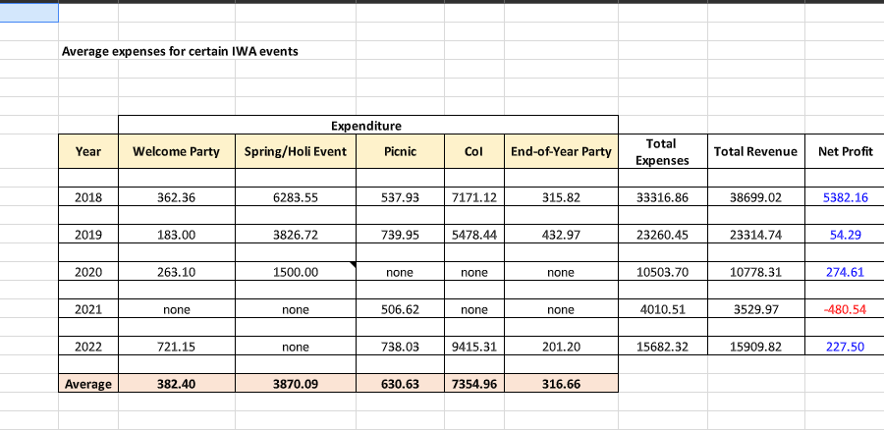

3)Aman & Rajashree:
Checked the IWA storage for tea, gifts, plates and cutlery.
Have gifts ready for the winner, and a few extra prizes.
Gift bag, Few papers to members to write COI / Spring fest ideas
Aman: Present IWA Academy activities /plan for 2023

4) Secret Judges: Anju ji, Manalee, Maha.
Before the disco Manalee write down the 3 names that all the judges agree on and hand over to the Presidents to announce the winner.

5) Aruna : Water from Sam's Club for 100 folks.
Aruna please show this custom id to get discounts if possible.
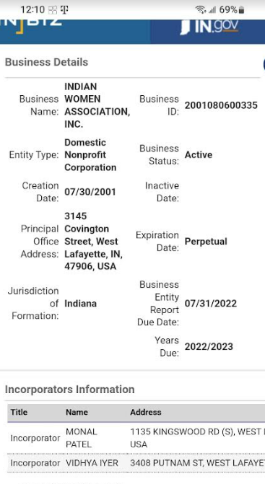

6) Priyanga :
Disco lights
Order and bring the Food from Dakshin.

Surya: We are genuinely grateful to you Surya for making the gulab jamuns & desserts.

7) DISCO Music: Aman and Harshoo

8) COI Venue:
Aman contact Lafayette School
Soma contact Lafayette Main Street Theatre halls/
Rashmi ji Street performance in Septor Oct

9) Gayatri: Contact Rajashree to Open Donations for Syria and Turkey on the Website.

10) Aruna/Mithila : Status on facebook access. Work in progress…..

11) Got email from Sudhanshu Shekhar, a Ph.D. student at Purdue University and the current President of the Cricket Club at Purdue University for donation.--- Don't response now.

