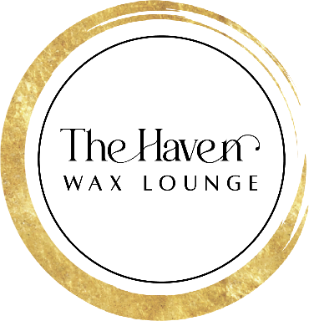 Brow Lamination Consent Form

Name: _____________________________
Brow Lamination is a semi-permanent procedure that tames unruly hairs for a symmetrical, fluffy look that lasts four to six weeks.
I understand:
Brow Lamination is a process of reconstructing the brow hairs to keep them in a desired shape and it is my own responsibility to brush them to achieve the desired look daily.
Some redness of the skin or mild sensitivity is normal but does not typically last more than a few hours.
Despite the use of the most high-quality ingredients, an allergic reaction is possible.
It is my responsibility to advise the esthetician of any concerns I may have prior to the Brow Lamination procedure.
The minimum or maximum duration of the Brow Lamination cannot be determined with certainty.
The Haven and the technician performing the Brow Lamination will not be held liable for any damage caused to me or my eyebrows for any reason, including allergic reaction, skin sensitivity, or any damage caused to previous procedures such as prior henna/tint on the brow.
*Brow Lamination is NOT recommended if any of the following apply to you*
Psoriasis/severe eczema Recent Eye Surgery Alopecia
Recent Microblading (must be healed over 8 weeks) Sunburn Super Sensitive Skin
Blood Thinners Pink Eye Scar Tissue in the Treatment Area Pregnant/Breastfeeding
Retinol, Accutane, AHA, BHA, etc. Current or Recent Chemotherapy Treatments (Doctor’s approval required in either case)
After Care
First 24 hours: NO hot water, Steam, shampoos, makeup, or skincare products on top or close to the Brow Lamination area.
First 48 hours: Do NOT use makeup remover or oils on top or close to the Brow Lamination area. Comb/brush your brow hairs into place as needed.
Do not have any type of permanent makeup or semi-permanent makeup done while your hair is still lifted, as your artist must be able to see the natural direction of the hair.
I give permission to The Haven permission to perform a Brow Lamination. I have accurately answered the
questions above, and understand the risks associated with receiving the treatment. I certify that I
have read, and fully understand, the above paragraphs and that I have had sufficient opportunity for
discussion to have any questions answered. I understand the procedure and accept the risks and will not hold liable The Haven or the esthetician.
Signature ___________________________

