The Presbyterian Graveyard
Reprinted in the Hampshire Review, April 5 & 12, 1927.
The following article is taken from the South Branch Intelligencer of date January 30, 1860. It’s under the heading of “Communication” and the writer’s name is not signed to it. The date line of the paper Romney, Hampshire County, Va. Following is the article:
Mr. Editor: In a recent number of your journal my attention was arrested by a notice of a sale of Lots in the new Cemetery at this place, and upon inquiry I was informed that the old Presbyterian burying ground was filled with occupants, and that the old Church was soon to be leveled with the ground and a new and costly one to be erected in another part of the Village. You, my dear sir, cannot imagine with what feelings, I received the information, for your childhood days were not spent 'neath the ministry from that pulpit, nor your boyish dreams of heaven, of death and of the dead ever aroused by long hours snatched from play and spent 'neath the shadow of those dear old oaks, which have so long stood the silent sentinels of this, to me, dear old city of the dead. Permit one who is almost a hermit as concerns the busy scenes of life to call up old memories.
Let us go to the old Church -- plain old brick edifice it is. There were plain workmen and plainer architects in the days it was planned and built. In the year 1816, we find from the Court Records, that Colonel Andrew Woodrow, plain old Scotch gentleman, Clerk of our Courts, not much given to the practical details of the religion of the heart, yet whose intellect was thoroughly instructed in, and whose reason at all times yielded obedience to the truth of the great principles of the old Scotch Irish Presbyterian Church, granted the land. The deed was not made by Col. Andrew Woodrow in person, but by his executor, James Dailey. The grant is to James Black, William Inskeep, Adam Hare, and John Lawson, Trustees, of two lots, for the use of the Presbyterian Congregation for the two-fold purpose of erecting a Church thereon, and for a "burial ground for the dead."
The old church was built and of course there was a little difference, and for a number of years it stood an unfinished tenement. At last it was finished, and who does not remember the great wide aisle taking up one half of the room just in the middle, and then the wide old unpainted pine side pews; and the great tall box for a pulpit -- the little round window at the back of the pulpit -- the great large gallery fronting -- the great beam reaching across the middle of the room, holding together, strengthening the upper part of the walls -- that beam which little children looked at and wondered at, and thought there was some great mystery about it? And oh! the sacramental occasions -- when the people poured in from the country all around -- on horseback, father with child before and behind, mother with the babe on the pillion -- young lads and lassies riding along cheerfully and often perhaps forming alliances for life, and from which many of us are the descendants; the village streets so quiet, and filled with the people dressed in their best, and wending their way slowly and sedately and solemnly to the church. You might know it was the Sabbath.
We enter the building -- in the aisle, is placed one long table, covered with snow white linen, reaching from near the door to within a few feet of the front of the pulpit, at the head of the table are placed the Sacramental plates and decanter, containing the bread and wine, the divine emblems.
The congregation enter -- here comes the Pastor, the same who now ministers, then he was young, now age tells on him, yet still retaining the quick active step of his youth, he merely bows as he passes the group at the door and walks straight to the pulpit-- following him into the Church are the session, who remembers them? Naylor, Ely, Blair, Miller & Burkett.
The congregation are seated -- where are the many dear faces we gazed on then? Go look to yon graveyard and drop your tear -- how many old ties have we lying out there in the ground now covered with the cold white snow! * * * If the old church is demolished we must preserve our graveyard—its graves, and not permit it to go to ruin, and become as another graveyard in this place (maybe bank lot), one where fifty years ago our people buried their dead and now no stone to mark its place—no trace of a single grave—men pass by it and little think that a garden covers the bones of their ancestors.
But let us go out of the Church into the “God's acre.” We turn to the left and behold we stand beside the resting place of William Naylor, the Elder and the good man, the lawyer, eloquent, courteous, honest, fearing God and doing right: living just, yet at times fearing that he had mistaken his pursuit, and that he should have preached the Gospel to his fellows. Do you not remember how he led in the singing? He, who raised so many children and whose delight was in the bosom of his family, sleeps not beside either his wives nor any of his children save his daughter, called from her family, her children, her friends at a too early day. Here we are by the grave of one, who lived the life of a Christian, whose amiability thro' life made her the model wife, and whose children now arise to call her blessed. We note here the graves of the "three sisters" -- they rest side by side.
And here, from this tombstone we learn that it is in memory of Eliza, the wife of the Rev. C. Parkison, of the M. E. Church, whose trust was in the merits of a Crucified Redeemer.
We pass on and stand beside the grave of another Elder, John McDowell, here he sleeps by the side of the wife of his youth, the daughter of Woodrow, and his son -- we remember his intimate connection with the business of our community, and how as age came on the strong body and the great will gave way. Let us pass on –
We read that William Sherrard died in San (sic.) Augustine, Florida, and his remains are interred here: he was a businessman, yet how few remember him, how quickly the living forget the dead! And here also rests a wife and mother, who but a little more than a year ago, passed away so triumphantly – Susan, consort of J. B. Sherrard. --
We stand beside an enclosure, within its palings lie the remains of the two wives of David Gibson, -- the wife of his youth, she the beautiful one, who was called away so young -- the wife of his maturer years, she whose deeds live after her -- her charity was as sweet incense, daily offered. There are little mounds in that enclosure: infants called away, angels they are.
Let us pause here: no stone marks who is the tenant of this tomb -- here lie the remains of Dr. Robert Newman, who spent a long-life ministering to the sick, -- whose very presence, in the sickroom, remarked and old man to us, gave assurance to the patient of a recovery; strong of intellect, yet child-like, confiding and trusting. His life had been a stirring one -- of six brothers in the army, he, the youngest, alone escaped the terrible massacre of St. Clair's defeat -- more than all, was intimately acquainted with and perhaps knew more of the great Burr and Wilkinson conspiracy, than any save the conspirators themselves, and, for this knowledge, his death was at one time determined on. Here rests his eldest daughter, she who, when far away from home, prayed so earnestly that she might once more worship in the old Church with her friends, and, than rest by the side of her beloved father. We step aside, and pass by this grave with the simple remark, the sister of an English baronet lies here -- when fortune smiled and frowned her trust throughout was in Christ.
Shall we pause here -- yes, for this fresh made mound contains the remains of one who was so good, so true, so gentle, yet so strong -- John Baker White, Jr., thy death bed showed how a Christian can die, and thy last words and last warnings were not lost. No one who stood by that bedside can forget that dying scene. Louisa Alcinda, the wife of John B. White, Sr., -- so beautiful, so gentle and graceful in her manners, so amiable, who passes away in the late Spring, with words so full of trust in God.
We pause ‘neath the shade of this old oak and read from the marble slab supported by the crumbling brick wall, that Mrs. Mary Blair is buried here -- it could also be said of her “blessed are” they who live and “die in the Lord.” We mark too Thomas Blair's mound, her husband -- Blair, the Elder, and the one whose life was so full of charity and good deeds -- by whose side sleeps his mother, one of whom it might be said, like Enoch, her walk on earth was with God. “Hic jacet” Wm. Mulledy -- remembered by many.
Mark you yon marble shaft, it is in memory of Wm J. Armstrong, who lived beloved by his fellows. The three who were friends, Armstrong, J. B. Kercheval, A. W. McDowell -- generous, noble, popular -- all lie in this yard, all passed away within a few months of each other. Do you remember them? We pause in sorrow -- who does not remember Mrs. Wm. Armstrong and her daughter-in-law? Both lie here -- their deeds were good, their faith was strong. David Armstrong and his wife driven from Ireland by oppressive laws, they found a home in this new world, and here a grave.
Let us go to this other old oak tree and resting against it let our eyes wander to the unmarked grave of Adam Heiskell -- he was one of Morgan's men -- he passed thro’ the trials of the great wilderness to Quebec -- he, one of the old famous “Dutch mess,” all his comrades rest in the graveyards at Winchester, here he awaits the commands of his "Great Captain." Shall the resting place of the "old soldier" be disturbed? Here rests Chris. Heiskell, a businessman and his wife. Aye, poor Mammy Betsey's grave, (Mrs. Elizabeth Fitzgerald), you can but remember the mild and gentle old lady, whose eye was softened by no light sorrow, whom young and old so loved, whom the infant was always taken to see.
There in that brick enclosure, rest John Jack and his wife, and his sons James and Carlton, and his daughter, Juliet. Mr. John Jack, prim, straight, dignified, with his long queue, you could but feel respect for him. His son, Carlton, known to everyone -- who, years before his death, ever doubted but that God had given him a new heart? Out there lie the remains of Mary, the grand-niece of Lord Fairfax -- young, beautiful, accomplished, consumption gave the hectic flush to her cheek and hurried her to the tomb.
And over there, a simple stone marks the "home" of Margaret Black, the little daughter of one of our first ministers, under whose administration the Church was built.
There, yes, away in the upper portion on the hillside is the pauper's grave. I remember his burial well -- a cold windy day, we boys stopped our game to see the burying, seated on the fence we witnessed it. No one was there save those who assisted -- no hymn was sung, no prayer made -- the winds whistled thro' the trees, the tall grass bowed mournfully, men drew their coats more closely to their bodies, and the cold hard clods fell so hard upon the coffin. Poor man, the light of reason had years before ceased to shine -- but now, his soul knew the realities of the other world -- the demented pauper had then more knowledge than the spectators.
Yes, up there is the burying place of the Endler's -- a good, honest, hardworking race -- the "old first settlers" have all departed -- our mind recalls John and William Endler, and the old lady "Mammy Endler," what boy ever raised in this village, what county-man who ever attended court in years past, does not remember the old house on the corner, Mammy's cakes and beer and her broken words full of life and hope, cheering as her beers, as good as her cakes. Where lies Thomas Ragland? Somewhere here – Ragland, the lawyer of promise, whose bright dreams of ambition were cut short, ere they were realized, by the deathly breath of the fever.
Over there lies Craig Woodrow -- the afflicted one -- whose classical taste and ready information and brilliant intellect and loving, gently heart so many remember. Yes, there rests also the old Clerk, Col. Woodrow, the man of strong will, and Andrew, his son, and other members of that once influential and large family.
And out there is the grave of James Dailey -- the father of a numerous family, sons and daughters -- Dailey, the Elder, the financier of his day and generation, the banker, a man of great foresight, of fine business qualifications, enterprising and energetic. And there -- follow the direction my finger point -- and you will find the grave of one once full of life, of mirth, of humor, who died because he was "too good a fellow" and could not resist the temptation of the sparkling bowl.
You see those graves -- several of them enclosed -- out there near to the fence on the West: those are strangers' graves -- Blackman, whom Consumption hurried away so young; George Porterfield, his last hours were soothed by the hands of kind friends.
How fast the snow falls! How thick the white flakes are! Soon the dead will be provided with another winding sheet. We must leave them here -- leave old memories -- leave the graves of those we love, for once we had two little brothers and a sister, their resting place is here. We are about opening the gate, when turning to our right we see a grave stone and the letters are almost filled with the snow flakes -- we brush them off and read Eliza Wilson Foote -- our Pastor's little child, whom the angels called away. We hurry to our warm fireside to dream of the past and cherishing as the spot dearest to our memory the old Presbyterian Churchyard.
As I sat by the fire and mused, I fell asleep and dreamed that I was lying upon the grass in the old churchyard ‘neath the broad limbs and leaves of the old oak by Mammy Betsey’s grave -- that it was the month of June -- the hills and the mountains and the fields and the old “God's acre” were all clothed in their garb of green, the grass seemed more than beautiful, for the dew drops glistened in the morning sun as millions of sparkling gems; the robins whistled to their mates in joyous notes from the trees and hopped upon the ground in search of food with merry twittering, proudly showing their red breasts, and the larks arose from the dewy grass and rising to the heavens uttered as ‘twere joyous notes of praise to their maker; the little sparrows sported fearlessly on the ground before me, and the little wren played in the adjacent fence, ever uttering his low chirrup, and the sun just over the eastern hills shone forth in all his glory, shedding his brightness around upon the earth and adding a glory to the quiet of nature -- even the cowbell's tinkling added to the music of the scene.
I laid and listened and mused and enjoyed; and as I mused methought that mid the quietness of the scene, I could hear voices issuing from the graves around, such sweet low voices, voiced of persons who were at rest -- rest from toil, rest from cares, rest from suffering.
And it seemed as if I could again see our old friend, Nathaniel Kuykendall, he who had known all the trials of the business of this life, had known friends, and had known the bitterness of desertion -- tall, straight, dignified, sorrow could not break his dignity of character, yet it touched his countenance and softened his heart, and as he lay upon his last bed of sickness his trust, his hope, his all was in Christ, and when a few days before his death the death of a beloved daughter was announced, he could say that they would soon meet in heaven. Yes, he rests, and by his side sleep, as often they did on his knee, his two little grandchildren -- are they not angels now?
And Peter Peters, that once handsome man, full of wit, the life of his circle, how many tears were shed over his fate! And how methought I saw old Mr. Joseph Combs, so cleanly clad, so prim, yet so polite and dignified -- he is standing at prayer, holding communion with his God, in the old Church – and I recalled how when Mr. Naylor was absent his voice was the one that led the notes of praise--thou art lying up there on the hillside by the side of thy wife, good and strict old Presbyterian, and poor Nelly and her babe, their wanderings all over, her troubles all gone, rest now quietly with thee awaiting the sound of the last trumpet.
I see again Eli Davis, the old jailor, kind, generous and lenient too, with a heart that could feel for, his fellows -- a large family now arise to bless him and his wife who sleeps by his side. A son and grandchildren have their home with him.
Yes, there is Steinbeck, the robust German, honest and simple in heart, confiding and trusting in his fellows, a few old persons remember the bountiful table he sat at the old middle tavern; long years ago, when our old men were but boys, he sought his home out there where the blackberry bushes now grow.
And over there Mrs. McGuire -- the mother of the second wife of Wm. Naylor, a lady of the old school, an Episcopalian by profession, and Catholic in her feelings, the willow tree waves mournfully over her grave and her son, Samuel McGuire, for a short time clerk of our county court, the husband of a daughter of Woodrow, who rests with him.
And who is here? Mrs. Sallie, the wife of Felix Davis, and the sister of Mrs. Thomas Blair. Oh! how strong was her faith, suffering purified her spirit.
“Suffering is the work now sent
Nothing can I do but lie
Suffering as the hours go by
All my powers to this are bent”
“Suffering is my gain; I bow
To my Heavenly Father's will
And receive it hushed and still
Suffering is my worship now.”
And by her side rests her daughter -- the merry, joyous, light-hearted girl, whom at school I knew so well, a stranger won her love and took her from us, but in a year a saddened man he brought her back and laid her by her mother.
Mary M., wife of Wm. S. Naylor, she lies here -- the amiable young wife and the infant by the side of its mother. By the side of the Elder Wm. Naylor lies his cousin, Miss Charity Johnson, who lived and died in his family: her deeds were worthy her name, Charity -- never a peace-breaker, always a peace-maker -- Many a dying bed was cheered by her presence and many a sick room brightened by her kind attentions -- her life was that of a good woman, her death that of the humble disciple of Jesus.
And Dr. Snyder, the physician, and Dr. Dyer, who was removed from his first grave, rest here -- old citizens, yet years have almost obliterated their memory. Mrs. Kitty, wife of James Vance, mild and gentle and lovely in her disposition, very pious, she lies there by the side of her first husband, Jacob Heiskell, and resting with them is Samuel Heiskell, and his son, Adam. They died professing glorious homes and there also lies Elizabeth, wife of F. W. Heiskell, daughter of Christopher Heiskell.
And over here at my feet, rests poor Granny Fitzgerald -- the old lady, not larger than a little girl, who when the news of the death of her two sons, soldiers in the war of 1812, was announced to her, laid down upon her bed and there for twenty years she remained until death came, and her bed was made here.
And there, rests poor Mrs. Cherry, near the graves of those who were friends to her through many years -- poor woman, her great troubles are all over, and her last wish that she might rest here in this old yard gratified.
And on the other side of the Church, we buried last summer James McDonald -- a young man whom so many loved. The last time we exchanged friendly and light-hearted words, little he thought that we would never meet again.
From those graves, hush, what voices do I hear speaking--how solemn the words: "Have ye forgotten how ye trembled at the pestilence, how ye quaked at the thoughts of God's judgment when you heard of our deaths, oh, men and women of Romney? The pestilence is stayed, but God's judgment is still near. Turn ye, turn, oh, thoughtless people."
As these words thrilled through my ears, I saw George Y. Houser's grave -- many friends stood with tearful eyes at his funeral, and a large family now mourn their loss.
A marble slab covers the grave of Mrs. Susan, wife of Otho W. Heiskell, of Wheeling, she whom dread consumption marked as its victim -- beautiful and amiable -- she rests alone, her father and mother (Maj. Gibson and wife), lie in the graveyard at Charles Town.
And here rests Mrs. Rachael, wife of our former old, respected citizen, Capt. George Leps, the mother of a large family -- with great bodily sufferings she passed through the valley and the shadow of death, cheered by Jesus -- with her rest her two daughters, Susan and Bettie.
Mr. Josiah Samuel, a stranger he came to our village, but soon death claimed him as his own -- two little grandchildren lie with him.
John Barker, ere thou entered into manhood the fell destroyer claim thee.
And sleeping by his sister, Mrs. White, lies Chichester Tapscott, a young lawyer of delicate organization and handsome appearance, the husband of a daughter of Naylor -- long years ago he passed away with the song of triumph. “Oh, grave, where is they victory? Oh, death, where is thy sting?”
And with the Blair’s he, Lloyd Rawlings, Blair's partner, and the stranger, Wood, a relative of Mrs. Blair, who sought our village for his health and found in a few weeks a grave.
Margaret Moreland rests with her infants -- children she left behind to praise her -- rests, aye rests, after years of earthly suffering.
“We cannot come to you, but you can come to us” are words uttered from so many graves. And I see again old Mr. John Friddle, an industrious man, the father of a large family, whom many yet remember, and old Mr. Busby who passed away years before this generation can remember.
Lo, a voice from that grave away in the southwestern part of the yard, in the corner, poor Betty Evans -- liquor maddened her, and poor woman an outcast she lived, and ceased her wanderings here. Mrs. Kitty Cookus, we all remember her, God gave her a new life and Christ blessed her last hours and bitter tears were shed over her grave.
I see one who was here at one time so beloved and whom his brothers in a benevolent institution buried, David Griffith, by his side rests his wife, she who was taken soon from him.
And here lies Catharine, daughter of John Endler, and wife of John W. Marshall -- sweet in her manners, amiable in her disposition, she passed away from her friends to a better world. Mrs. Kitty Kirk, who raised a large family, rests with her son and her little grandchildren.
There are voices coming up from many other graves, but we cannot recognize them--their tenants have passed away -- immortal souls they are, we living know them not, and yet their sweet voices fall upon our ear in conjunction with those from other graves.
A stranger stood before me, and asked, “Why muse you here? These graves contain but dead bones and this is the last of man.” A voice from Mammy Betsey's grave replied, “The fool hath said in his heart there is no God,” but we know how we are they which came out of great tribulation and have washed their robes and made them white in the blood of the Lamb. I looked and behold the stranger was gone, and it seemed as if the voices from the graves were more sweet, and I could hear the echo and re-echo of the words “blood of the Lamb.”
And I cried with a loud voice to some of the tenants of the tomb, "Newman, how now thy desire after scientific knowledge -- how thy cravings to add to the knowledge of the world? Naylor, how now they dream of family power? Ragland, how thy great dreams of ambition? Craig Woodrow, how now thy classical tastes?" And voices of thunder cried out, “Vanity of vanities, all is vanity -- prepare for death -- heaven is the only goal fit for immortal souls to fix their hopes upon.” And it seemed as if every grave echoed and re-echoed those words -- little infants, mothers, fathers, old gray headed men, the youths, all spoke forth from their resting places, and like St. John of Patmos, it seemed as if the angel cried with a loud voice, “I am the Alpha and the Omega, the beginning and the end, the first and the last.”
I awoke with a start -- my shovel had fallen, my fire was out, I arose and looked out -- it was not June, the snow was lying thick upon the ground, and the cold moon glistened upon its surface. I took one look at the old Church, and the yard, how silent rested the dead -- soon perhaps I may be with them to rest, and this may be my last writing.
R. N. Harper
Let us turn from the window. The services have commenced -- how "old hundred" ** to those beautifully solemn lines;-- "Before Jehovah's awful throne," resounded in the old building; how the voice of the old elder, Naylor, trembled and swelled, how the whole congregation joined and followed him throughout the entire hymn; that prayer made for that congregation as they stand in the presence of Jehovah,-- the sermon,-- those solemn words to be thought over by so many, heart-treasures to be revealed perhaps to the world in years to come, -- the gathering around the sacramental board-- the solemn exhortation,-- the words "'Twas on that dark and doleful night," sung so that if once heard never forgotten -- the silent and quiet movings about of the old Elders. That greatest of all penitential Psalms: "Show pity, Lord; oh! Lord, forgive!"
Oh! how those words now thrill through my heart and soul -- how many prayers have gone up to the Throne of the Almighty with those words -- prayers that were answered by peace to the soul. Old Church! I love thee -- I love thy walls--thou art indeed a sacred place to me--to us--to this people! Here nearly all of us worshipped as children with our parents -- now gone -- here at the Sunday School we learned those lessons of divine truth which we hope may ne'er be obliterated from our hearts: here we listened to the words of wisdom from the pulpit, --here we gathered when friends died, and with tearful eyes listened to the solemn words, so enforced by the presence of the dead -- here were many of us baptized, and many have stood and taken the solemn vows at the baptism of their children: here, how many have sought for and received that pardon of their sins so long and tearfully sought?

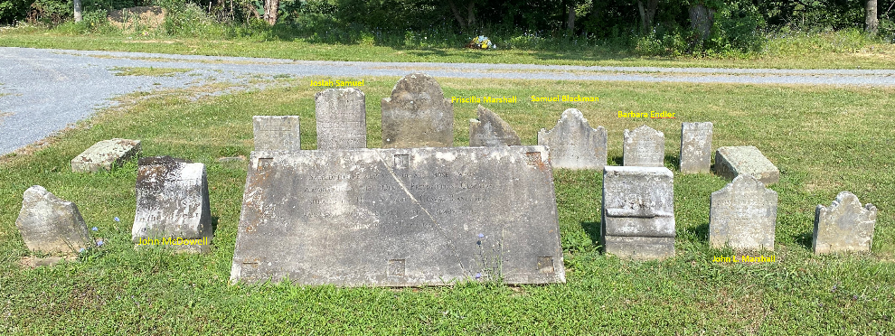
Those stones moved to Indian Mound in 1941.
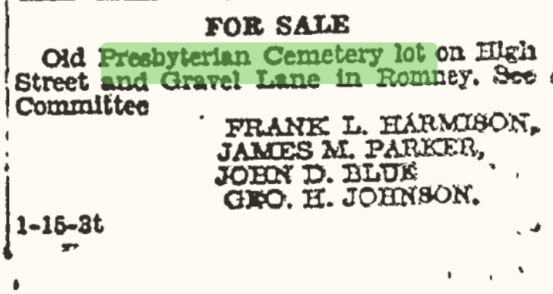

1/22/41 & 1/29/41
Pg. 7

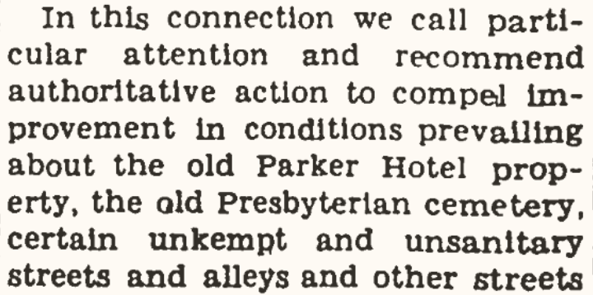

7/16/41 pg. 2

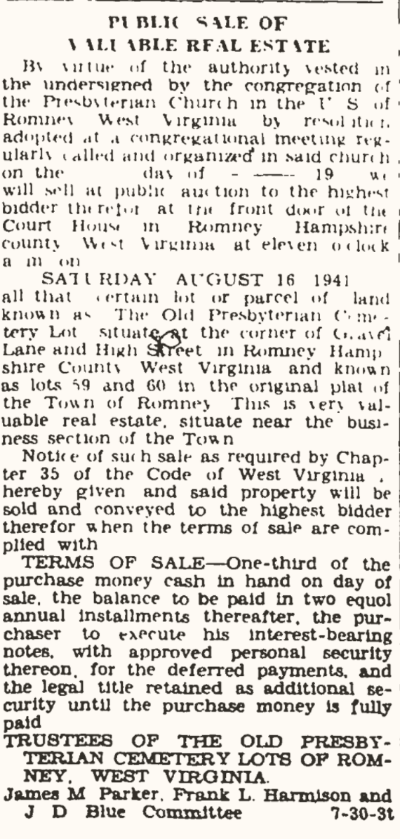

7/30/41 pg. 4

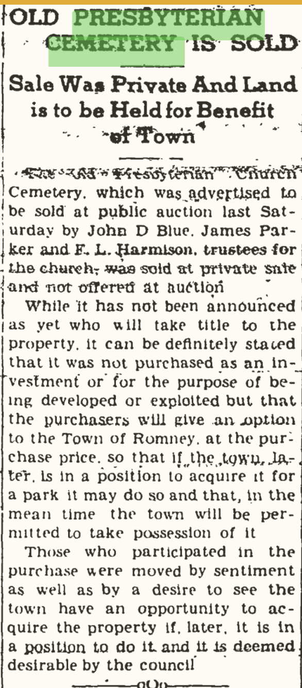
8/20/1941, pg. 1

SBI, 9/14/1888, pg. 3 – Indian Mound in a bad state of repair, pleading for assistance. A tax on lots.

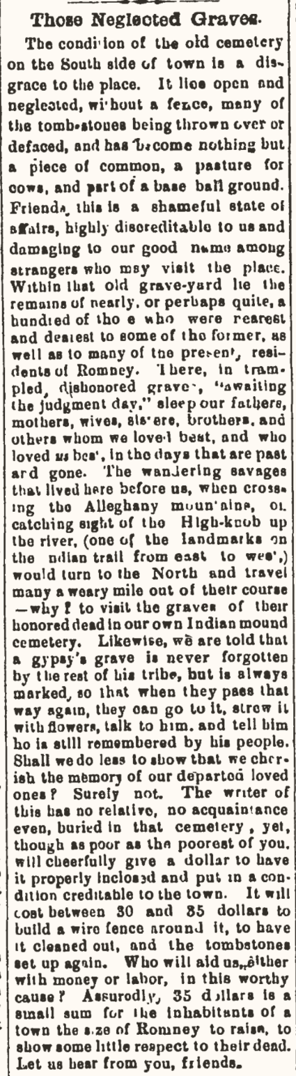
SBI – 5/6/1887, pg. 4

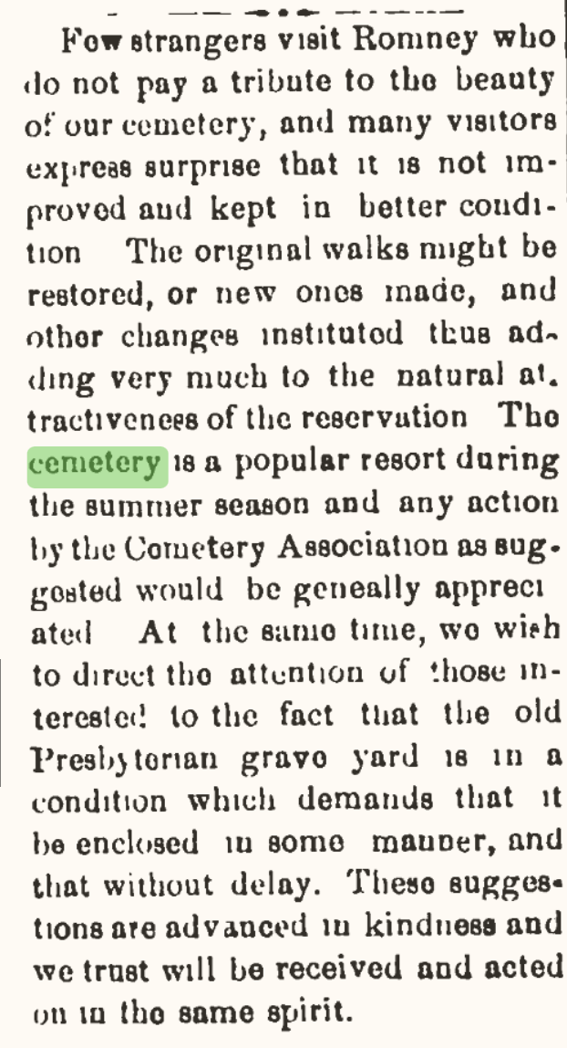
SBI, 9/11/1885, pg. 2

Originally printed SBI, 1/13 & 20, 1860. Combined may be a longer article. First reprint of the article - SBI Apr. 7, 1871, pg. 1. Concluded the following week, 4/14.

Old Presbyterian Church Cemetery Names
I am making the assumption that anyone buried in this cemetery would have had to die before or around 1860, when Indian Mound opened.

Armstrong, David, Indian Mound, 1768-1838. History on Find-a-grave.com.
Armstrong, David’s wife, 1774-1826. History on Find-a-grave.com
Armstrong, Mrs. William, wife of William J. (Jr.). She was Susan C. White, 1786-1843. Reference in Historic Hampshire, pg. 241, 308
Armstrong, Mrs. William’s daughter-in-law
Armstrong, William J. (Jr.), 1813-1847
“Mark you yon marble shaft, it is in memory of Wm J. Armstrong, who lived beloved by his fellows. The three who were friends, Armstrong, J. B. Kercheval, A. W. McDowell -- generous, noble, popular -- all lie in this yard, all passed away within a few months of each other. Do you remember them? We pause in sorrow -- who does not remember Mrs. Wm. Armstrong and her daughter-in-law? Both lie here -- their deeds were good, their faith was strong. David Armstrong and his wife driven from Ireland by oppressive laws, they found a home in this new world, and here a grave.”
Barker, John, “ere thou entered into manhood the fell destroyer claim thee.” Assuming he died young. No information can be found.
Black, James, member of the Presbyterian Congregation who received lots for the church and cemetery from Andrew Woodrow. Mention in Historic Hampshire, pg. 439. No mention of his burial.
Black, Margaret, “And over there, a simple stone marks the "home" of Margaret Black, the little daughter of one of our first ministers, under whose administration the Church was built.” See M & S, pg. 378 for Rev. James Black.
Blackman, (m), “You see those graves -- several of them enclosed -- out there near to the fence on the West: those are strangers' graves -- Blackman, whom Consumption hurried away so young.”
Blair, Mary, wife of Thomas, Mary (Clark) Blair, (1795-1824). Ancestry Co. died Hamp. Co.
Blair, Thomas, founding member of the Romney Literary Society (M & S, pg. 430, 433). Ancestry.com, Thomas Charlton Blair (1791-1826),
Blair, Mrs. (Thomas’s mother). Ancestry.com shows his mother was Phebe Mills (1769-1855) but her burial and picture of her tombstone are in Frostburg, Md.
“We pause ‘neath the shade of this old oak and read from the marble slab supported by the crumbling brick wall, that Mrs. Mary Blair is buried here -- it could also be said of her “blessed are” they who live and “die in the Lord.” We mark too Thomas Blair's mound, her husband -- Blair, the Elder, and the one whose life was so full of charity and good deeds -- by whose side sleeps his mother, one of whom it might be said, like Enoch, her walk on earth was with God.”
Busby, Mr., Historic Hampshire, pg. 240
Cherry, Mrs.
Combs, Joseph, Presbyterian Member Rolls, pg. 270
Cookus, Kitty
Dailey, James
Davis, Eli, Brannon, pg. 240
Davis, Mrs. Eli
Davis, son of Eli
Davis, grandchild of Eli
Davis, grandchild of Eli
Davis, Sallie, wife of Felix (sister of Mrs. Thomas Blair)
Davis, daughter of Felix & Sallie
Dyer, Dr.
Endler, John
Endler, “Mammy”, maybe Barbara, Indian Mound, (moved) 178?-1826
Endler, William
Evans, Betty
Fairfax (Lord), Mary, grand-neice of,
Fitzgerald, Elizabeth
Fitzgerald, Granny
Foote, Eliza Wilson, Indian Mound, no dates, no picture
Friddle, John
Gibson, David, Indian Mound
Gibson, First wife (Eliza Jane Armstrong 1804-1847), Ancestry.com
Gibson, Second wife (Ann Markee Van Meter 1805-1859), Ancestry.com
Griffith, David
Griffith, wife of David
Hare, Adam
Heiskell, Adam
Heiskell, Chris, Indian Mound, 1780-1851, Ancestry.com
Heiskell, Chris’s wife (Eleanor Abernathy 1782-1845), Ancestry.com
Heiskell, Elizabeth, wife of F. W., Indian Mound, 1823-1852
Heiskell, Jacob
Heiskell, Susan, wife of Otho W., nee Gibson, b. 1815, died after 1840, Ancestry.com
Heiskell, Samuel, (1791-1834), Ancestry.com
Houser, George Y., Indian Mound, 1808-1856
Inskeep, William, Indian Mound, 1766-1845
Jack, Carlton, Presbyterian Church Member Rolls, 275
Jack, James
Jack, John, Indian Mound, 1763-1837
Jack, John’s wife
Jack, Juliet
Johnson, Miss Charity, cousin of Wm. Naylor
Kercheval, J. B.
Kirk, Kitty
Kirk, son of Kitty
Kirk, grandchildren of Kitty
Kuykendall, Nathaniel, Indian Mound, 1796-1859
Lawson, John
Leps, Bettie
Leps, Rachael, Presbyterian Church Member Rolls, died 1854
Leps, Susan
Marshall, Catherine, wife of John W. nee Endler, (1822-1851), Ancestry.com
McDonald, James
McDowell, A. W.
McDowell, John, Indian Mound (moved), 1782-1855
McGuire, Mrs., see Naylor
McGuire, Samuel
McGuire, Samuel’s wife, nee Woodrow
Moreland, Margaret
Moreland, infants
Mulledy, William
Naylor, child
Naylor, Mary M., wife of Wm. S.
Naylor, Nelly
Naylor, 2nd wife of Wm., (Mrs. McGuire)
Naylor, William, Indian Mound, 1771-1840
Naylor, William S.
Newman, Robert Dr., (1772-c. 1843), Ancestry.com
Parkison, C. Rev.
Parkison, Eliza
Peters, Peter
Porterfield, George
Ragland, Thomas
Rawlings, Lloyd, (1802-1824), Ancestry.com
Samuel, Josiah, (1786-1849), Ancestry.com
Sherrard, J. B.
Sherrard, Susan, Indian Mound, 1828-1858, wife of John B.
Sherrard, William
Snyder, Dr.
Steinbeck, Mr.
Tapscott, Chichester, (1801-1829), Ancestry.com
Vance, Kitty, wife of James, (1789-1848), ancestry.com
White, John Baker Jr., (1794-1862), Ancestry.com
White, Louise Alcinda, wife of John Baker White, (1795-1827), nee Tapscott, Ancestry.com
Wood, Mr., related to Blair’s
Woodrow, Col. Andrew, possibly (1752-1814), Ancestry.com (wodrow)
Woodrow, Craig, possibly son of Andrew

Hampshire Review, Aug. 20, 1941, Old Presbyterian cemetery lot sold, pg. 1
Hampshire Review, Aug. 13, 1941, Notice of Public Sale of Land. Pg. 6

