HISTORY OF THE WEST VIRGINIA SCHOOLS FOR THE DEAF AND THE BLIND
INTRODUCTION

The following historical sketch of the West Virginia Schools for the Deaf and the Blind has been extracted from the information compiled for the Multi-Cultural Day Program presented February 18, 1988. Although much additional like the presentation itself, has been condensed in order to provide a brief, overview of the background of the schools.

Much of the information has been taken from the "History of the West Virginia Schools for the Deaf and the Blind, 1870 - 1970", by Selden W. Brannon, a former student, teacher, and the Principal of the School for the Blind from 1948 to 1971. Mr. Brannon compiled and edited this one-hundred-year history during the Schools' centennial year. Mr. Brannon's work is a very comprehensive version of the schools' history prior to 1970.

1870-1900

Five years after the Civil War had ended, a few citizens of the new state of West Virginia began to seek support for an in-state school for its handicapped children. From the time of her entrance into statehood in 1863, West Virginia had continued to send her deaf and blind students to the schools in the neighboring states of Virginia, Ohio and Maryland. This was inconvenient and expensive, and only a few families could afford to have their handicapped children educated in the out-of-state schools. The result was that the deaf and blind of West Virginia were virtually without adequate educational opportunities.

The first advocate of a West Virginia school for the handicapped, was Howard H. Johnson, a blind teacher in Franklin, Pendleton County. Mr. Johnson led a delegation of the blind to the capital of the state, at that time located in Wheeling, and by giving a very persuasive presentation, convinced the legislature and the Governor, to establish a school for the blind. The resolution was amended before it was passed, to also include the deaf and the "dumb", as was then the accepted term.

Four sites were offered as locations for the new school by citizens of the following communities: Wheeling, Clarksburg, Parkersburg, and Romney. The records indicate that the location in Wheeling received the majority of votes, however, there was a court decision regarding the transfer of title which prohibited the conveyance of that property. For some unknown reason, the offer by the Parkersburg delegation also was dismissed, and at that time, a resolution was presented to accept the building and grounds of the Romney Literary Society.

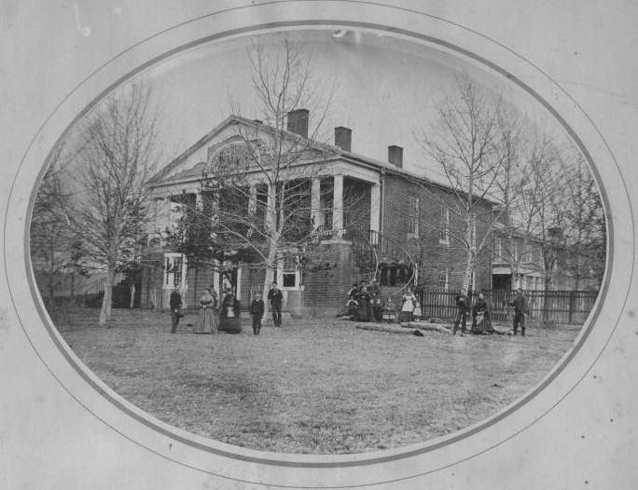
Early Picture of the Classical Institute Building (source http://www.historichampshire.org)

It appears that the property was offered by the Literary Society of Romney on behalf of the people of Romney. It seems that other grants were made besides that of the Literary Society. No doubt this organization owned the building known as the Romney Classical Institute, and the other grantors gave adjacent land. At that time, the front portico was enclosed at the first- floor level and the porch supported by columns extended across the front of the second story only. As you will see in later photographs, the appearance of the building has changed several times over the years.

On June 20, 1870, the offer of the Romney Literary Society was accepted, and a meeting was held soon after to plan the opening of school in the fall.

Mr. K. K. Hollister, of the Ohio School for the Deaf was selected as the first superintendent (at that time called the principal). Twenty-five deaf and five blind students were enrolled the first session, beginning September 29, 1870.

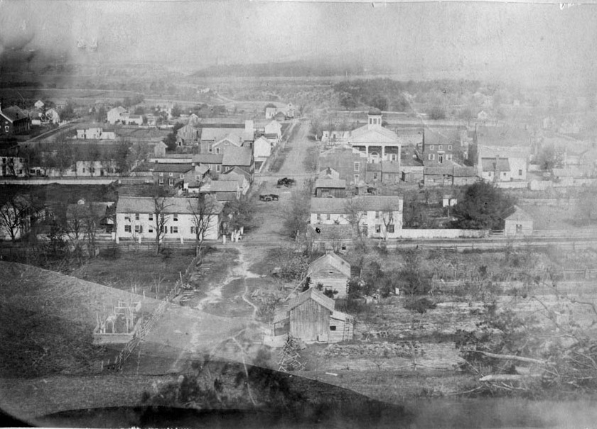
Center of the Town of Romney, as it appeared in the late 1800's. (source http://www.historichampshire.org)

It shows the intersection of High Street and Grubb Lane, which is now Main Street. This is taken from the top of the hill south of Gravel Lane, looking north toward the Court House, which is easily identified on the northeast corner of Grubb Lane and High Street. Other structures shown in the picture and still familiar to us today are the Presbyterian Church on Rosemary Lane and Marsham Street; Literary Hall, located on the northwest corner of Grubb Lane and High Street.; and the large home on the northwest corner of Gravel Lane and High Street, now the residence of Mr. and Mrs. Bernard Hill. The Methodist Church, shown directly north of the Literary Hall was built in 1869. It was destroyed by fire and⁻ the present Methodist Church was erected on the same lot.

The staff and students arriving for the first term of school in the fall of 1870 found the setting for their school to be this small town with a population of approximately 800-900 citizens. Romney, the county seat, was the hub of activity for folks from miles around.

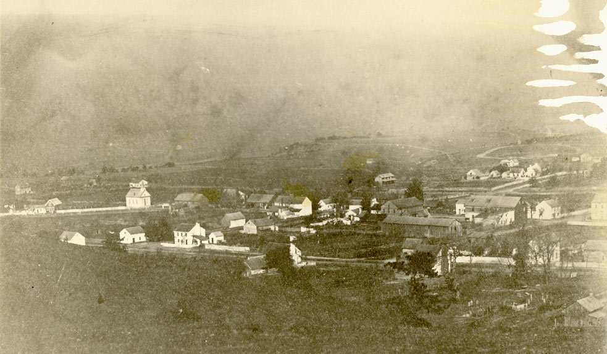
Romney looking northwest from the hill south of town (http://www.historichampshire.org)

A view of the town of Romney from Marsham Street to the west as far as the brow of the hill overlooking the South Branch River Valley and the mountain beyond. The white church on the left is believed to be the Northern Methodist Church, situated at the end of Grubb Lane (or Main Street), the same location as the present First Baptist Church. Grubb Lane ended at the Church and the road leading west out of town was at that time Gravel Lane, not Main Street as it is today. The Church was built around 1885 by the Methodists and was purchased by the Baptists around 1920.

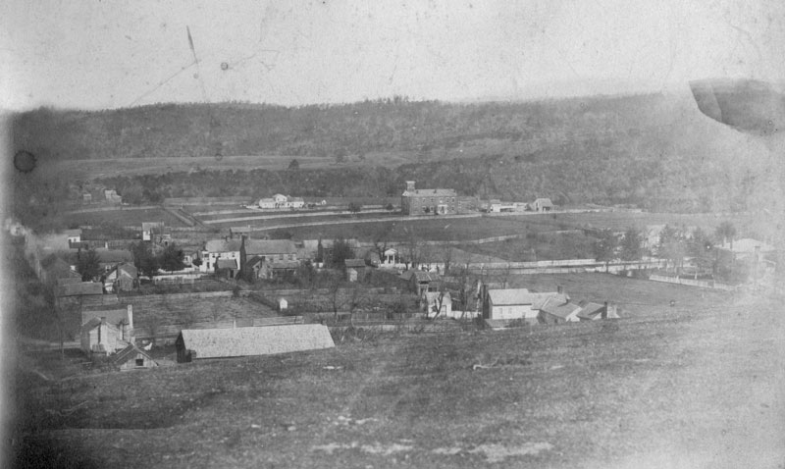

The eastern section of the town was dominated by a few substantial residences and buildings.
The large home shown on the right edge of the picture was headquarters for Stonewall Jackson during the War and was later owned by Mrs. Mary Kirk and Miss Susan Arnold, sisters of Mr. George Arnold. It is now the home of Mr. and Mrs. Royce Saville. The Romney Classical Institute Building, which was located across the street from this home was just one lot too far to the east to be included in this picture.
The large structure in the center of the picture is the Potomac Academy, later to become the School for the Blind classroom building. To the left of the Academy is the home owned by the Gilkeson family, later known as the George Arnold property, and recently purchased by the West Virginia Schools for the Deaf and the Blind.

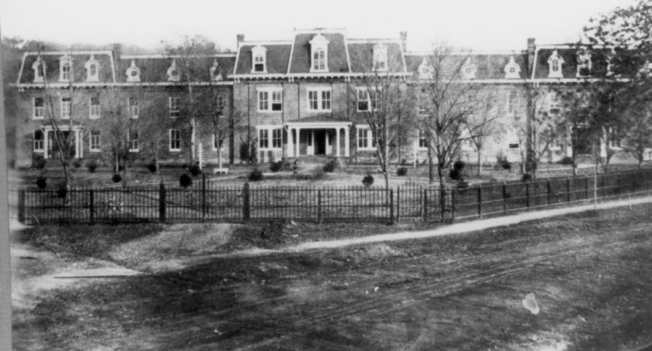
Front of Main Building following the addition of north and south wings and third floor. (source: http://www.historichampshire.org)

During Mr. Hollister’s three years as principal, the state legislature approved the construction of north and south wings to the original building, and the addition of a third floor in 1871-72. Thus, a structure about 200 feet in length and three stories high afforded much needed accommodations for the students and staff of the two schools.

It probably was during this period of construction that the original portico of the building was removed and replaced with the smaller front porch shown in the above picture.
This one building served as classrooms and living quarters for all students, teachers and matrons, as well as the principal and his family.

Local citizens and business activities played an important role in the lives of the students. Romney was their home for nine months of every year. Transportation was limited to horse and buggy or the stage line to Greenspring, where the B&O Railroad was the principal means of personal and commercial transportation.

The students arrived in September for the opening of school and most did not return home until early June. Holidays were spent at the school.

The earliest "Tablets" are filled with compositions by the students which give us some good descriptions of the typical school term in the 1800’s. During the first nineteen years of the school's existence, the "Tablet" was edited and published entirely by the Deaf Department.
It was not until January 1889, that the announcement appears that the "Tablet" will thereafter include regular contributions from the blind pupils.

The following excerpts taken from the "Tablet" illustrate the strict, but dedicated philosophy of the administration and the respect shown by the students. Many writings also describe the difficult journeys undertaken by many of the students in order to reach Romney from their homes throughout the state.

October 10, 1881. Samuel Fox writes about -his trip from home to Romney for the opening of school.
"I left the county seat of Braxton County for Weston and came by stage a distance of 43 miles in one day. I stayed in the Hayden Hotel in Weston. In the morning I rode in the cars that stopped at Clarksburg. I got out and waited for another train from Parkersburg on which I traveled to Grafton where I stopped for my dinner. After dinner I got on the train that came from Wheeling and stopped at Cumberland where I waited for about one hour before taking the Local Train that stops at Green Spring Run. The stage had left for Romney, so I spent the night there. I would have come here that night, but I thought it better to wait until early next morning, when we left and arrived here before ten o'clock. I shook hands with our Principal and then with the rest. I came here all right and safely. I was sorry to find the "Tablet" behind hand. There were not enough boys to get it out on time.
The printers are now trying to make it up in time and publish it every Monday. Every Monday, Wednesday and Friday after supper the boys run to the gate near the turnpike where the Winchester stage passes. They are expecting that some pupils may be in the stage but are often disappointed. The first class is not full yet. We are all very well. The boys enjoy themselves playing baseball, hide and seek, tag, etc. I heard that two deaf boys were coming this Monday evening. The pupils come here very slowly this fall. I think they should come more promptly. Tardiness makes it inconvenient."

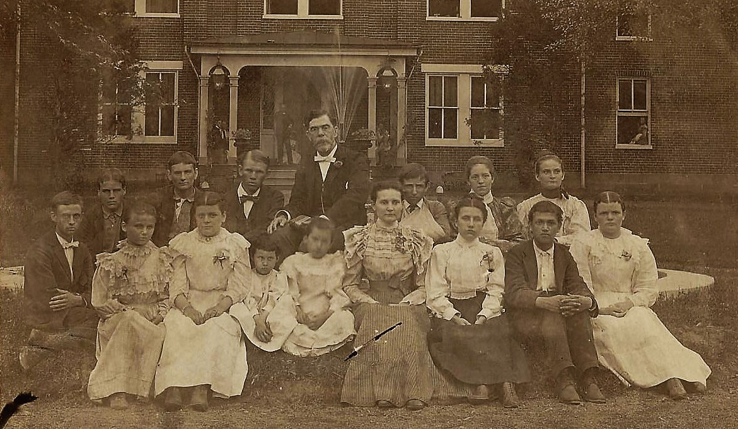
Mr. Chapin and his class posed for this picture on the front lawn in 1899. The picture names Margaret Keller and
Mary Browning Keller Miller, although it is not clear which two, they are. A very formal looking group.
(Source: Dan Oates personal collection of digital images)

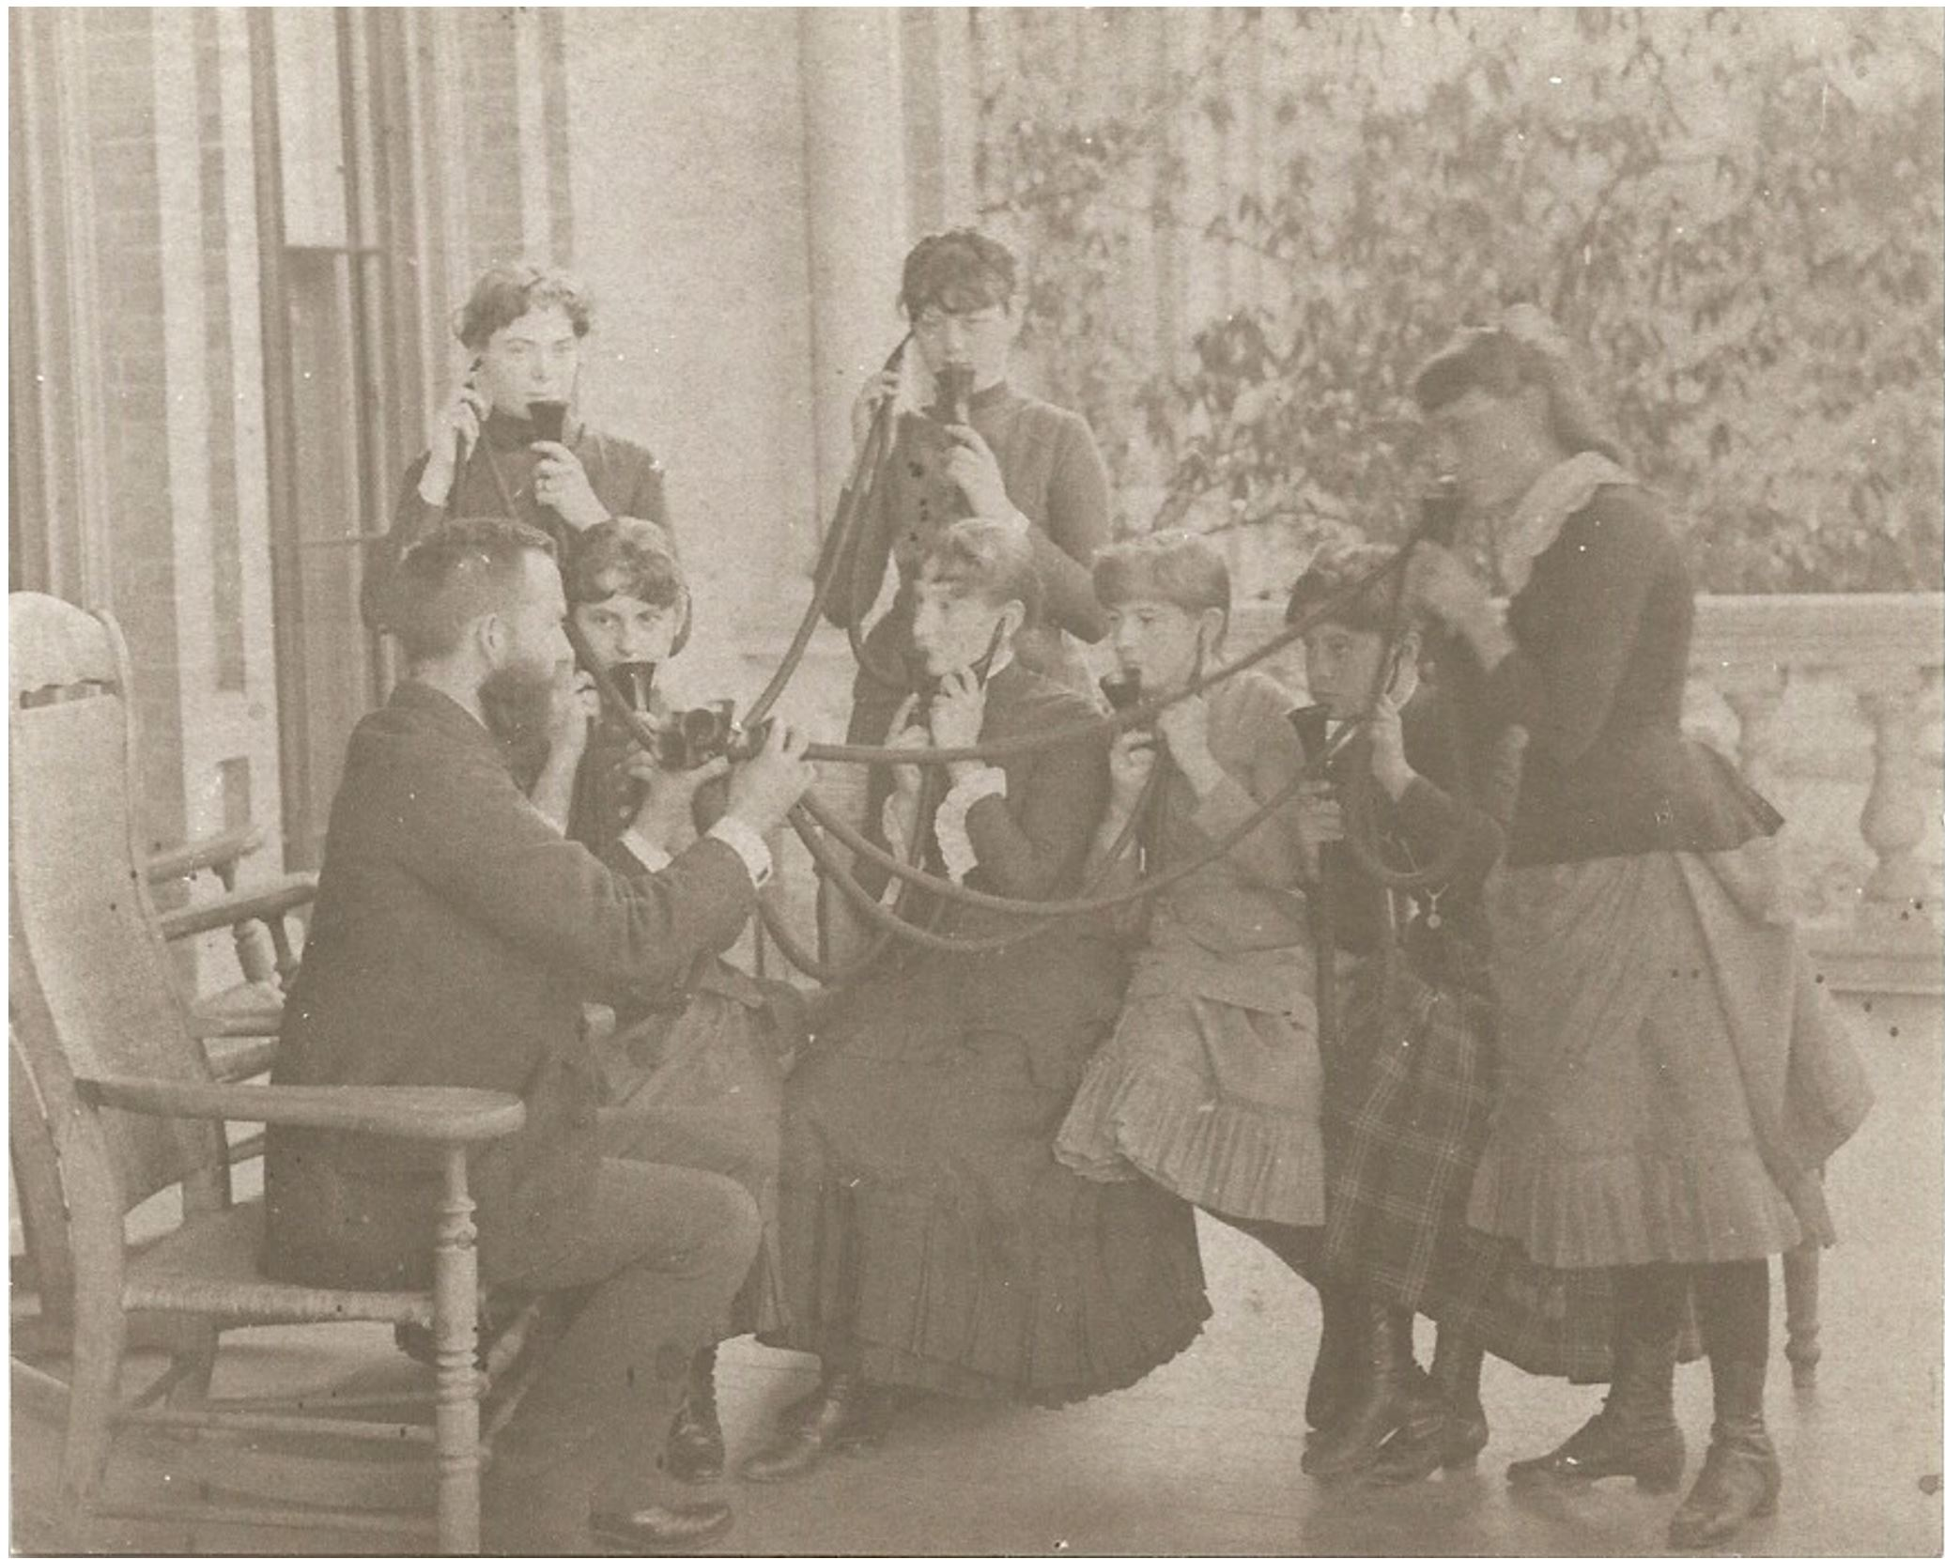

Picture of early articulation class on the front porch of the School Building. These students in 1885, appear to be demonstrating the use of some type of new hearing aid equipment on the front porch of the Institution. Perhaps they are catching up on the latest gossip.

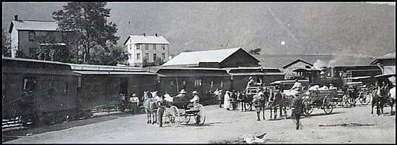
Romney Train Depot, c. 1888. (Source: Nancy Lee Biggs post to Hampshire History Facebook Page)

The completion of the B & O Railroad extension from Greenspring to Romney and the building of the depot in 1884 was hailed as a great convenience and boon to the economy of the area. The October 6, 1884 “Tablet” reports this event. This article reprinted from the Cumberland Times, reads: “Since the completion of the South Branch Railroad to Romney, a gentleman named Kelley, representing one of the large iron establishments of Pittsburgh has been prospecting for ores, and on Monday next he expects to have one hundred men at work in the Valley. The road crosses several veins , on of which is 12 feet thick and is said to carry 68 percent of iron.”

Another item of interest relates:
"An excursion train brought to Romney last Thursday some fifty of Cumberland’s solid businessmen who represented the oldest firms in that city. They were accompanied by their City Cornet Band. They were received at the Institution by the Principal and entertained in the chapel by an exhibition of a number of pupils of both departments. They also expressed much interest in the shops of the Institution. They left at 5 p.m. expressing themselves as having been highly entertained and delighted."

The December 8, 1884 issue of the "Tablet" reports on the completion of the construction of the Romney depot. It is described as a 25 X 95-foot building of modern and ornamental design with windows of stained glass and interior of imitation mahogany. For those who do not remember the depot, it was damaged by fire around 1970, and later torn down. It is ironic to note that the railroad, which was completed in 1884, was destroyed 101 years later by the flood of 1985.

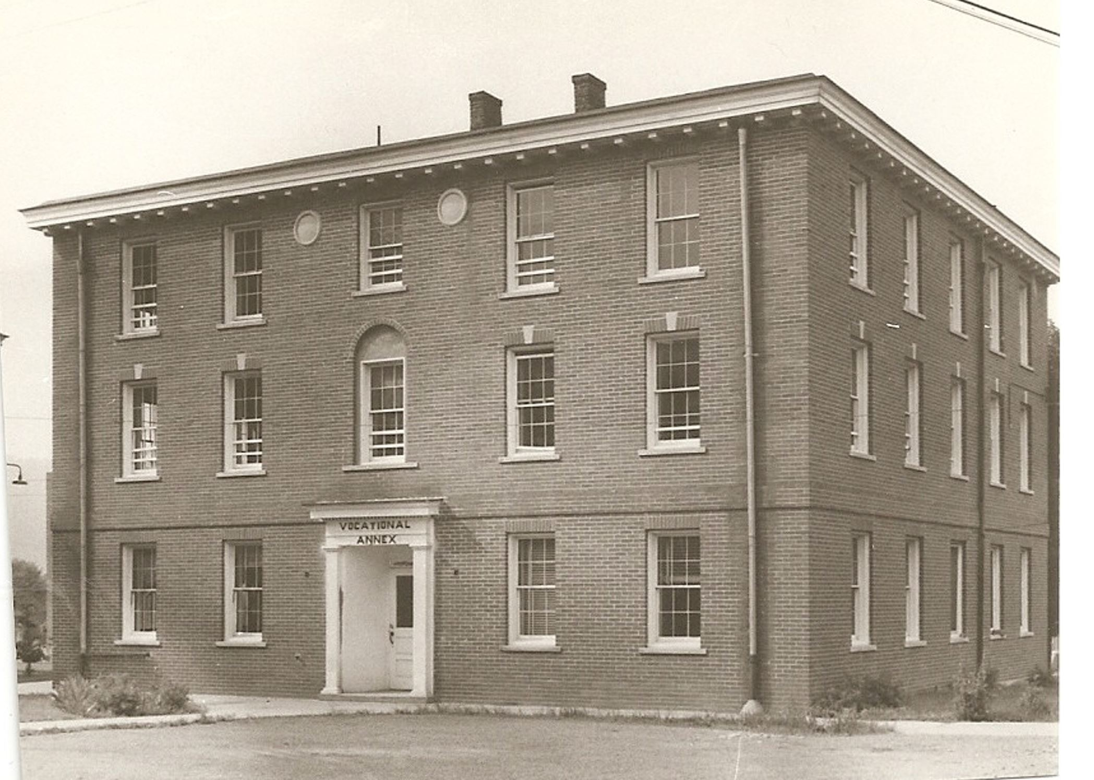
Place picture of the Vocational Annex here.

The Vocational Annex, originally a wooden frame exterior was later covered with brick veneer. It was erected behind the north wing of the main building in 1872 to serve as a vocational shop. This building was later enlarged, used as a deaf boy’s dormitory, and then ultimately changed back to a vocational building before it was razed in the 1970’s. This picture shows its most recent use as a vocational building.

In 1873, Mr. Hollister resigned in order to take up the practice of medicine, and Dr. Lupton was made temporary principal of the schools.

In 1874, Mr. Levens Eddy from the Wisconsin School for the Deaf assumed the position of principal, but remained only a few months, resigning in July 1874.

The Board of Regents then extended the principalship to Major John C. Covell, Superintendent of the Virginia School for the Deaf at Staunton. The schools made very rapid progress under Major Covell's 13 years of leadership until his death in 1887. During Major Covell's years of service to the schools, a steam heat system was installed, and a pupil’s dining room and chapel were erected. The field situated between the original school property and the Potomac Seminary (later to become the School for the Blind) was purchased in 1881.

The Music Department was an important part of the school program for the blind students as early as Mr. Covell's administration during the 1870's and 1880's. The "Tablet" tells of a joint performance given in front of the Institution by the blind boy’s band along with the town band, led by Professor Shaeffer. It also includes invitations to the public for the Annual Concert of Vocal and Instrumental Music as well as Commencement Exercises.

Following Major's Covell's death, Mr. H. B. Gilkeson, Secretary of the Board, was appointed as temporary principal.

In the fall of 1888, Mr. C. H. Hill, of the North Carolina School for the Deaf, accepted the duties of principal. Mr. Hill served in this capacity for nine years, and during that time many improvements and changes occurred. The name of the schools was changed by the legislature from the "Institution for Deaf, Dumb ana Blind" to the "West Virginia Schools for the Deaf and the Blind".

The educational status of the schools likewise advanced under his direction by the adoption of wider and more up-to-date curriculum and procedures.

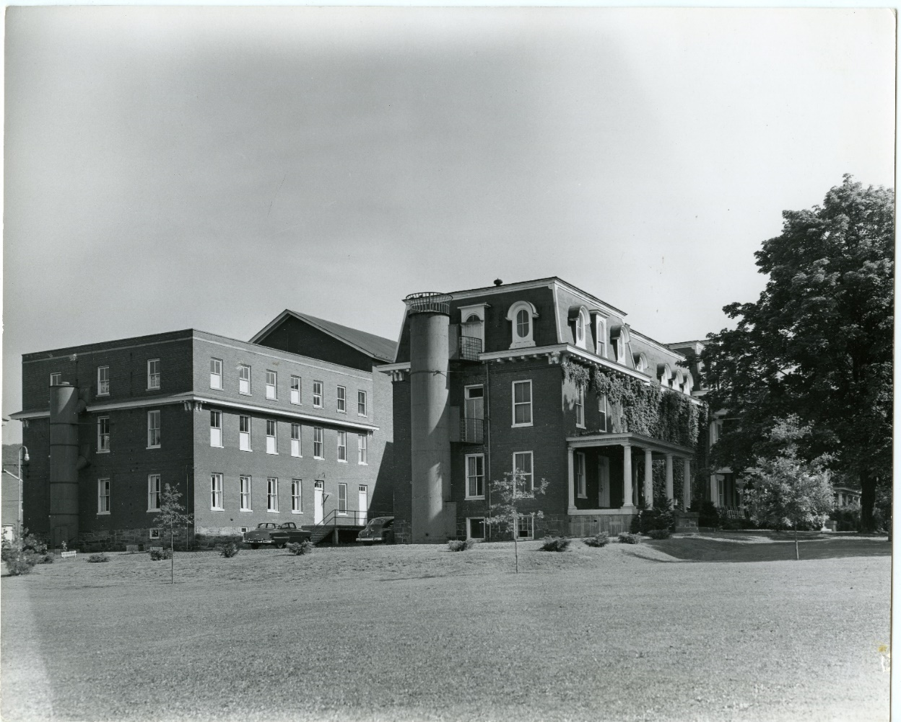
Administration building, showing north wing, with third floor still intact and "H" shaped addition on the rear of the building.
(Source: http://www.historichampshire.org)

In 1891-92, additions were made to the main building on the east side, parallel to the original structure and wings. These new sections, which gave the entire building the form of an "H", provided accommodations for about 200. By that time, the number of students had reached 125 and Mr. Hill recorded that the school had already served a total of 320 deaf and 138 blind students.

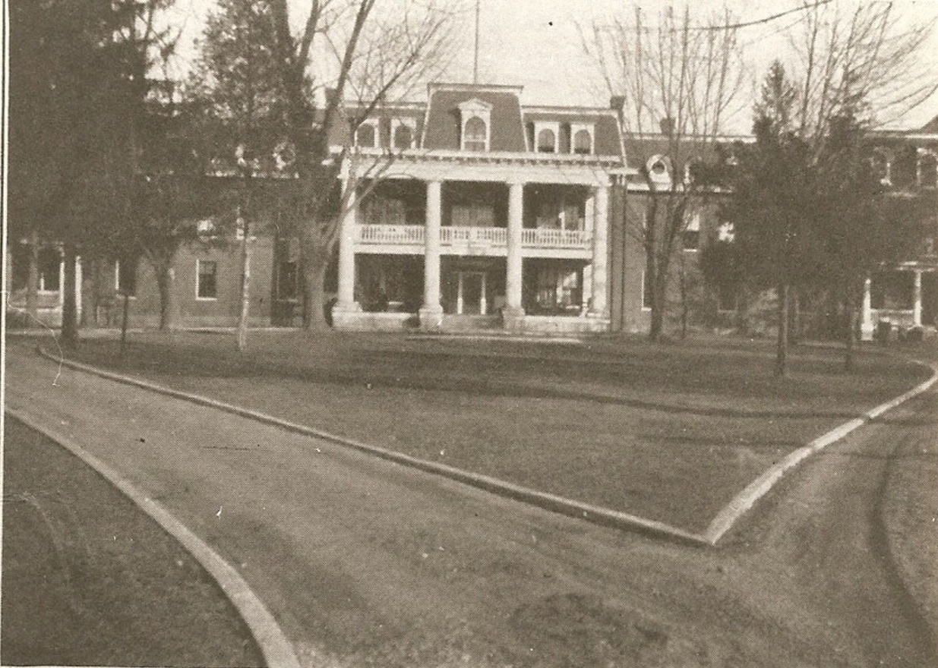
We are not sure, but perhaps it was during this period of renovation and addition to the building that the main entrance was given a facelift in the form of a two story porch supported by the massive white columns that are still in use today.

In the fall of 1897, Principal James T. Rucker assumed the reins, continuing until January 1910. He, also being a teacher of good training and experience, continued the elevation of the school in educational achievement. It appears, that under his regime, oral instruction was given increased emphasis, although the manual method predominated, most of the teachers being deaf. Under Hr. Rucker the title of Principal was changed to that of Superintendent.

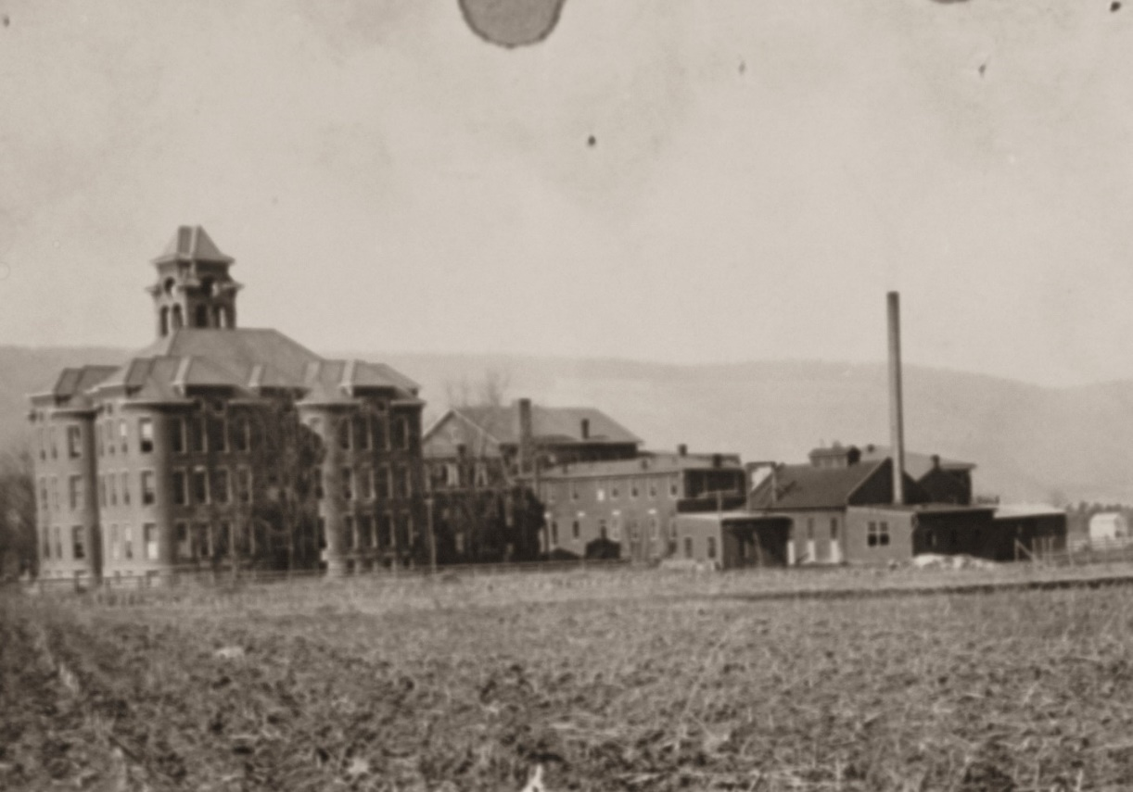
Known as Rucker Hall, this four-Story Classroom Building originally erected to provide classrooms for both the deaf and the blind
students, was later used solely by the School for the Deaf. (Source: Collection of Charles Hall)

During Mr. Rucker’s administration, a four-story classroom building, known as Rucker Hall,
was erected on the southeast side of the original building, very near the main street. (This building was occupied in 1900 and remained in use until it was destroyed by fire in 1971.) The area in the foreground of the picture shows a harvested field of corn.

A composition by Rufus H. Callison from the "Tablet” helps us envision the appearance of the campus during these early years. He describes the building of brick with large windows and covered with a Mansard roof of tin. In the back yard there are a laundry, a bake house, a bowling alley, an icehouse, a stable, a meat house, a trade shop, a barber shop, a chicken house, and a gymnasium for the pupils. The front lawn is described as somewhat sloping, with beautiful walks and trees and a fountain in the central part of the yard.

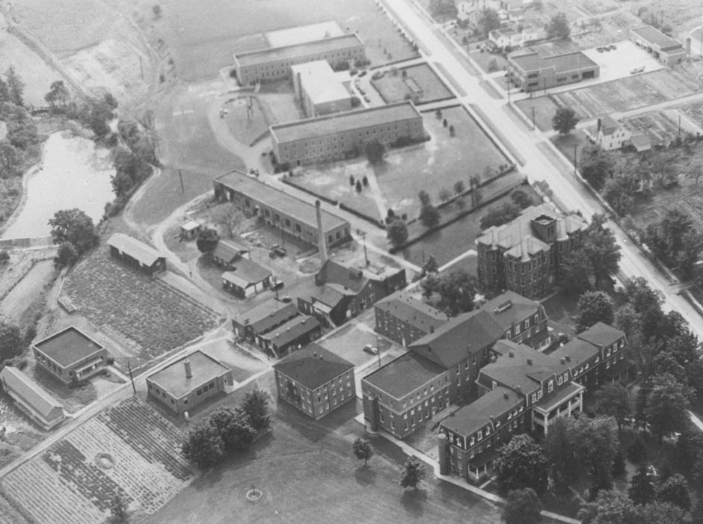
Aerial View of Administration Building and surrounding complex. (Source: http://www.historichampshire.org)

The Music Department was an important part of the school program for the blind students as early as Mr. Covell’s administration during the 1870’s and 1880's. The "Tablet" tells of a joint performance given in front of the Institution by the blind boy’s band along with the town band, led by Professor Shaeffer. It also includes invitations to the public for the Annual Concert of Vocal and Instrumental Music as well as Commencement Exercises.

With the establishment of the schools and the rapid improvements in both facilities and curriculum, the state of West Virginia ended the 19th century and entered the 20th, well equipped to provide educational services to the hearing impaired and visually impaired youth of the state.

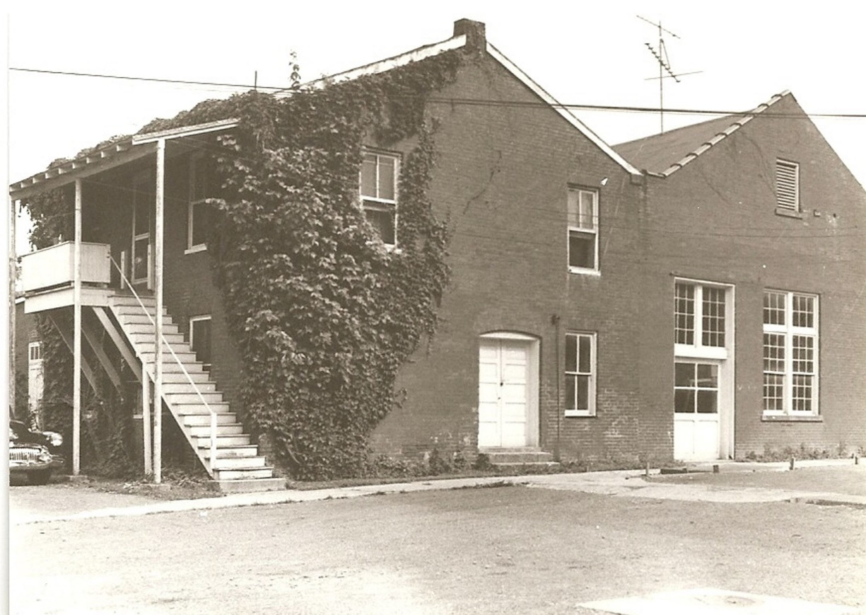

1903-1905. Heating Plant for steam, heat also ran the dynamo for the campus lighting system.

In 1901 and 1902, the State of West Virginia purchased additional land adjoining the main part of the 35-acre campus from the heirs of John Heiskell. In addition, the 140-acre farm of A. B. C. Whitacre was purchased for $4,385.

The Potomac Academy property was purchased in 1919 and the northern end of the campus was ultimately developed into separate facilities for the School for the Blind. A dormitory for the blind boys was constructed and occupied in 1922. The building which was the original Potomac Academy (a privately owned school tor the higher education of local youth), was remodeled in 1923 and used as a classroom building by the blind students. The girls’ dormitory was constructed and occupied in 1925, completing the three-building complex which was to house the School for the Blind for the following two decades.

Mr. Rucker continued as superintendent for thirteen years until January 1910. By the end of his administration, in addition to the completion of the new four-story classroom building and the purchase of the farm property, an electric system had also been installed.

In January 1910, Mr. R. Cary Montague was appointed the new superintendent of the schools. During his tenure, advances were made in oral methods of teaching the deaf, with the number of hearing teachers increasingly more proportionate to the number of deaf teachers. It appears that the trend toward oralism in teaching the deaf was greatly opposed by the deaf population of the nation. Mr. Montague was a strong contender for oralism but was wisely temperate, realizing that there were many deaf whom this method could not approach. Therefore, he also gave due place to the manual methods of teaching.

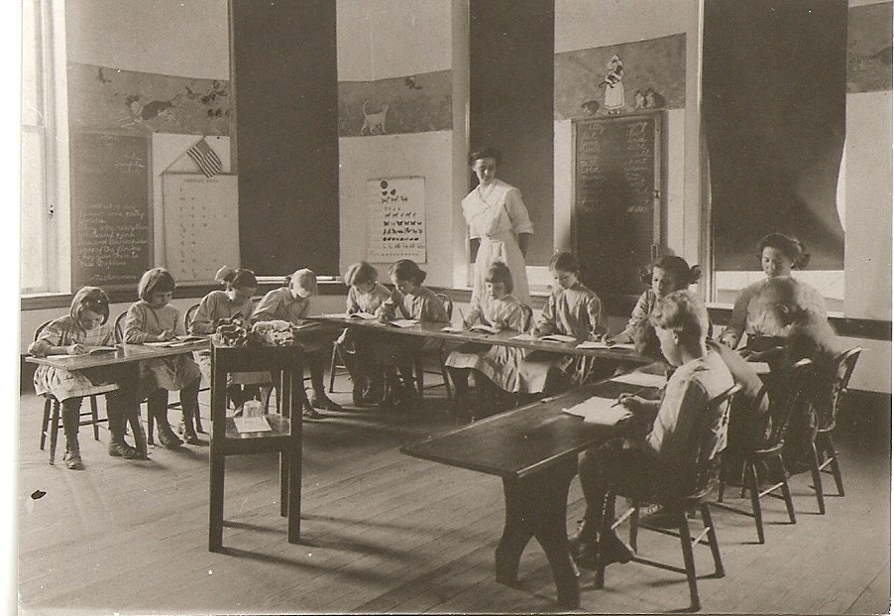
Miss Edna Wirgman’s elementary writing class

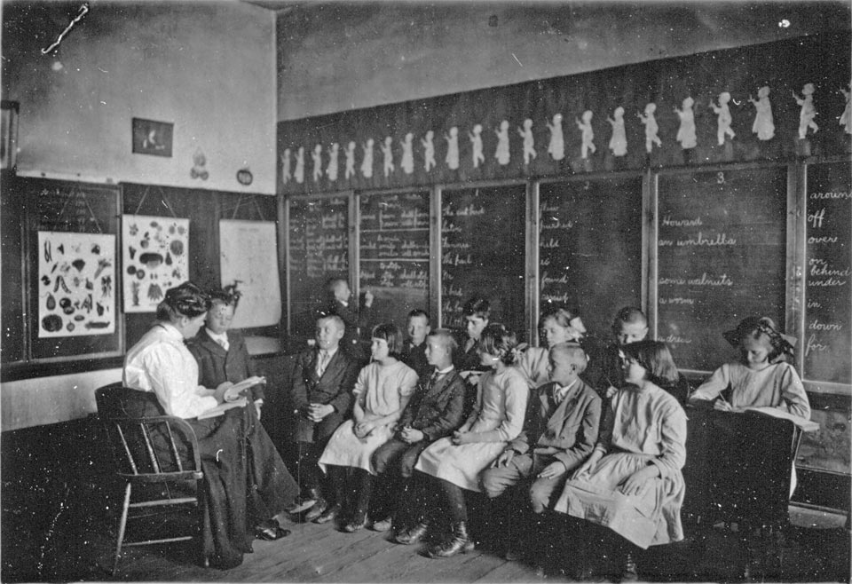
1908 classroom scene with Miss Ann Gibson and students, (Source: http://www.historichampshire.org)

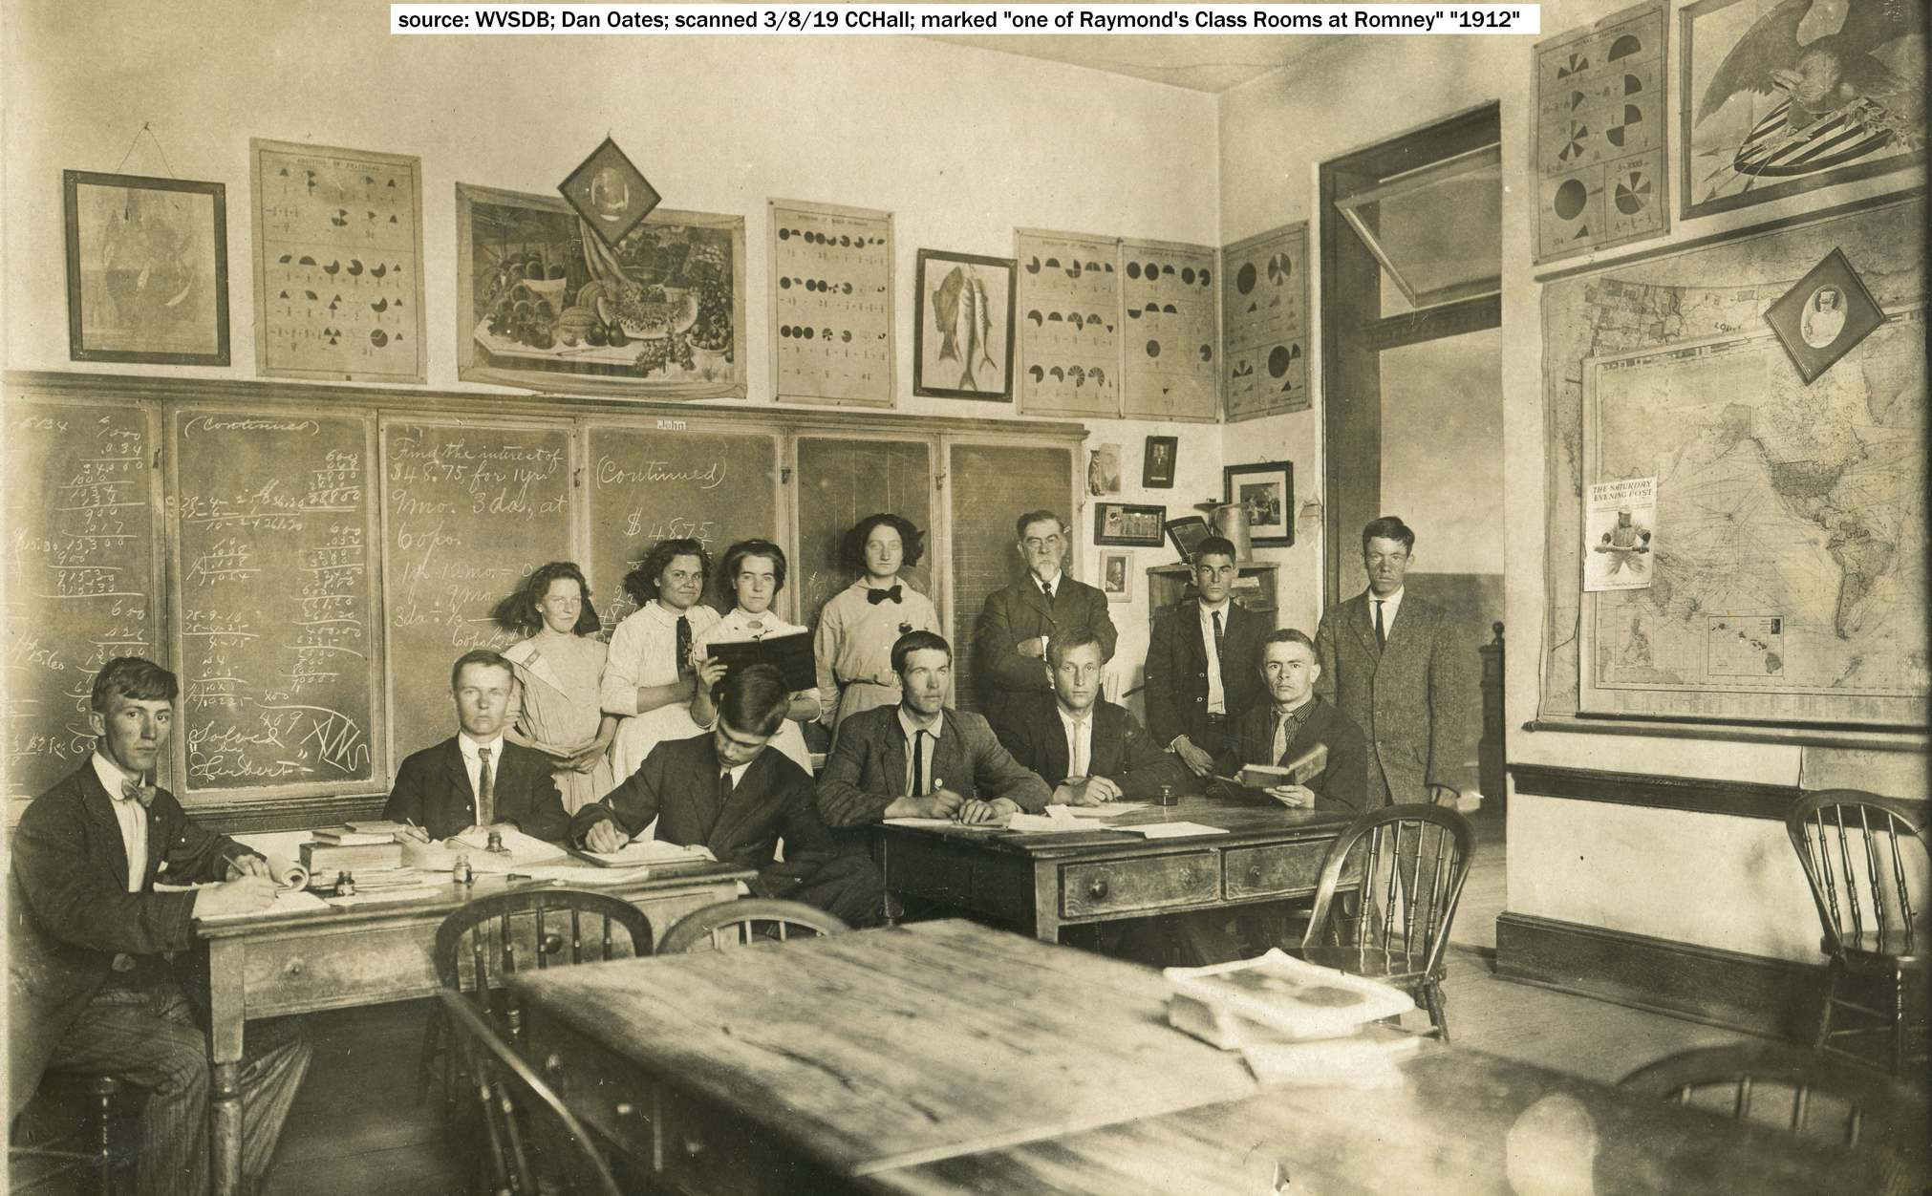
1913 Math Class under the instruction of Mr. Chapin. (Source: http://www.historichampshire.org)

Upon Mr. Montague’s withdrawal as superintendent, Mr. Parley DeBerry of Terra Alta, was appointed on January 1,1914.

Mr. DeBerry's experience as a teacher and administrator, together with a keen business ability, were invaluable assets for a successful administration. Mr. DeBerry was always keenly interested in political issues, and as so often happens, this brought about his removal at the completion of the 1916-1917 term
During Mr. DeBerry's administration the school was honored by the visit of the famous deaf-blind speaker, Miss Helen Keller.

Mr. F. L. Largent was appointed acting superintendent until in 1917 when Mr. F. L. Burdette, from Huntington, assumed the position.

Mr. Burdette, after only two years as superintendent, resigned. It was during his administration that the tragic Spanish Influenza epidemic swept through the campus, taking the lives of four deaf girls and rendering almost all of the students and staff members ill to some degree.

The administration of the schools has fallen under the direction of three state departments; first the Board of Regents, then a Board of Control, and finally, in 1919-1920 the State Board of Education. The placement of the schools under the Board was a big step toward removal of the influence of politics which had so adversely affected the welfare of the school.

It became then, for the first time in the fifty years of the schools' existence, the prerogative of the State Board of Education to select a new administrator. In 1920, they chose Hr. K. F. Griffey, likewise a man of experience in the field of education. An outstanding achievement of his administration was the separation of the two schools with the remodeling of recently purchased Potomac Academy and the construction of the boy’s dormitory for the School for the Blind on the northern end of the main campus.

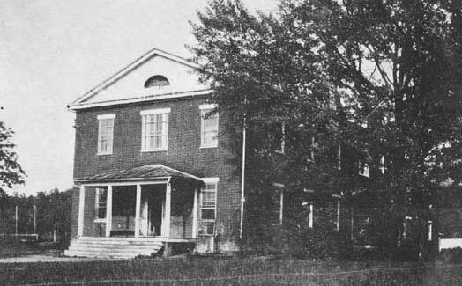
The Potomac Academy, not used after 1916, was purchased by the State in 1919 along with seven acres of land from the
Presbyterian Church, Winchester Presbytery. Remodeled in 1923 for use as a classroom building for the School for the Blind.
(Source: http://www.historichampshire.com)

Upon Mr. Griffey's resignation in August 1923, the State Board of Education, at the consent of Governor Cornwell, appointed former Superintendent Parley DeBerry for the second time at the beginning of the 1923-24 term.
Immediate steps were taken to construct a dormitory for the blind girls at a cost of $100,000. During the ten years of DeBerry's service from 1923-1933, a large dairy barn was erected on the farm property, and a bakery and industrial arts building were built on the main campus. The old vocational building was remodeled to serve as a dormitory for the older deaf boys.

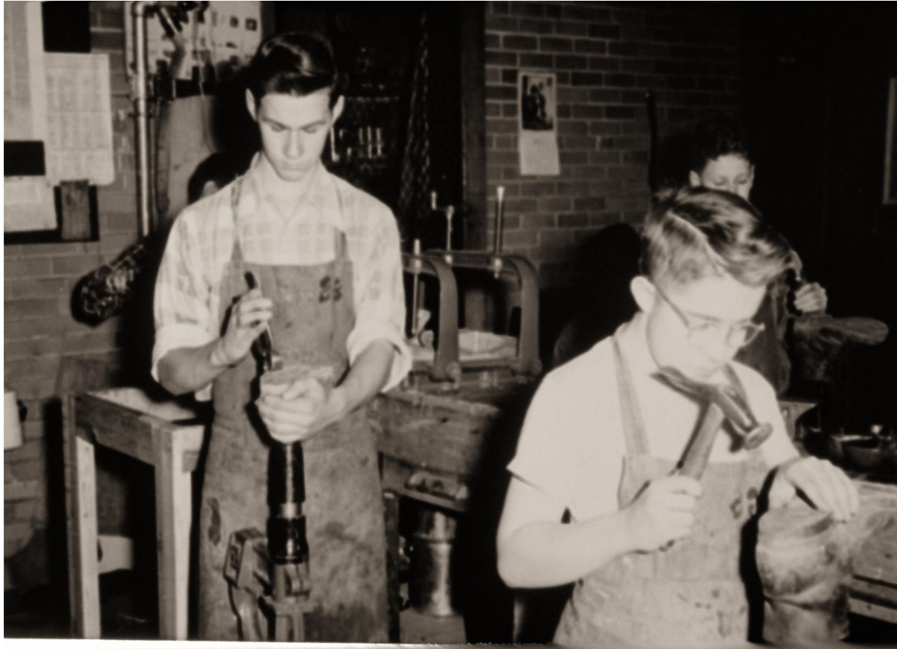
The shoe repair shop was popular among the students for wanting to learn the trade of a cobbler. The class was in the Industrial Arts Building.
(Source: http://www.historichampshire.org)

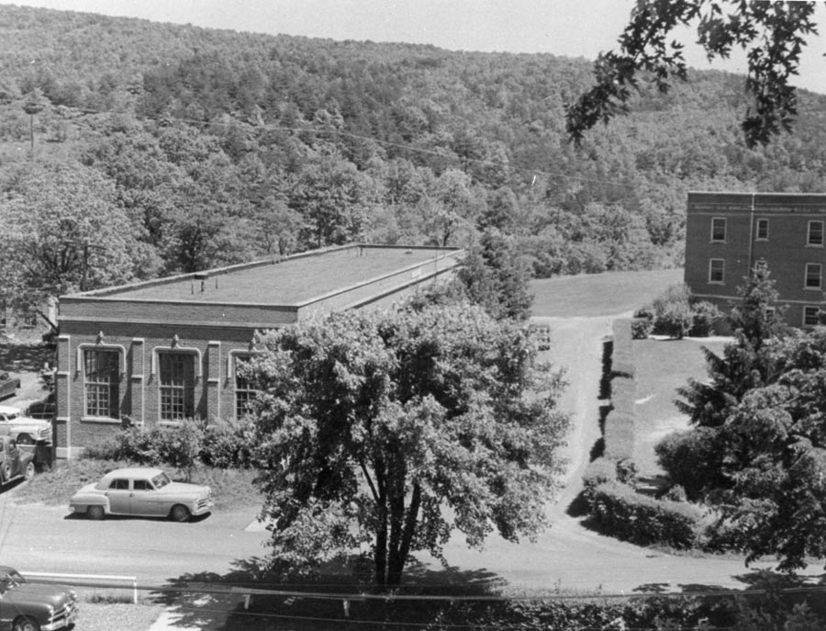
The Industrial Arts Building was very popular in the late 1940’s with the printing shop, shoe repair, and auto mechanics.
(Source: http://www.historichampshire.org)

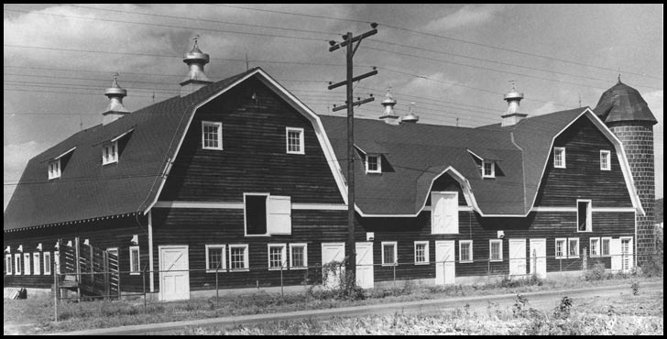
The school’s dairy barn was built in 1926-27, located on the farm property purchased from A. B. C. Whitacre. Portions of this property have since been acquired by the Town of Romney, The West Virginia State Police, the Department of Natural Resources, Hampshire Memorial Hospital, and the Hampshire Corporation for the establishment of an industrial park. (Source: Dan Oates Digital Image collection)

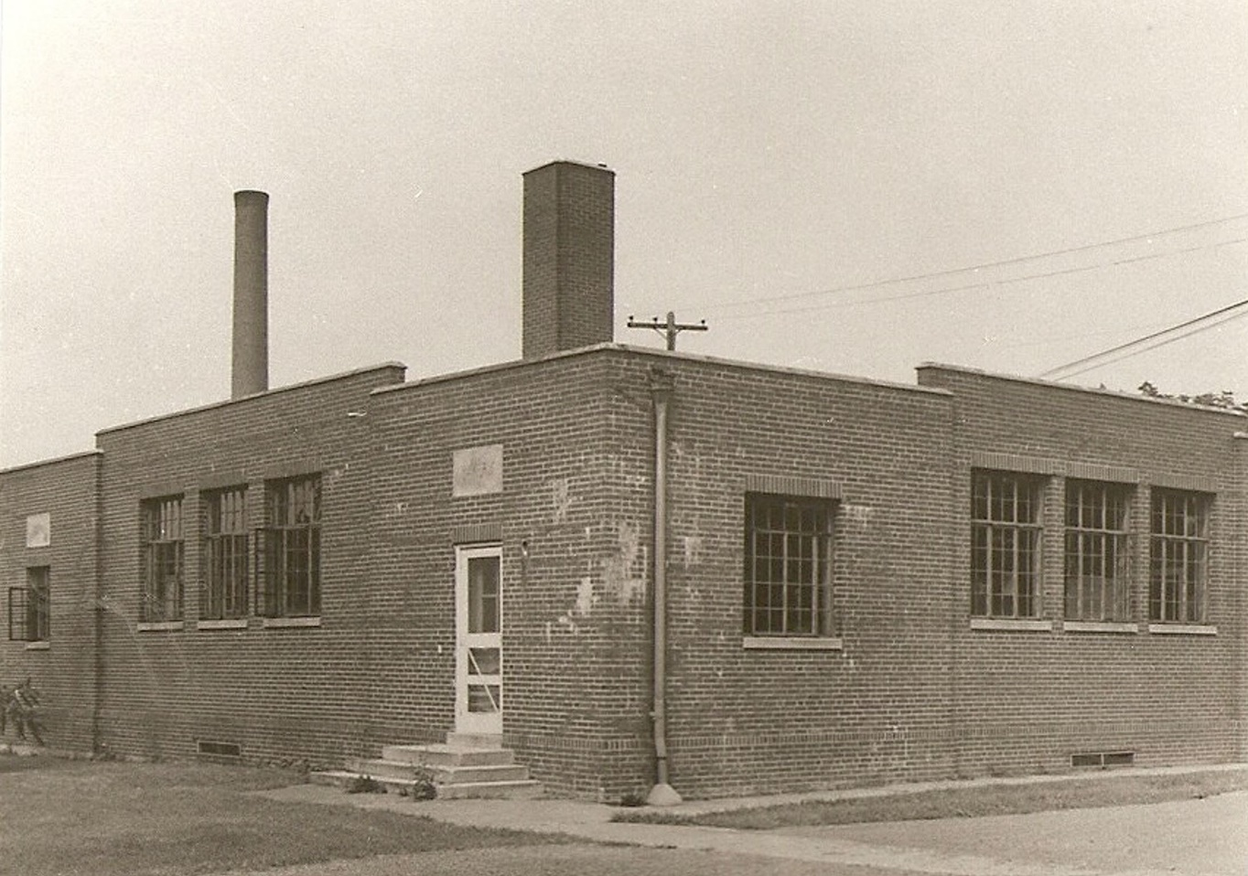

The Bakery, built in 1929, provided all of the bread and other baked goods used by the kitchens on the
School campus. The Bakery was later, for a short period, operated by the Hampshire County Sheltered Workshop.

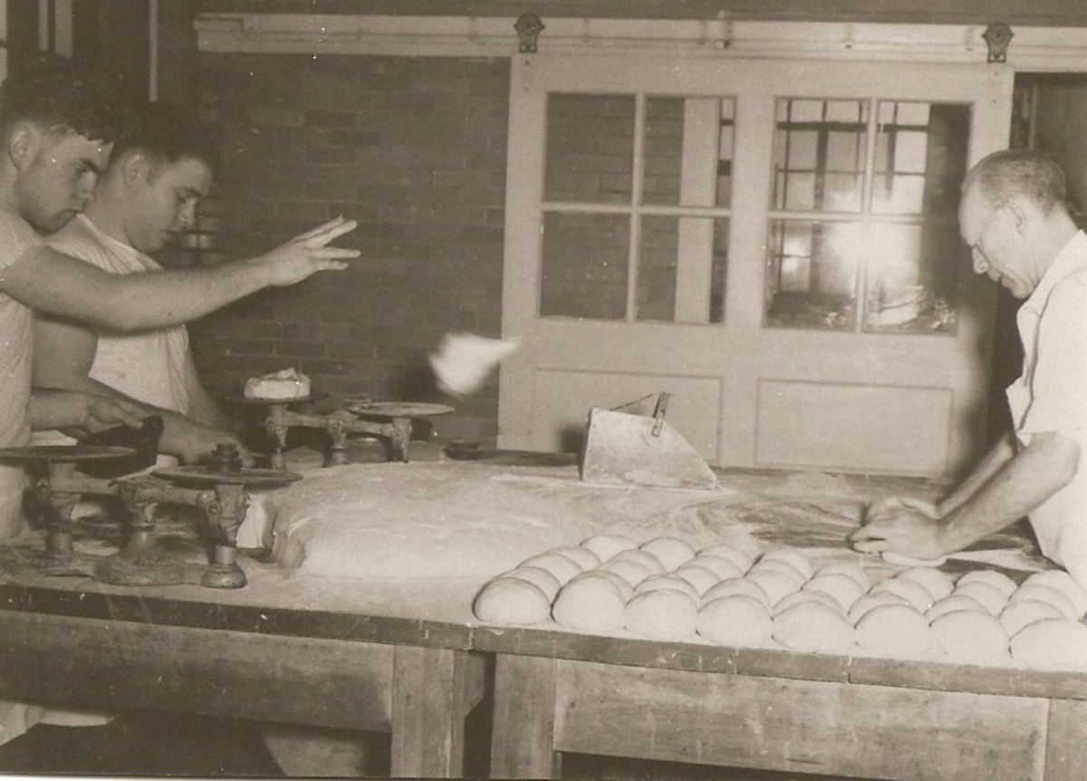
Source: April 1954 Tablet

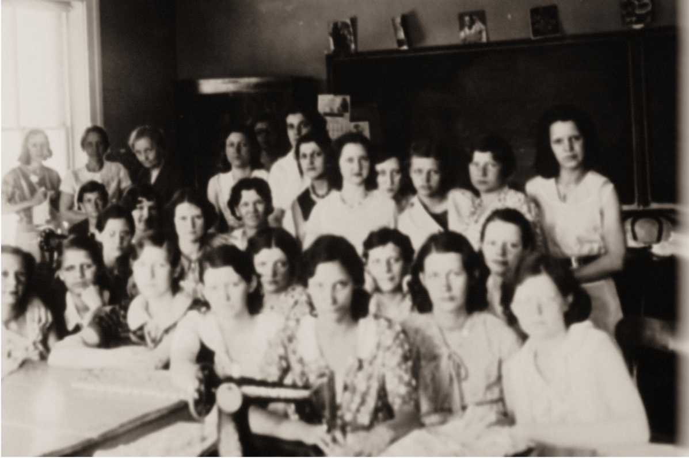
Older girls’ sewing class with new Singer Sewing Machine

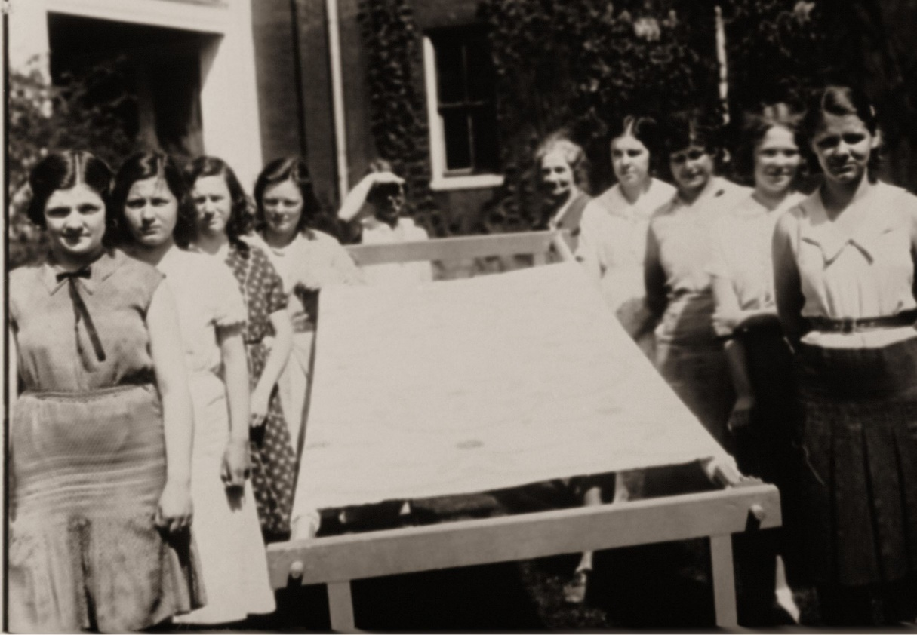

Sewing Class with quilting frame

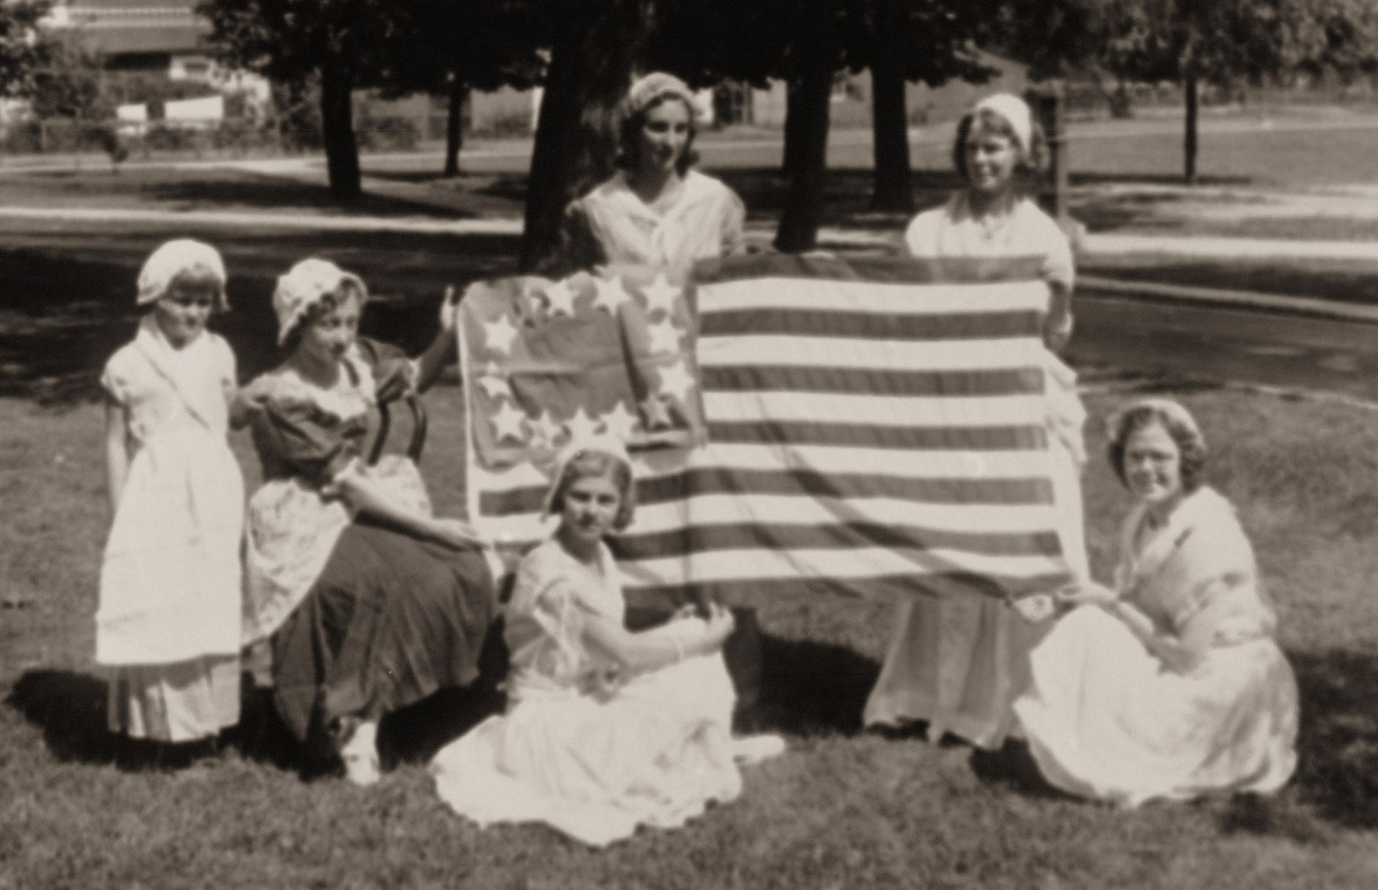
The dates for this the following picture are unknown. The students apparently were in patriotic costumes for some important occasion.

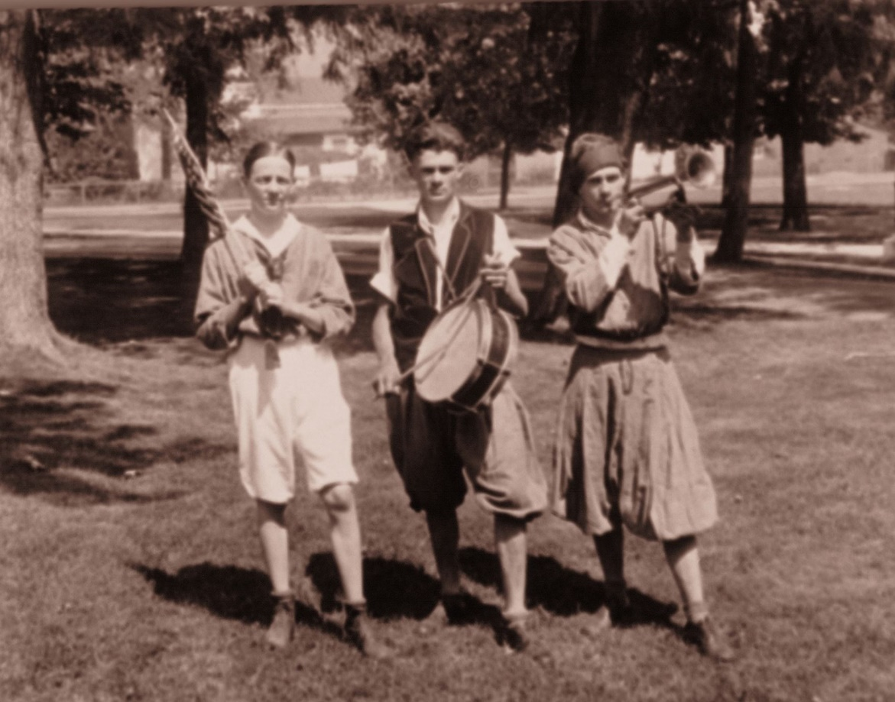
The “Revolutionary War Heroes” in front of the Main Building

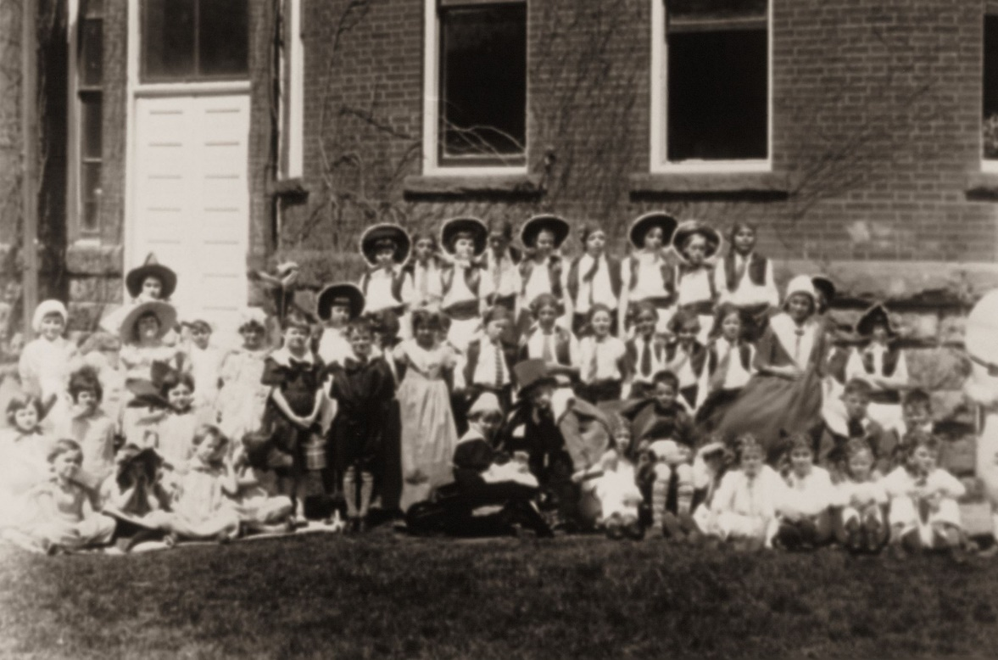
Several nursery rhyme and storybook characters, including Humpty Dumpty, are ready to perform for their classmates.

Under Mr. DeBerry's administration, the enrollment of the schools reached 400, and the teaching staff numbered about 60. Mr. DeBerry became a valiant champion for the cause of the deaf and the blind, and he did much to bring the schools to a higher standing both in physical plant and equipment and personnel. He successfully worked for the right of the deaf to drive automobiles.

Mr. DeBerry, well into his eighties, retired to his home in Terra Alta in the summer of 1933.

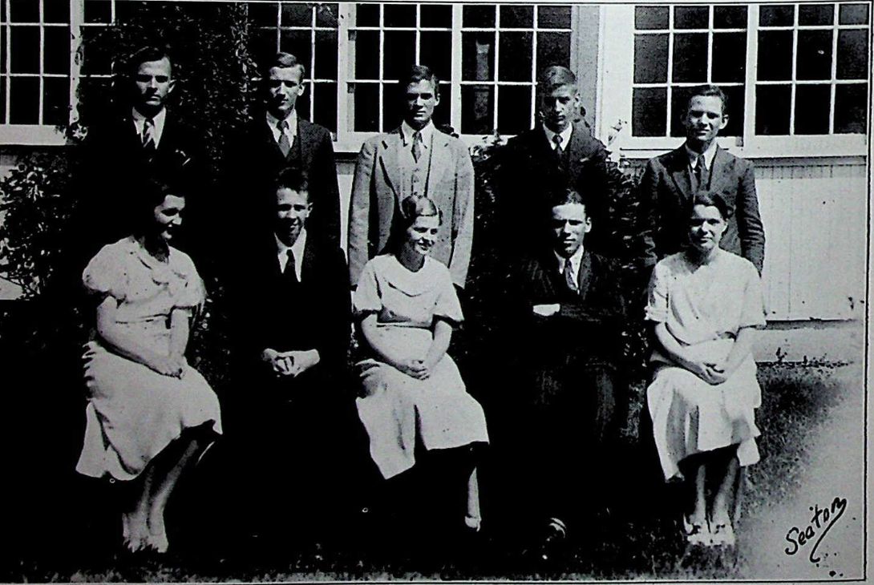
^{Graduates of the Class of 1933}
Standing L to R – Hugh Bias, Edgar Sparks, Elbert Gilbreath, Merle Sparks, and Ferrell Corbett,
Sitting L to R – Aileen Moorhead, Charles Griffith, Reba Lilly, Lesley Griffith, and Lucy Haslacker, (Source: May 1933 Tablet)

Dr. A. E. Krause became superintendent August 1, 1933. As a Lutheran minister, he was responsible for the establishment of St. John’s Academy and St. John’s Junior College in Petersburg. He assumed the office of superintendent following his recommendation to the Department of Education by Governor H. G. Kump. During Dr. Krause’s administration, athletics took on a more important role with the re-establishment of a football team for the School for the Deaf and a wrestling team for the School for the Blind. In previous years, greater emphasis had been placed on the deaf boy’s baseball and,
basketball teams, which successfully competed against teams from many of the surrounding communities.

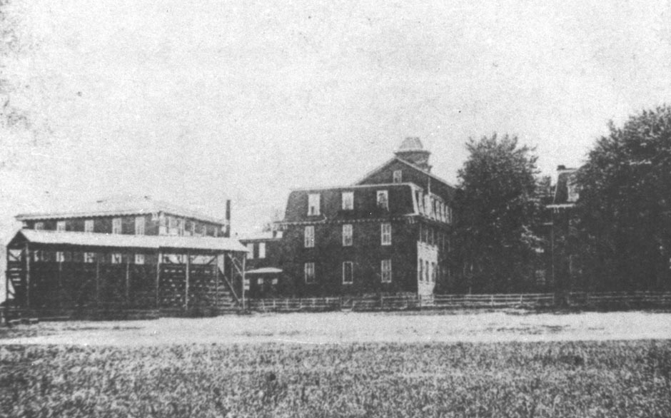
1915 View of the grandstand and baseball diamond situated on the playing field just north of the lawn in front of the administration building. (Source: http://www.historichampshire.org

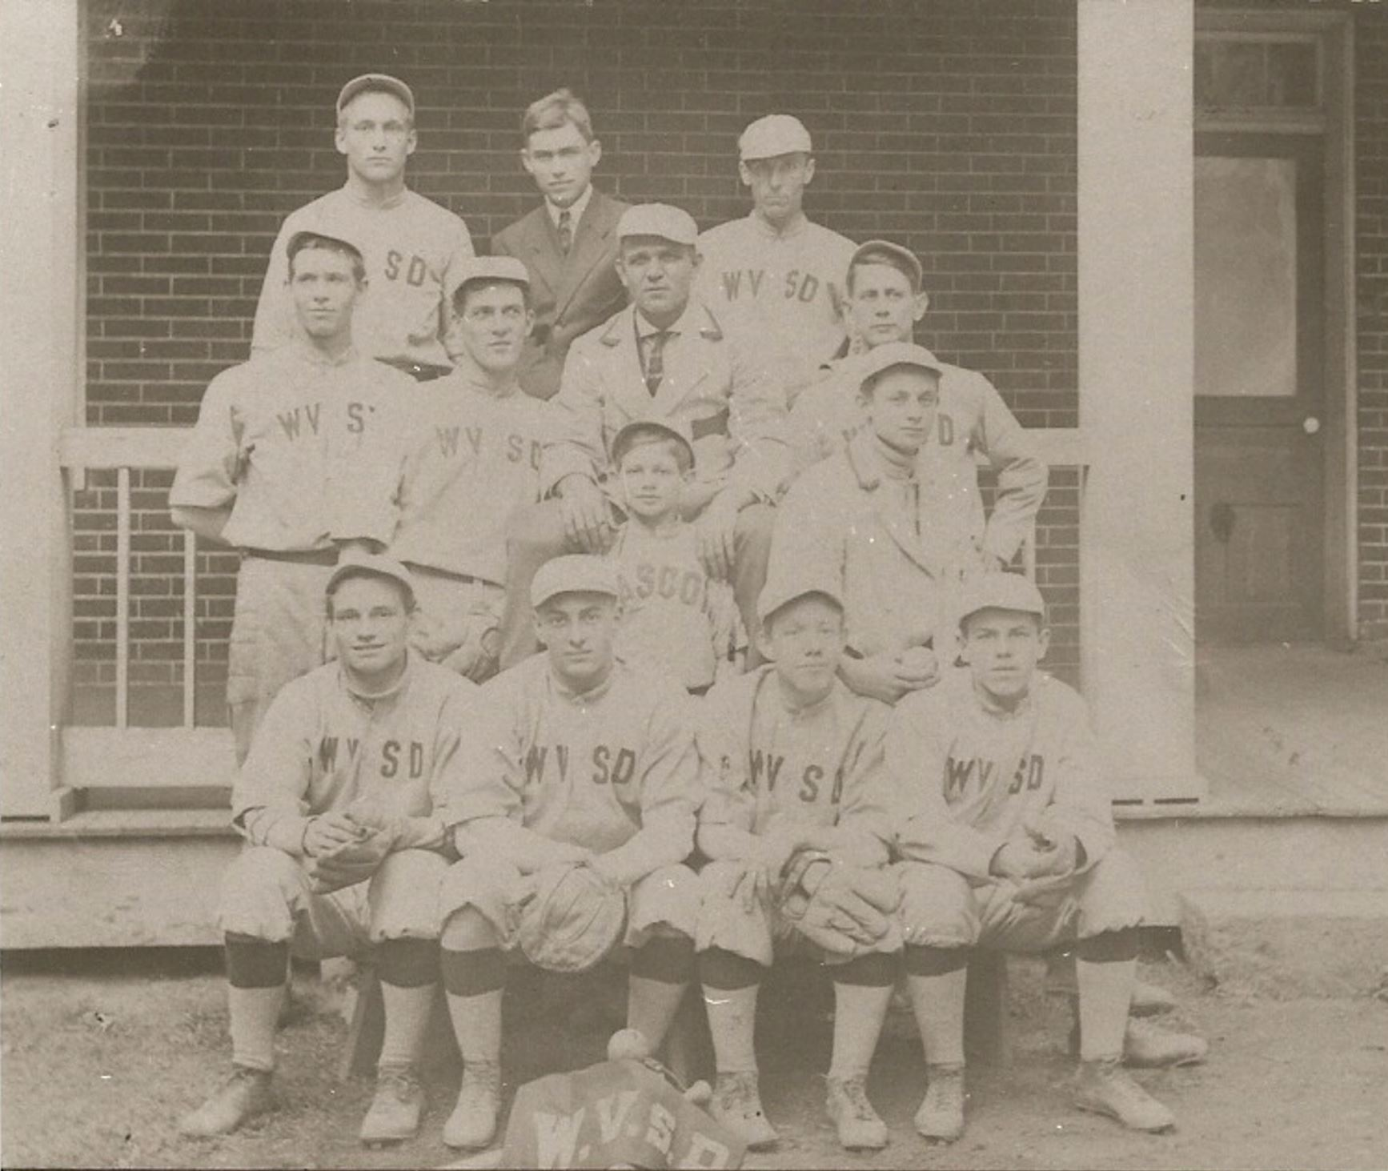
Baseball Team with coach and manager on the front porch
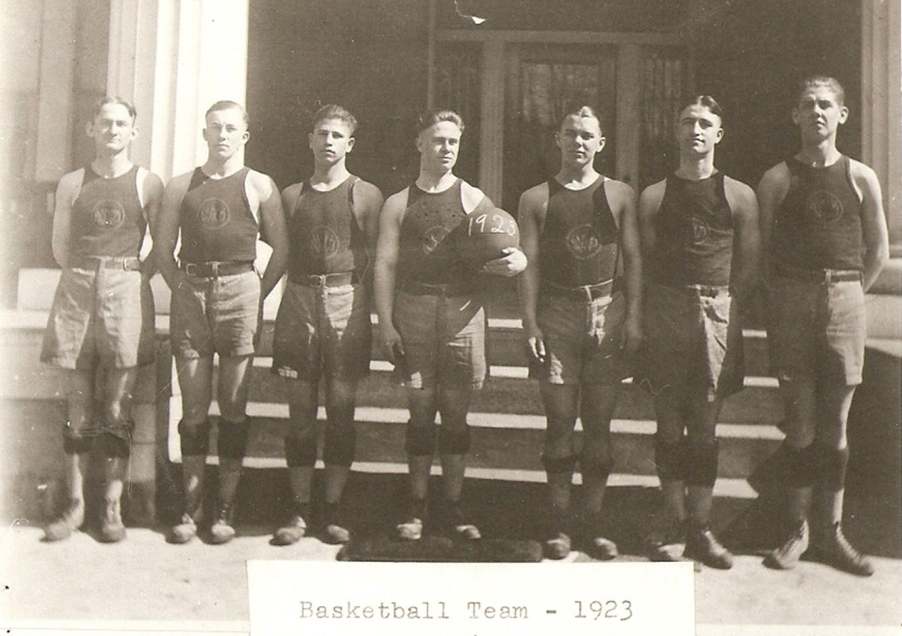

1923 Basketball Team posed at the Main Building

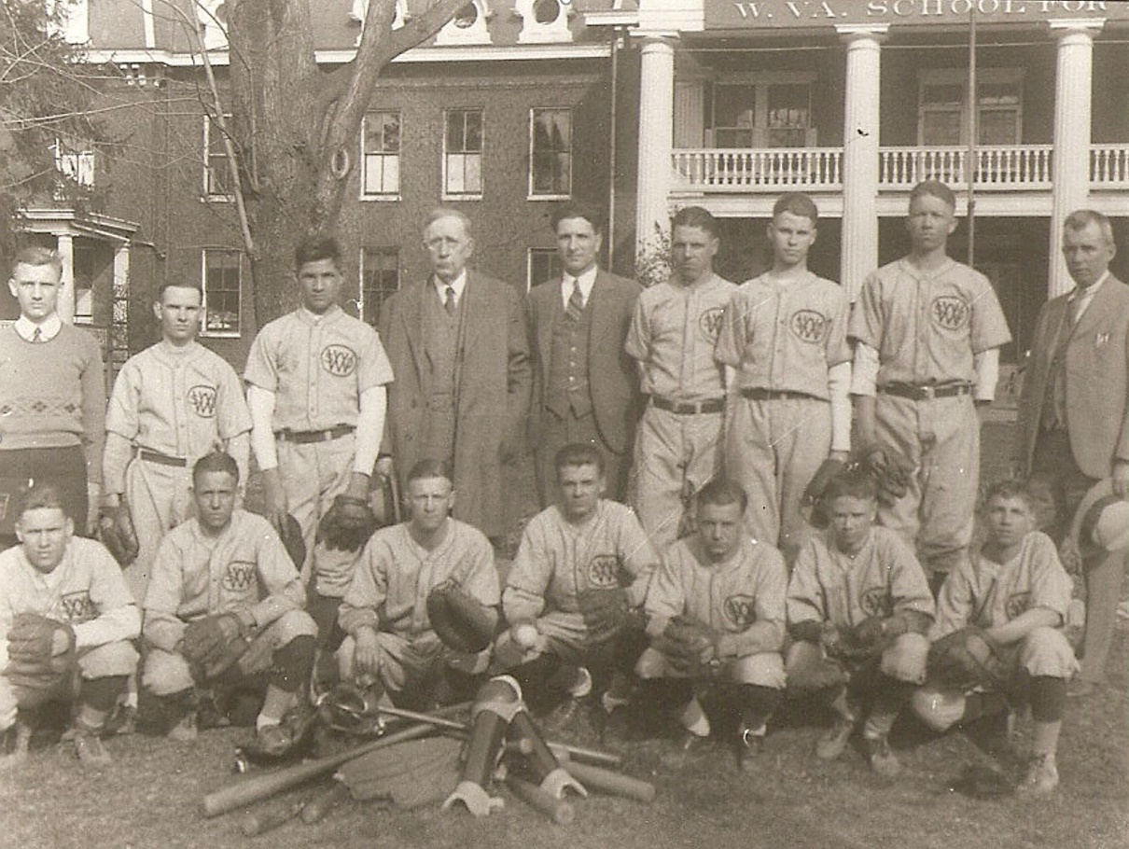
Baseball team of 1932 with Supt. DeBerry, Business manager, E. F. Staub, who was team manager;
and Mr. McCallister, supervising teacher at the School for the Deaf
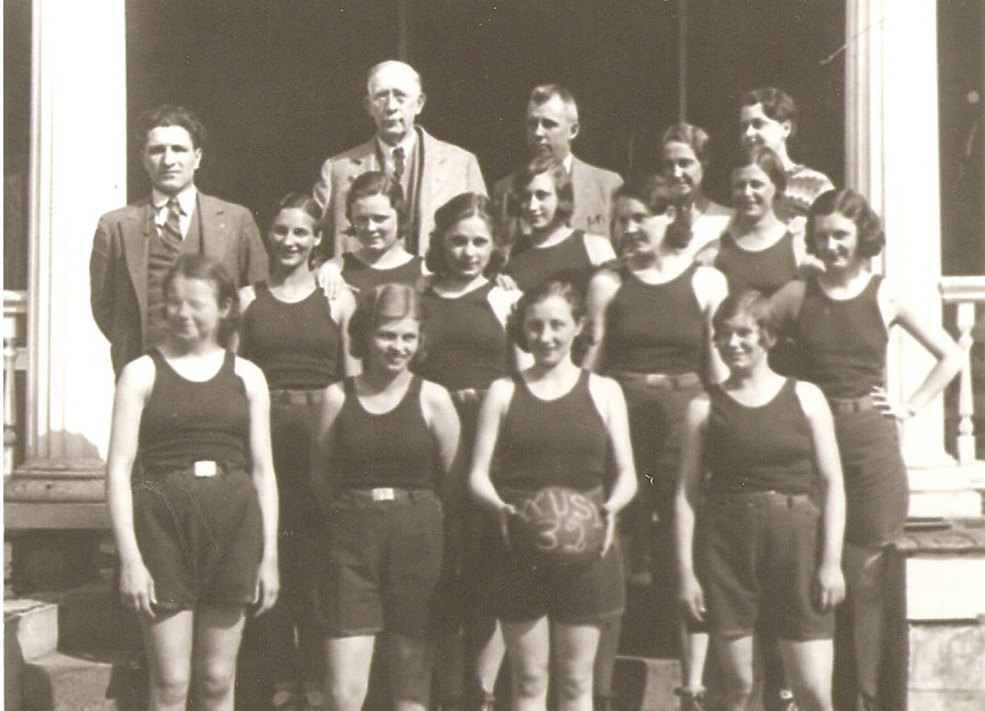
This was the era of outstanding girls’ basketball teams. Source: June 1932 Tablet

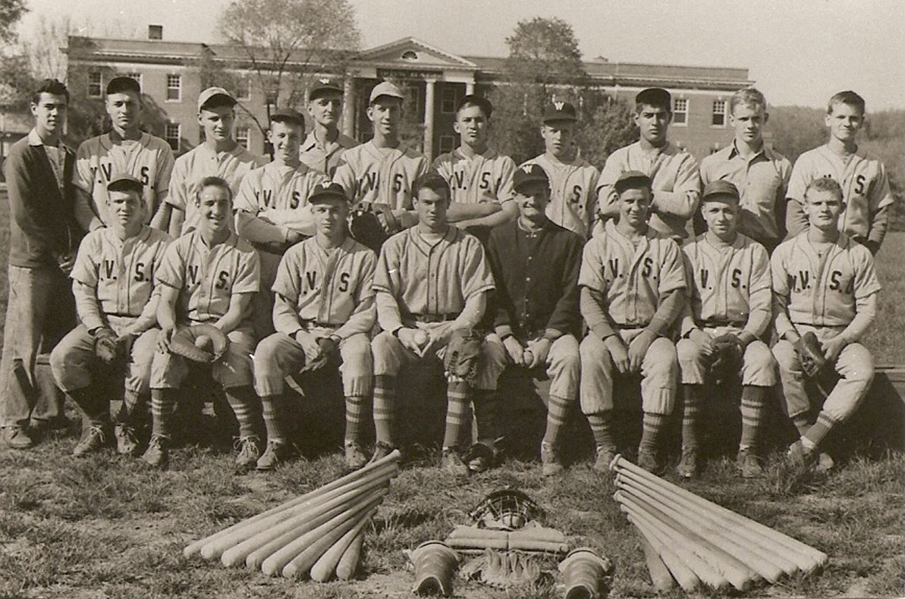
Insert another baseball team with Coach Wiltse

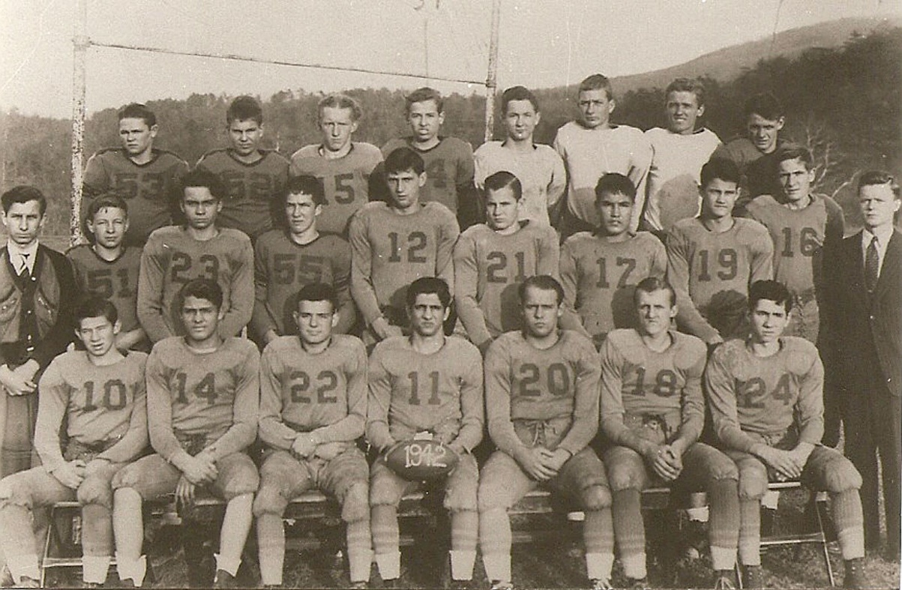
1942 Football Team suited up and ready to tackle. (Source: January 1943 Tablet)

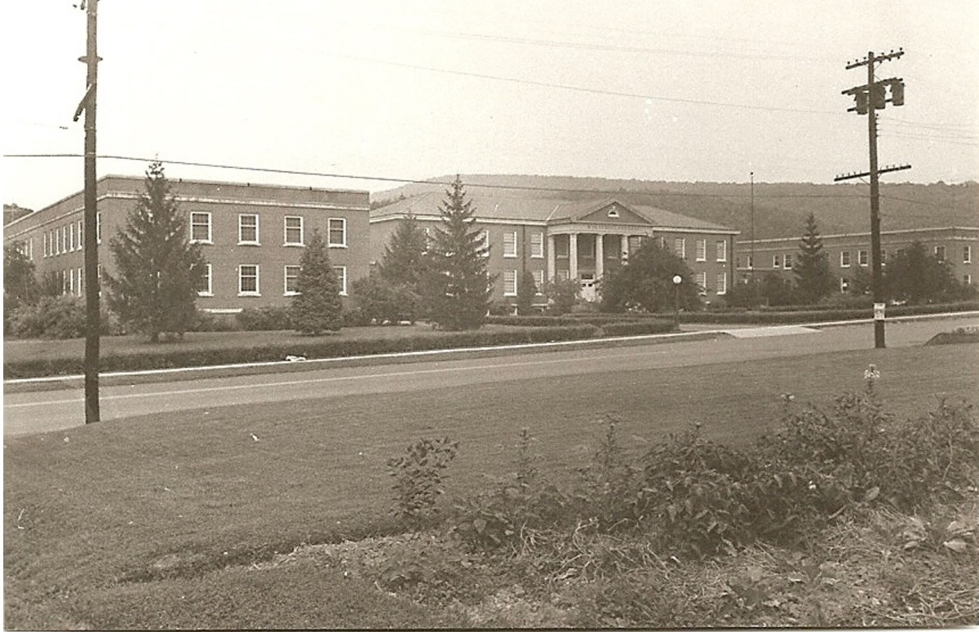
Dr. Krause secured P. W. A. (Public Works Administration) funds for the construction of the Elementary School for the Deaf (Primary Building) in 1937-38 at a cost of $290,000. Also constructed during this period of time were the Cannery in 1936 and the Laundry in 1937.
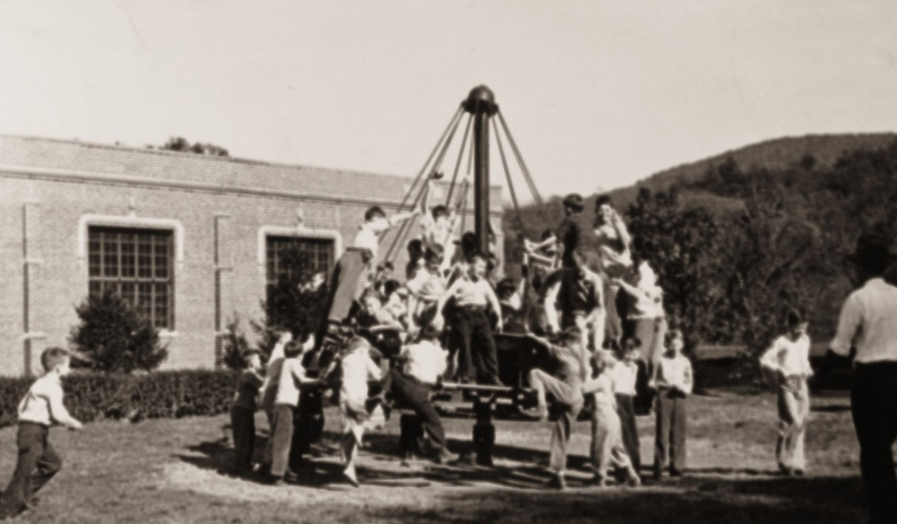
A Merry-Go-Round on the playground at the Elementary School for the Deaf. This apparatus was moved a number of times
and then eventually retired in the 1980’s.
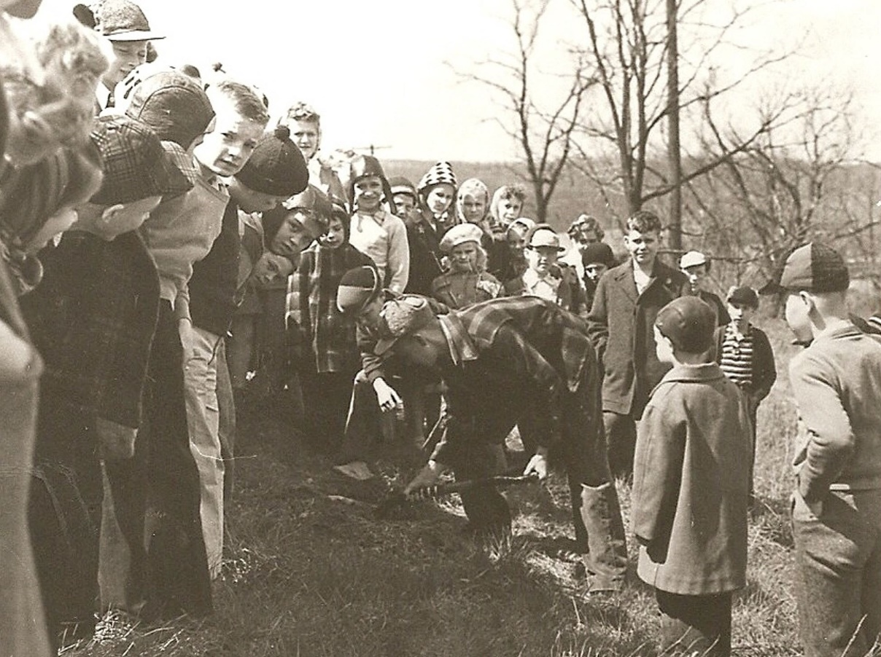
A planting of a tree for Arbor Day, supervised by Mrs. Alfreda Shanholtz (need other picture), teacher at the Elementary School for the Deaf

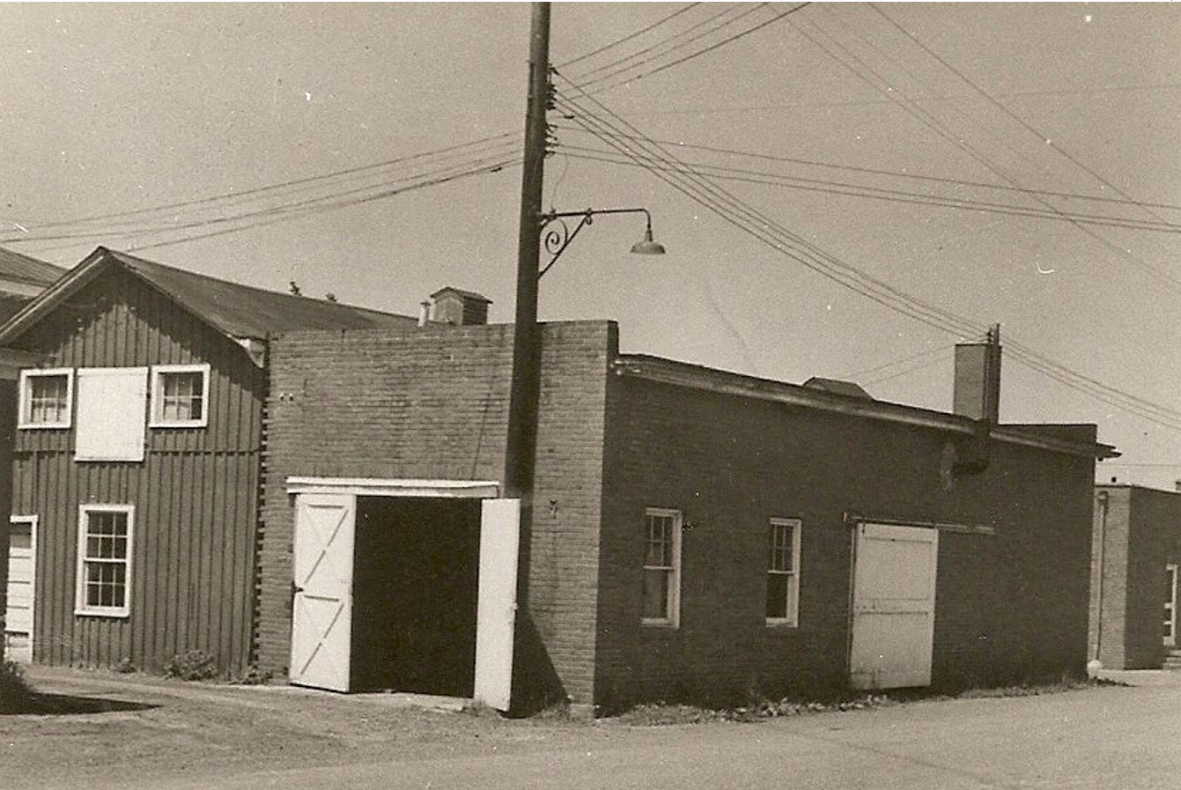
The Cannery is reported to have “put up” approximately 20,000 gallons of delicious good were processed in the cannery for wintertime meals for the students. The produce from many gardens and the employment of many people went into this effort. Mr. Harry Parker was the supervisor of the cannery and bakery.

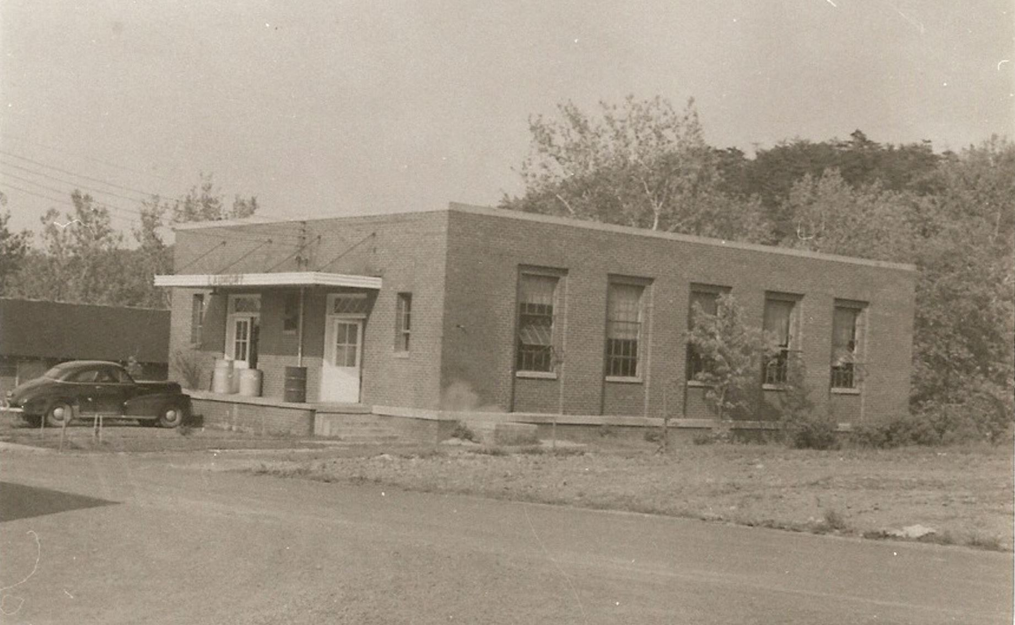^{P}
The Laundry later became the Central Supply Storeroom and office
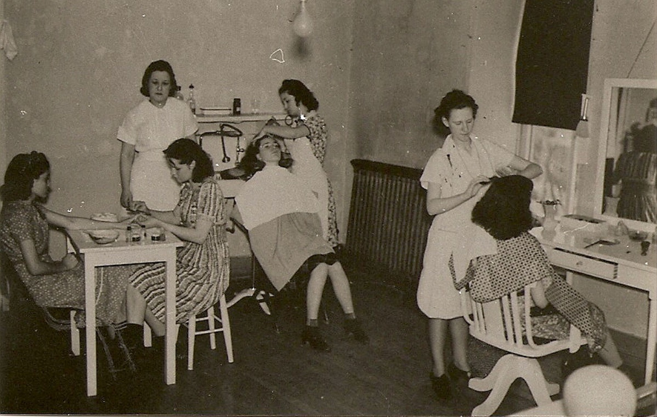
Miss Elsie Siebert had a cosmetology class in 1939. Note the nice direct lighting overhead.

Dr. Krause resigned in July of 1941 and Stanley R. Harris became superintendent. Mr. Harris was previously Principal of Romney High School and a teacher in the public schools of Wayne and Cabell Counties.

Some outstanding achievements of Mr. Harris’ administration were a new heating system, construction of the physical education building, Seaton Hall Dormitory and infirmary, and increased salaries which more than doubled during his twelve years as superintendent.

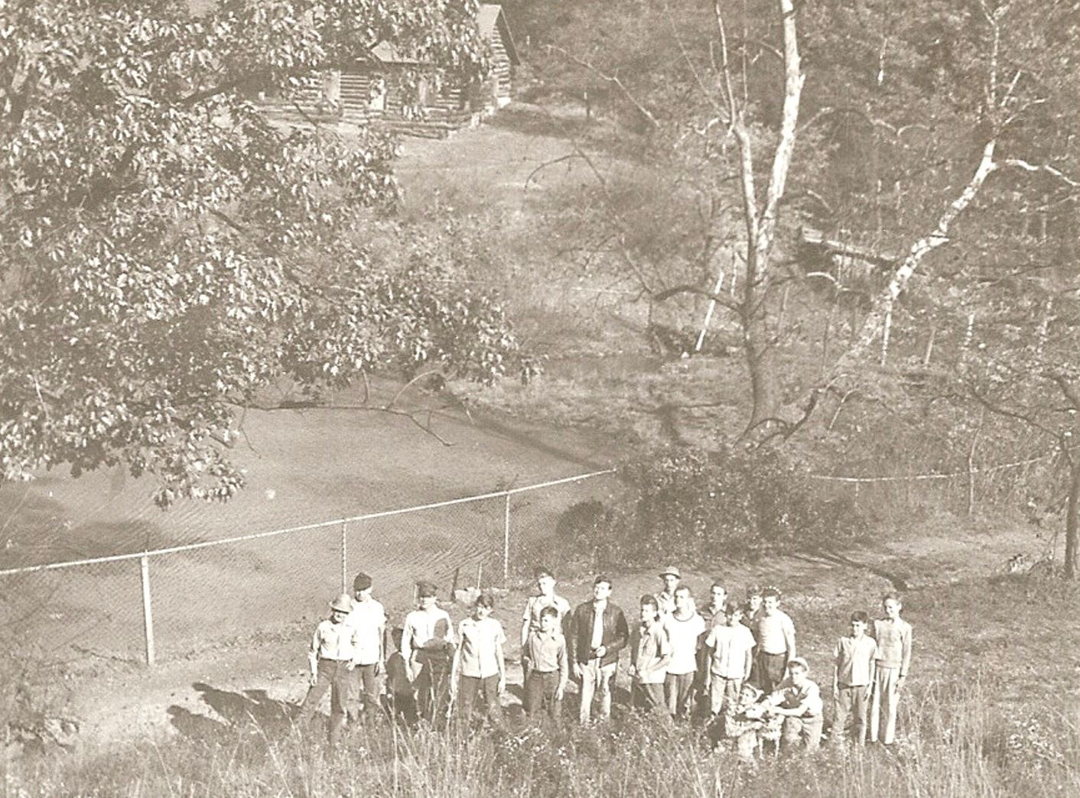

A group of students at the site of an early barn where at one time teams of horses and wagons were kept. In the background is the pond where many of the students in the enjoyed ice skating. On the opposite side of the pond is a cabin built by CCC (Civilian Conservation Corp) workers and used by the boys as a scout cabin and refuge until the 1970’s.

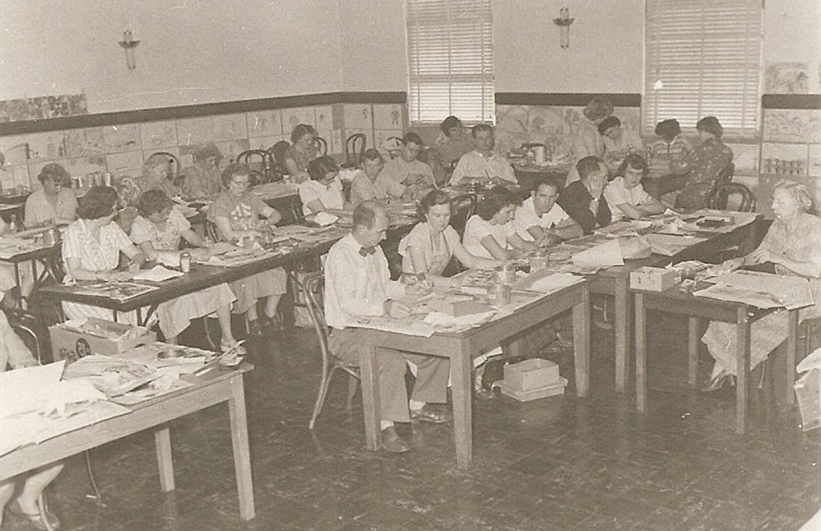
Superintendent Harris participating in a fingerpainting exercise along with Yearl Arnold, Margaret Haines, Miss Teagarden, Miss Streeter, Anne Pancake, Andy Dugan, and many other staff.

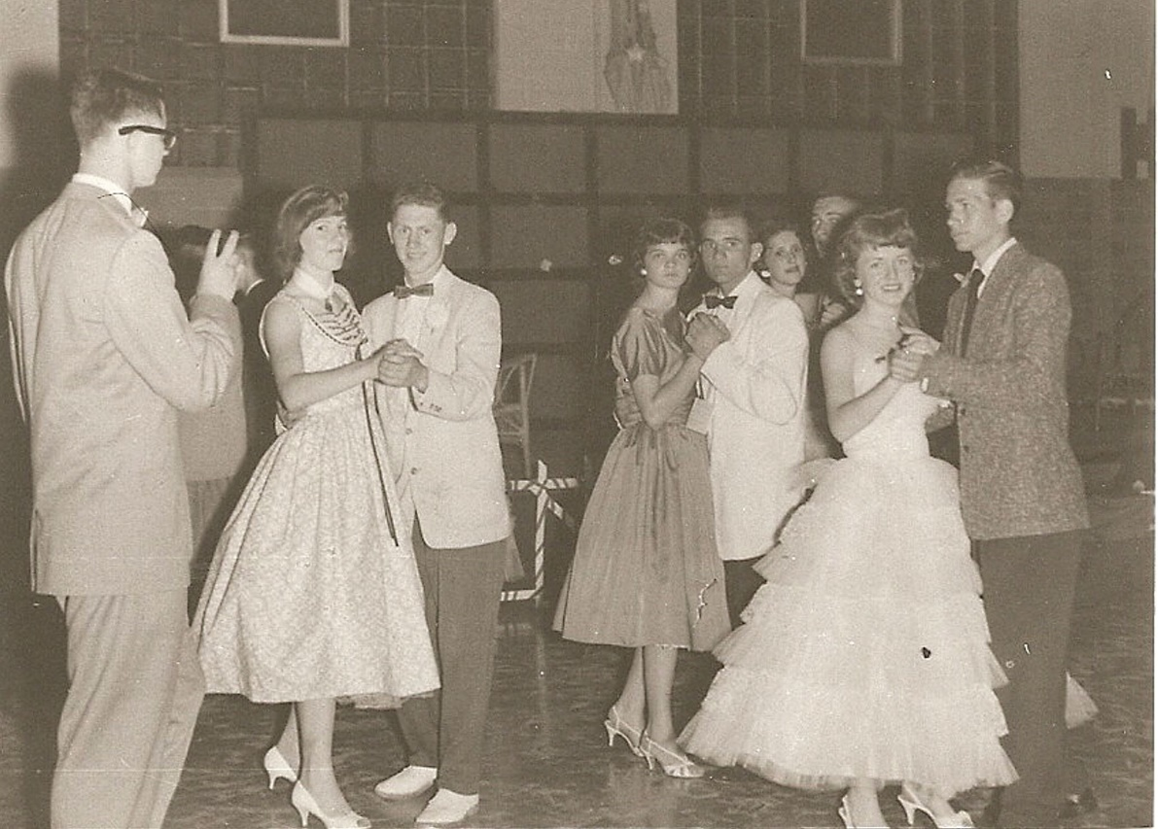
These students must be enjoying the prom.

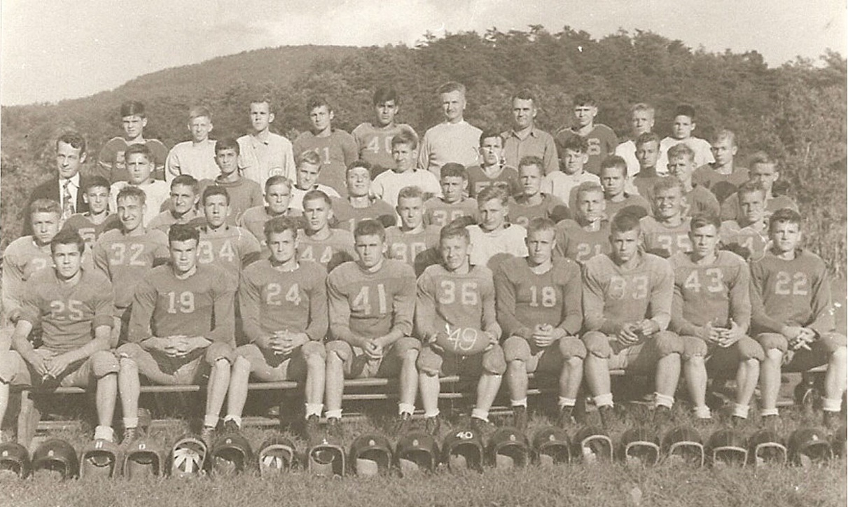
Coaches Glenn Hawkins and Frank Rebal fielded a fantastic team in 1949. Principal John Blue, shown on the left.
Notice the frugal uniforms, bare legs, and rolled socks.
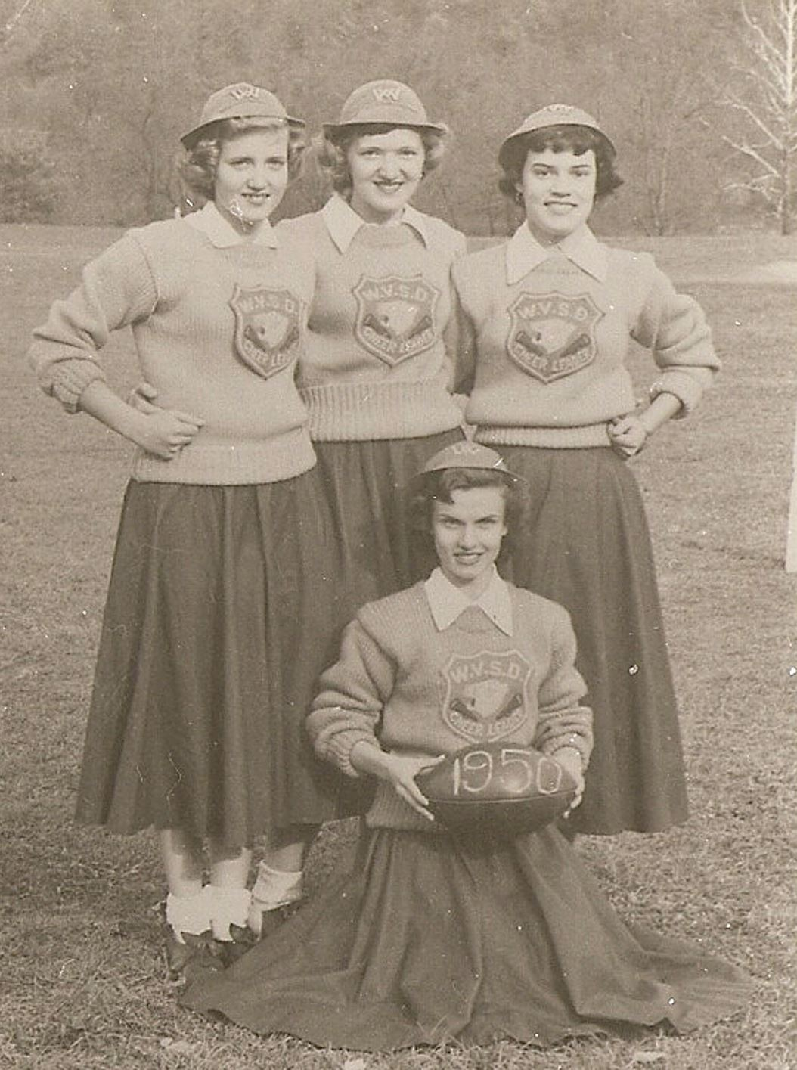
A good football team was always followed by pretty cheerleaders. Barbara Krainer, Lois Uhl, Irene Ancharuk, and Merle Loony
lead the cheers in 1950.

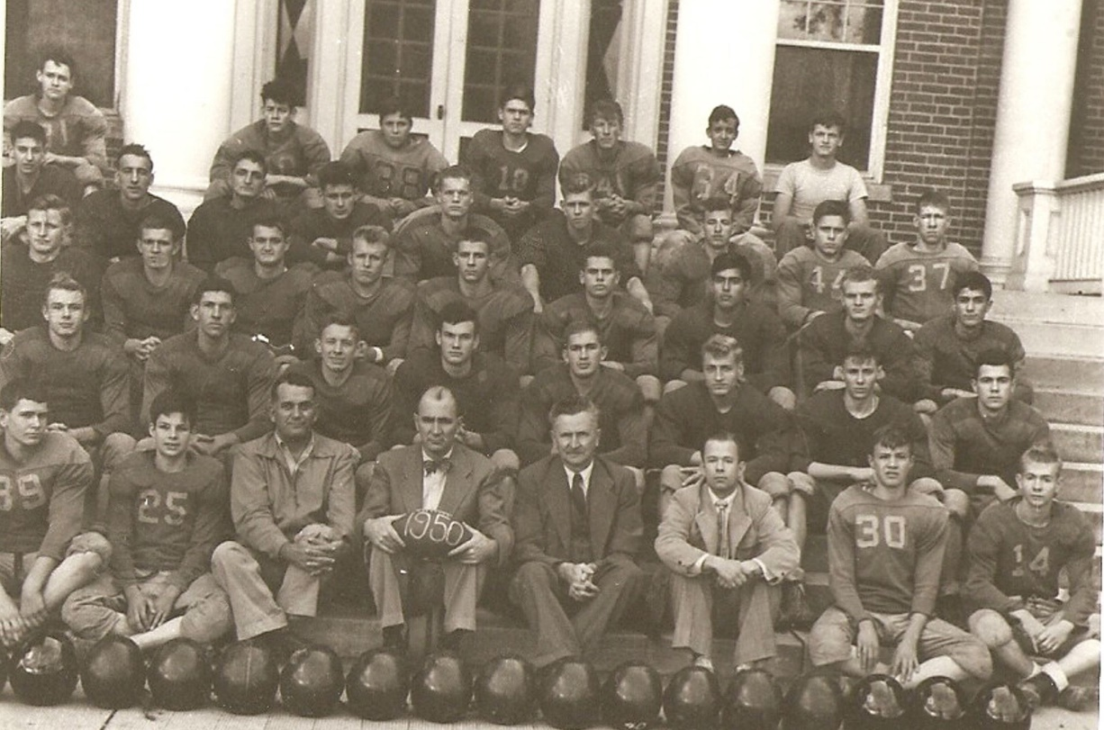
Superintendent Harris, Coaches Hawkins and Rebal, with the 1950 Lions on the steps of the Boys Hall at the School for the Blind. The practice field located near this dormitory was also the play area used for all Physical Education classes at the time.

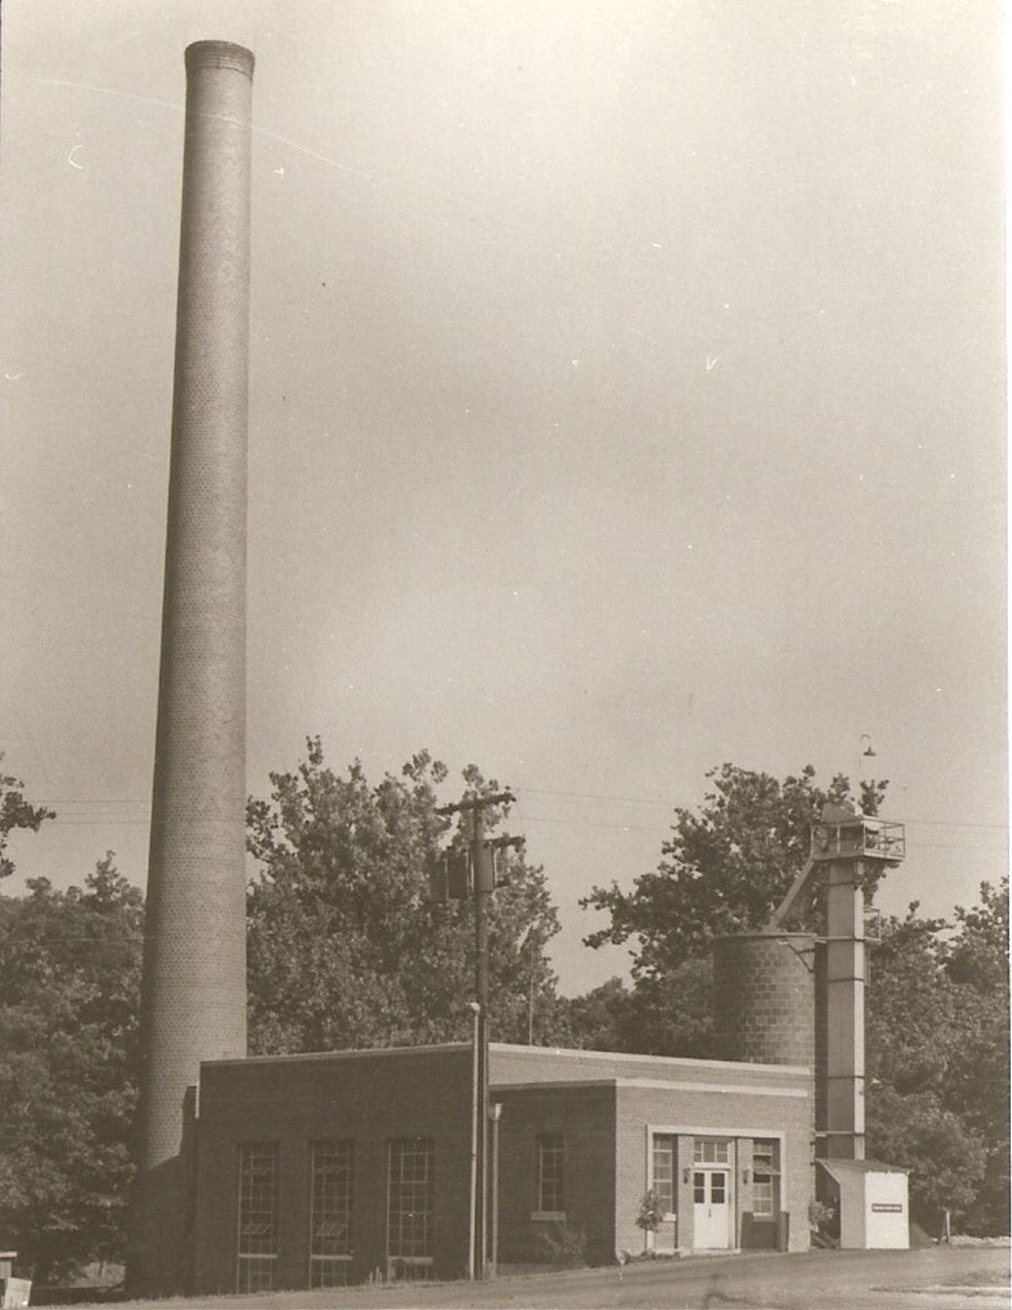
The new power plant of 1949 shed lots of cinders and grief into the community. The steam locomotive whistle originally used was later replaced by a proper steam whistle. The familiar sound woke up the campus as well as the townspeople for many years.

Mr. Ferris’ work was interrupted by active service in the Armed Forces from March to October 1945. During this period, Mr. R. M. Golladay, Principal of the School for the Blind, served as acting superintendent.

In May 1953, Mr. Harris announced his resignation in order to become the assistant registrar of West Virginia University.

Mr. James R. Thompson, Business Manager, served as acting superintendent for about six weeks during the summer of 1953 until the arrival of Dr. Hugo F. Shunhoff.

Dr. Shunhoff, from Illinois, was superintendent from 1953 until 1960. Graduation 1954 was the first for both schools to be combined. Dr. Shunhoff felt the addition of music by the chorus from the School for the Blind would enhance the graduation exercise.

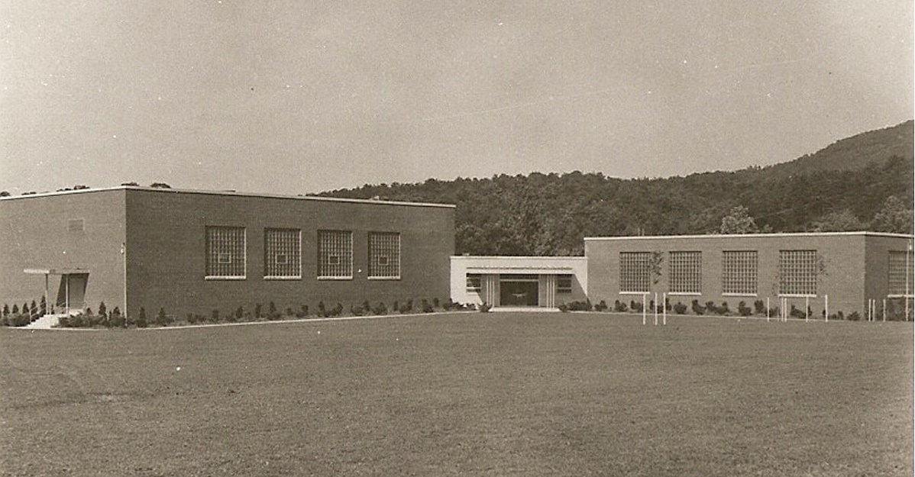
Physical Education Building, completed in 1953. The 1953 Commencement Exercises were held in the newly
constructed gymnasium on May 27.
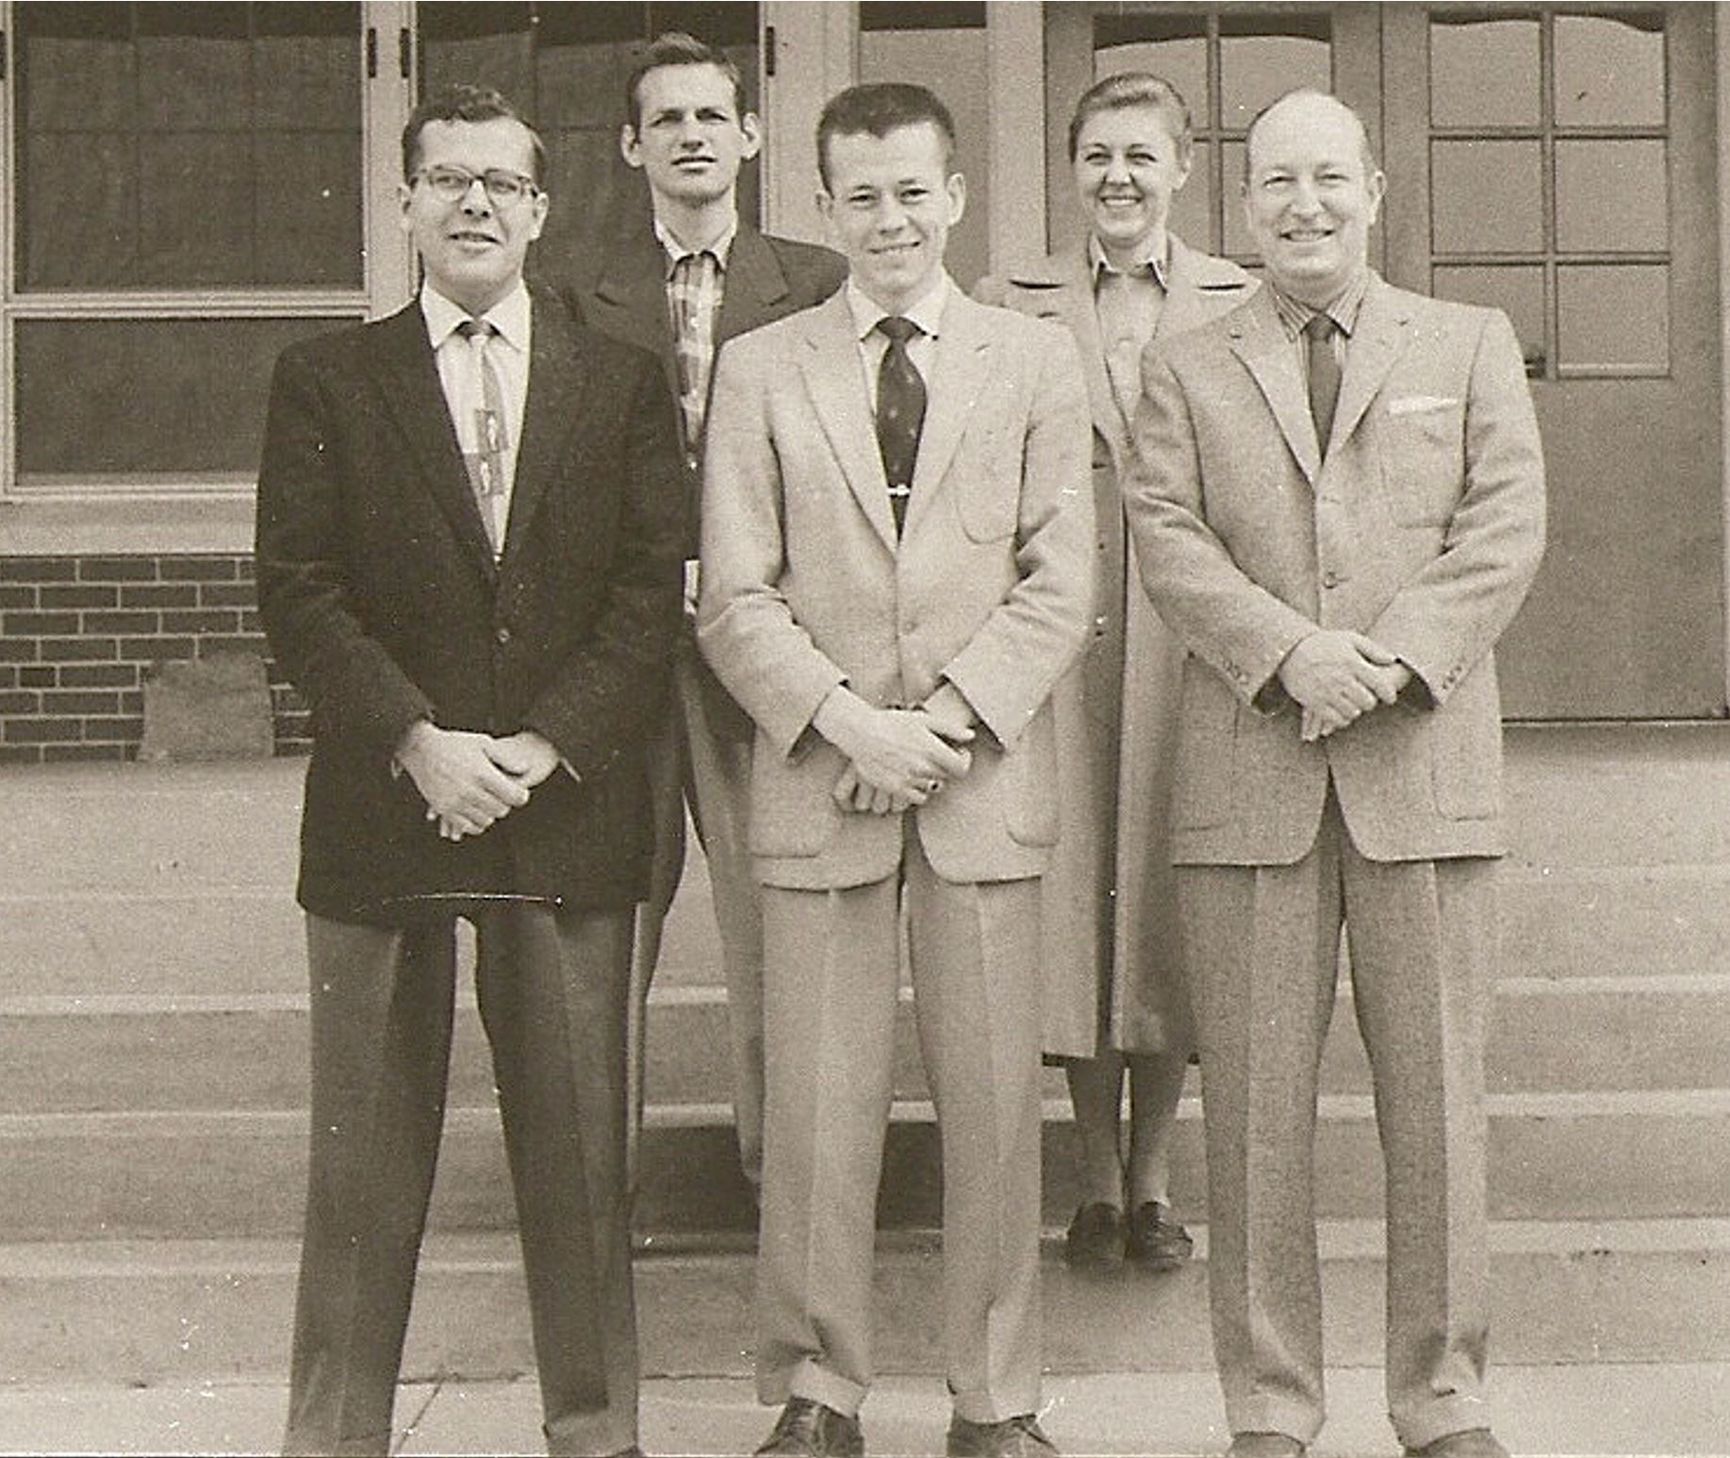
In this 1956 picture of the Physical education staff you may notice some familiar faces,
Louis Boley and Carl Flanagan

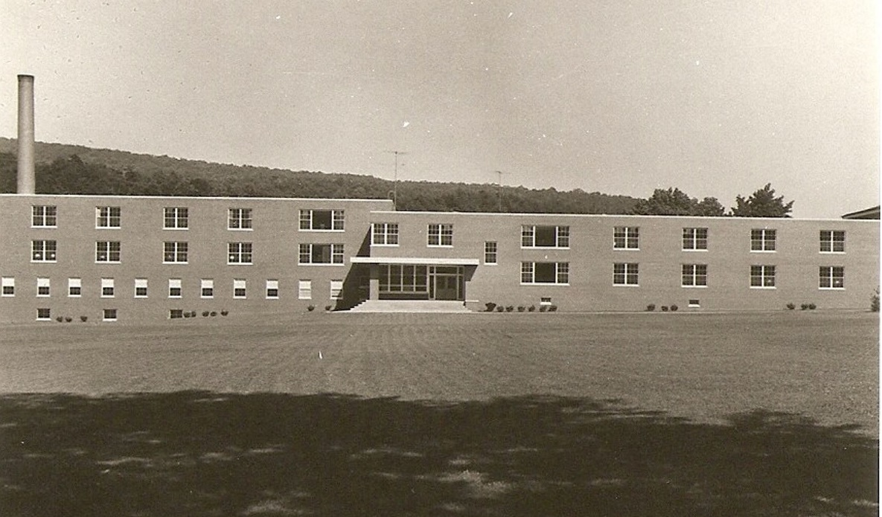
Under Dr. Shunhoff supervision, Seaton Hall Dormitory was completed in 1955.

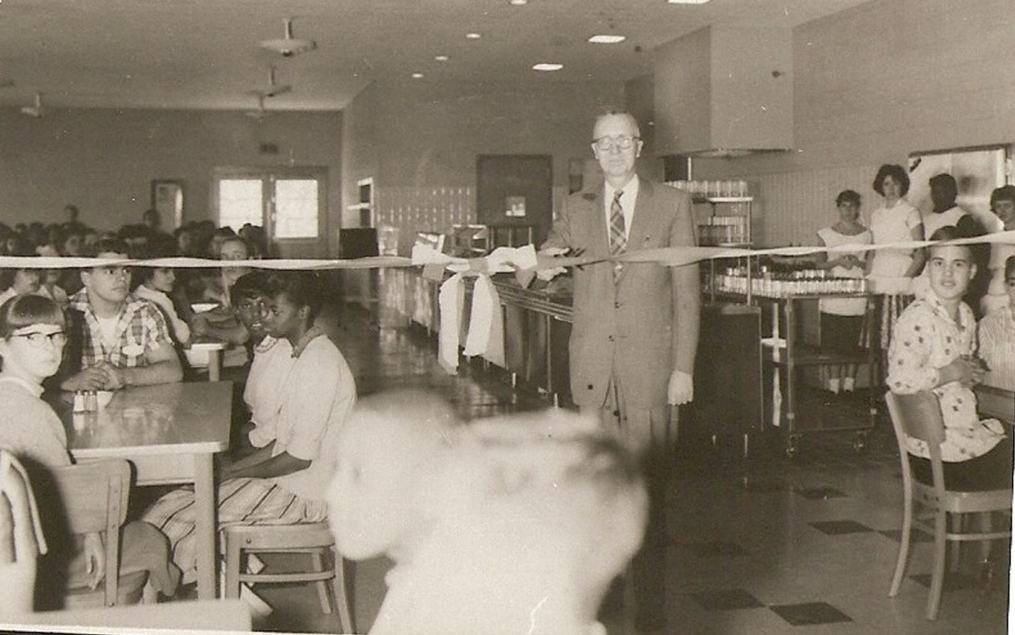
The dining room and recreation areas were added to Seaton Hall Dormitory in 1958

In 1959, the old dormitory wings on the east side of the Administration Building were razed. This area now is the site of outdoor basketball courts and parking for Seaton Hall Dormitory.

Dr. Shunhoff’s major project was the new athletic field established on the north end of campus and first used in 1957. Dr. Shunhoff was so pleased this project that he called it “Shunhoff’s Folly”.

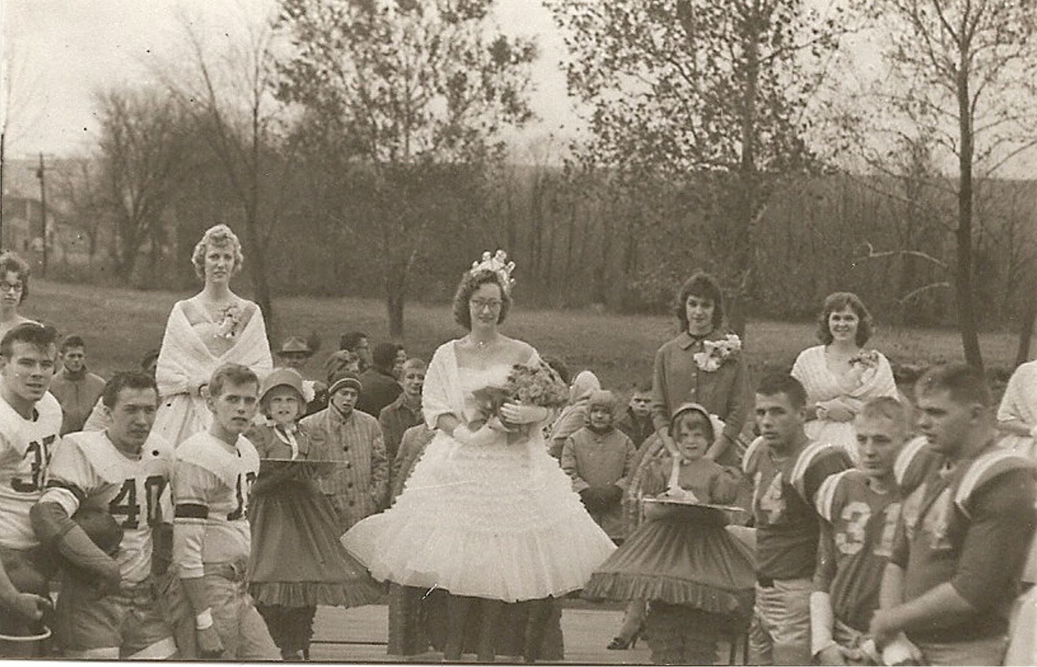
The School for the Deaf Football team and Homegoing Queen and her Court on the new athletic field.

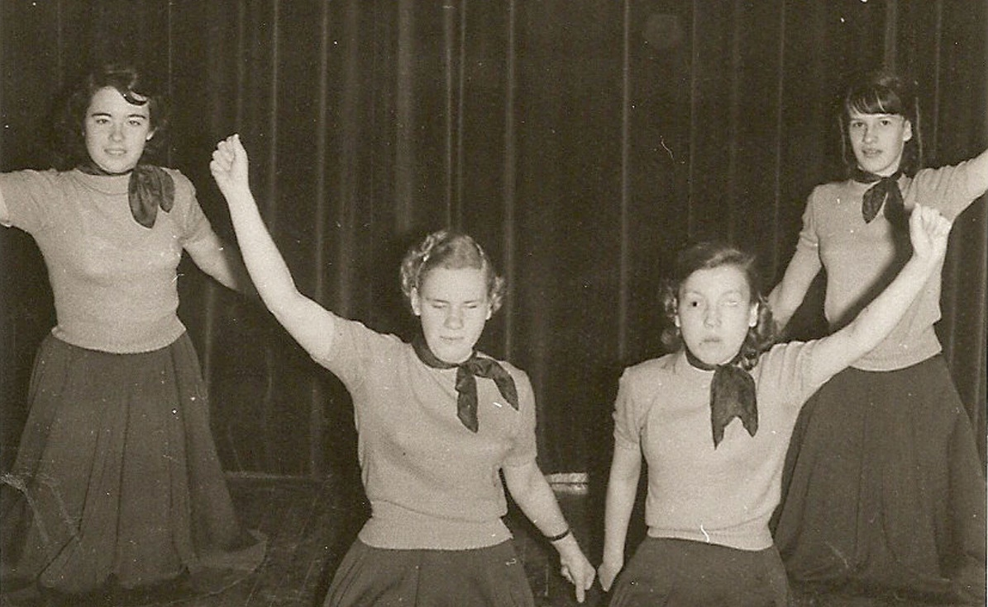
1957-58 School for the Blind Cheerleaders including Ninetta Garner (far right).

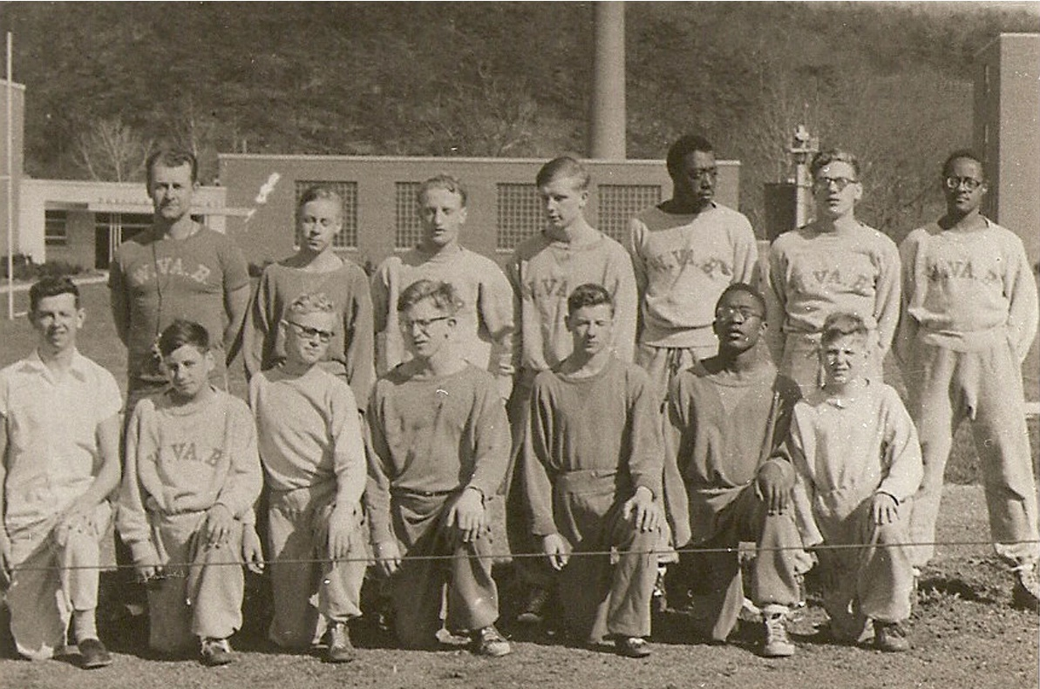
1957 undefeated Eastern Athletic Association for the Blind Wrestling Team.

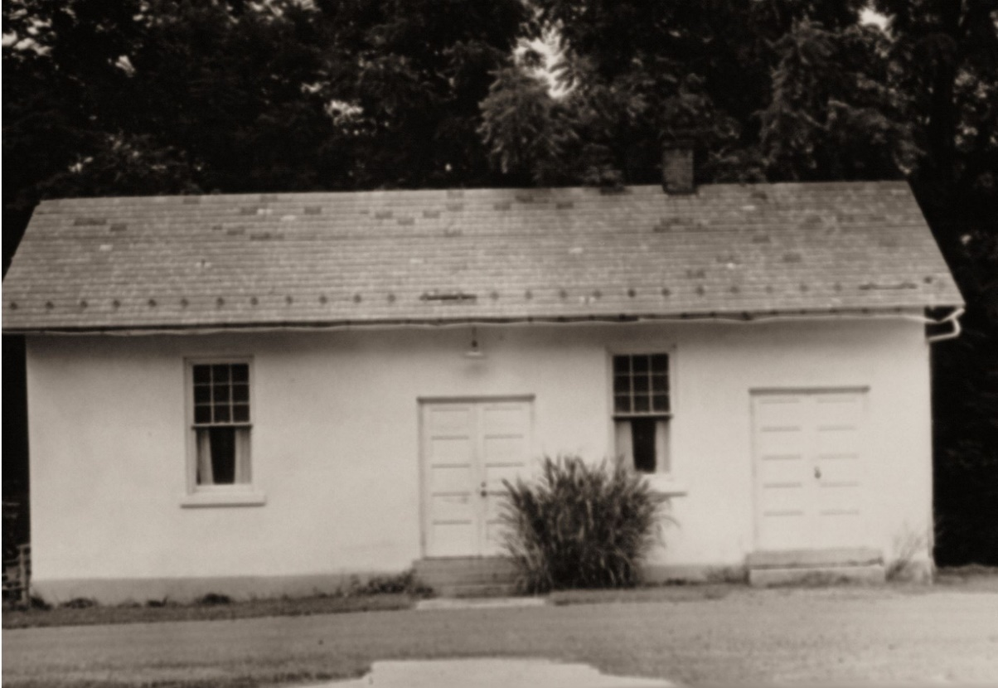
The Canteen (also known as the Wagon Wheel) at the School for the Blind opened in March 1954 in a small building behind the boys’ dormitory. The canteen for the deaf students was opened in the basement of the classroom building in April 1954. Both canteens were operated for and by the students with some supervision by staff members.

Dr. Shunhoff also did much to increase salaries. Salaries were up to $2150 per year average. Student/staff ratio was slightly less than 2-1. Average school population for the School for the Deaf was 217; the School for the Blind was 100; for a total average population of 317.

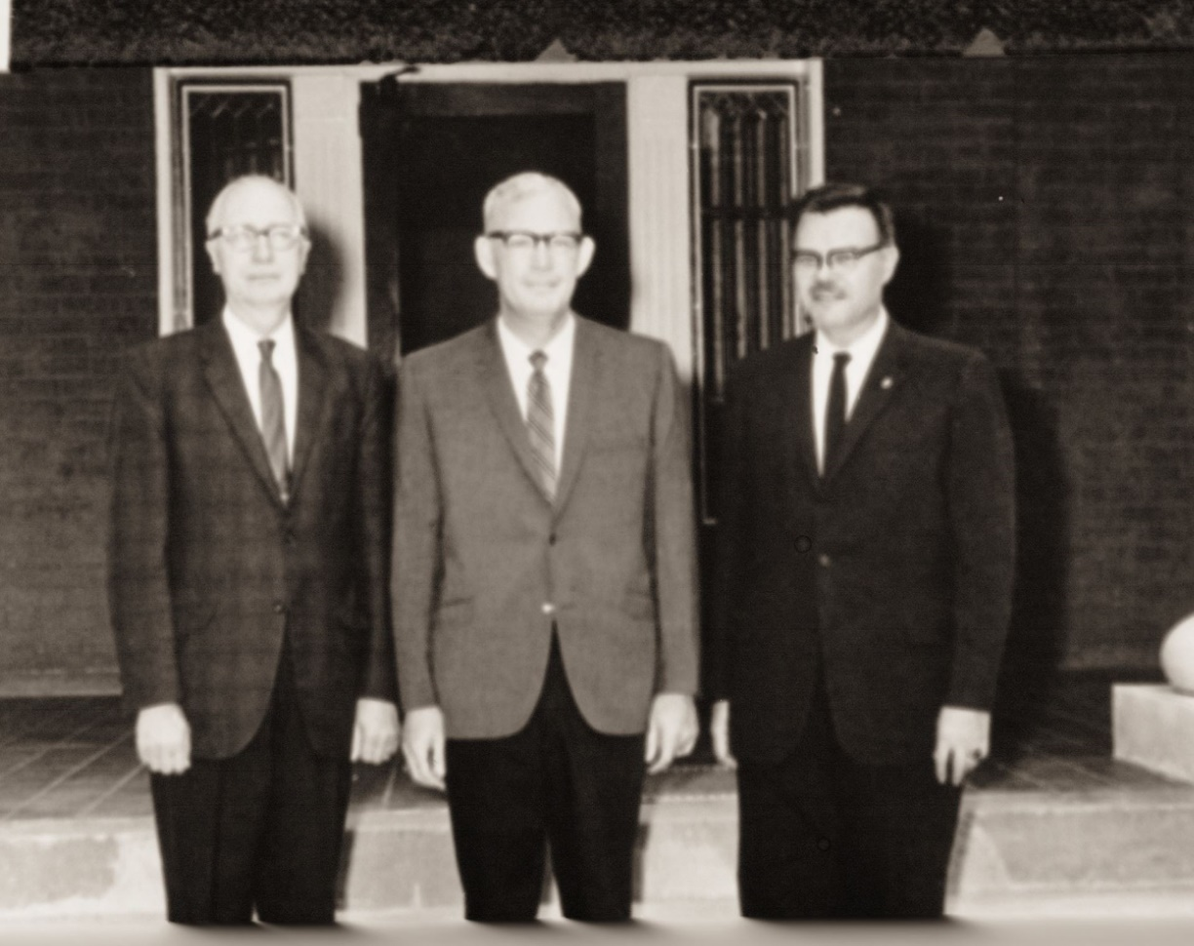
From left to right, Dr. Shunhoff, Mr. Brady and Mr. Shipman, Administrators from 1953 to present.

Dr. Shunhoff resigned as Superintendent August 31, 1960 to head the California School for the Deaf at Berkeley, California.

Mr. Eldon Shipman, Principal of the School for the Deaf, became Acting Superintendent for one month upon Mr. Shunhoff’s departure.

Jack W. Brady, Principal of the American School for the Deaf at West Hartford, Connecticut, was appointed superintendent by the West Virginia Board of Education on August 29, 1960. During the next six years, Mr. Brady was responsible for obtaining funds through the legislature for a classroom building for the School for the Blind and the renovation of the old classroom building (formerly the Potomac Academy) into a cafeteria. Two rooms in the girls dormitory were remodeled into classrooms for instruction in Home Economics. The administration building offices and superintendent’s residence were remodeled and refurbished and electric heat was installed.
Mr. Brady resigned July 1, 1966 to become the Superintendent of the Kentucky School for the Deaf at Danville, Kentucky.

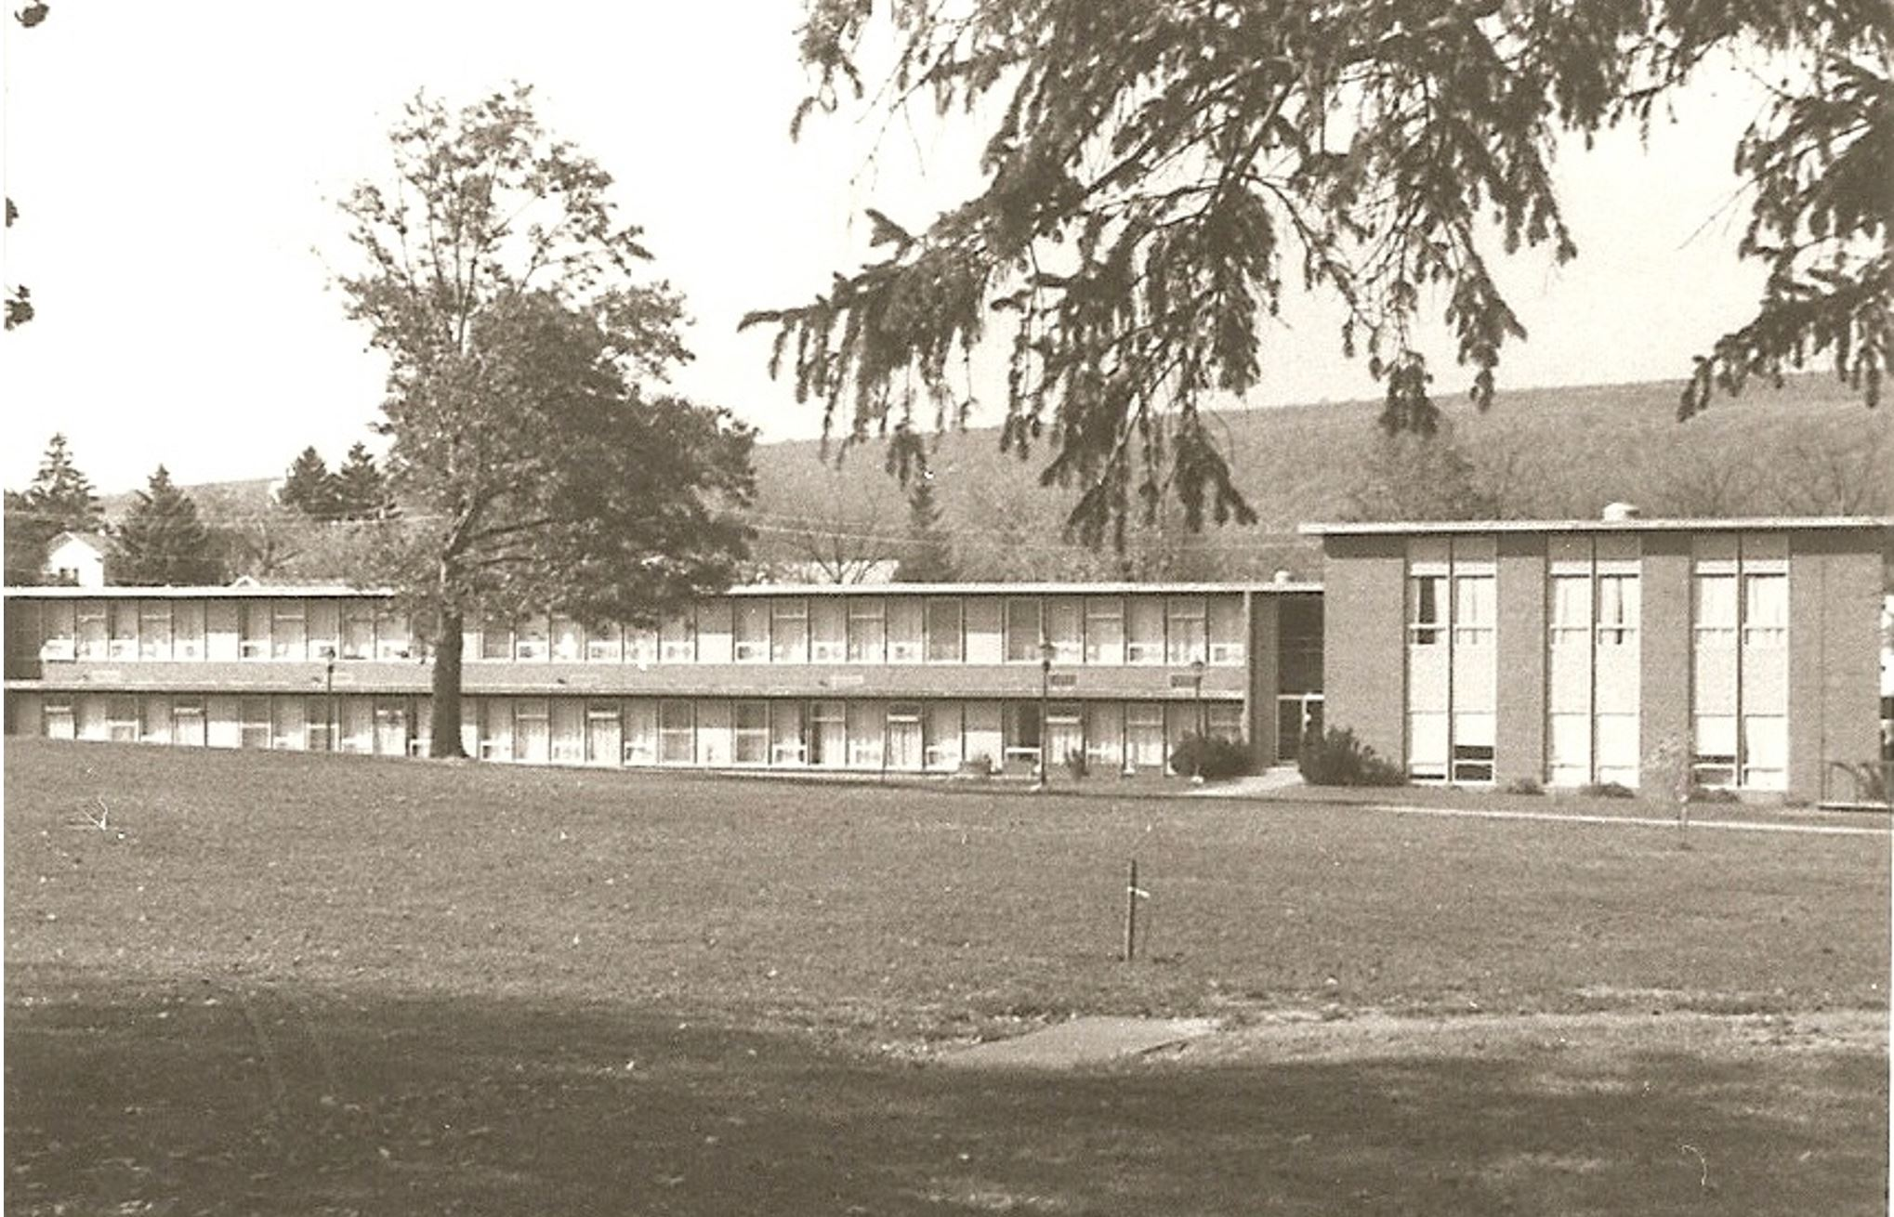
Classroom Building, School for the Blind

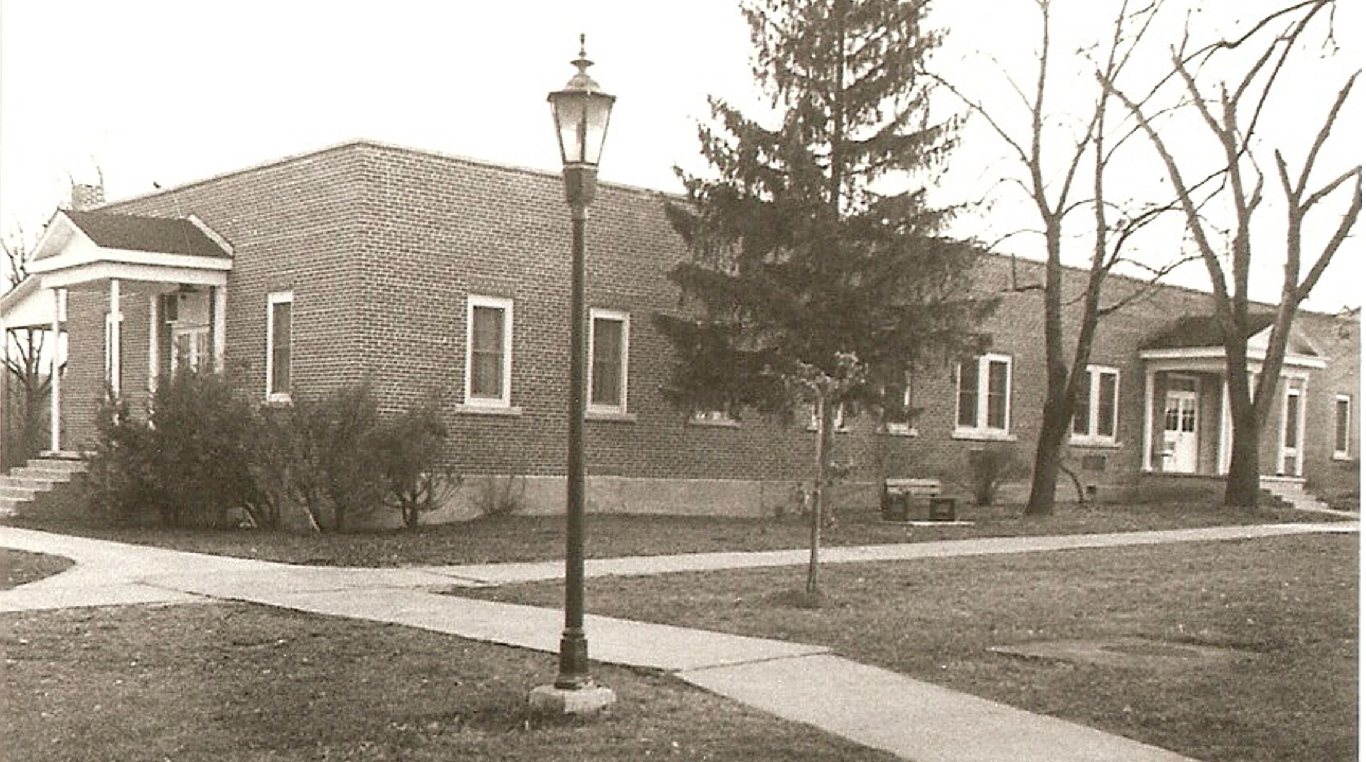
Cafeteria, School for the Blind (originally the Potomac Academy, first used as a classroom building for the School for the Blind.)

The following pictures and excerpts from the W. Va. Tablet recall some memories from the 1960’s and 70’s.

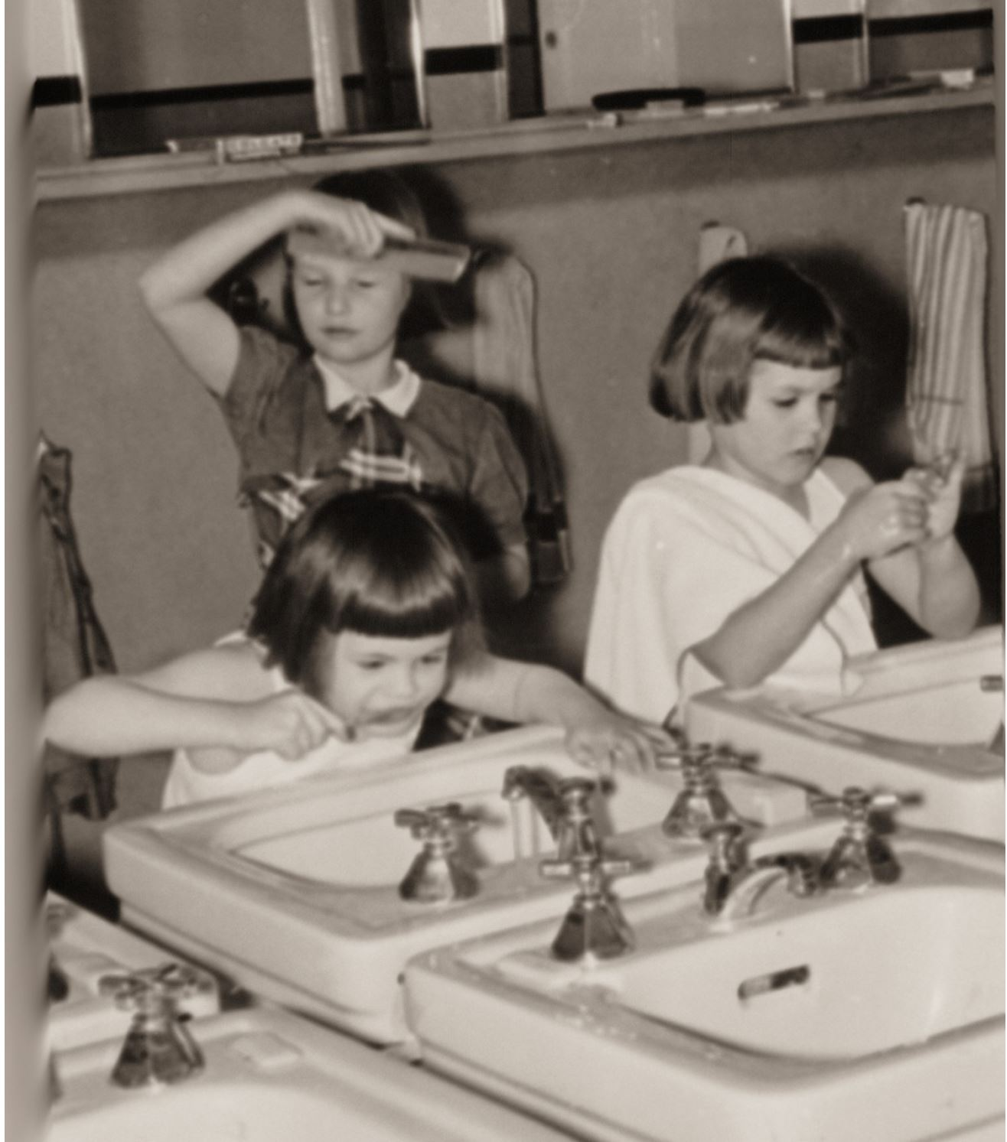
Rise and shine! Morning in the dormitory at the Elementary School for the Deaf.

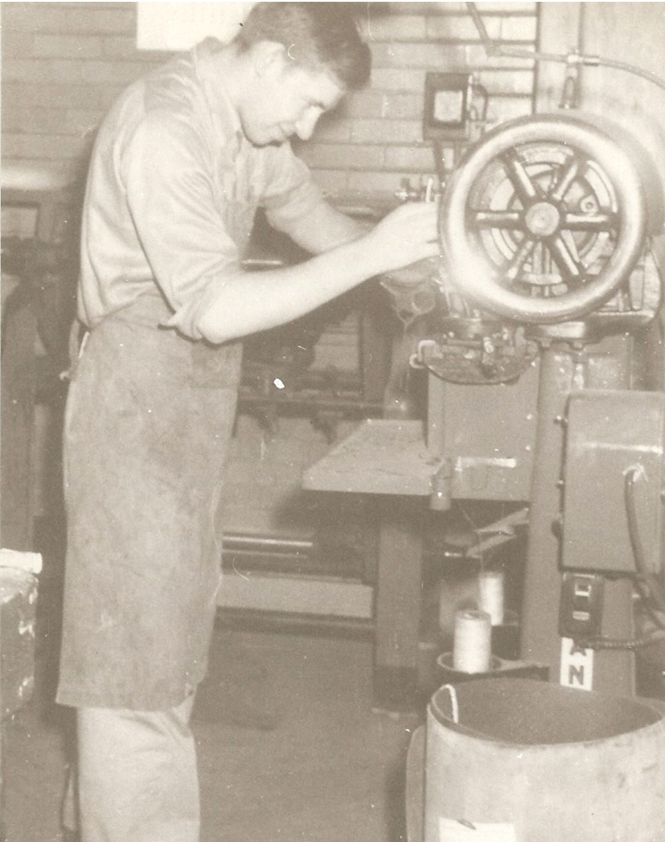
Shoe Repair shop in 1950

From the January 1952 Tablet Obituary….there is no news from the craft shop or caning shop so we take it for granted that they just plain died out of existence.

Not so! The chair caning and crafts classes continued as part of the instruction at the School for the Blind until the late 1970’s.

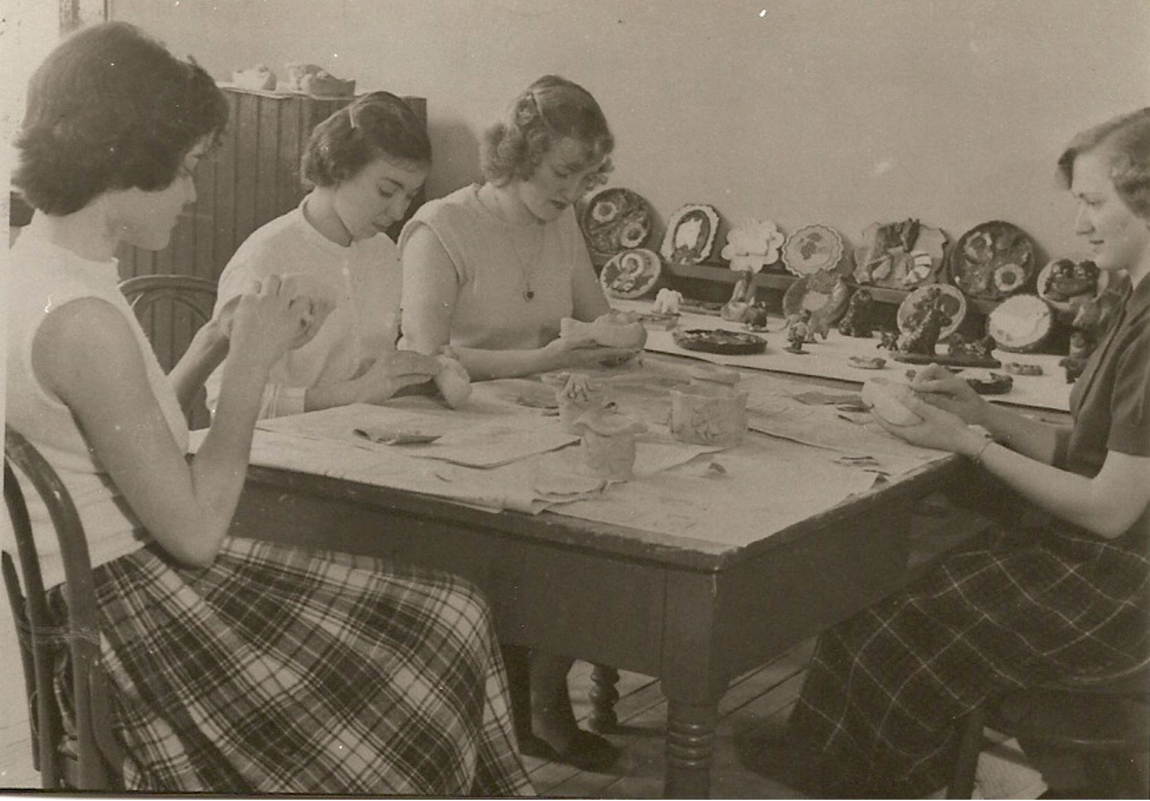
A money-making ceramics shop was in operation during the 1950’s in the original vocational building located behind
the administration building. On sale day customers would line up two hours ahead of time with baskets fir their purchases.

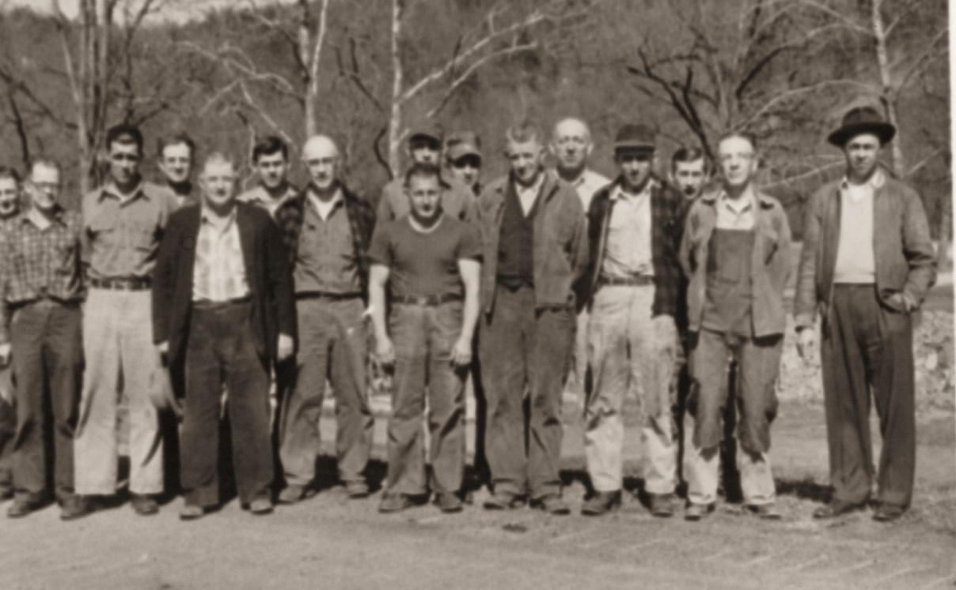
Maintenance Staff in full force, 1950’s

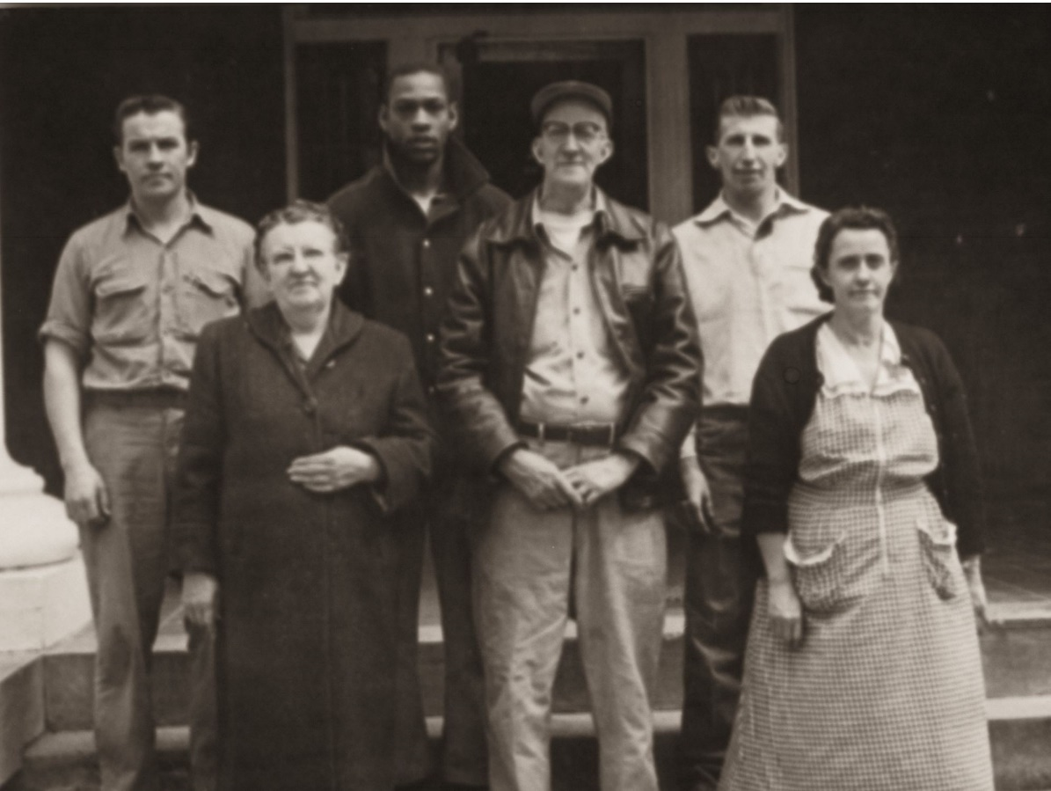
This 1960’s picture of the Custodial Staff includes one familiar face – Herman Shawver –top, far right

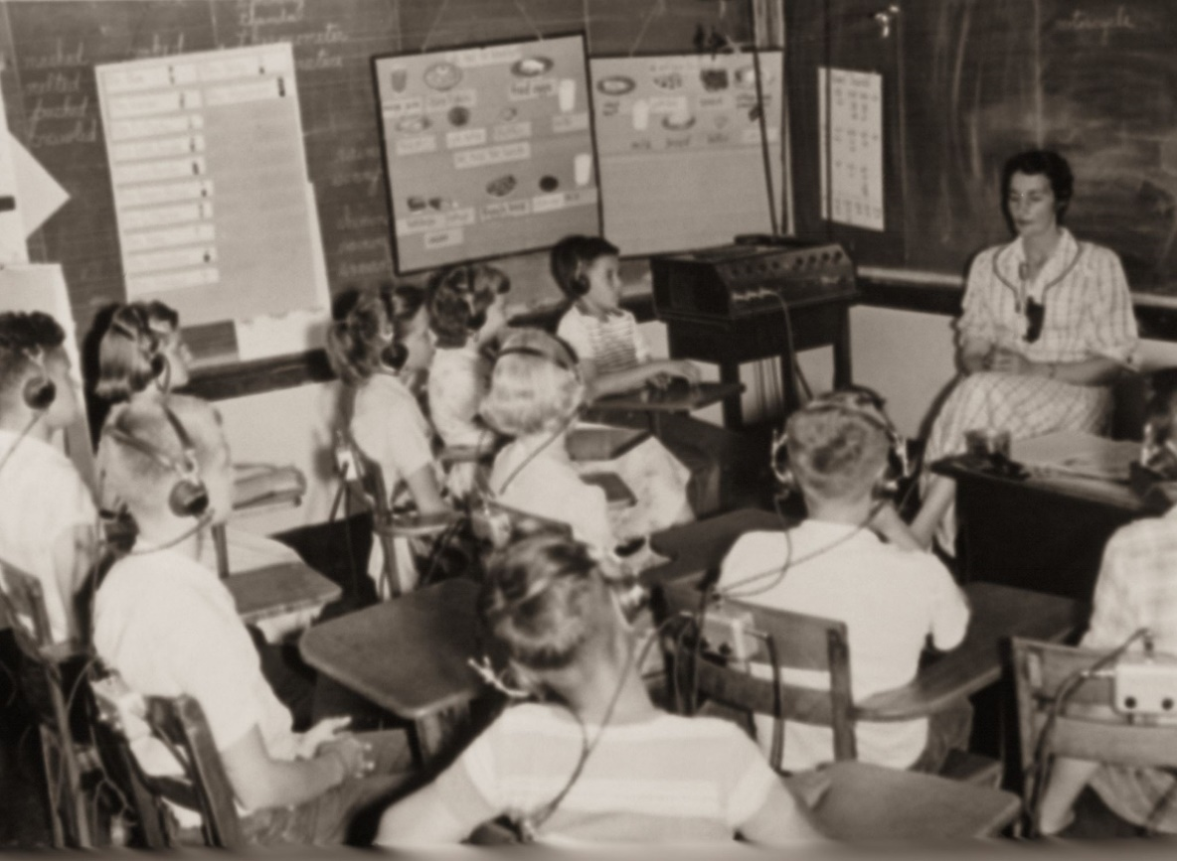
Miss Edith Pancake around 1952 with her Speech and Language class.

From Miss Pancake’s class and recorded in the January 1952 Tablet comes the following story:
“There was a dead rabbit in our front yard. We buried it today. Eddie dug
A big hole. He put the rabbit in the hole. Then he covered it up. James put
A cross on the grave. Roger and Kenny put some flowers on it. Eddie wanted
$3.98 for his work.”

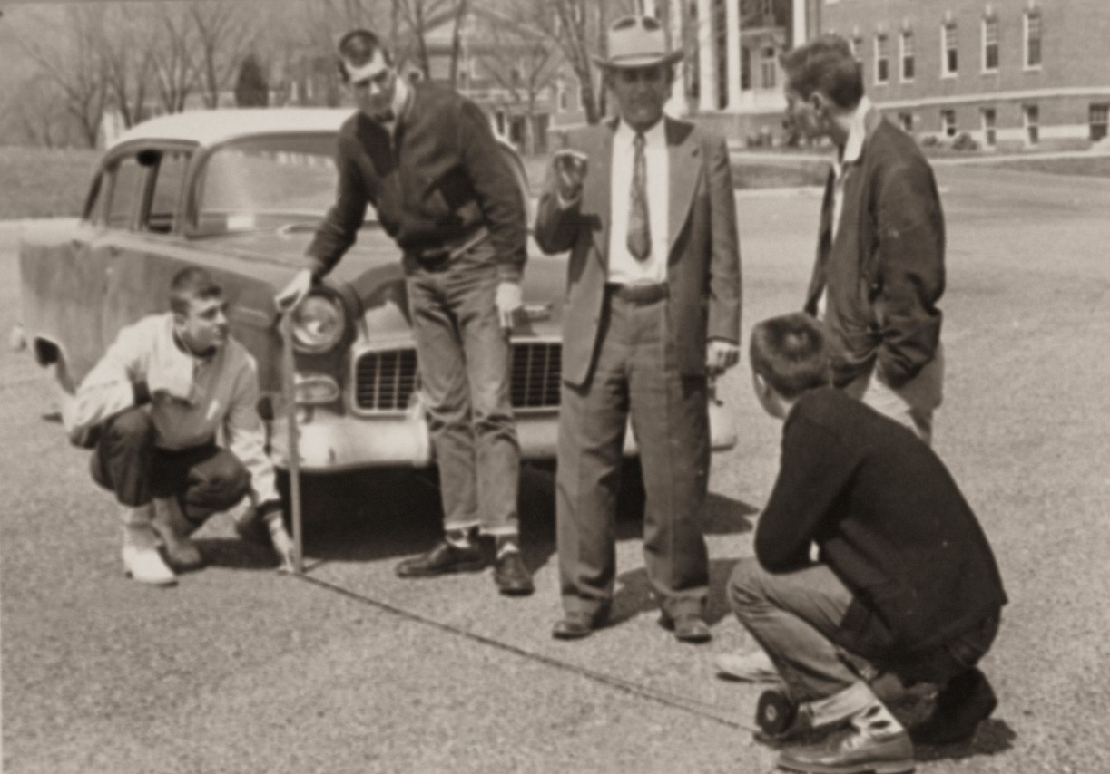
Driver’s Education, instructed by Mr. Hawkins, was added to the curriculum in 1951

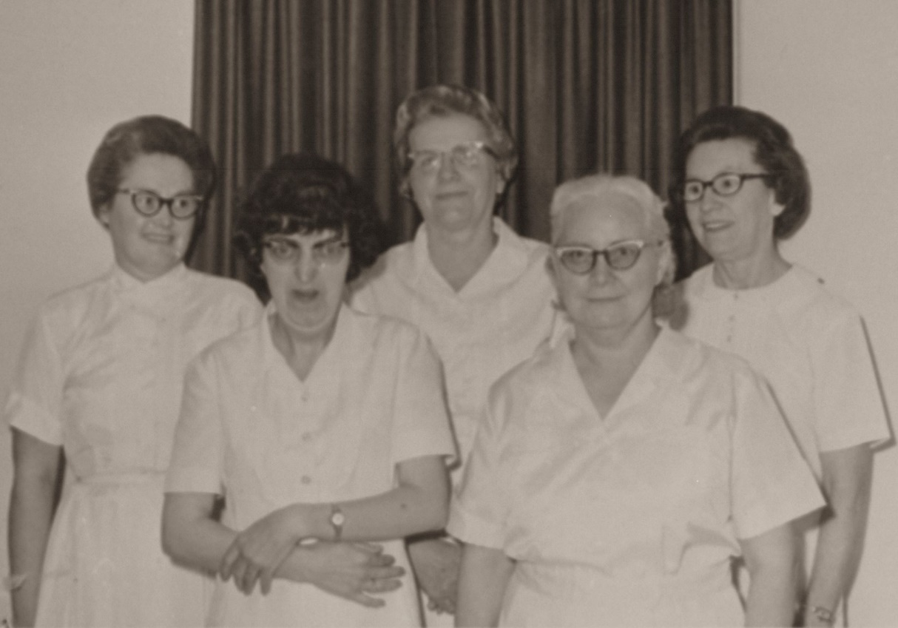
The Infirmary Staff in the early 1960’s

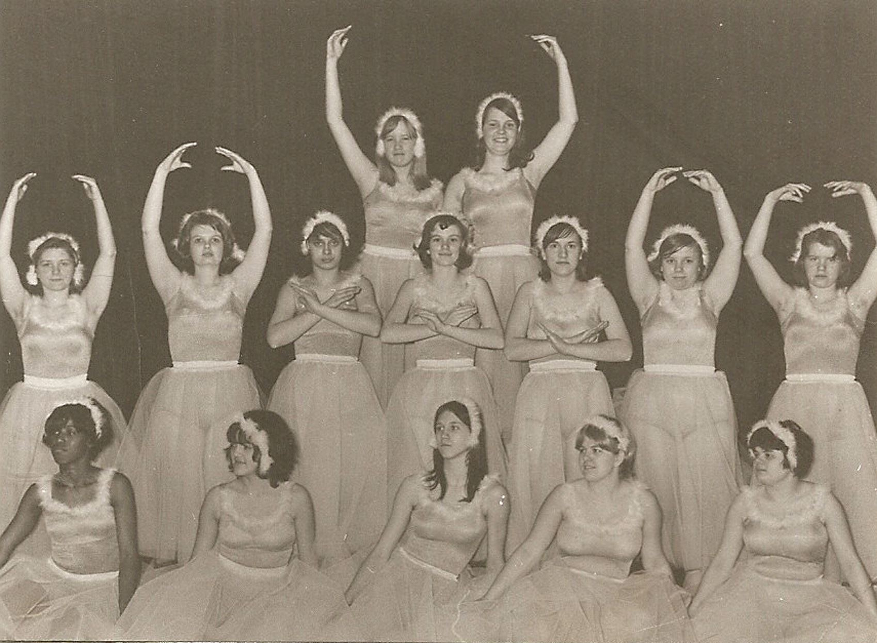
Emmett and Nina Oldfield have instructed many, many students in various forms in dance
Including this group around 1965. Mr. & Mrs. Oldfield came to our campus in 1951 and
Continue to work with the elementary deaf students.

Eldon E. Shipman was appointed Superintendent of the West Virginia Schools for the Deaf and the Blind July 1, 1966. Mr. Shipman came to the School for the Deaf as a teacher in 1952. He next served as Principal of the School for the Deaf from 1956 to 1966.

Superintendent Shipman opened in school in August 1971 with a total enrollment of 320 students, 198 in the School for the Deaf and 122 for the School for the Blind. Activities proceeded at a rather quiet and normal pace until September 12, when a fire broke out in the old Secondary School. No one was hurt, but the building was destroyed. Some educational supplies were saved and both staff and students “pitched in” to make the best of this terrible situation.

Fortunately, the new school building was already under construction during this period. Classes were held in the dormitory until completion of the present Secondary School for the Deaf Academic Vocational Building. Classes were first held in the new facility following its dedication of March 30, 1972.

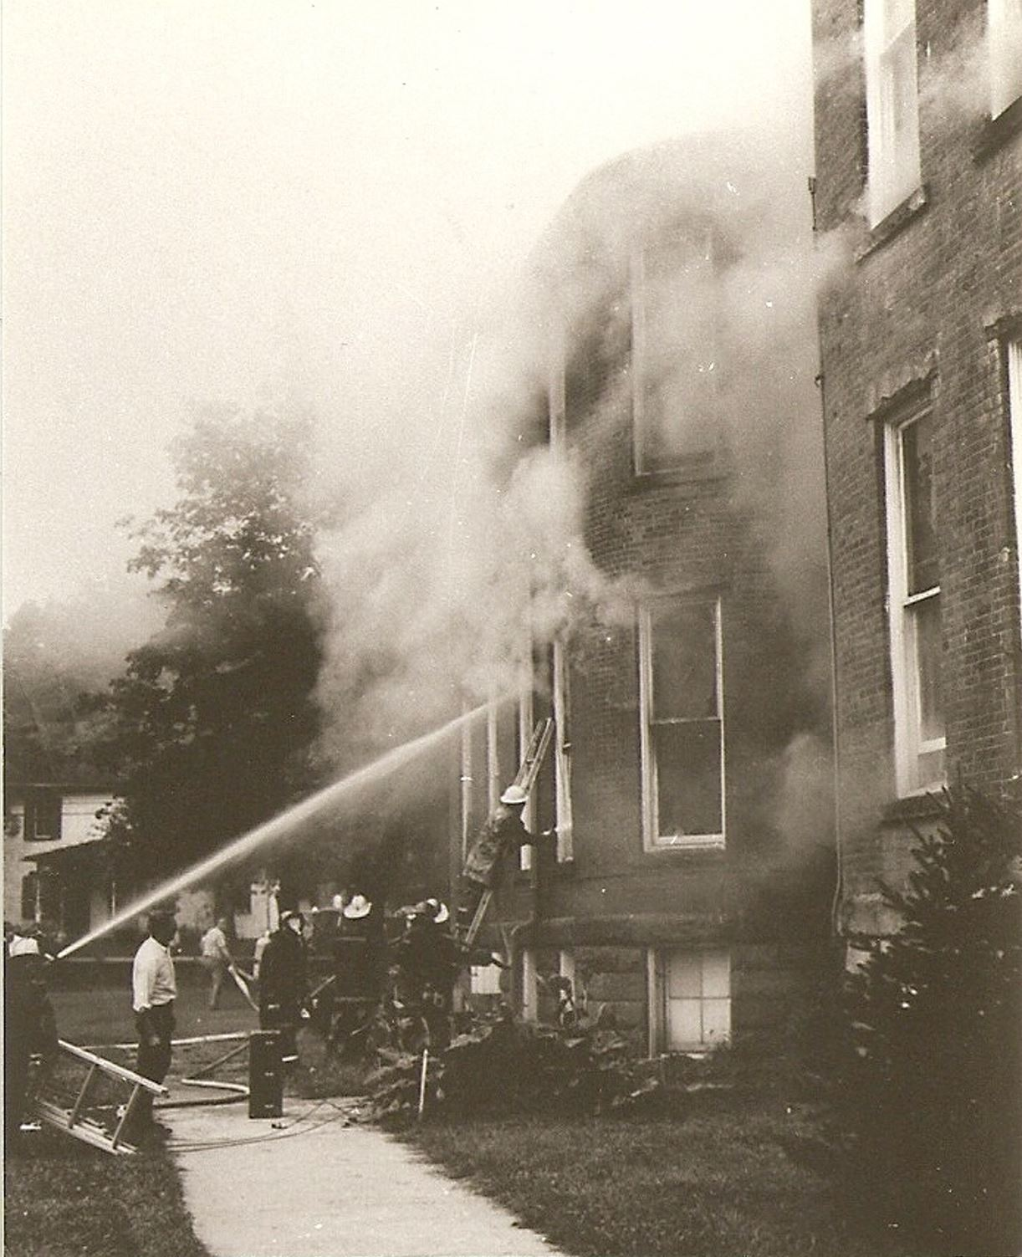
Fire broke out in Rucker Hall, September 12, 1971

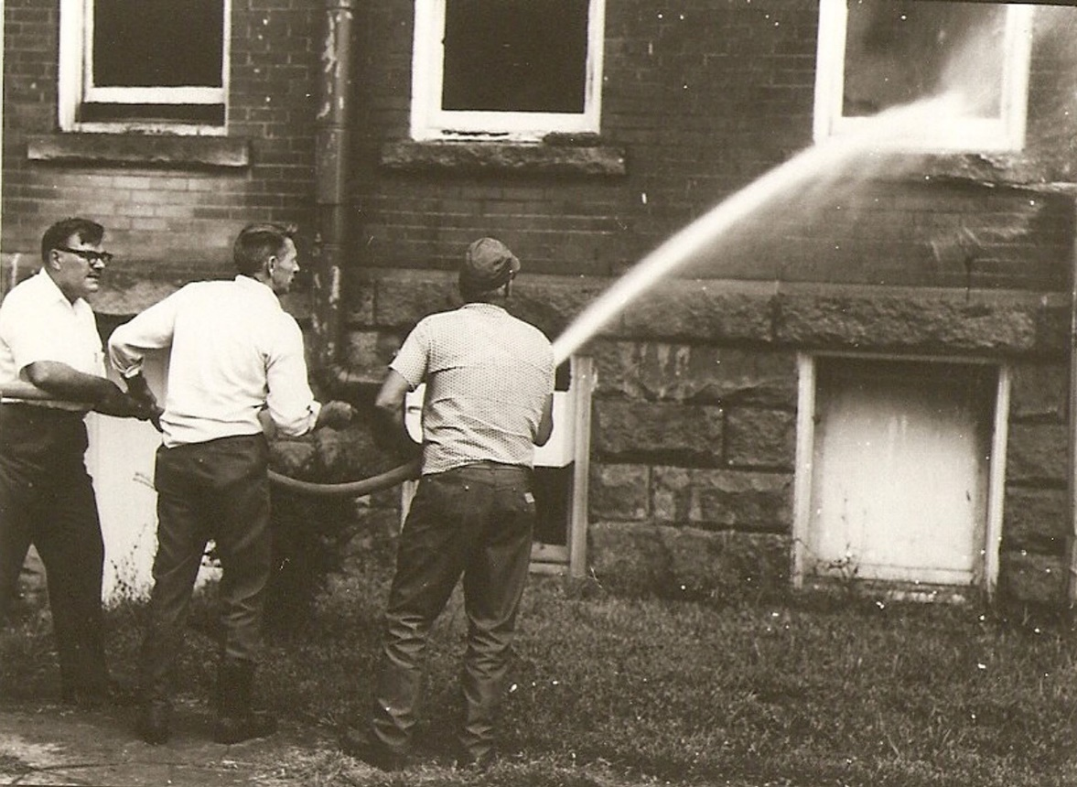
Superintendent Eldon Shipman, far left, and Eddie Ganoe, Storekeeper, center, help battle the fire.

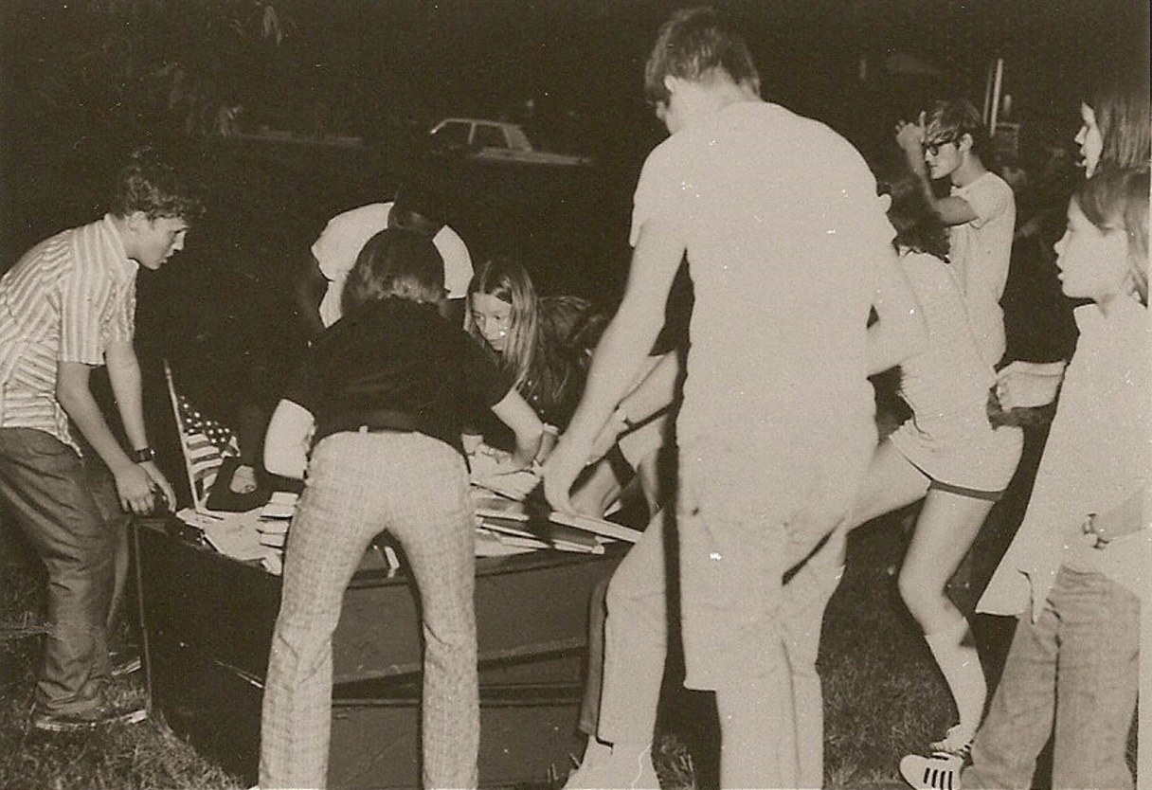
The students assisted in the rescue of some classroom materials and office records

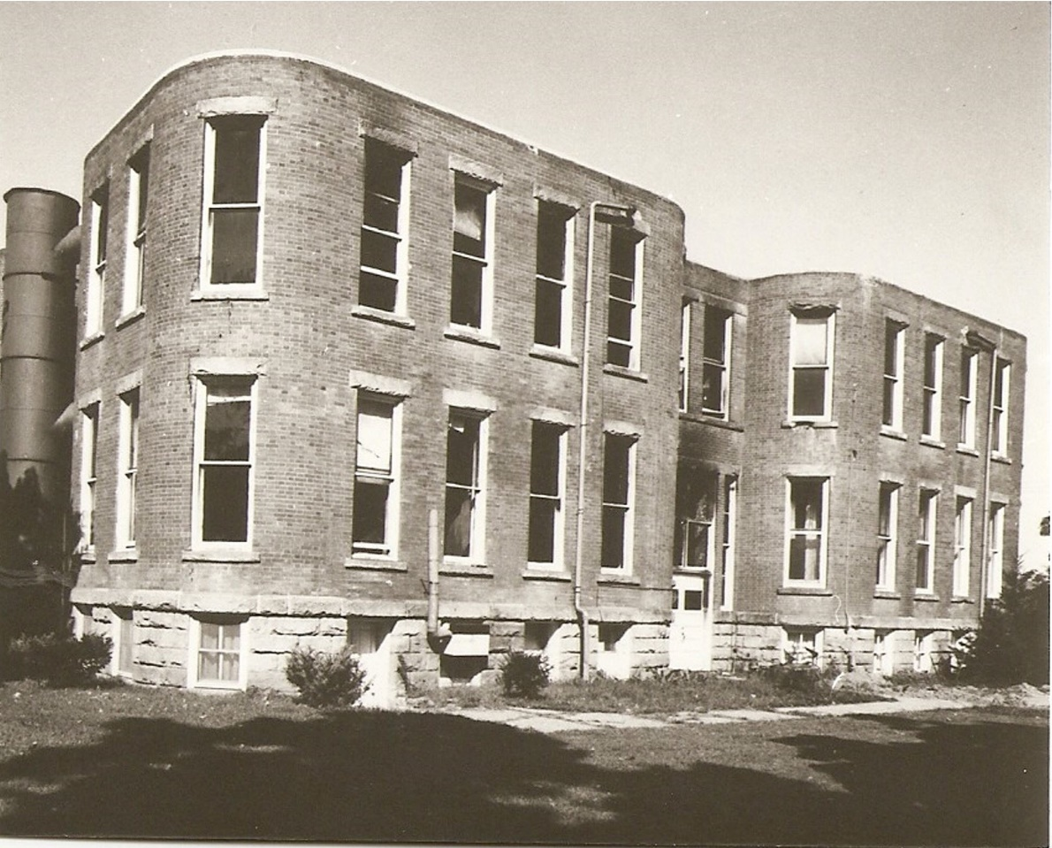
The smoke-stained brick shell and a blackened interior is all that remained of
Rucker Hall following the fire.

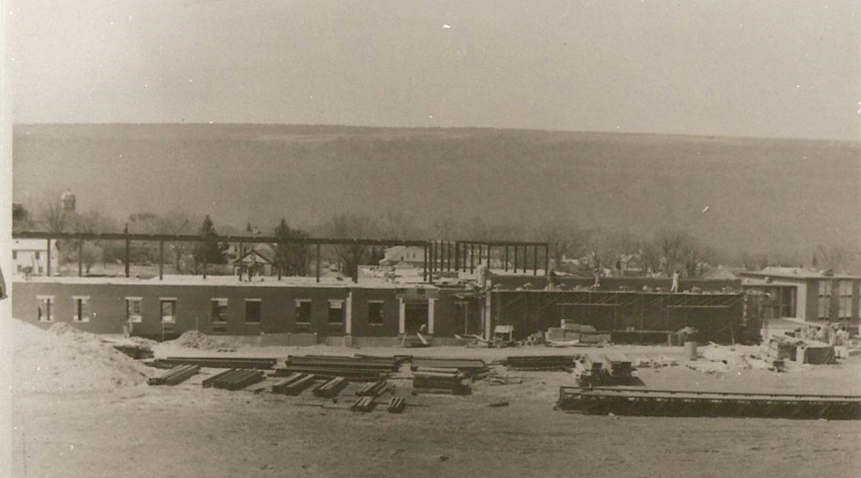
Plans for the new Secondary School for the Deaf Academic-Vocational Building
were already underway in 1971

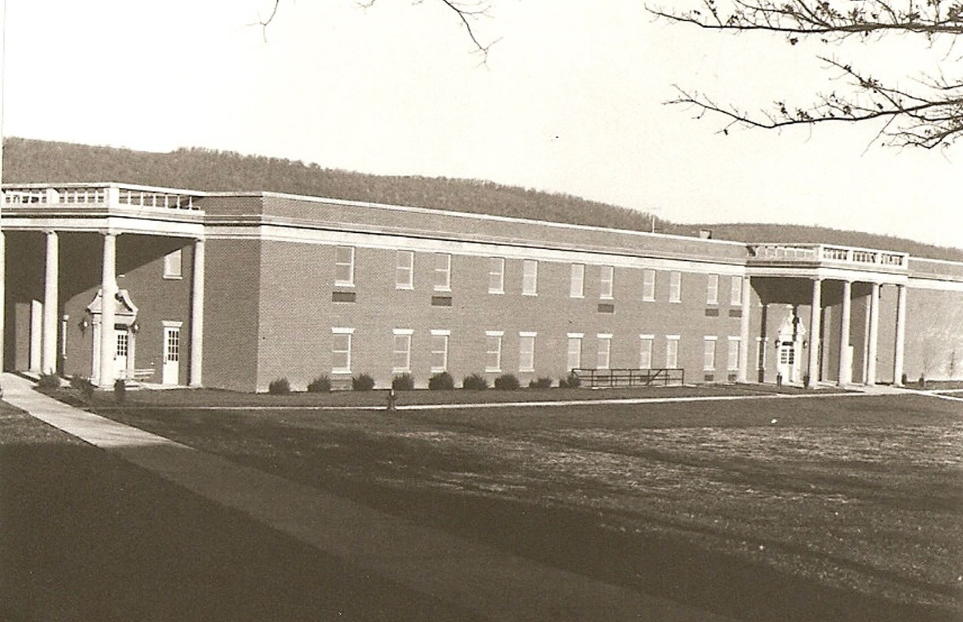
The new classroom building was dedicated on March 30, 1972

The B & O Railroad donated an old caboose to our students during the 1971-72 school year and through careful manipulation it was transported through the streets of Romney to it new home on the playground of the Elementary School for the Deaf.

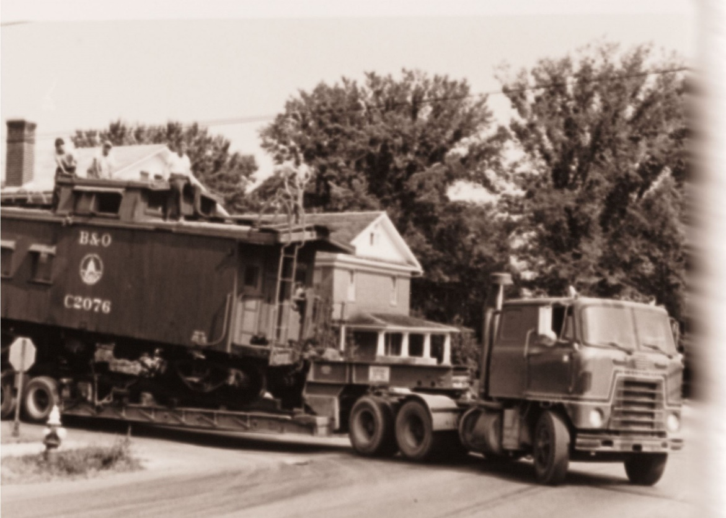
The caboose, making a turn from Sioux Lane onto High Street, on its journey from the depot to our campus.

In addition to the completion of the new Secondary School for the Deaf Building, Mr. Shipman’s administration was responsible for the Planning and construction of a new coed dormitory at the School for the Blind, the addition of a wing to the Elementary School for the Deaf for use of a deaf-blind/multi-handicapped unit, the erection and operation of a greenhouse as part of the horticulture program at the Secondary School for the Deaf; the establishment of a radio station, WJGF; and many other plant and equipment changes designed to improve the efficiency and safety of the campus.

Increased emphasis was also placed on student education and expanded participation in off-campus projects; the enrollment of four-year olds in the residential program and the beginning of “Parents Institution”, a program for parents of preschool age hearing impaired and visually impaired children. Preparation was done by both schools for accreditation by national organizations.

Mr. Shipman submitted his resignation effective September 30, 1973, in order to accept a position as Vocational Principal at the Missouri School for the Deaf.

With Mr. Shipman’s departure, Mr. Max Carpenter, Principal of the School for the Blind, assumed the duties of Acting Superintendent from August 1973 to February 1974.

In February 1974, Mr. Jack W. Brady returned to our campus to again accept the position of superintendent. Enrollment at the time averaged 315. Home/school counselors for both schools were hired as well as a mental health counselor.

During the 1973-74 school year, the Elementary School for the Deaf received a new electric heating system. With the opening of the school in 1974, the students at the School for the Blind were welcomed to their new dormitory. During this year also, the laundry was relocated from the current Central Supply Building to the old maintenance (Industrial Arts) building. The second floor of the Administration Building was converted into office space.

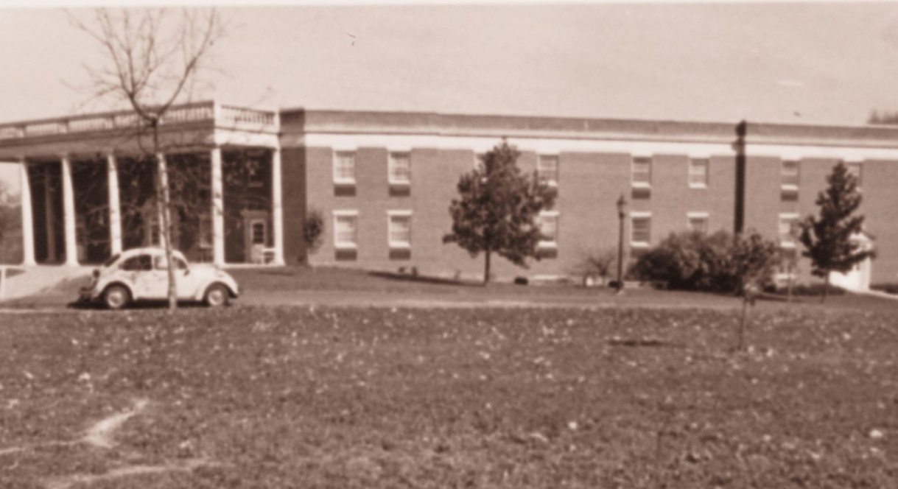
New dormitory at the School for the Blind, occupied August 25, 1974.

The 1975-76 school year opened with total enrollment at 278, the first time that enrollment dropped below 300 since 1954. Improvements to the buildings and grounds during that year included sandblasting and tuck-pointing of the brick exteriors of the Administration Building and the Cafeteria (old Potomac Academy).

Public Law 94.142 was the "buzz-word” for the 1976-77 school year. Individual Education Programs (I.E.P.'s) were begun and much time and effort was spent on perfecting this system. Enrollment was slightly up at 286. The Vocational Annex saw its last school term. It was razed to make way for the new parking area.

Individual Education Programs for all students were required at the beginning of the 1977-78 school term. The School for the Blind received a Kurzweil Reading Machine thus making us the envy of many other schools. $100,000 was appropriated to demolish the old dormitories at the School for the Blind.
1978-79 saw a further drop in enrollment to 276 students campus-wide.

Work was begun on the new Child Study Center in the basement of Seaton Hall and the newly acquired Phonic Ear Auditory Training System was in use in the Elementary School for the Deaf.

During the 1979-80 school year, the National Accreditation Council Self-Study was completed at the School for the Blind and at the same time the entire campus completed a self-study for North Central Accreditation. The Child Study Center began services in its new location and a play therapy room was also established in the basement of Seaton Hall by the mental health counselor.

The 1980-81 school year saw the establishment of the eight-county, Itinerant Pre-School Programs for both the School for the Deaf and the School for the Blind.

The 1981-82 swim team from the School for the Blind had a perfect season and also won first place at the EAAB Swimming Tournament. Enrollment in the Unit for the Deaf-Blind/Multihandicapped Unit increased to 14 students. The School for the Blind also initiated “Toddler Program” for visually impaired children and their families.

On January 1, 1982 the West Virginia School for the Blind assumed responsibility for operation of the State's Instructional Resource Center. The WVIRC is responsible for providing specialized textbooks, materials and equipment to visually handicapped students in West Virginia's public and private schools. In addition to distributing materials, the center is also committed to offering technical services to the county systems.

The old dormitories at the School for the Blind were razed during the 1982-83 school term and a new underground wiring and lighting system was completed. These two improvements added greatly to the beauty of our campus.
The first "Family Learning Vacation" was conducted by the Elementary School for the Deaf in the summer of 1983. Fifteen hearing impaired children and their families participated in this program, providing the inducement for several new students to be enrolled in the fall.

The Unit for the Deaf-Blind/Multihandicapped held a home visitation program that enabled staff members to visit in the homes of students during the summer of 1984 to conduct instructional sessions on a variety of topics, with parents or care givers.
During the 1984-85 school year the School for the Blind was once again accredited by NAC. The School for the Deaf began a formal tutoring program. The Elementary School for the Deaf received a facelift in the form of 135 pairs of new curtains.

The entire campus was given a greening-up during 1985-86, due to the efforts of the maintenance department. New trees and shrubs were planted campus-wide to give us a "breath of spring" throughout the year. The maintenance department moved their headquarters to the recently acquired and remodeled "Quail Hill Stables" property located on the northern edge of the school property, adjacent to the athletic field. It was also during this period that the West Virginia Schools for the Deaf and the Blind were able to acquire the "George Arnold property" from the Hampshire County Commission. This property is situated on Antigo Place, directly north of the School for the Blind classroom building and west of the dormitory.

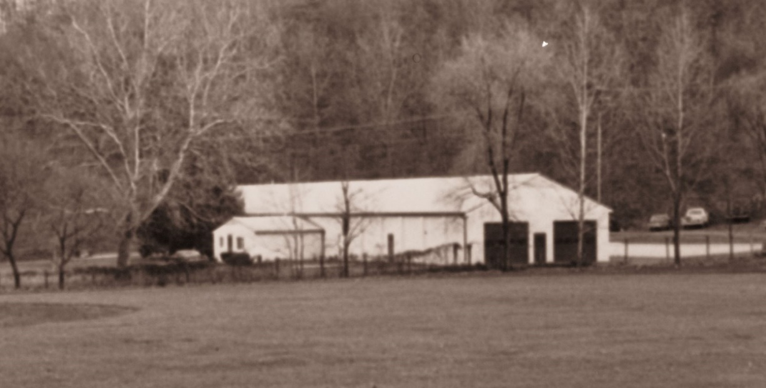
Maintenance Complex, formerly Quail Hill Stables.
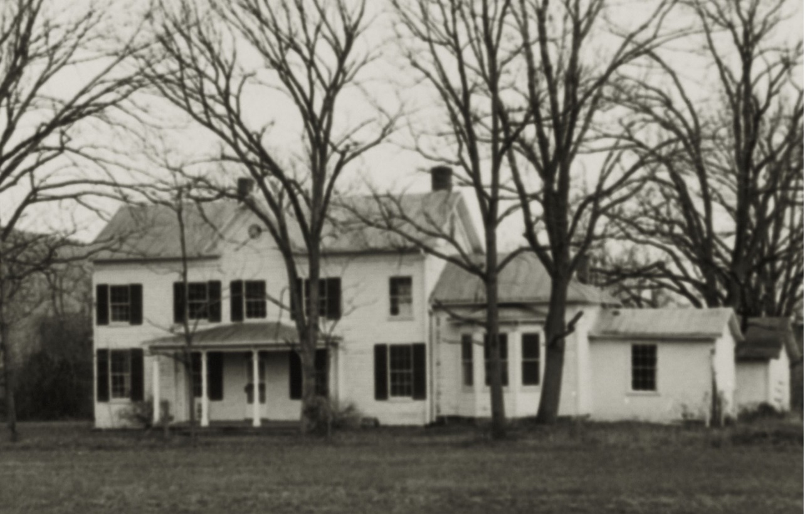
The “George Arnold Property” was acquired from the Hampshire County Commission.
It was the most recent addition to campus at the time.

The 1986-87 school year was a busy one for the entire staff as all three schools prepared for the upcoming North Central On-Site Visit as well as the West Virginia Special Education Monitoring Team visit. By 1986-87, average yearly student population had dropped to a low of 202 full-time students, (due mainly to the increasing emphasis on, and development of educational services to handicapped children within the county school systems.) However, the Itinerant Programs were serving an average of forty preschool children and their families in RESA's I and II, essentially a 20 county area in the northeastern section of West Virginia. The schools were also frequently called upon for technical assistance and outreach services by the county school systems and other agencies serving the hearing impaired and visually impaired.

During the summer of 1987, the schools again provided facilities for classes and lodging for the participants in the teacher certification programs. These on-going programs for certification of teachers of the hearing impaired or the visually impaired have been offered on the campus of the West Virginia Schools for the Deaf and the Blind for several summers. Teaching endorsements and/or Masters degrees are available in either field. George Peabody College of Vanderbilt University offers the program to teachers of the visually impaired. Teachers of the hearing impaired are enrolled in the program through Western Maryland College.

The 1987-88 school year saw a substantial increase in enrollment even though the previous year had been the final one for sixteen graduating seniors. Enrollment during the last quarter of the 87-88 school term had risen to 217 with an additional 33 children being served in the itinerant preschool programs.
The West Virginia Schools for the Deaf and the Blind have a proud place in the history of this state, this county and this community. The school has been a crucial factor in the economic well-being of this area, as well as the drawing card for many wonderful people who have come to call Romney their permanent homes. We can be proud that these schools have provided quality educational services as a residential school for over 4400 young people.

The West Virginia Schools for the Deaf and the Blind continue to meet the needs of the hearing impaired and visually impaired youth of our state by continually revising its programs to keep pace with the educational requirements of today’s society.

The campus of the West Virginia Schools for the Deaf and the Blind in 1988 not only continues to serve as a residential school, but also offers the expanded services of a pre-school program. More and more, members of the staff are called upon to furnish technical assistance and consultation to county school systems and other agencies throughout the state. Educational evaluations and screening for visual and/or hearing impairments are often requested for students enrolled in the county school systems as well as prospective students for this school.

The ultimate goal of the schools continues to be the provision of quality educational programs, geared to the individual needs, interests and abilities of each student, and the development of independent, well-adjusted and productive citizens.

