Lauren Wise

Organizational Com.

Prof. Bednar

6/25/24

The Arts as Communication Practices

Within the Houston Methodist Hospital System

For this project, I will be discussing experiences during a week-long trip to the Houston Methodist Hospital system. During this trip, my classmates and I had the opportunity to observe how the Houston Methodist Willowbrook (HMW) and Houston Methodist Hospitals (HMF) Flagship location was structured in terms of organizational communication. Throughout these observation processes, we were able to meet and speak to over 40 employees, ranging anywhere from marketing, legal teams, spiritual life workers, facilities workers, and many more. All the information following in the paper is an overview and analysis of the week spent observing, specifically from the viewpoint of someone who may not be familiar with commonalities among hospitals or medical centers. This being said, this paper will consist of my own observations as well as comments or conversations had with various staff and employee’s.

Although we spoke to a diverse range of employees within the system, I found it interesting that practices such as the arts were mentioned relatively frequently. In my past experiences with hospitals, I never would have considered the arts to be an important part of how a hospital was organized apart from the standard non-specific art pieces that you often see floating around, or occasionally a pianist playing in the entry lobby. However, the arts were something that was found quite often throughout our stay at both Houston Methodist Hospital Willowbrook (HMW) as well as the Houston Methodist Flagship location (HMF). The way that Houston Methodist organizes their relationship to the arts as both non-medicinal, and medicinal practices is structured to benefit just about everyone the hospital encounters, while being a wonderful strategic way to benefit employees, patients, the community, doctors, and the creators of art themselves. The use of the arts implemented throughout the Houston Methodist Hospital system acts to first establish and introduce their brand/values through various religious artworks and passive art. Secondly, it strengthens their internal relations by actively showing their brand/values through programs such as the NICU Music therapy program while also offering artistic opportunities to employees and local artists and musicians. Finally, they use it as an opportunity to grow their brand through external arts partnerships that simultaneously medically supports the arts while all together cementing and reinforcing their brand as whole.

*Artwork in Introducing Brand/Values*

Figure 1

When first walking into the main entrance of Houston Methodist Willowbrook, I couldn’t help but notice a life-sized statue picturing Jesus healing a kneeling figure by touching them on their forehead. This statue immediately catches the eye being put in the center of the entry pavilion and is complemented by other various religious artworks such as mosaics, framed quilts, and paintings. To my surprise, when our group took a visit to the flagship location, we saw that same statue sitting in the main entry pavilion **as seen in Figure 1**. We met with VP of Spiritual life, Charles Millikan, who discussed the statue with me. I learned that they currently have this statue at all 8 hospital locations and serves as a symbol for what they strive for within their hospital system.

Within the flagship location there is also a large mosaic **as seen in Figure 2** 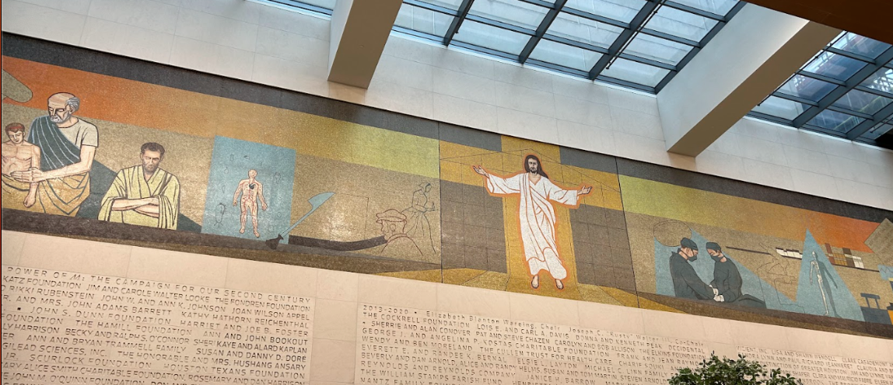

Figure 2

which is replicated in smaller scales throughout all 8 locations. The mosaic itself pictures Jesus in the center in front of a cross, surrounded by both scientific and biblical imagery. This larger-than-life mosaic takes place in a lounge outside of one of the hubs for their spiritual services, and was moved from the outside where it was being blocked by greenery, to an inside area with heavy traffic. Charles Millikan expressed the hard work and detail that went into the moving of the mosaic, in an attempt to preserve the art, alongside a visualization of their mission. Not only are there intentions within this system to create art that goes alongside their message, but they also act intentionally to preserve these values. These two art pieces introduce and establish the hospital's values and branding to those who may be first time visitors like me, or generally unknowing of what Houston methodist stands for. These art pieces overall introduces patrons to two main practices that are established within this hospital, religion within the Christian faith, and healing.

*The Arts in Actively proving Values/Brand*

Branding and values do nothing for organizational communication if the organization itself does not uphold them. In the case of HMHS, from every person we talked to it seemed that as a whole one of the benefits of this system is that they uphold their values, just one example being “Patients first” used as a term consistently throughout the system.

The hospital offers opportunities in actively proving their helpful, supportive, and healing focused brand through the arts. Medically they have a program within the NICU or “Neonatal intensive care unit” section of the hospital that offers music therapy. As well as having leading research surrounding Dementia and Alzheimer's patients with a positive cognitive reaction to songs that said patients enjoy. These uses of music therapy is one of the few cases that I have seen the arts and healing implemented within western medicine.

Apart from using the arts to support patients medically, the arts are used to support employees by offering occasional worker-featured pop-up galleries throughout the hospital, as well as concerts for employees that are musically inclined. Additionally, almost every time we were at the hospital locations, there was at least one musical artist playing in the lobby. According to an employee that gave us a tour around the Willowbrook Branch, they often have music playing sourced from local artists, as well as accepting artwork to be hung around the A painting of a group of people wearing masks
hospital as donations such as that seen **in Figure 3.** This use of hiring and supporting local artists and musicians also cements their values throughout the community. The use of the arts both medicinally and non-medicinally in this case takes a step above the previous introduction of values/brand, to showcase and act upon their previous implications, overall solidifying their intended branding and values.

*The Arts as a Tool for Brand Growth*

Not only does the Houston Methodist Hospital system use the arts as a form of implementing and cementing their values and brand, but they also utilize it as an important form of external communications through marketing. During our trip to marketing headquarters, we learned that an important part of the hospital's functions relies on external partners. Houston Methodist puts a heavy emphasis on their Sports medicine and orthopedic departments, so it was no surprise to see local sports teams such as the Astros and Texans on their lists of partnerships. However, they also had partnerships with the Houston Opera and Ballet, as well as showcasing various advertisements featuring the arts (Specifically ballet) in regard to their orthopedic program. The heads of the marketing department also explained that with these partnerships (using ballet as an example) that different physicians have the chance to work with clients at these spaces, which inherently builds their clientele for specialty practices through their direct work with the ballet. This not only benefits the artists that often are prone to work-related injuries but benefits the already working physicians and grows the overall brand outreach of the overall hospital system.

*Conclusions*

From my observational period at the Houston Methodist Hospital System, I learned that this system uses the arts as a tool for the larger scope of their organizational communications, and branding. By first starting off with the introduction of their values and brand through artwork, it inherently carves a spot for themselves to prove their values and branding through their practices with patients such as their NICU Programs, as well as supporting their employees and community artists. However, this is not limited to their internal relations with their heavy marketing emphasis on partnerships with the Houston Ballet and Opera. Overall, Houston Methodist uses the arts as an organizational communication tool as a way to introduce, prove, and grow their brand through their set values.