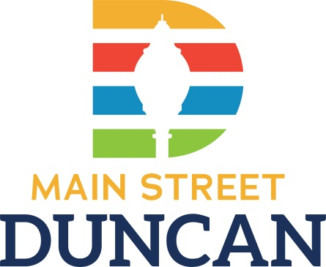
Business of the Month FAQS
- Who?
Main Street Duncan, Inc. would like to recognize those businesses that are contributors to the downtown district.
- What?
First, our organization we will send a press release to our 30+ media contacts during the month your business is being honored. Secondly, we will have a photo opportunity of the business and owner/employees for the press release and for a memento of the nomination and will be awarded a small but special prize. Lastly, we will host a Facebook live of the recognition of the business and will include an additional Facebook post in the same month separately. Of course, we encourage you to share the media posts on your social media too.
- When?
The business can be eligible for recognition once during the fiscal year of July 1st to June 30th
- Where?
This event can take place anywhere you see fit; outside your storefront is ideal. You do not have to be located in the downtown district to host this event; the only requirement is membership to Main Street Duncan, Inc.
- Why?
Duncan is a wonderful community full of vibrant people and businesses. Being the county seat, we do a great job of promoting all we have to offer to those both inside and outside our area. With the Business of the Month recognition, we can further increase not only foot traffic but also long-term customers and clients for your industry through media recognition.
- How?
Your business is nominated by fellow businesses or members of our community. Then, the Organization Committee (which meets regularly the 2nd Thursday of the month at 10 AM) meets to review nominations. Finally, we let you know you’ve won and being to setup the date for your business photo opportunity to be distributed via social media and press.

**Please submit applications via email or direct mail; addresses can be found on the other side of this page

