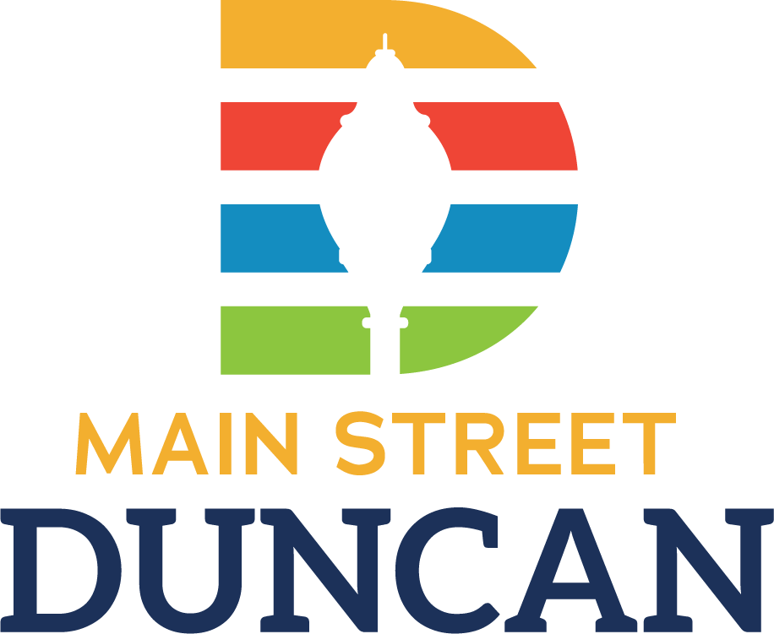

Facade Grant Program
Providing financial incentive to businesses and business owners in downtown Duncan to improve the exterior of their building.

We are currently offering our Façade Grant Program, matching the investment you make on the exterior of your property dollar-for-dollar. For 2023, the grant may be distributed as one matching grant up to $2,000 or two matching grants up to $1,000.00.
Eligible Improvements
- Masonry or mortar joint repair
- Window or door repair/replacement
- Transom and window repair/replacement
- Exterior painting
- Repair, replacement or addition of awnings
- Exterior lighting and signage (No temporary signage)
- Other improvements may qualify on a case-by-case basis.

Application Deadline: April 30, 2023
Notification of Award:
Notification will be made within one month of the application deadline.

Projects must be completed and receipts for reimbursement received no later than October 31,2023.

Priority of projects will go to those who can prove:
- High visual impact – Would the work make a dramatic difference in the district?
- Lasting Improvement – High quality improvement that will be durable for years.
- Active Street Front – Eligible facades must have a public entrance to qualify.

What costs do not qualify for the matching grant?
- Labor by the applicant or friends of the applicant.
- Any costs that exceed the grant amount awarded will be the sole responsibility of the owner.
- Any work done that does not meet standards or was not on the original application.
- New construction, as in a new building that did not exist in that location.
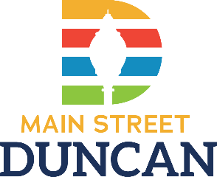
Facade Grant
Program

Program Rules
- Applicant must be a current program supporter at the Storefront Business level or higher.
- Building owner(s) are in agreement regarding proposed work.
- The building must be located within the boundaries of Main Street Duncan’s program area. (See map below)
- Your application must be submitted and approved before beginning work. Grants are not awarded for work done prior to approval.
- Façade work, including painting, window repair and/or replacement, and/or cleaning of masonry must follow the Oklahoma Design Guidelines as published by the Oklahoma Main Street program.
- Before and after photos must be submitted to Main Street Duncan.
- An eligible façade is defined as an individual storefront or side of a building with a public entrance.
- Grantees must use local products and companies as available.
- Main Street Duncan will not award a grant if a qualifying proposal is not submitted per this application’s guidelines. All decisions regarding applications are the sole authority of Main Street Duncan and are final.
- Once the project is complete, submit paid receipts for the improvements. Main Street Duncan will verify the work was done in accordance to the approval of the project plans before reimbursing funds.

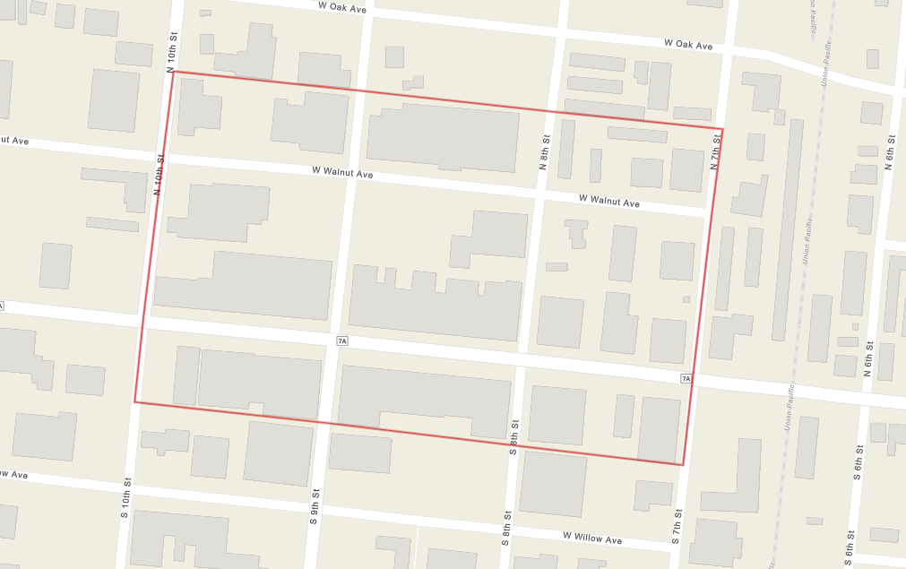

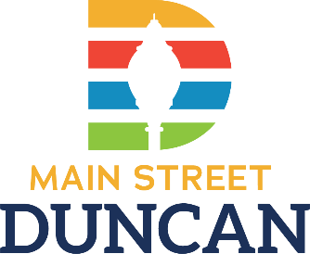
Facade Grant
Applicant Information

Date:
Applicant Name:
Business Name:
Business Address:
City: State: Zip:
Email Address:
Phone #: Cell Phone #:
Type of Business:
Estimated total cost of the project: Amount Requested:
Give a detailed description of the project:

Describe current condition of property, any unusual problems currently existing, or reason why project is needed.

