FLAWLESS FACE BROW AND BEAUTY BAR LLC

Carmeesha Arscott Owner and Certified Powder Brow Artist

1468 West 9th Street Suite 100

Cleveland, OH 44113

(419) 297-1345 Carmeesha@FlawlessBrowsandBeauty.com





























        































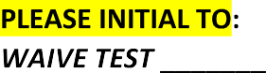























I certify that I have read or have had read to me the contents of this form. I understand the risks and alternatives involved in this procedure(s). I have had the opportunity to ask questions, and all of my questions have been answered. I acknowledge that I have reviewed and approved the material given to me, and I authorize Carmeesha Arscott, owner of Flawless Face Brow and Beauty Bar, as my permanent makeup practitioner to perform on my body the PMU procedure today.

























































































