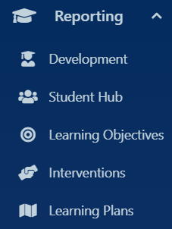
Select Reporting tab:
This opens a dropdown menu of:
- Development
(Student Reporting Homepage):
  - Assign Objective
  - Lesson Aims
  - Formal Assessments
  - Interventions
- Student Hub
- Learning Objectives
- Interventions
- Learning Plans

Select Reporting tab:
- Development:
  - Student shortcut Options:
    - View
    - Student Actions
    - Student Reports
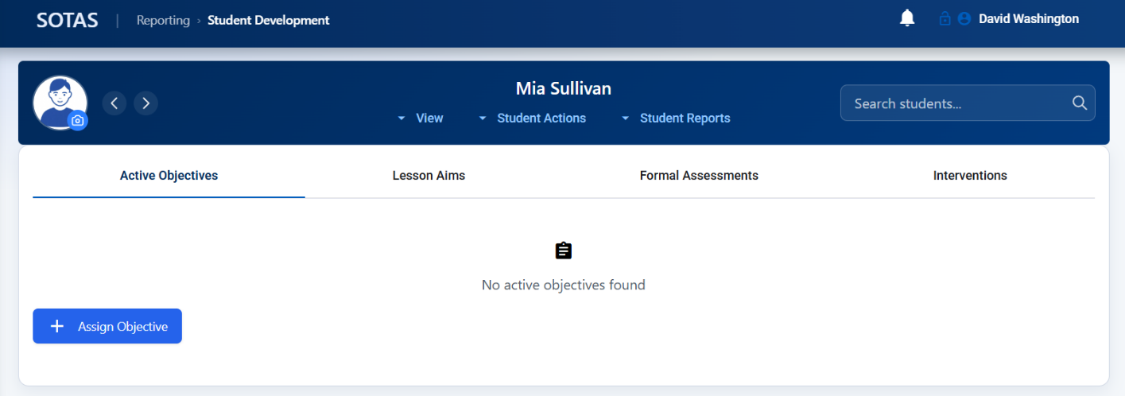
Student Shortcut options:
- View –
  - Student details
  - Student Dashboard
  - Students on Roll
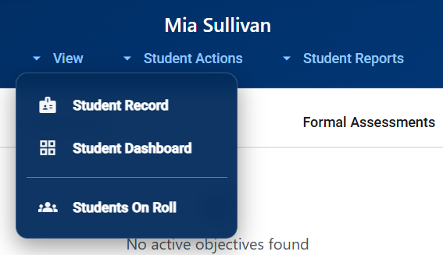

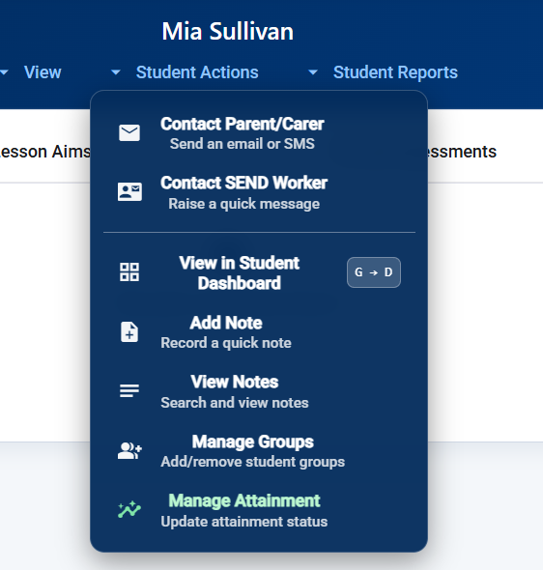
Student Shortcut options:
- Student Actions –
  - Email parent
  - Email SEND worker
  - View in Student Dashboard
  - Add note
  - Manage groups
  - Manage Attainment

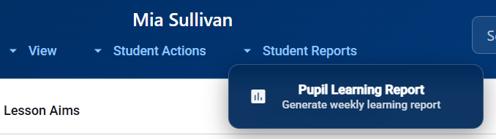

Student Shortcut options:
- Student Reports –
  - Generates Pupil Learning Report

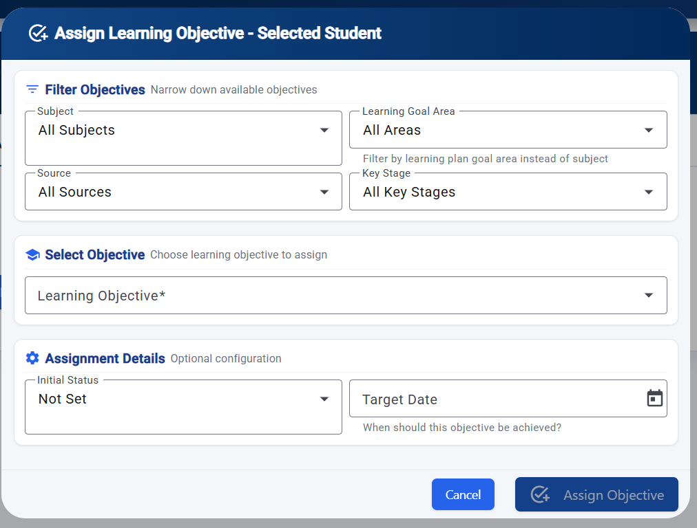
Select Reporting tab:
- Development:
- Select 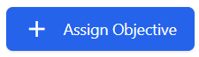 Icon to add individual objectives
  - Download CSV for full list of preset objectives.

- Opens Assign learning Objective page (See below)
- You can choose either a pre-selected Objective or create a custom objective from the source tab.

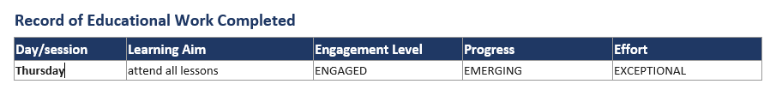
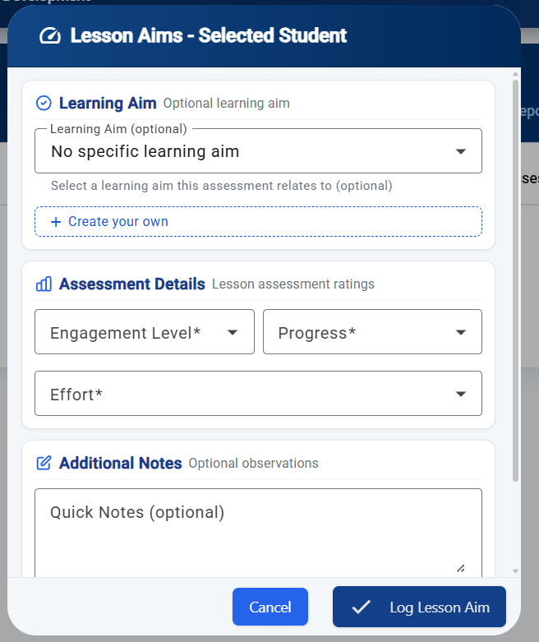
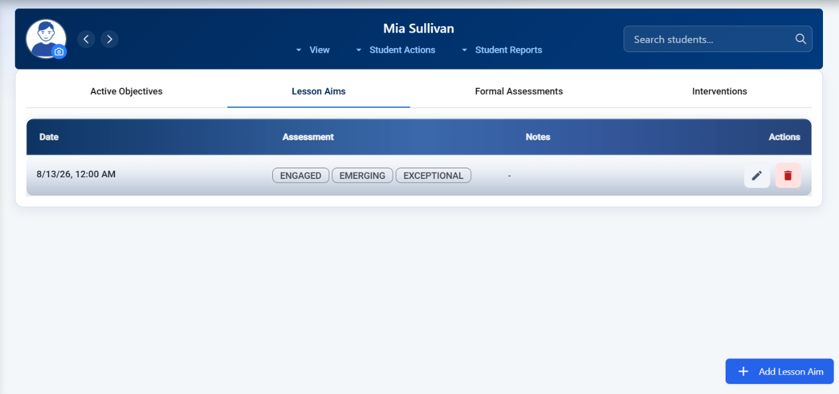
Select Lesson Aim (optional):

- Assessment levels and progress link to PLR.
Select Reporting tab:
- Development:
- Lesson Aims – Record of Educational Work Completed (PLR)
- Select or write your own lesson aim and assessment for each student for each subject/day
- Select 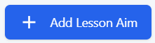 Icon to add individual Lesson Aims
- Opens Lesson Aim tab (Optional) See below
- You can choose either a pre-selected Aim or create a custom objective from the source tab.

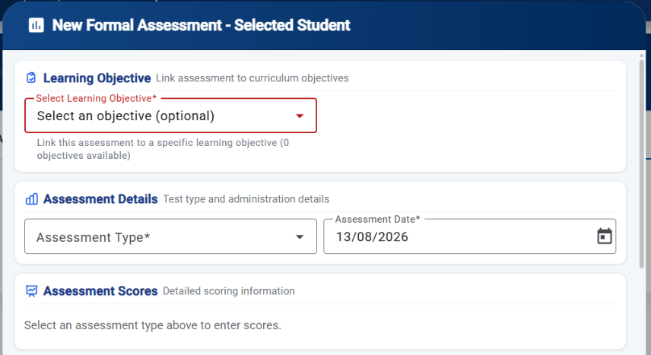
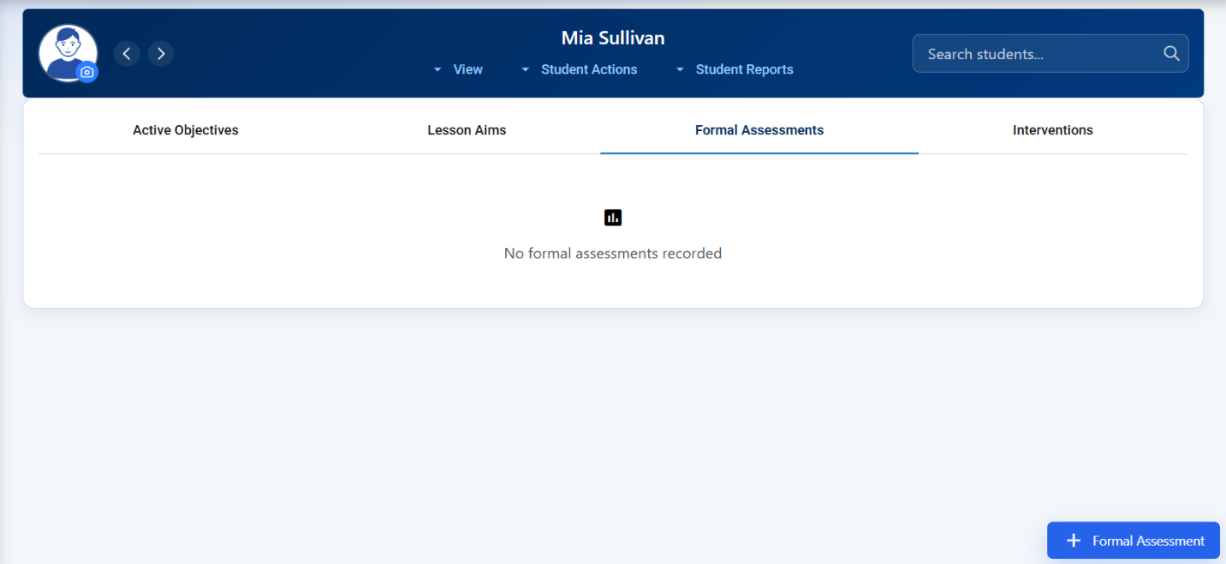
Select Reporting tab:
- Development:
- Formal Assessment – Personal Learning Objectives (PLR)
- Select or write your own Formal Assessments linked to your objectives
- Select 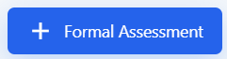 Icon to add Formal Assessment
- Opens Lesson New Formal Assessment (Optional) See below
- Selected your Objective Aim to link to an assessment or add an individual assessment & date

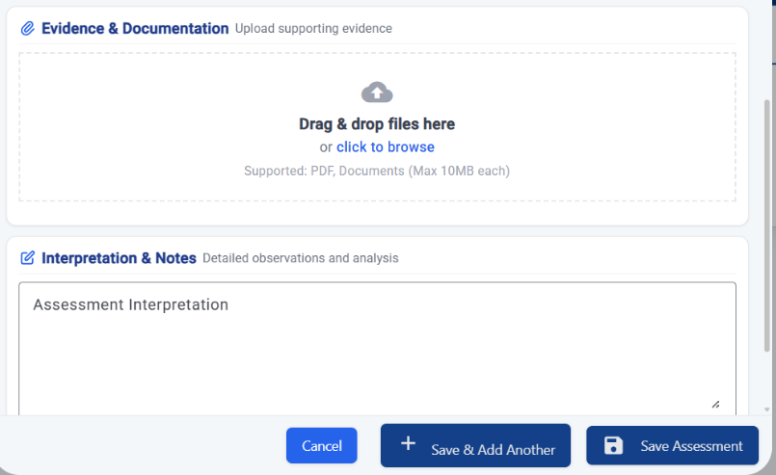

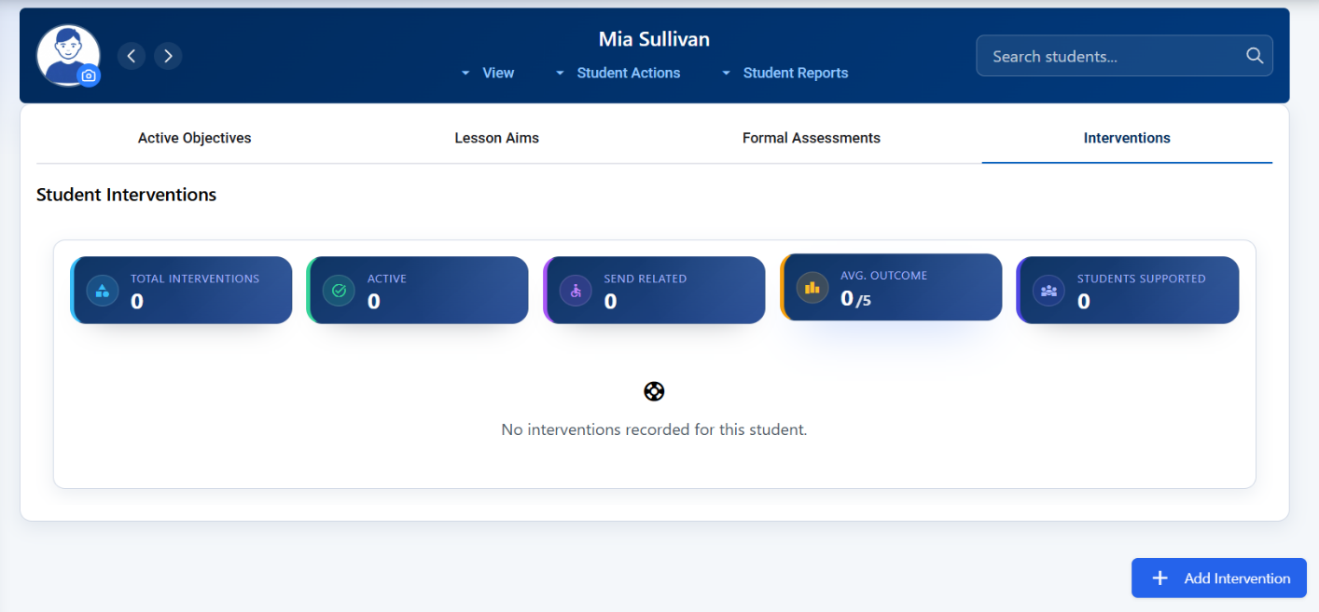
Select Reporting tab:
- Development:
- Interventions – Personal Learning Objectives (PLR)
- Select or write your own Formal Assessments linked to your objectives
- Select 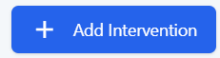 Icon to add Interventions
- Opens Lesson New Formal Assessment (Optional) See below
- Selected your Objective Aim to link to an assessment or add an individual assessment & date

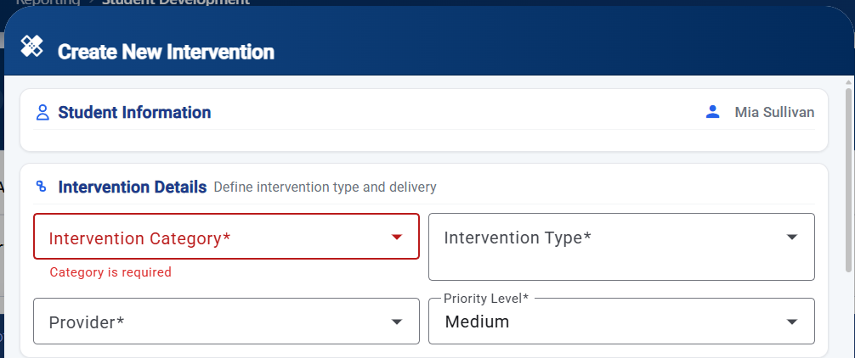
Select Create New Intervention tab:
- Choose:
  - a category
  - Type
  - Provider of the intervention
  - Priority level

- Set start & finish dates
- Frequency
- Duration of intervention
- Review dates

- Add Intervention Objectives

- Strategies

- And success

Permission details:
- Select who sees the Intervention.
Select Create Intervention – you can edit in Development Page. (see below):

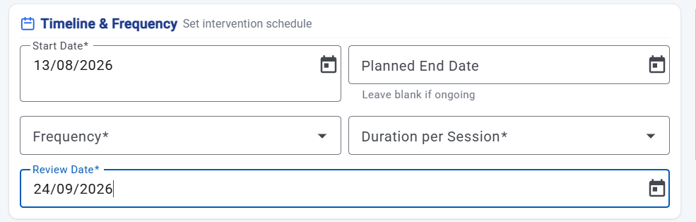

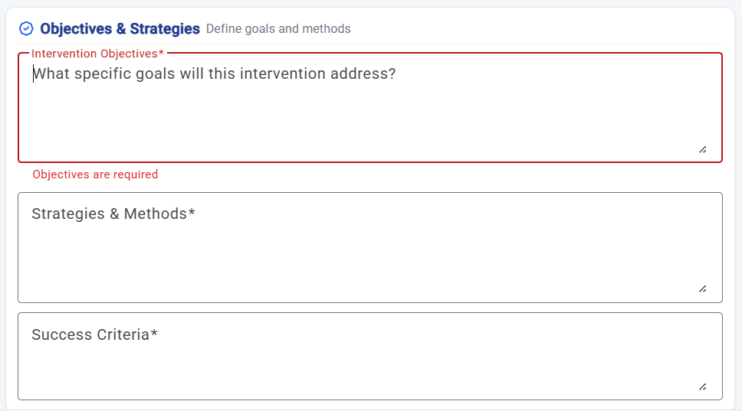

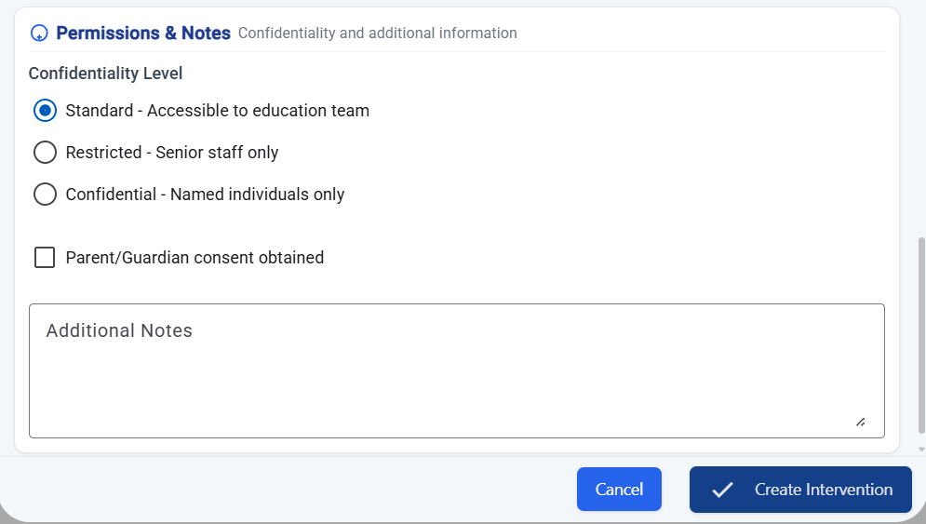

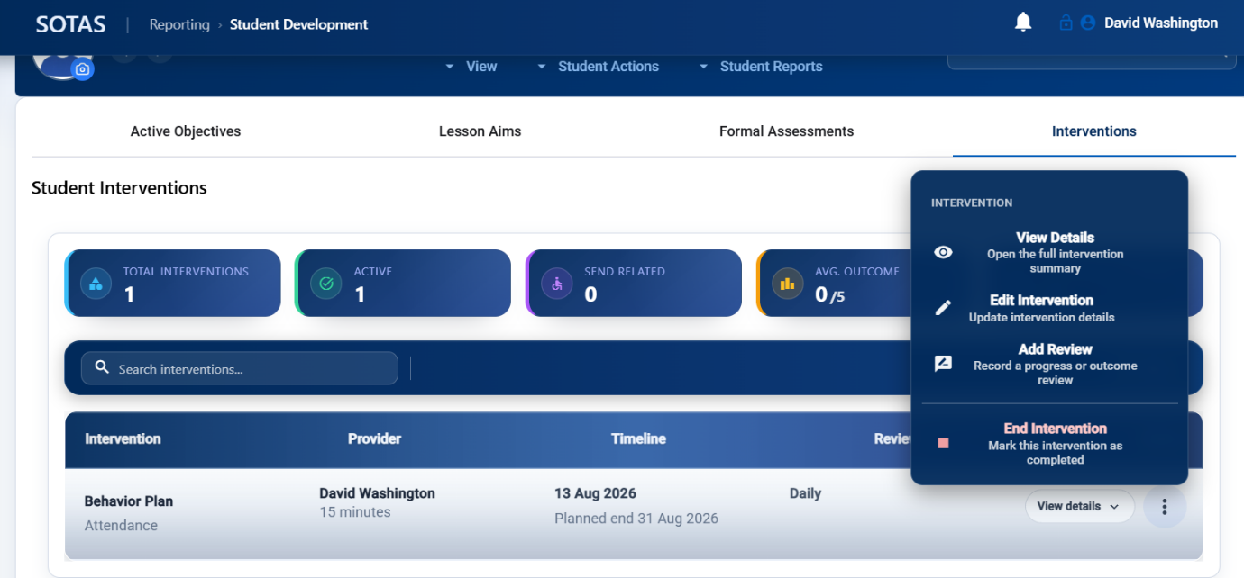

Select Student Hub tab:
- Opens overview of each student:
  - Objectives
  - Recent Assessments
  - Interventions

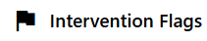
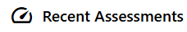
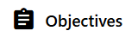
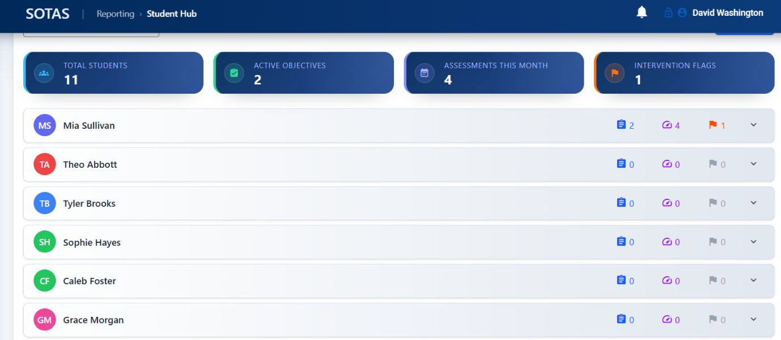

Select Learning Objectives tab:
- Opens all pre-set Objectives
- You can add new objectives in this page.
- You can edit pre-set objectives to suit your provision/students
- You can reduce the number of objectives available by selecting deactivate button
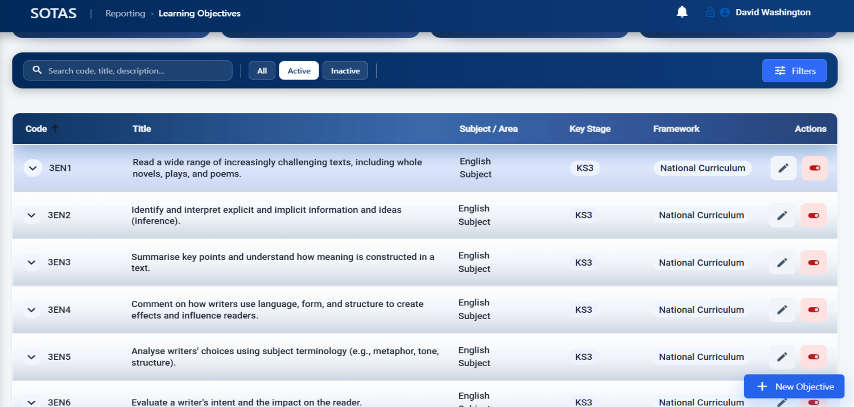

Select Interventions tab:
- Opens all pre-set Interventions
- Use the Action button to:
  - Edit existing intervention
  - Add a review
  - End the intervention
- You can also add interventions.

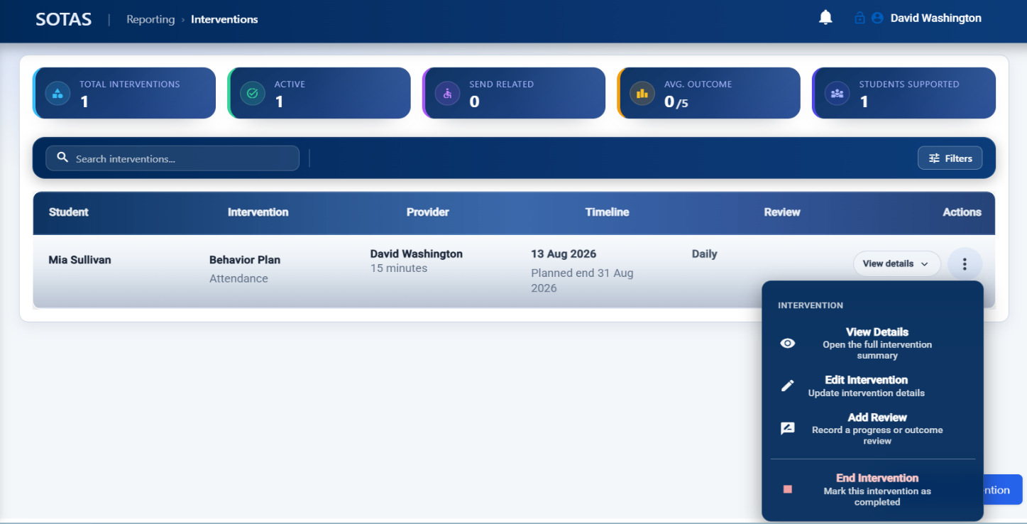

Select Learning Plans tab:
- Opens all Active Plans (IEP)
- Select 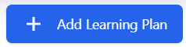 Icon to add a Learning Plan (IEP).

