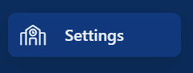
Select SETTINGS tab, this opens Settings Page (below). Here you can:
- Add School Information- your name, address & Logo
- Set up Notifications
- Set up List of Values (LOV) Admin

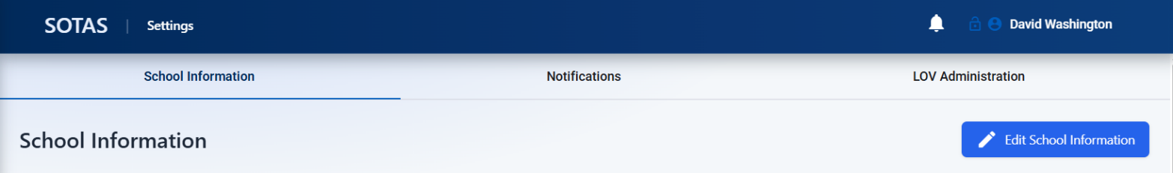

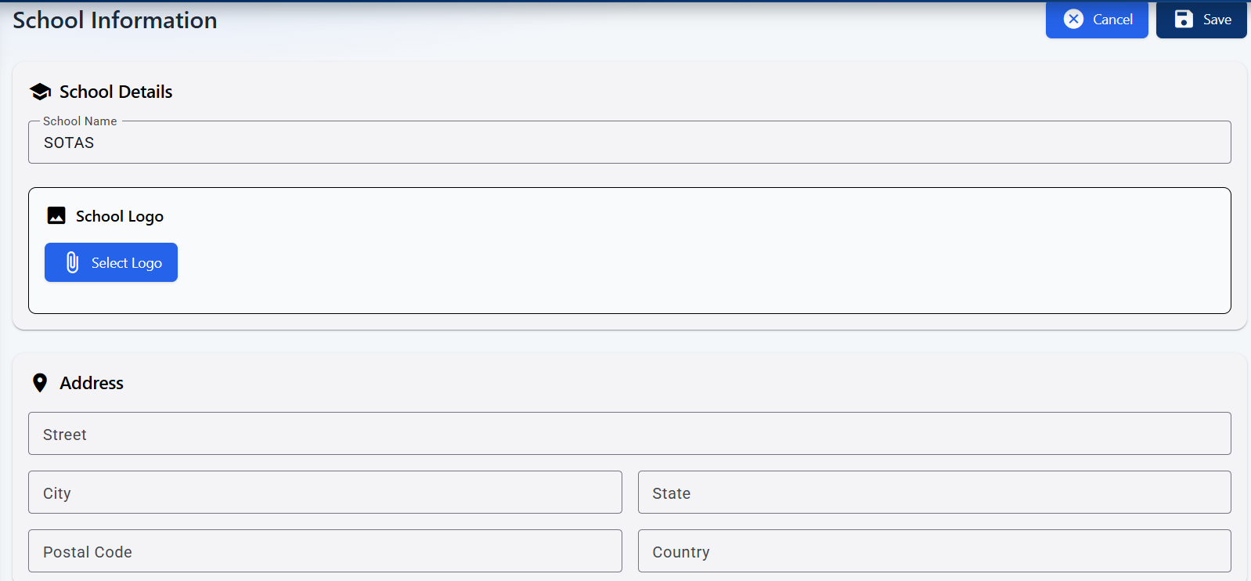
SCHOOL Information
- Add School/provider information to appear on reports or external documents

Notifications main page
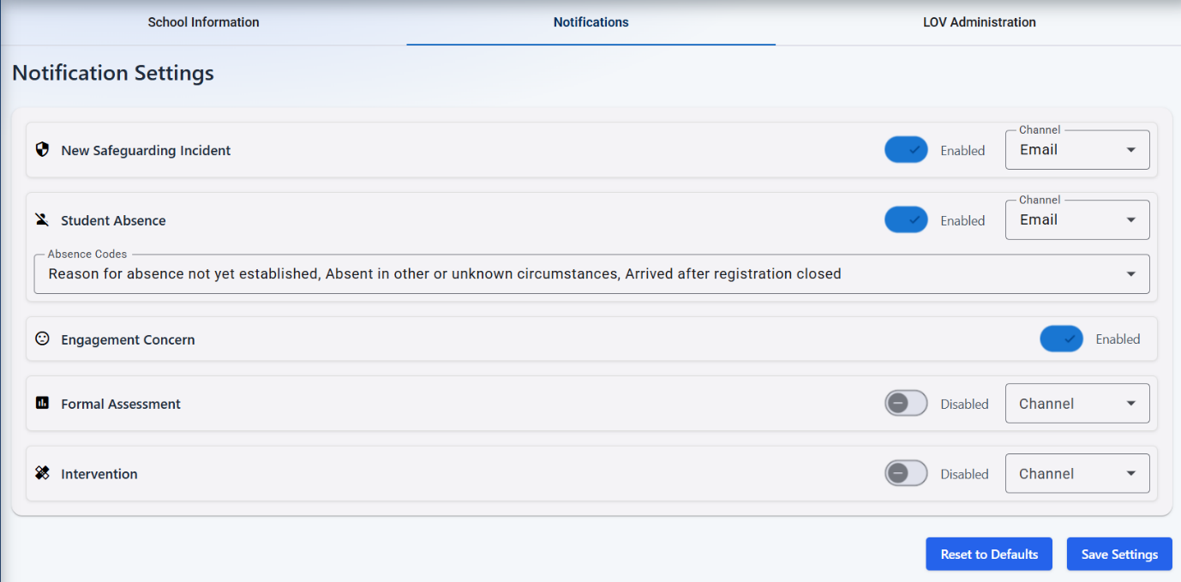
Safeguarding Notification
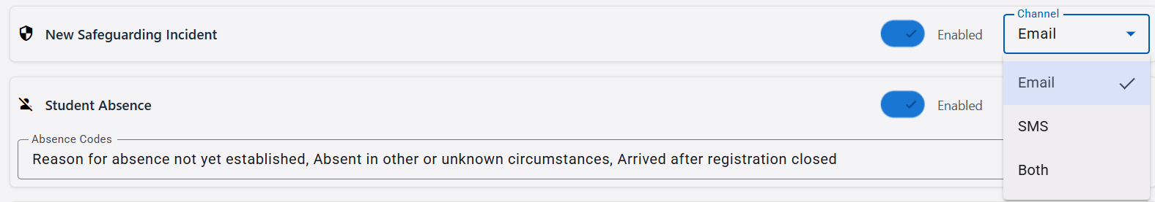
Student Absence
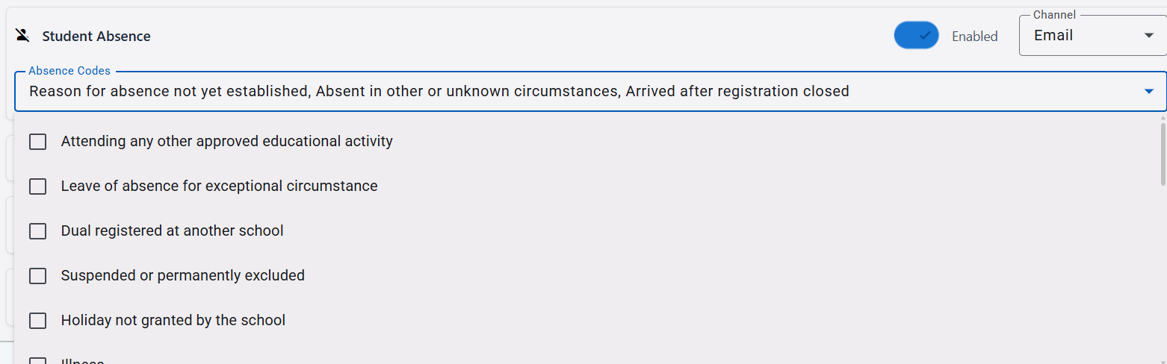
Notifications tab allows you to set the type of notification for your school e.g.
- Safeguarding Incident – enabled – email, text or both Safeguarding Lead linked to the student in their current setting.
- Student Absence - email, text or both Attendance Lead linked to the student in their current setting.
- Set absence codes to report.
- Engagement concern –
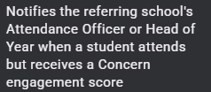
- Formal Assessment –
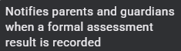
- Intervention –
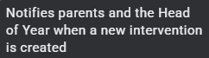

List of Values (LOV) Admin
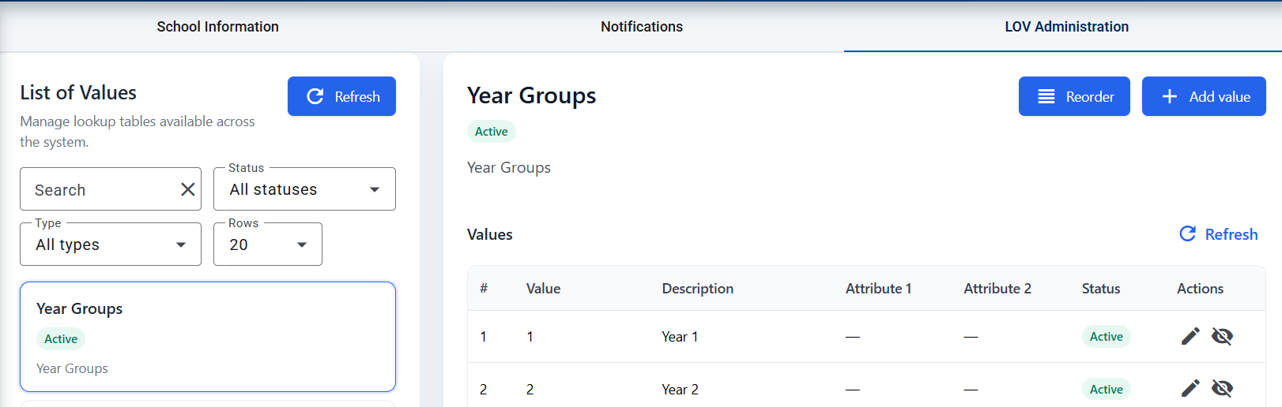

LOV Administration tab has preset codes (DFE recognised) for:
- Year Groups
- Languages
- Religion
- Ethnicity
- Gender
- Attendance
- Medical
- Safeguarding
- Assessments
- Subjects
If a value is not present you can add (top right hand corner)

