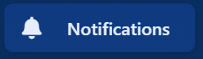

Select the Notifications tab, this opens Notifications Page (below). Here you can:
- Check on what notifications are urgent or critical
- Check recorded safeguarding incidents
- Register concerns
- Escalations
- Attendance concerns
- New staff notifications

