
Select Admin tab, this opens admin Page (below). Here you can:
- Add staff (Staff members)
- Create new users (external staff)
- Create subjects/sessions/groups (timetable)
- Create Academic year

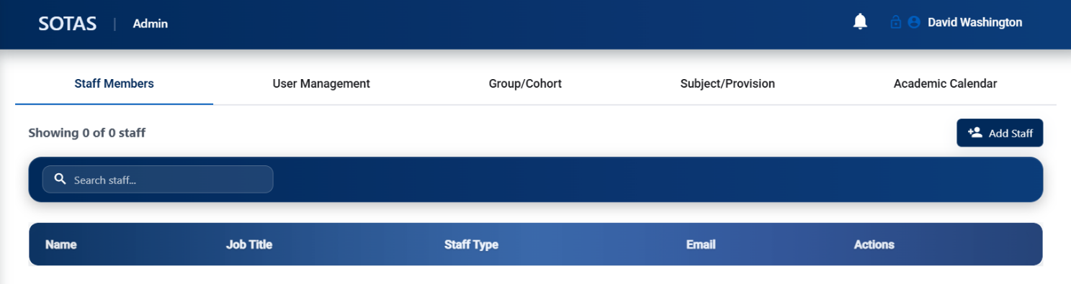

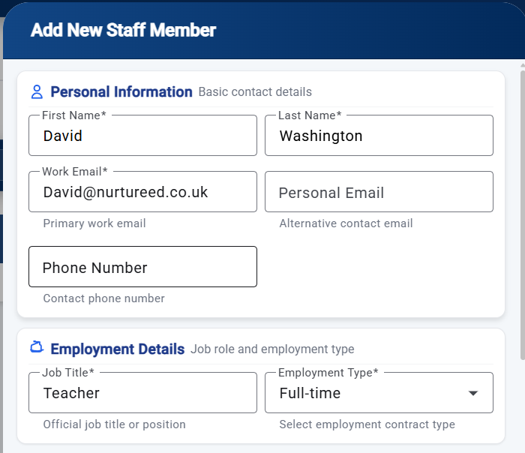
Staff Members:
In the Add New Staff tab you can input:
- Name
- Surname
- Email addresses
- Employment status/role
- Contract start/end dates
- DBS Reference
- DBS check (SCR)
- Hours
- Type of user account –
  - Staff
  - External
  - Parent
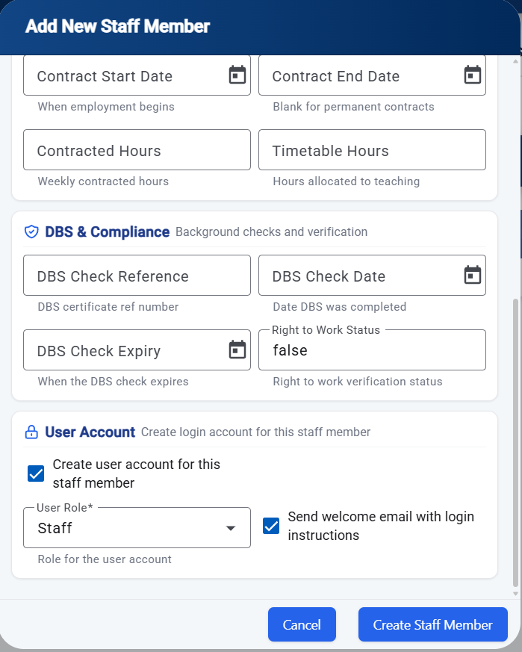

User Management:
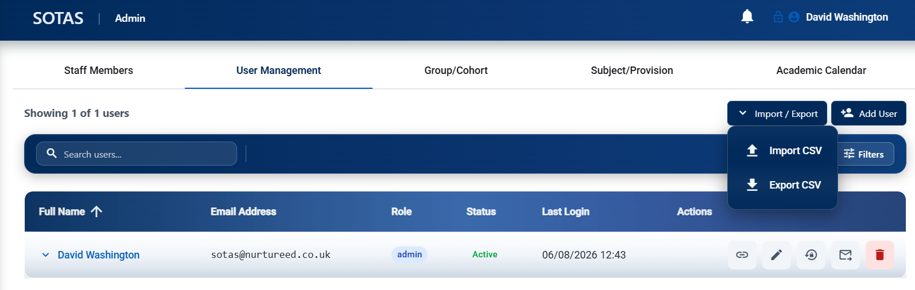
In the Add User Management tab you can input:
- Import CSV (large number of users)
- Type of user – Parent, external agency etc
- Send Welcome email with login details

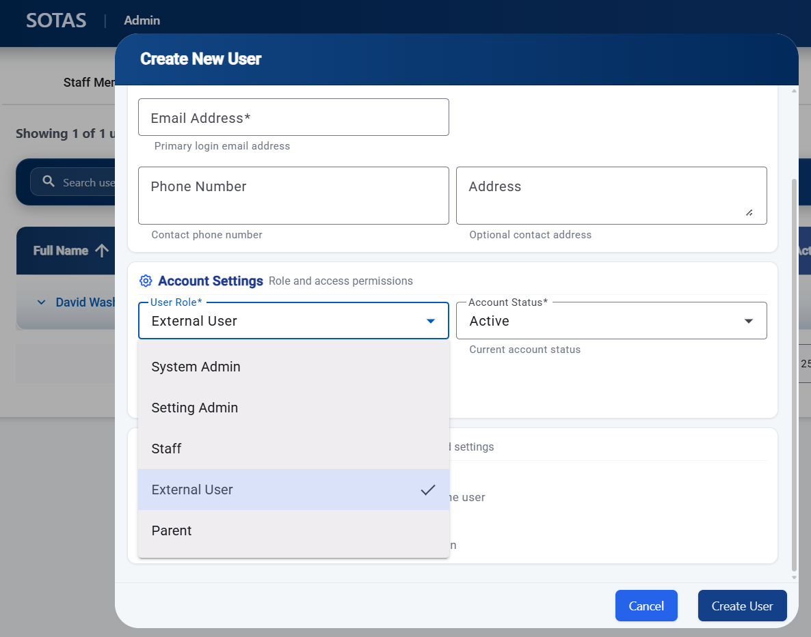

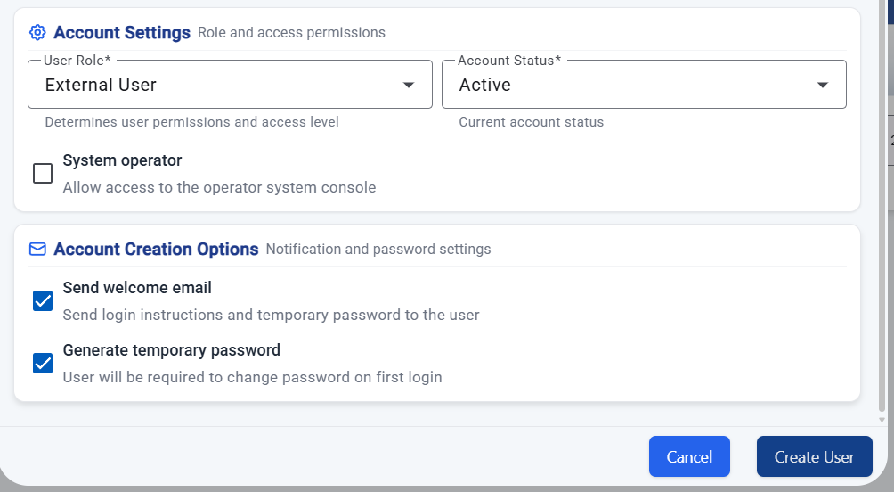

Group/Cohort tab:
In the Add New Group tab (top right) you can create:
- Groups of students
- Sessions
- Cohort
Optional to add year groups to the above
If a group or session finishes you can the status to inactive or Archived.
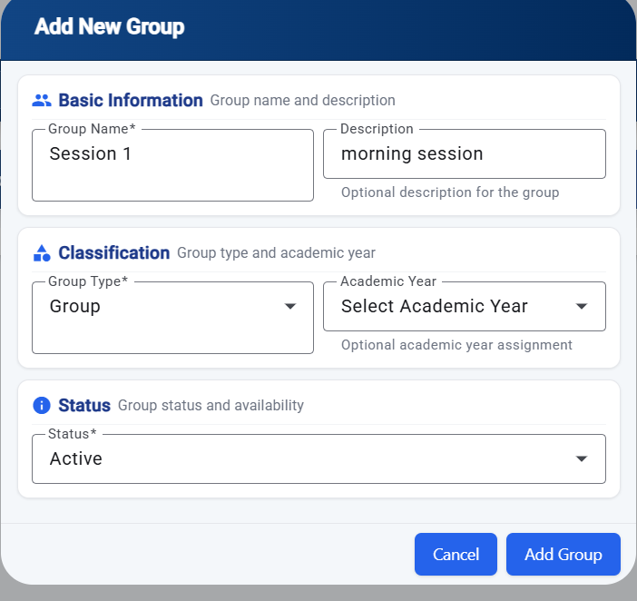

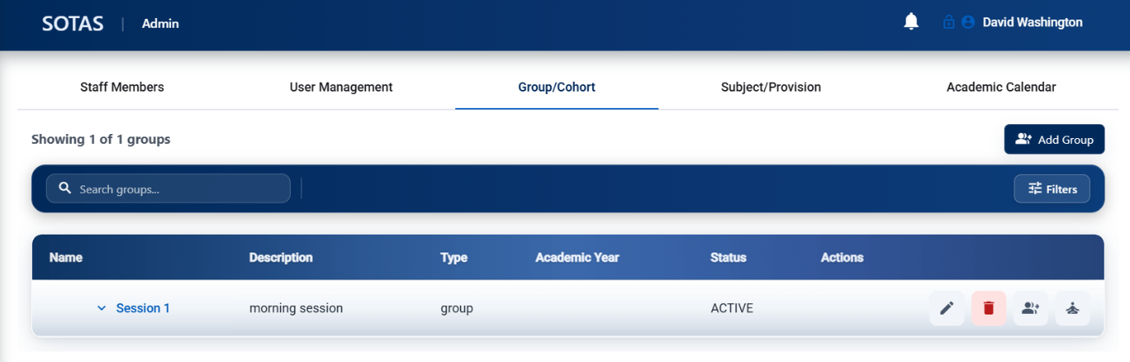
Assign Students to a group or Cohort:
In the Group/Cohort tab (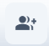) you can:
- Assign students to groups
In the Group/Cohort tab () you can:
- Assign staff to groups

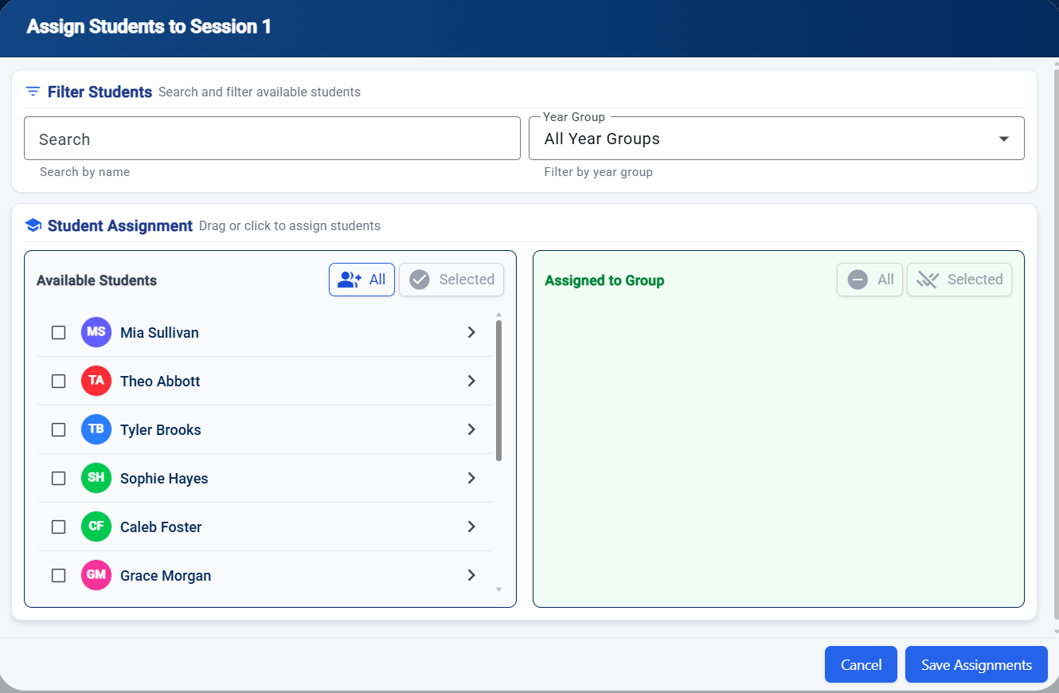

Subject/Provision tab:
In the Subject/Provision tab 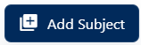you can add:
- Add a subject code
- Subject
- Type of curriculum
- Link to a key stage
- Type of qualification
- Hours allocated to subject

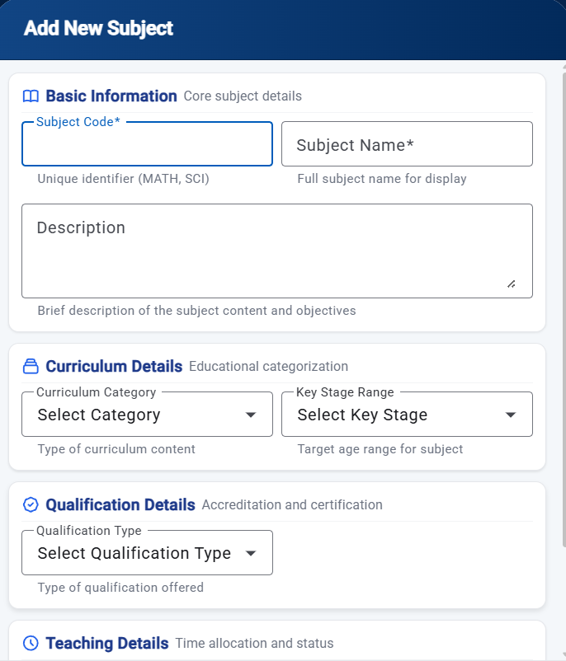

In the Subject/Provision tab you can add:
 Create activity for the subject
- Links to the timetable to create
an attendance slot
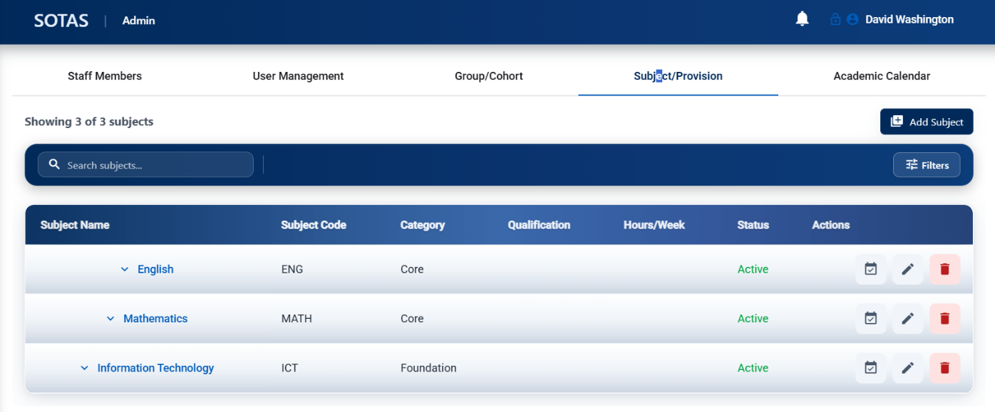

Academic Calendar:
Select Academic Calendar tab, this opens admin Page (below). Here you can:
- Set your academic year
- Manage holidays
