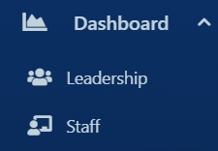
Select the Dashboard tab, this opens a dropdown for Leadership or Staff. Here you can:
Leadership:
- At a Glance
  - check the days attendance %
  - Check the days engagement levels
  - Students at Risk (attendance)
  - Attendance overview (PA)
  - Attendance trends
  - Assessment Analytics

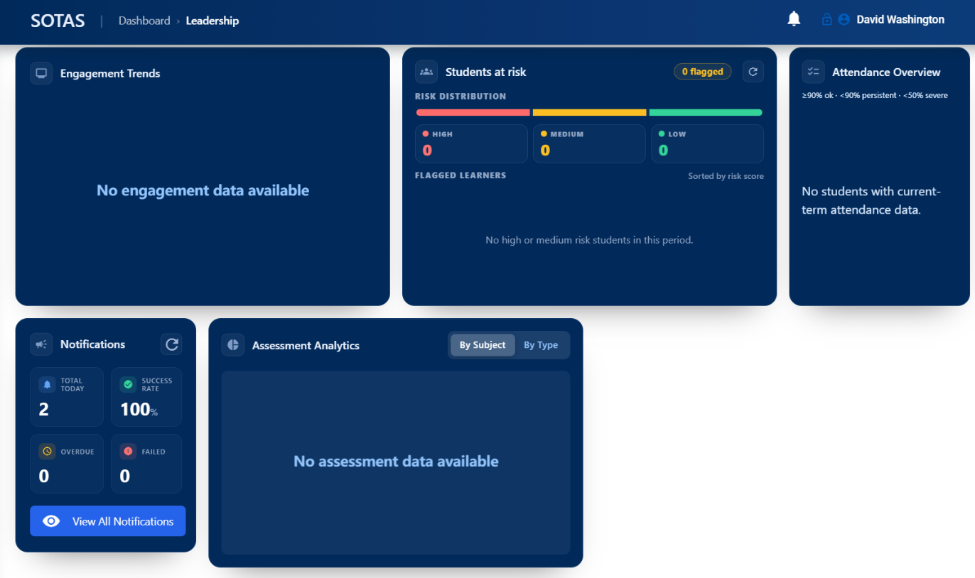
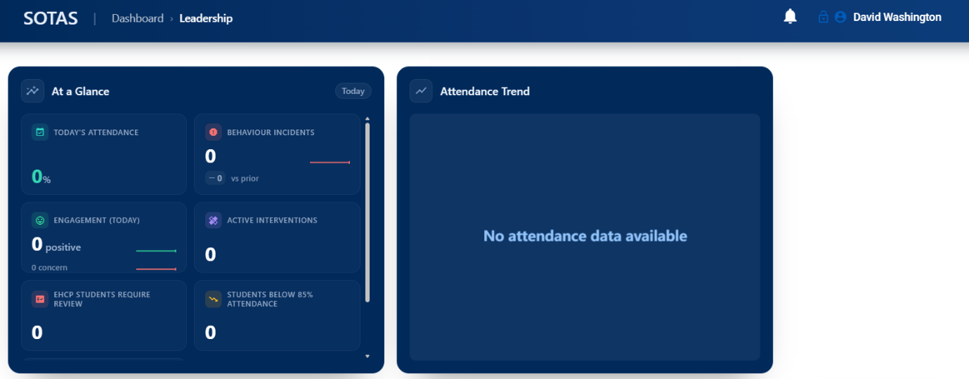

Select the Dashboard tab, this opens a dropdown for Leadership or Staff. Here you can:
Staff:
- View staff timetable
- View staff members groups
- Student attendance by staff member
- Overdue registers
- Jobs to do e.g. report notes
- Student notifications

