
Select the Agencies tab, this opens agencies Page (below). Here you can:
- Add new agencies/schools/Local Authorities
- Set Attendance summaries
- Add main contact details

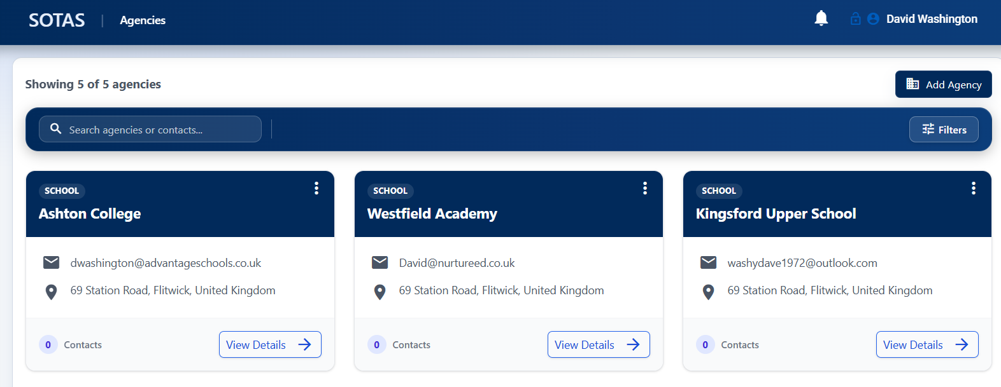

Select Add Agency tab,  this opens add new agency Page (below).

