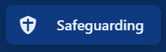
Select Safeguarding tab, this opens Safeguarding Page (below). Here you can:
- Record Safeguarding incidents
- Track Actions & notifications
- Log medical incidents
- Log restrictive interventions

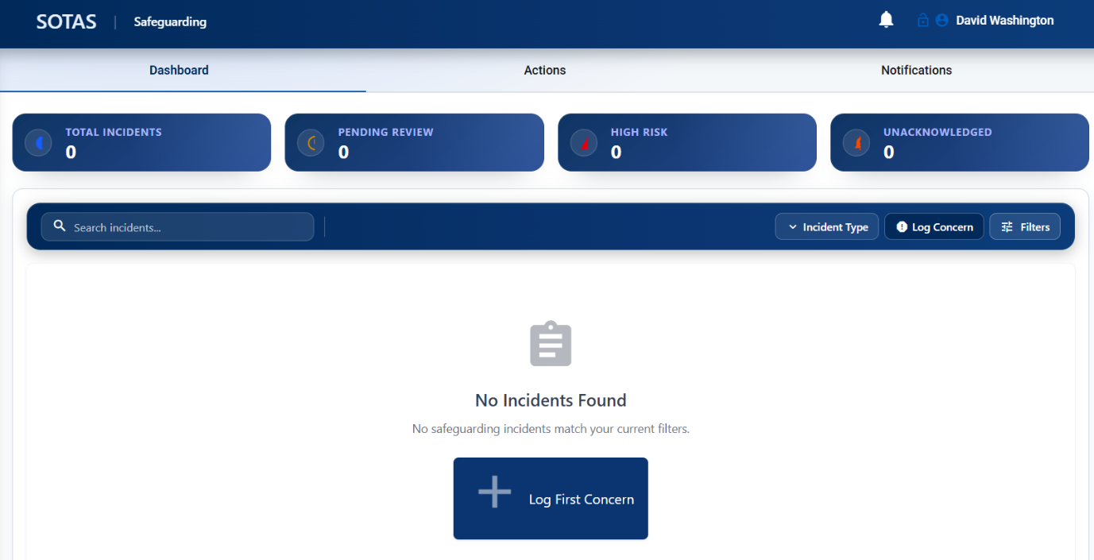

Select 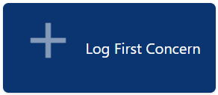 icon
- Complete all sections.
- Once complete the incident will be emailed to the DSL of host school or agency.

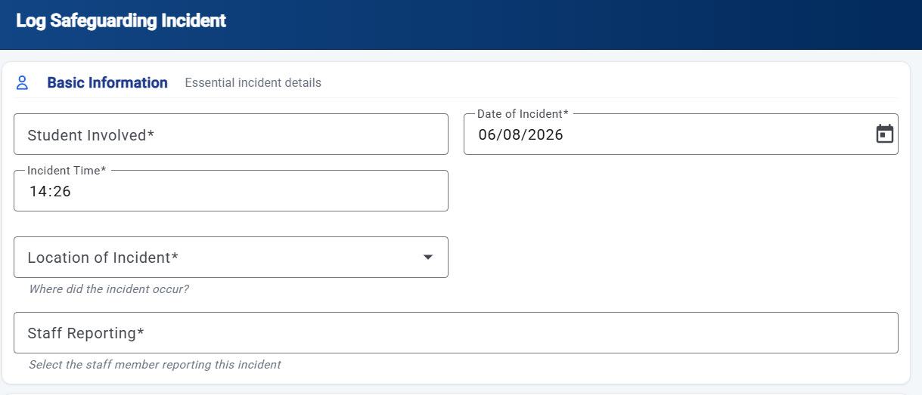
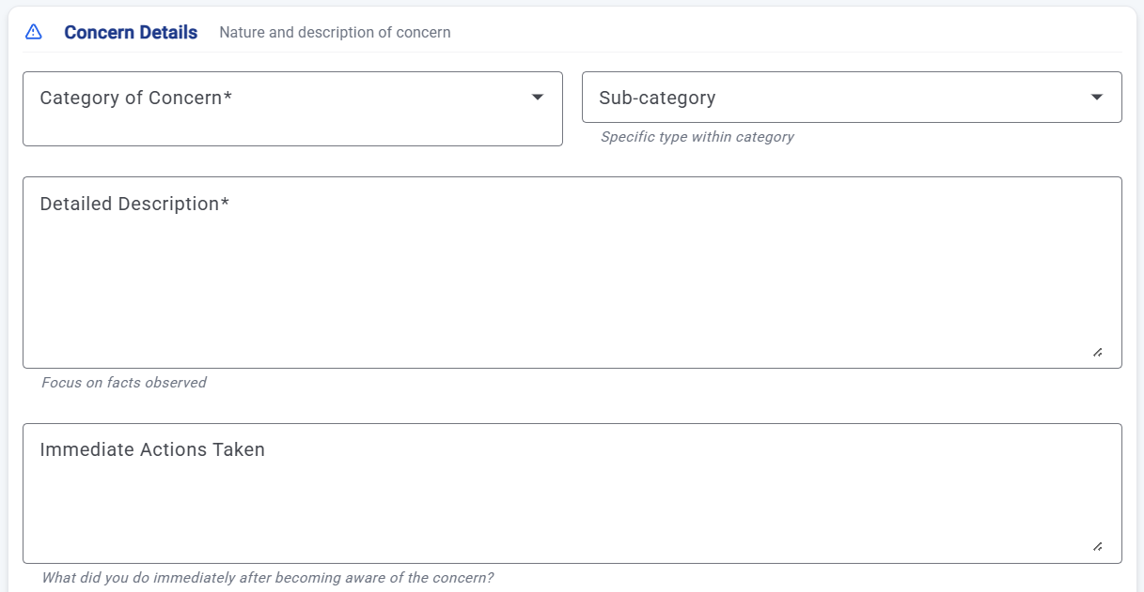

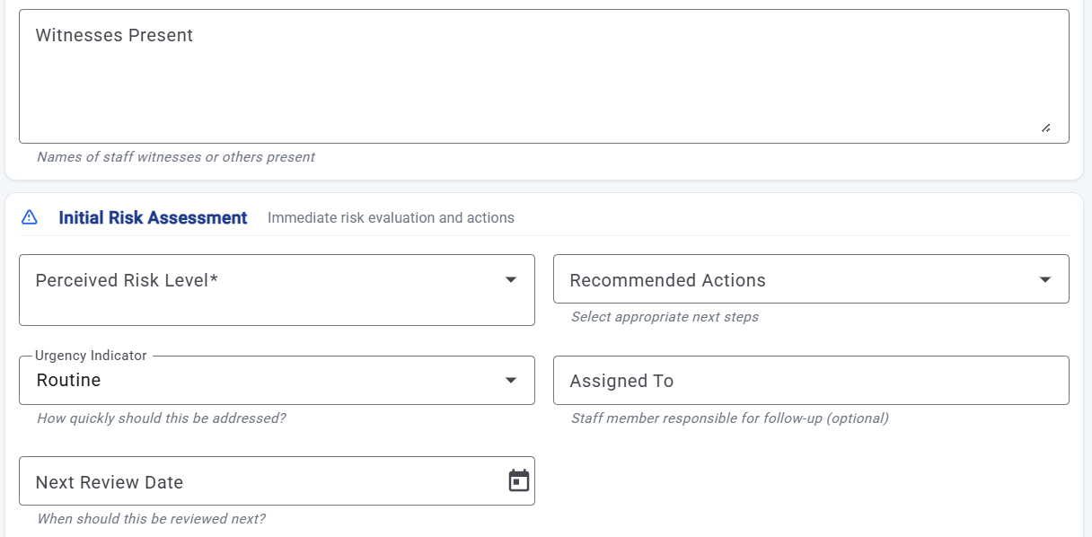

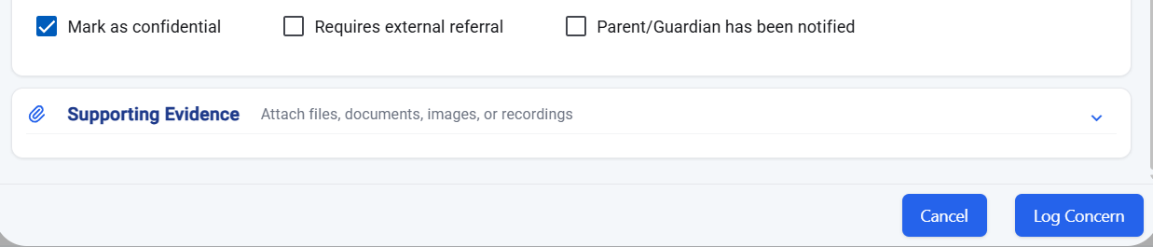
Select Incident Type to select either medical or restrictive intervention

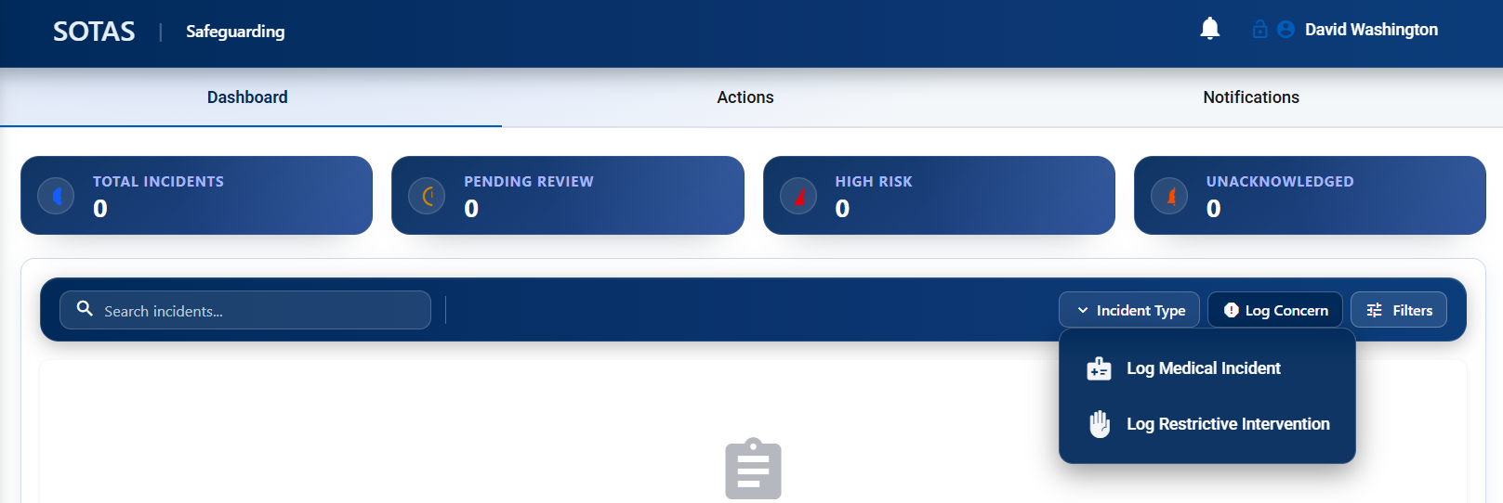
Select Action tab:
Track follow ups, assignments, and completion progress.

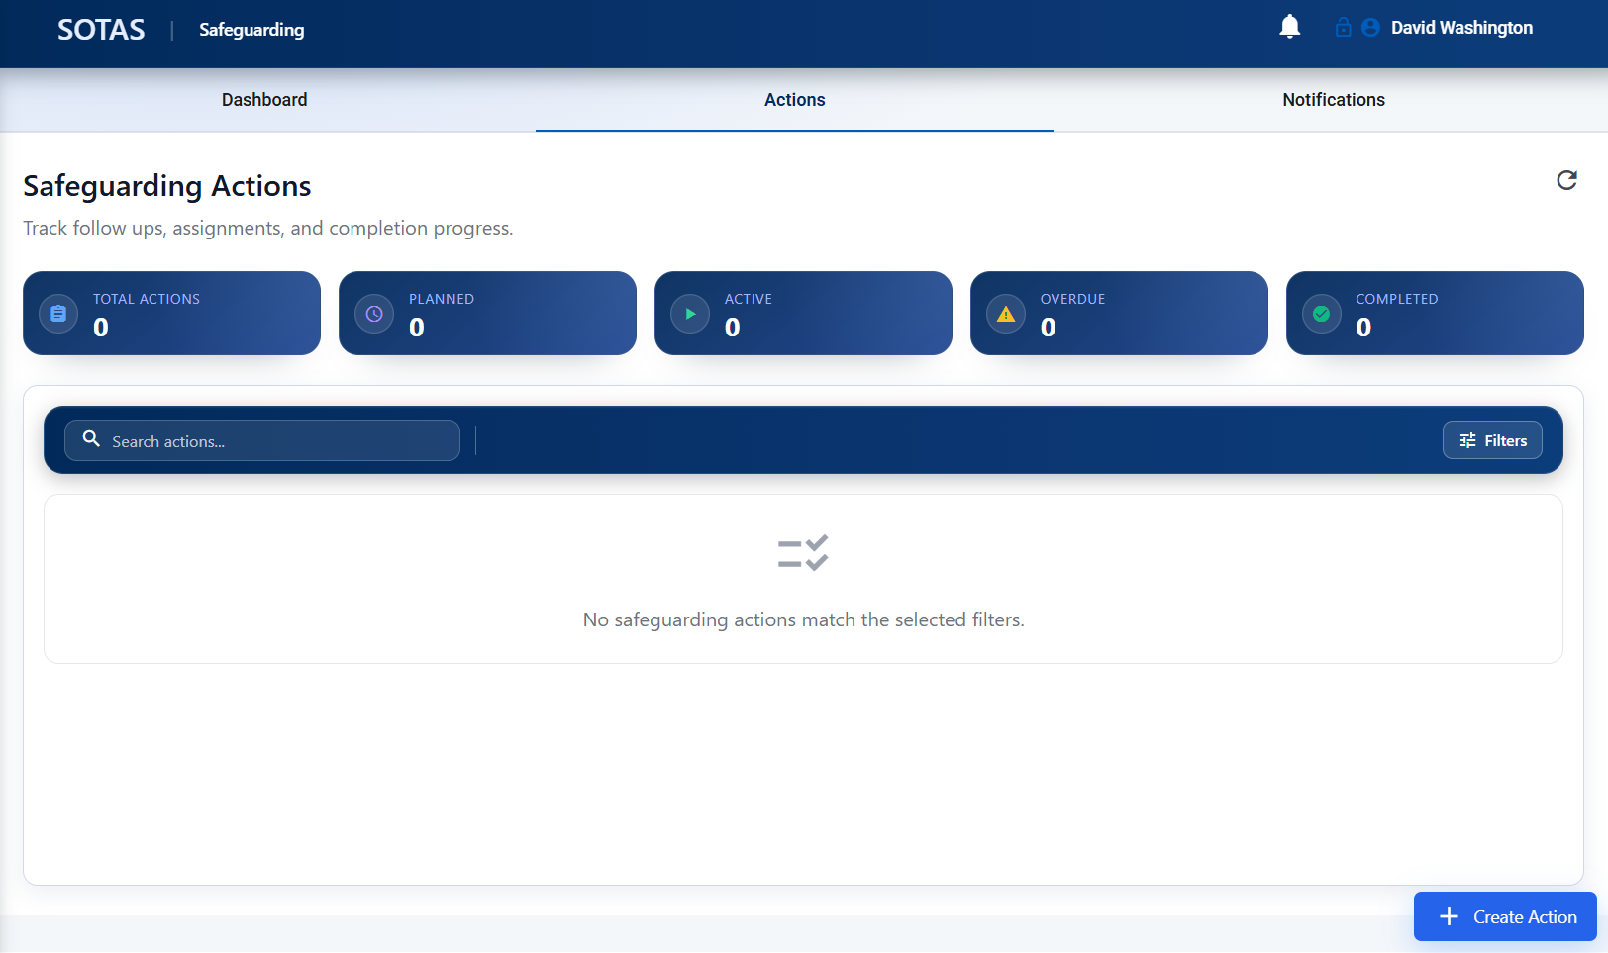

Select Notification tab:
Track notifications. These link through to Notifications tab.

