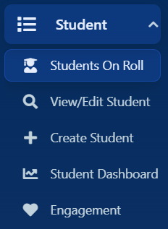
Select Student tab:
This opens a dropdown menu of:
- Students on Roll
- View/edit Student
- Create student
- Student Dashboard
- Engagement

Select Student tab:
- Students on Roll:
- Select  Icon to add individual student
  - Download CSV template for more than one student

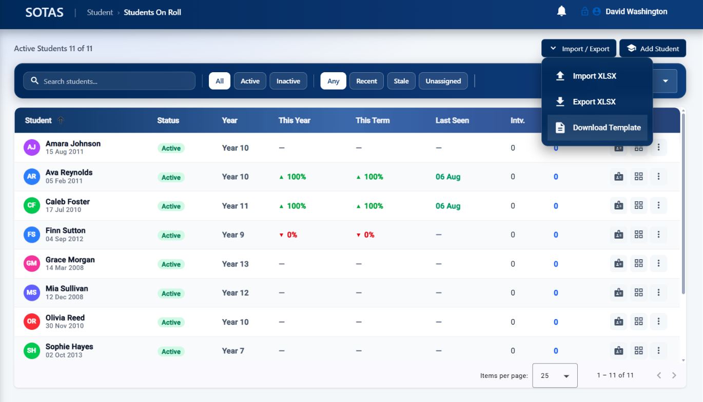

Create New Student:
- Fill in 7 steps for each student:
  - Student details
  - Family contacts
    - Set emergency contacts
  - EAL
    - Add religion, Ethnicity, Language spoken & home language
  - SEND
    - Add SEN Status & LAC
  - Medical information
    - Add medical Conditions, dosages & GP contact details
  - Education information
    - Current school details & key contacts – DSL, Attendance, HOY
  - Agency details
    - Go to Agency tab to choose agencies to link
Student details:
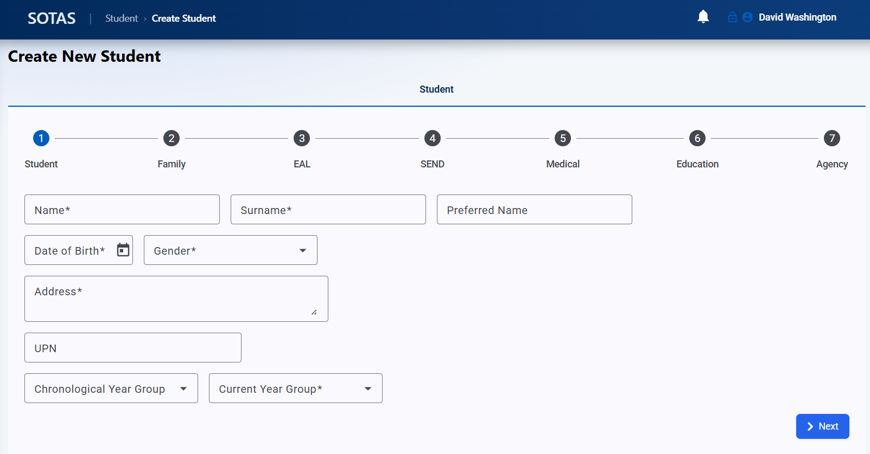

Family contacts
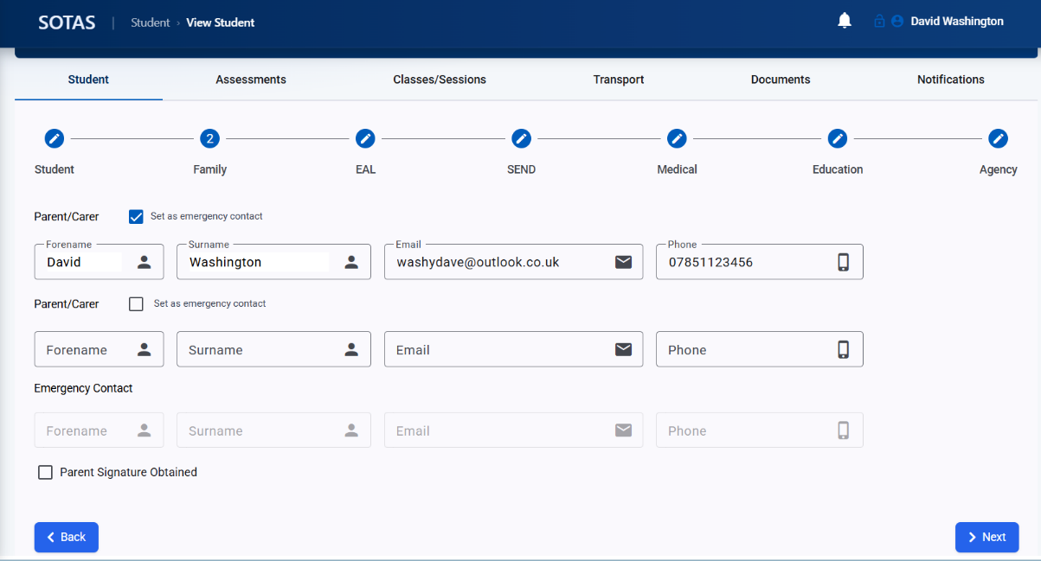

EAL
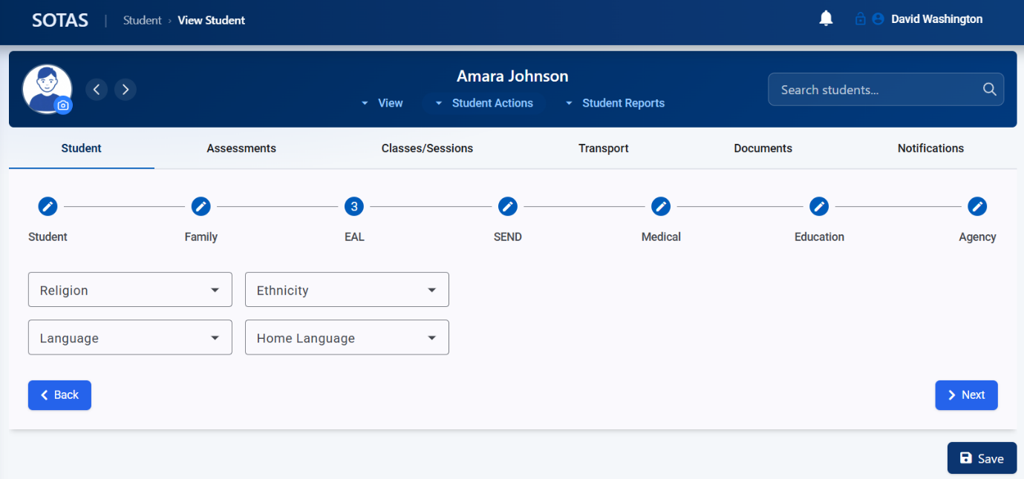

SEND
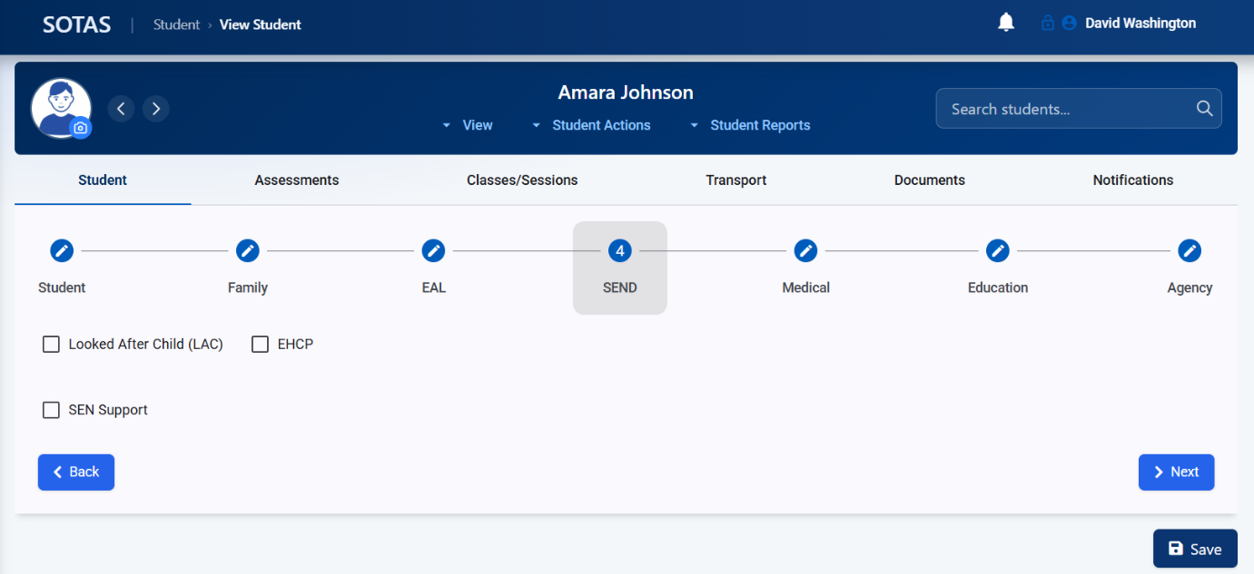
Medical information
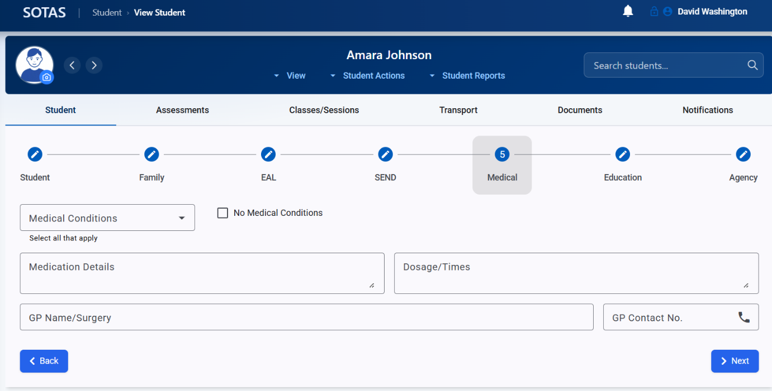

Education information
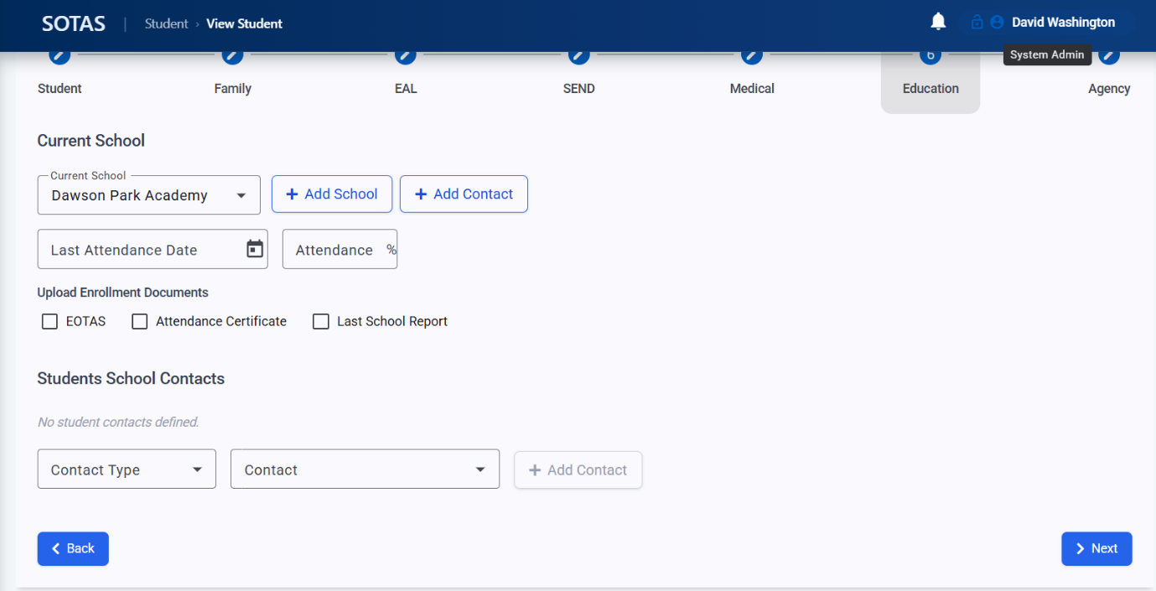
Agency details
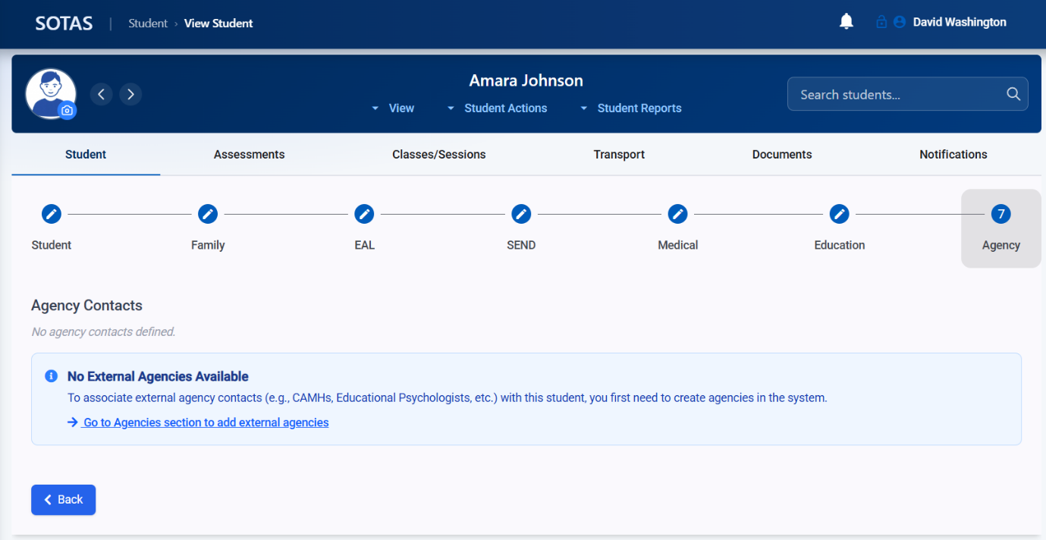

Student Dashboard:
Select Student tab:
This opens a dropdown menu of:
- Student Dashboard
  - Monitor student attendance
  - Safeguarding active incidents
  - Learning Plans
  - Assessments
  - Assigned subjects
  - Student Notes
  - Interventions

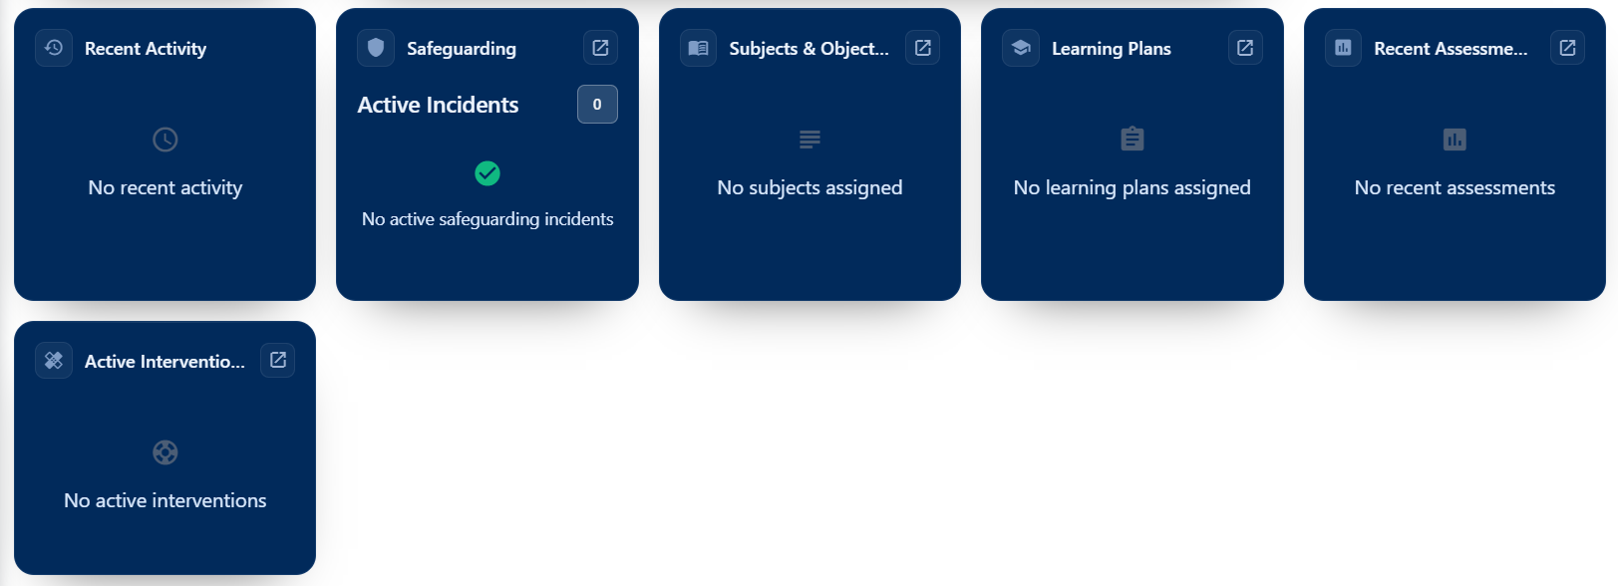
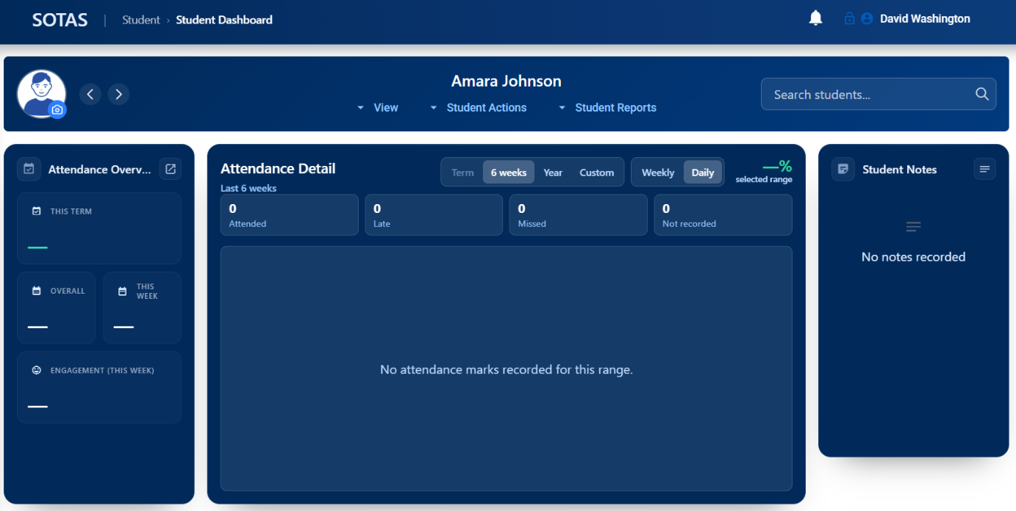

Student Dashboard:
Select Student Actions:
This opens a dropdown menu of:
- Student Actions
  - Contact Parent/Carer
  - Contact SEND worker (if completed)
  - Add quick note
  - View notes
  - Manage groups
  - Manage attainment

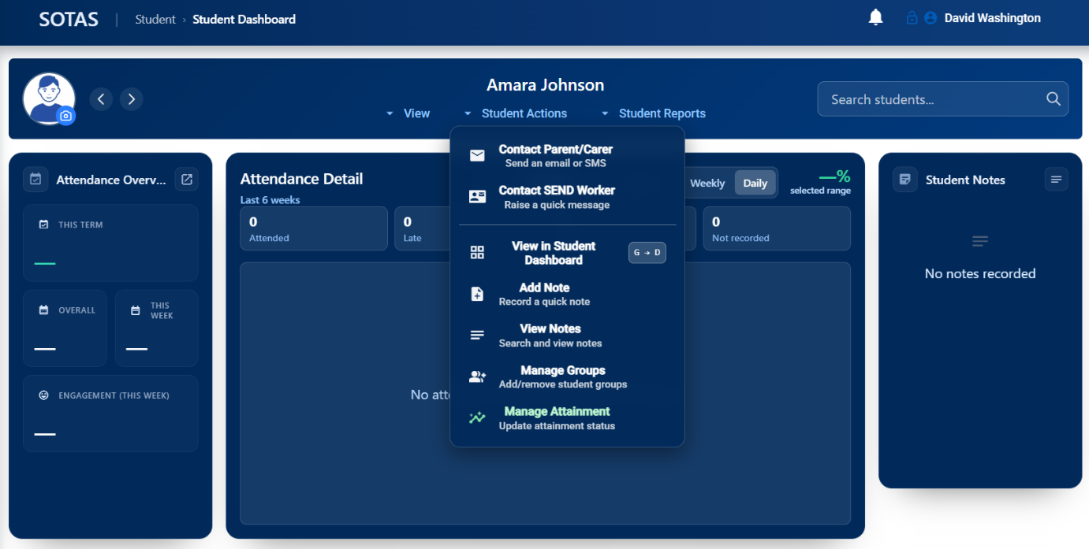

Student Dashboard:
Select Student Reports:
This opens a dropdown menu of:
- Pupil Learning Report
  - Generates a weekly downloadable report

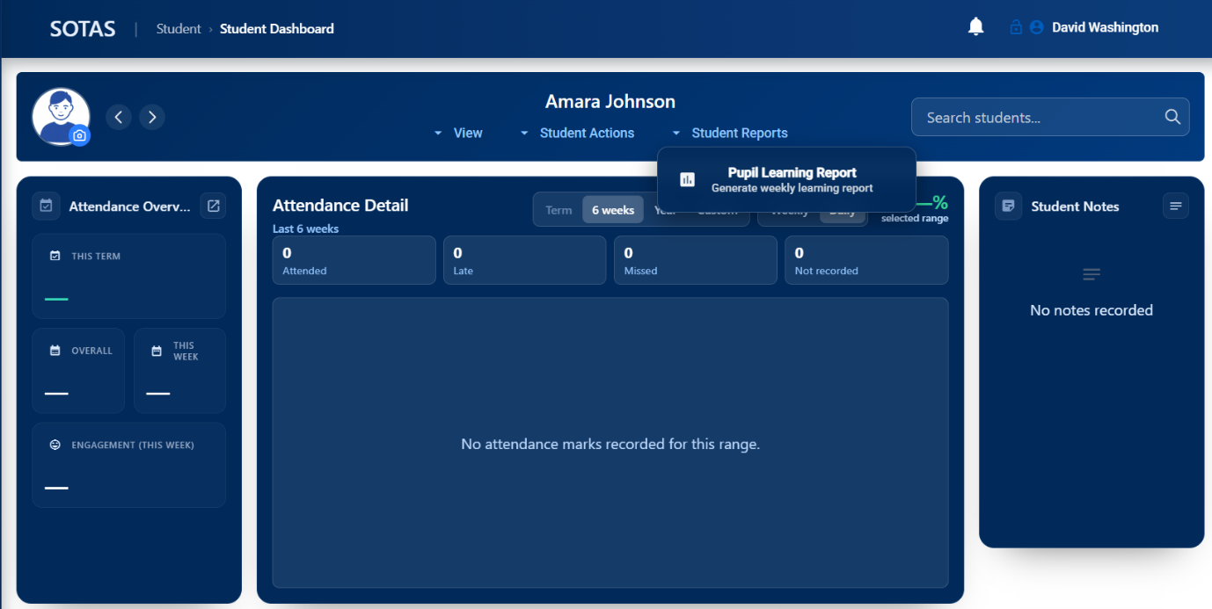

Pupil Learning Report
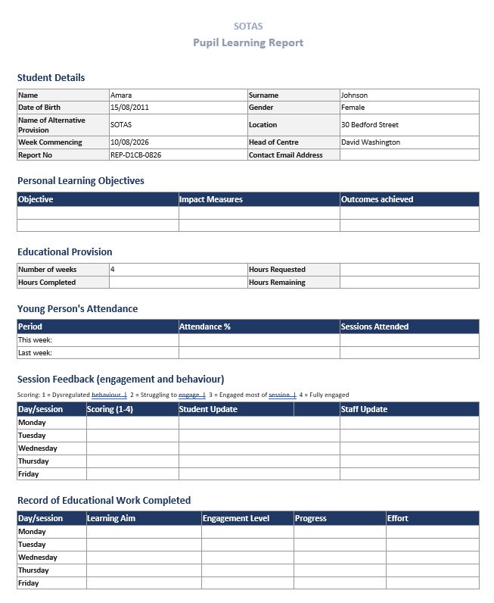

Student Dashboard:
Select Engagement:
- Add Student and staff commentary (links to Pupil Learning Report)
