
Select Timetable tab, this opens Timetable Page (below). Here you can:
- Create your timetable either by subjects, groups or sessions
- Identify location
- Assign staff
- Assign students

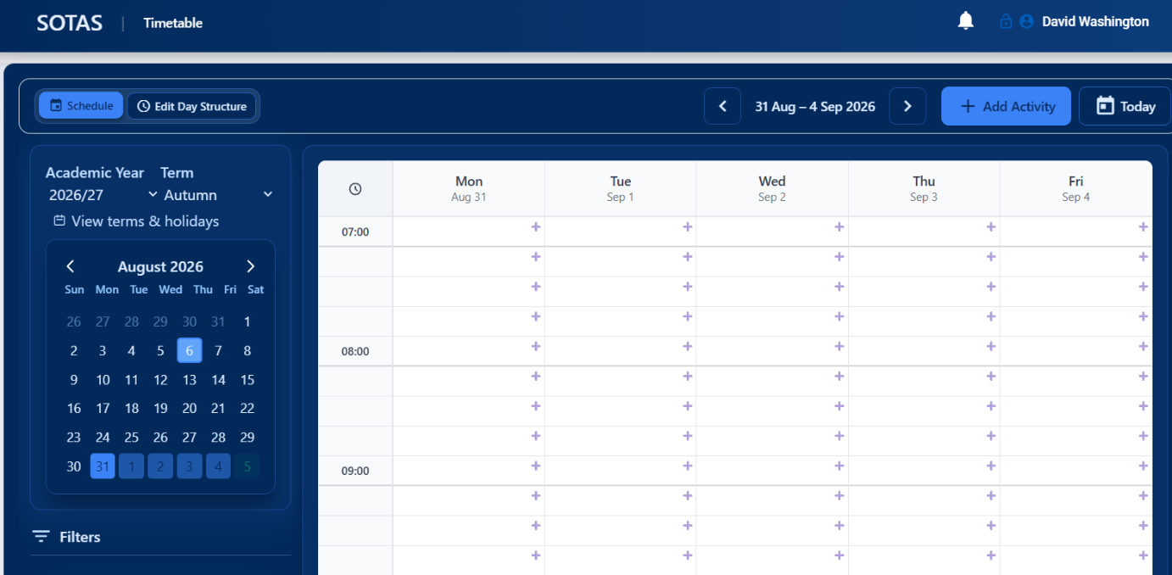

- Select Add Activity 
- Opens 6 stages of adding an activity
- Create a name for the timetabled slot
  - Subject
  - Start date
  - Start and finish time
  - Notes – description of activity

- Activity
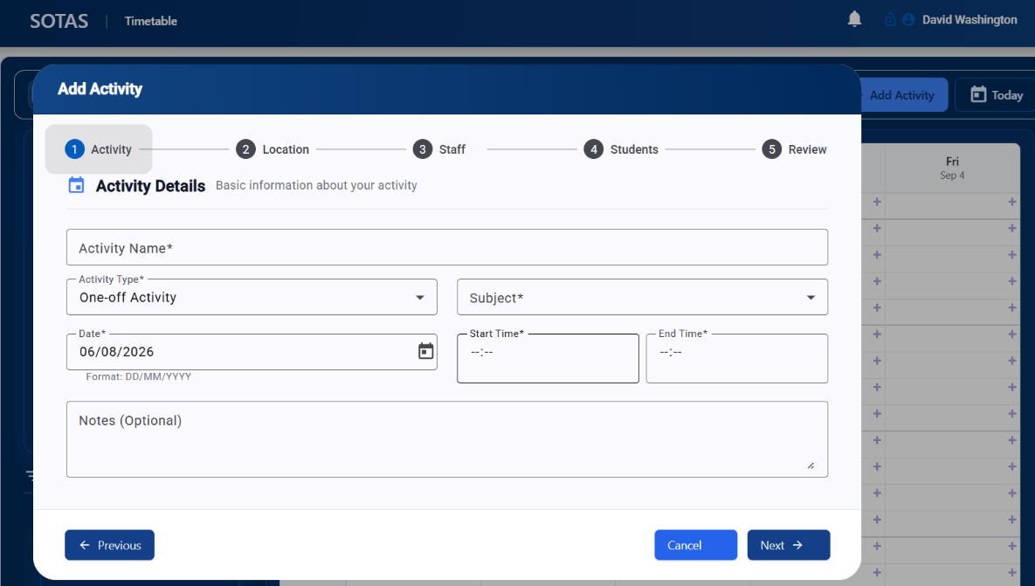

- Location
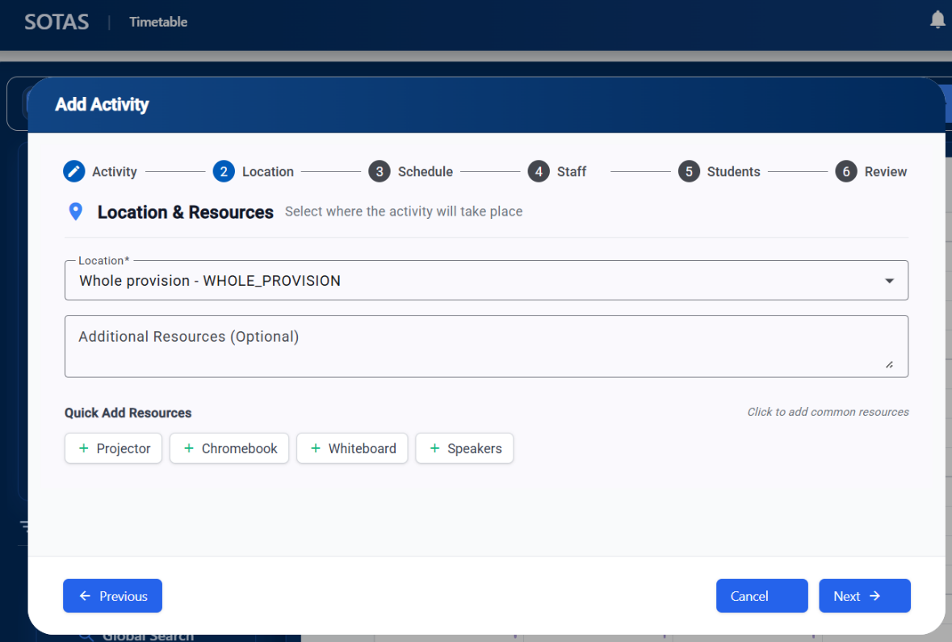

- Schedule:
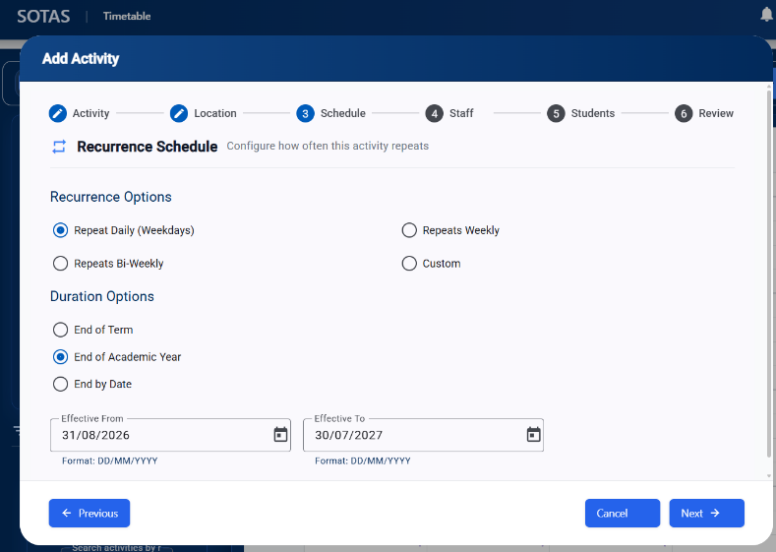

- Select recurrence schedule

- Staff:
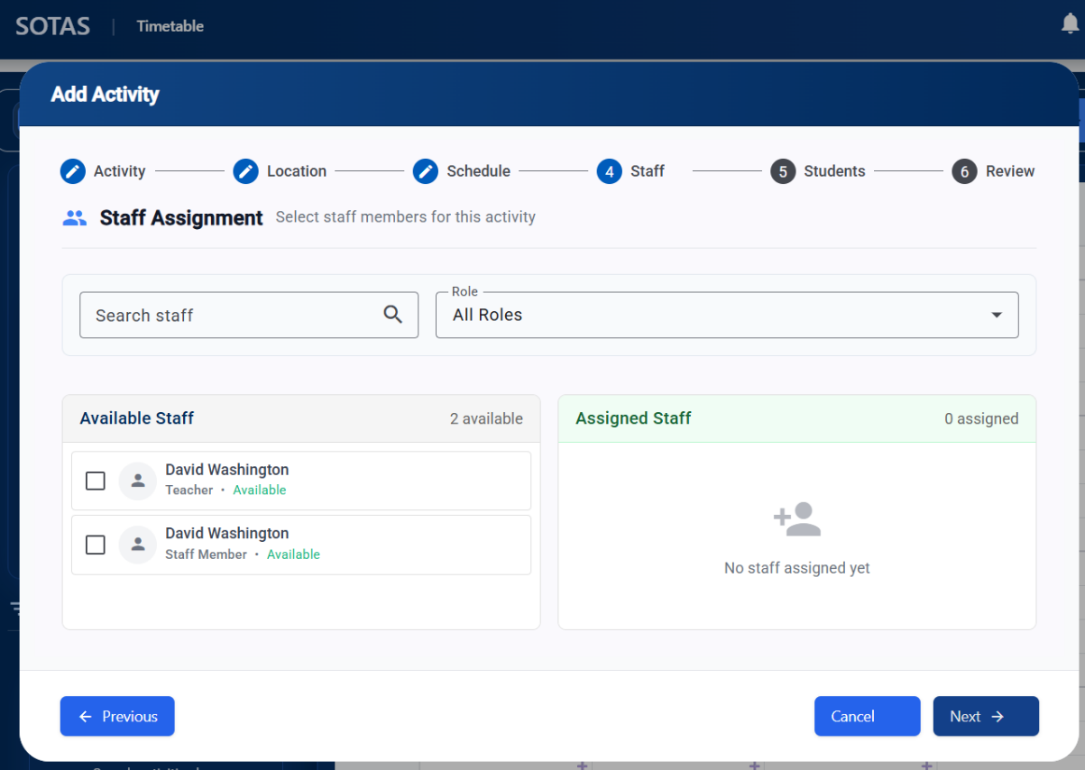

- Assign staff

- Students:
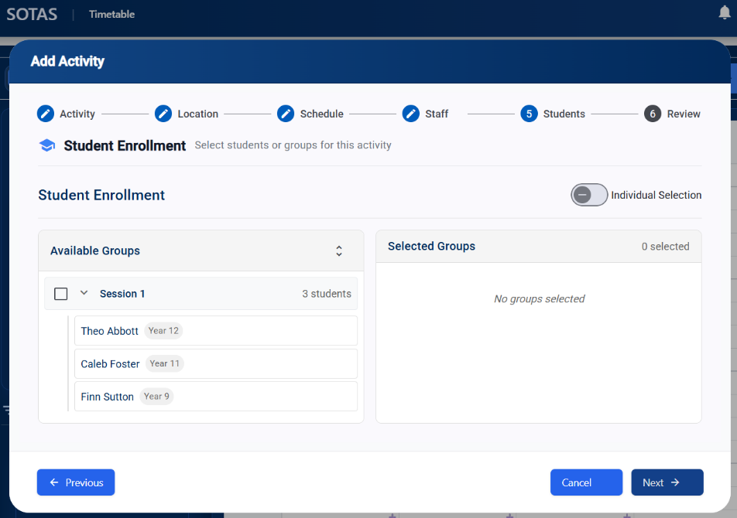

- Assign students individually or by group/cohort

- Review:
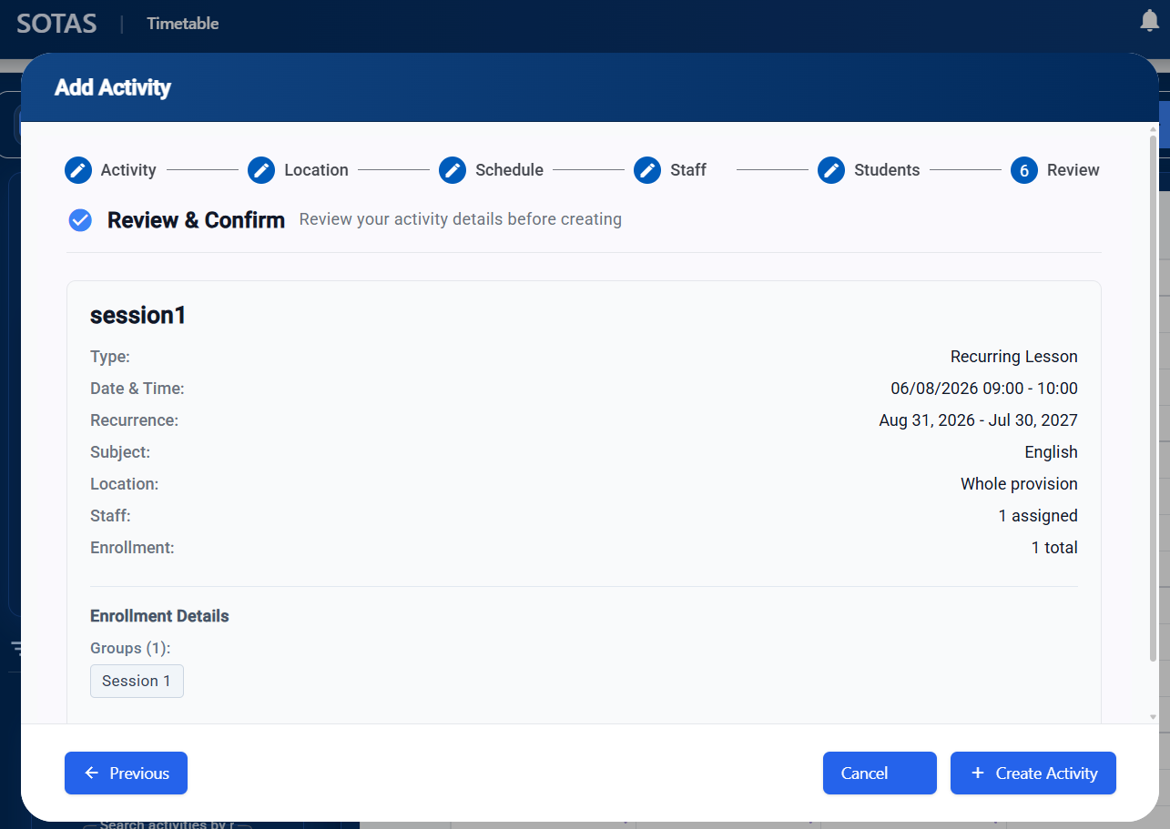

Timetable home page
- Select yellow boxes to change recurrence
- Hover over yellow box to see details of the slot
- Select calendar to change date/term

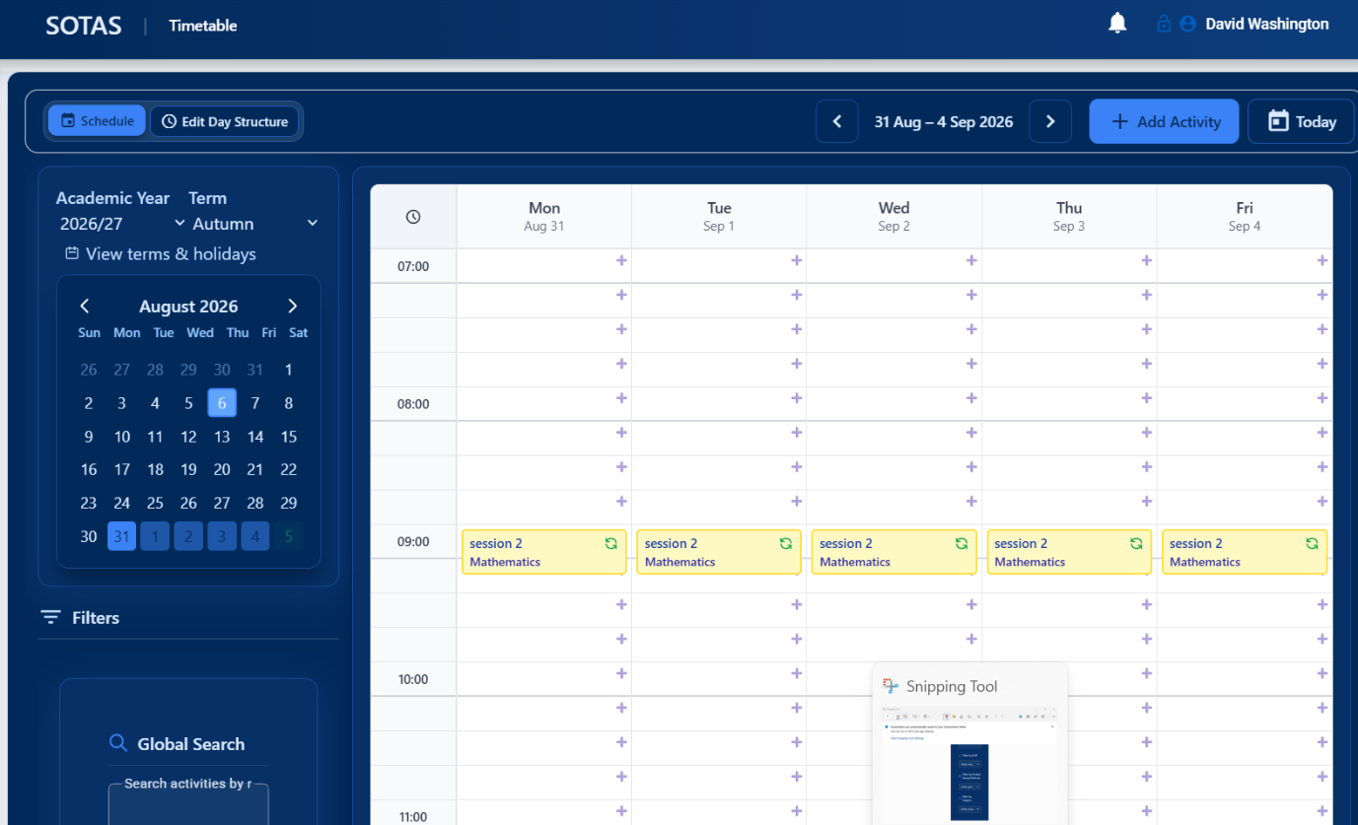
- Select Filter –
  - Search by staff
  - Search by group
  - Search by subject
