lawn bowls – dave’s simple guide for beginners

(YOU WON’T BE EXPECTED TO KNOW EVERYTHING)
  - So what do you need, and need to know?
A bowls match – start to finish
Basic etiquette

LAWN BOWLS – DAVE’S SIMPLE GUIDE FOR BEGINNERS

SO WHAT DO YOU NEED?
Bowls – well of course, but don’t rush out and buy on impulse. There are so many available, differing in weight and size, never mind a myriad of colours, and they don’t come cheap – so borrow some to start, use any the club has until you are happy that they are comfortable to handle, the weight and bias are correct. Try as many as you can, then make your investment.
Clothing (dress code) – bowling shoes are a must, but should only be worn on and around the green, please do not travel to and from the club in them. There are a wide selection of shoes on offer, from slip-on to trainer style. Until you get a club shirt, a white shirt is acceptable for friendly games. Unless otherwise stated, grey trousers (or skirts for ladies if they wish) are the norm for weekday games, whilst white is worn at weekends. Shorts are now widely accepted. Formal shorts for friendlies and competitions. Waterproofs are a sensible addition to every bowler’s bag, given our unpredictable weather.
Equipment – As you progress, chalk and a measure will become a part of your game, but not essential from the start.
And again, once you become more familiar with the game, you learn as you go along. The aim of this leaflet is not to clog you up with facts but just to get you started. You won’t be expected to know everything, and most bowlers are only too glad to help those just starting. So if you are not sure, just ask.
And remember, our coaches are on hand to offer free advice and invaluable coaching.
MAKE SURE you check the notice board. Put your name down for any games you would like to participate in. The club captain will select the teams for friendly (mixed) matches, the captain/vice-captain for competitive games and the ladies captain for lady’s friendlies and competitions. Don’t be afraid to enter internal club competitions. It’s all good experience.
You can keep abreast of goings on within the club, plus fixtures and team sheets on our website. The club will also from time to time email or text with items of interest.

A BOWLS MATCH – START TO FINISH. (What to expect and what is expected of you)
Be ready and suitably attired (see dress code). The captain will call players to the side of green, after a brief welcome to the visiting side, both captains will name their sides in rink order. On reaching your rink, introductions will be made before the game commences. Shake hands. Normally, two trial ends will precede the game, each player will bowl two woods. This should give you an idea of how the green is running. Occasionally, the trial ends will be waived and the game will start straight off, but with only one shot counting on the first two ends, then the game will proceed normally. If playing triples (18 ends) it is normal to play straight through. If rinks (21 ends) a refreshment break may be taken approx. half way through, this is at the home team’s discretion.
At the end of the game, shake hands with your opponents. Once in the club house, it is courtesy for the home players to offer their opposite number a drink. A meal will follow, tables will be numbered to correspond with rinks. If you do not intend to stay after a game, please inform either your captain or the catering staff beforehand. Most clubs hold a raffle, it is customary to take part. At Bradwell, following the speeches and raffle draw, the highest losing home rink will be expected to wash up. After the meal, both captains will make a short speech. You are then free to go or stay and socialise. If you have a change of clothes, now is the time to change. While in the clubhouse team colours are worn, but you may change from whites to greys for the meal if you so wish.

Take a look at the following basic guidelines to green etiquette, observe these and enjoy your bowling!

BASIC BOWLING ETIQUETTE

SIMPLE, COMMON-SENSE GUIDELINES - a few do’s & don’ts

Please DO wherever possible use the steps provided when going on or off the green
DON’T sit on the side with feet on the edges of the green (the edges are very susceptible to damage)
DON’T drop bowls onto the green
DO keep one foot on or over the mat when delivering your wood
DO stand behind the mat while others are delivering woods
DON’T move about in the head when a player is about to deliver a bowl
DON’T walk across another bowler’s line of sight i.e. on the bank or to and from the clubhouse/smoking areas
DON’T deliberately waste time
Although we encourage team involvement DO let only one player measure and question the score if necessary
DO try and gain a workable knowledge of the rules and always ask if unsure
And in general
DO avoid dropping litter into the ditches/using mobile phones on the green
Bowling is a friendly game, DO shake hands with your opponents after the game, whatever the outcome. It is also customary to offer to buy your opposite number a drink (This works in reverse at away games)
And finally
DON’T criticize your team mates but show encouragement. Accept that flukes are a part of the game. Sometimes they go for you, sometimes against.

Following these simple guidelines will not only enhance your enjoyment of the game, but those around you

Dave (2015)
Updated March 2018
This revision Sept. 2019

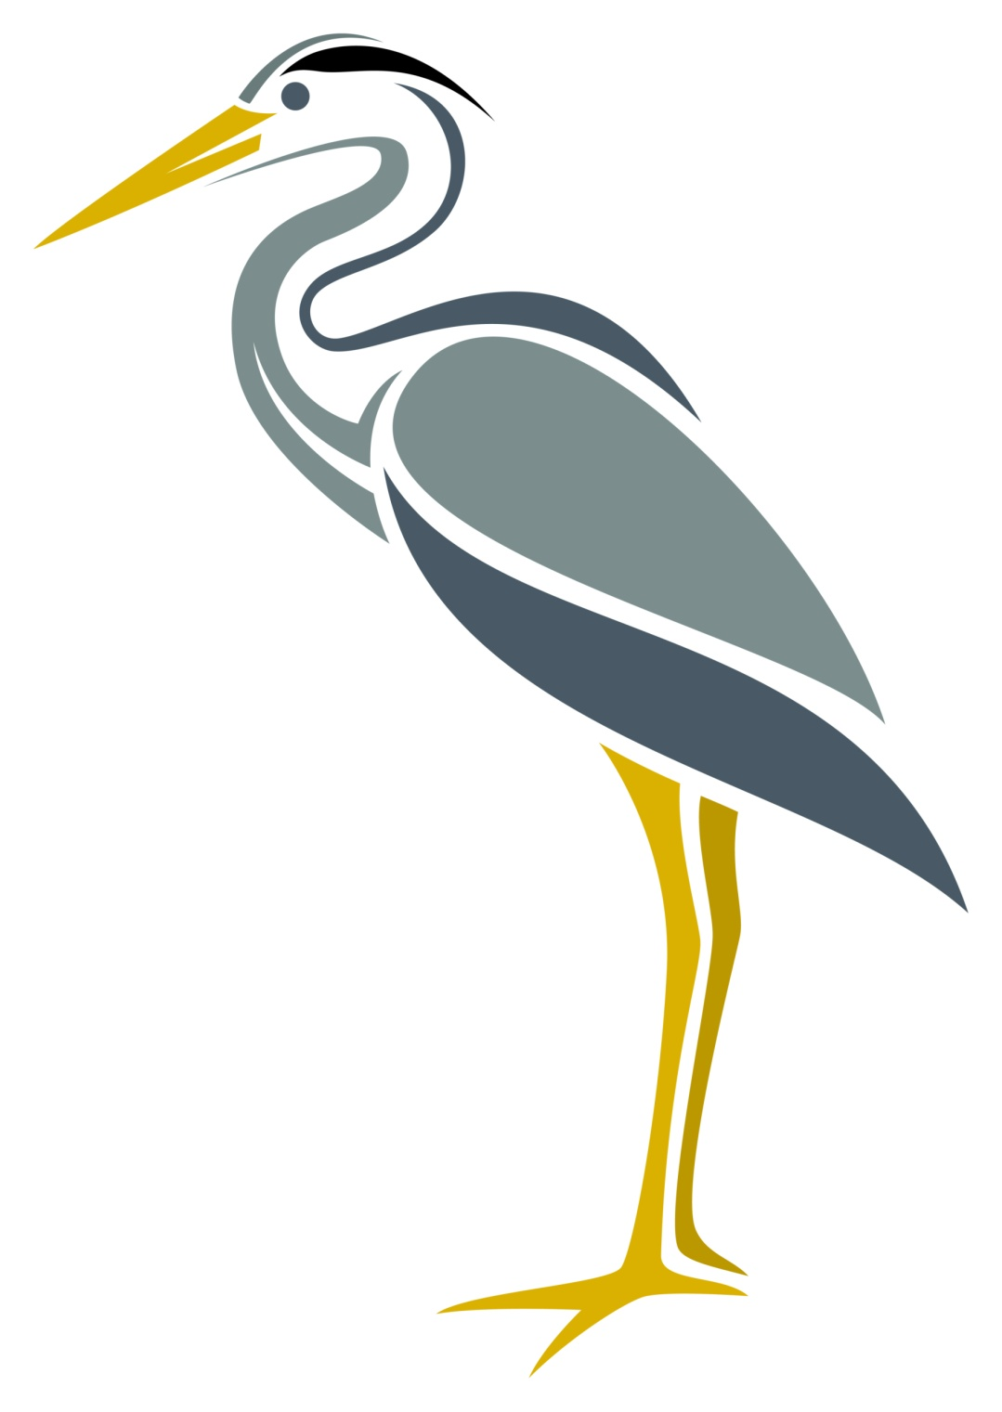

www.bradwellbowlsclub.co.uk

